NSW Government Geospatial Value & Strategic Benefits Guide
Transferring Cloud Spatial Analytics Patterns to State Supercomputing & Inter-Agency Planning
Document Reference | AURA-GOV-NSW-20260907-V2.4
Target Audience | NSW DCCEEW, NSW Spatial Services, State Planning Panels, Treasury & Finance
Strategic Pillars | Statutory Approvals Acceleration, Waratah HPC Integration, Inter-Agency Digital Twin Alignment
Delivery Entity | GetBack2Basics Spatial Analytics
Platform Gateway | https://aura.getback2basics.net
Source Materials | docs/business/nsw_govt_geospatial_benefits.md

PUBLIC SECTOR VALUE REALIZATION
Outlines the strategic and economic return on investment (ROI) for state agencies adopting modern cloud-native geospatial architectures. Highlights how high-throughput GeoParquet pipelines, parallel spatial I/O on Waratah HPC, and client-side zero-cost query offloading accelerate statutory assessment timelines while maintaining sovereign data integrity.

Visual Portfolio & Interactive System Captures
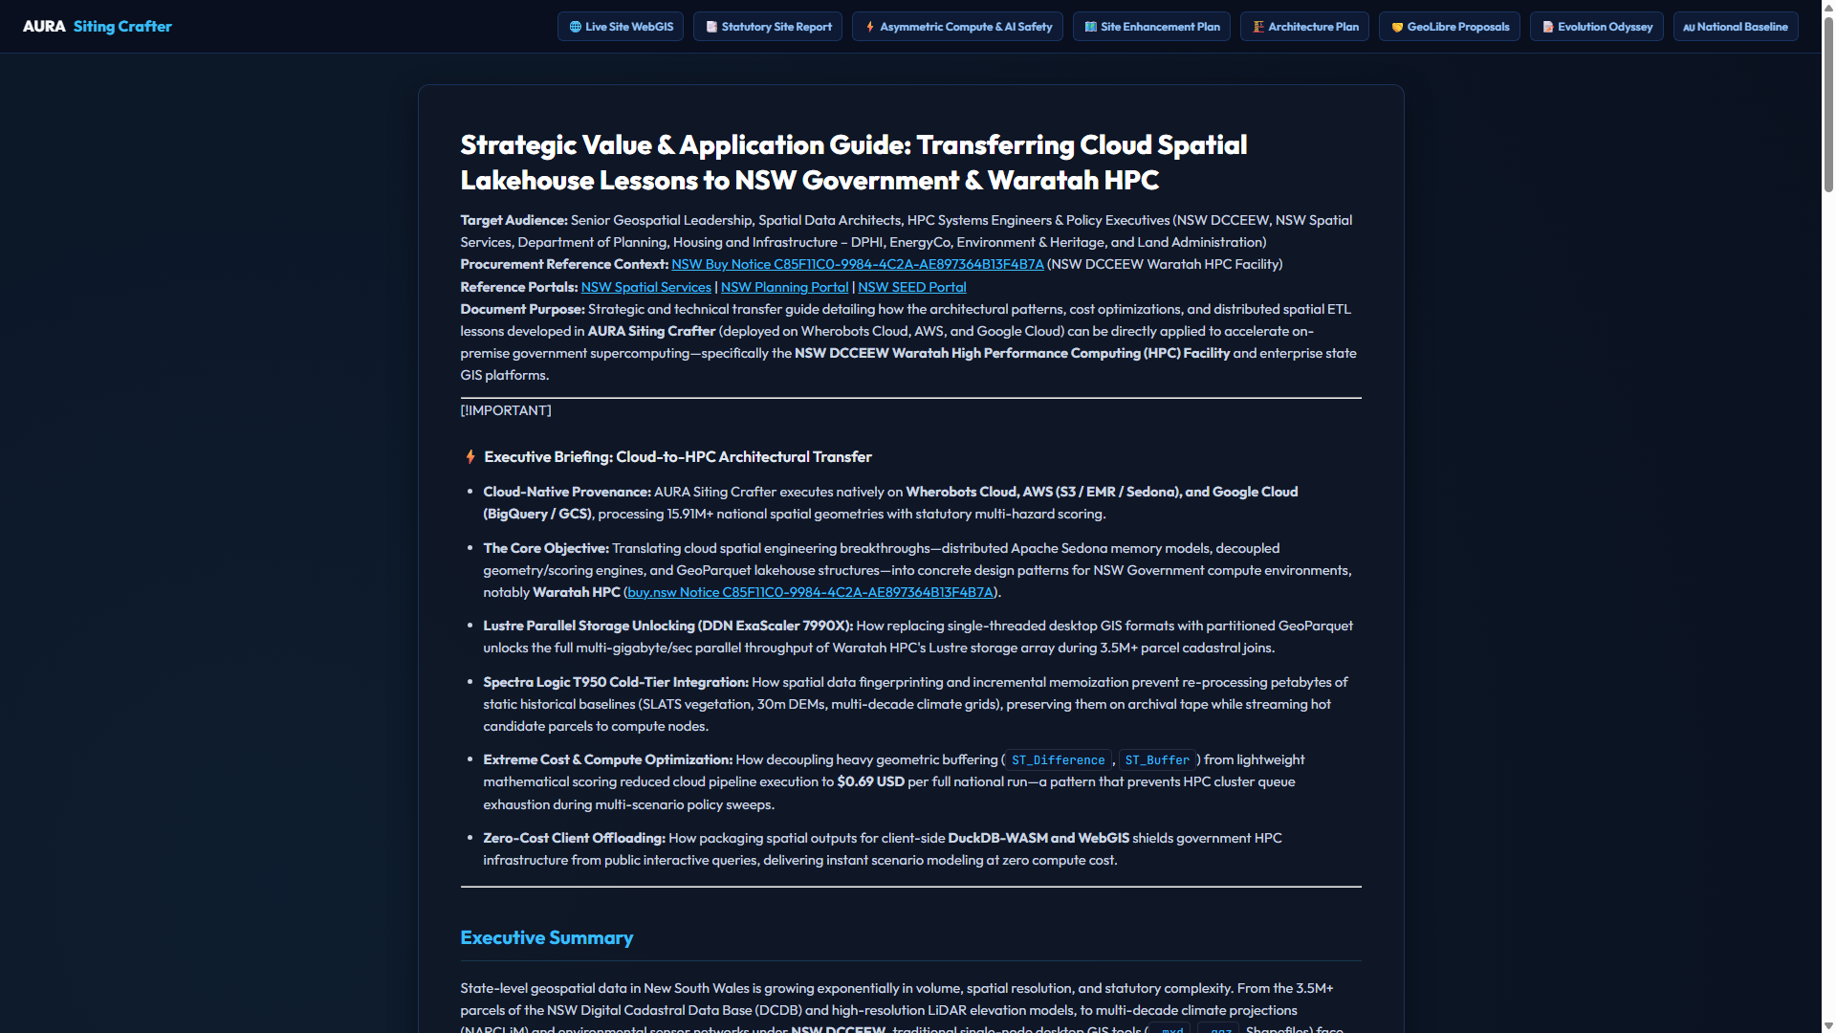
Figure 1: Strategic benefits matrix and economic ROI model for NSW Government.
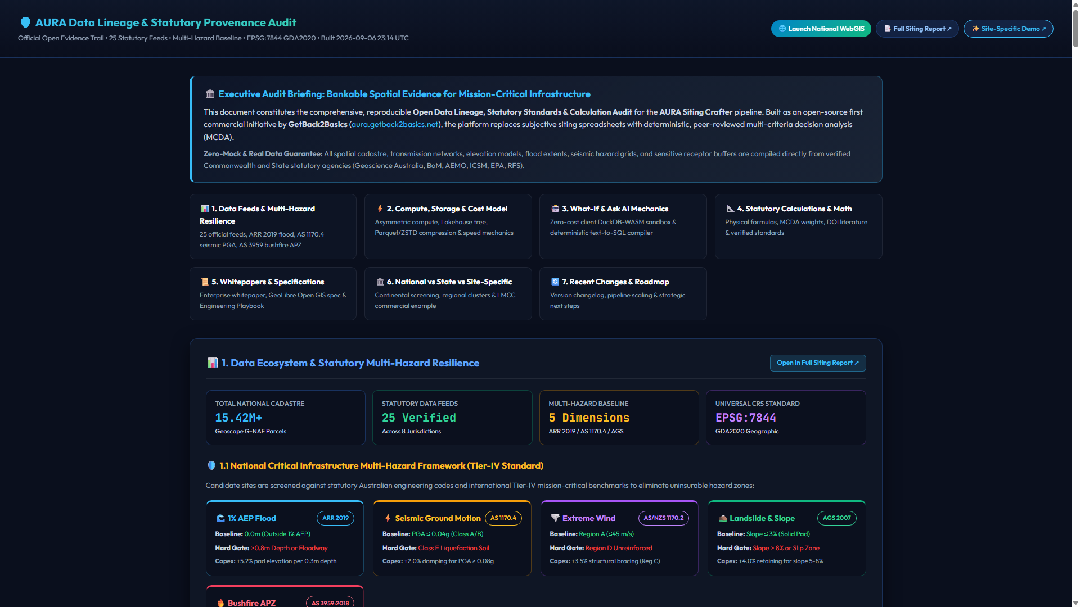
Figure 2: Verifiable cryptographic data lineage and automated compliance auditing.

Strategic Value & Application Guide: Transferring Cloud Spatial Lakehouse Lessons to NSW Government & Waratah HPC
Target Audience: Senior Geospatial Leadership, Spatial Data Architects, HPC Systems Engineers & Policy Executives (NSW DCCEEW, NSW Spatial Services, Department of Planning, Housing and Infrastructure – DPHI, EnergyCo, Environment & Heritage, and Land Administration)
Procurement Reference Context: NSW Buy Notice C85F11C0-9984-4C2A-AE897364B13F4B7A (NSW DCCEEW Waratah HPC Facility)
**Reference Portals:** [NSW Spatial Services](https://www.spatial.nsw.gov.au/) | [NSW Planning Portal](https://www.planningportal.nsw.gov.au/) | [NSW SEED Portal](https://www.seed.nsw.gov.au/)

Document Purpose: Strategic and technical transfer guide detailing how the architectural patterns, cost optimizations, and distributed spatial ETL lessons developed in AURA Siting Crafter (deployed on Wherobots Cloud, AWS, and Google Cloud) can be directly applied to accelerate on-premise government supercomputing—specifically the NSW DCCEEW Waratah High Performance Computing (HPC) Facility and enterprise state GIS platforms.
---
> [!IMPORTANT]
> ### ⚡ Executive Briefing: Cloud-to-HPC Architectural Transfer
> * Cloud-Native Provenance: AURA Siting Crafter executes natively on Wherobots Cloud, AWS (S3 / EMR / Sedona), and Google Cloud (BigQuery / GCS), processing 15.91M+ national spatial geometries with statutory multi-hazard scoring.
> * The Core Objective: Translating cloud spatial engineering breakthroughs—distributed Apache Sedona memory models, decoupled geometry/scoring engines, and GeoParquet lakehouse structures—into concrete design patterns for NSW Government compute environments, notably Waratah HPC (buy.nsw Notice C85F11C0-9984-4C2A-AE897364B13F4B7A).
> * Lustre Parallel Storage Unlocking (DDN ExaScaler 7990X): How replacing single-threaded desktop GIS formats with partitioned GeoParquet unlocks the full multi-gigabyte/sec parallel throughput of Waratah HPC's Lustre storage array during 3.5M+ parcel cadastral joins.
> * Spectra Logic T950 Cold-Tier Integration: How spatial data fingerprinting and incremental memoization prevent re-processing petabytes of static historical baselines (SLATS vegetation, 30m DEMs, multi-decade climate grids), preserving them on archival tape while streaming hot candidate parcels to compute nodes.
> * Extreme Cost & Compute Optimization: How decoupling heavy geometric buffering (ST_Difference, ST_Buffer) from lightweight mathematical scoring reduced cloud pipeline execution to $0.69 USD per full national run—a pattern that prevents HPC cluster queue exhaustion during multi-scenario policy sweeps.
> * Zero-Cost Client Offloading: How packaging spatial outputs for client-side DuckDB-WASM and WebGIS shields government HPC infrastructure from public interactive queries, delivering instant scenario modeling at zero compute cost.
---

Executive Summary
State-level geospatial data in New South Wales is growing exponentially in volume, spatial resolution, and statutory complexity. From the 3.5M+ parcels of the NSW Digital Cadastral Data Base (DCDB) and high-resolution LiDAR elevation models, to multi-decade climate projections (NARCLiM) and environmental sensor networks under NSW DCCEEW, traditional single-node desktop GIS tools (.mxd, .qgz, Shapefiles) face severe scalability bottlenecks.
The AURA Siting Crafter project was architected on commercial cloud infrastructure (Wherobots Cloud, AWS, and Google Cloud) using Apache Sedona (PySpark), Apache Iceberg, and GeoParquet to solve large-scale spatial siting, multi-hazard constraint analysis, and circular economy modeling.
This document synthesizes the operational, mathematical, and architectural lessons learned from AURA's cloud implementation into a roadmap for NSW Government agencies. It demonstrates how these patterns can modernize state workflows and maximize return-on-investment for specialized state computing assets such as the NSW DCCEEW Waratah HPC Facility.
---

The Reference Environment: NSW DCCEEW Waratah HPC
The Waratah High Performance Computing (HPC) facility is a government-managed supercomputing cluster operated by the NSW Department of Climate Change, Energy, the Environment and Water (DCCEEW) (buy.nsw Notice C85F11C0-9984-4C2A-AE897364B13F4B7A, supported by Xenon Systems).
+----------------------------------------------------------------------------------------------------+
| NSW DCCEEW WARATAH HPC FACILITY ARCHITECTURE |
| (Procurement: buy.nsw Notice C85F11C0-9984-4C2A-AE897364B13F4B7A) |
+----------------------------------------------------------------------------------------------------+
| |
| [ PRIMARY STORAGE ] [ ARCHIVAL & BACKUP ] |
| DDN ExaScaler 7990X Lustre Storage Array Spectra Logic T950 Tape Library |
| • High-throughput parallel filesystem • Petabyte-scale preservation |
| • Optimized for massive concurrent streaming • Multi-decade environmental data |
| |
| [ COMPUTATIONAL MANDATE ] [ VENDOR & SYSTEM SUPPORT ] |
| Dedicated to NSW DCCEEW Policy & Science Maintained by Xenon Systems |
| • Climate Modeling (NARCLiM) & Extreme Projections • Node reconfiguration & tuning |
| • Environmental Monitoring, SLATS & Biodiversity • Continuous system maintenance |
| • Renewable Energy Zone (REZ) & Grid Simulations • High-throughput interconnects |
| • River Basin, Flood & Water Resource Management |
| |
+----------------------------------------------------------------------------------------------------+
Unlike academic compute facilities, Waratah HPC is dedicated to direct public policy, environmental stewardship, and statutory spatial planning. AURA's cloud-proven engineering patterns offer a blueprint for running high-throughput spatial analytics across these portfolios.
---

5 Transferable Spatial Engineering Lessons: Cloud (AURA) to On-Premise HPC
+----------------------------------------------------------------------------------------------------+
| AURA CLOUD PIPELINE (Wherobots / AWS / GCP) |
| 15.91M Geometries | Decoupled Geometry/Scoring | GeoParquet / Iceberg | $0.69 USD Full Run |
+----------------------------------------------------------------------------------------------------+
|
ARCHITECTURAL LESSONS & PATTERNS TRANSFERRED
v
+----------------------------------------------------------------------------------------------------+
| NSW DCCEEW WARATAH HPC FACILITY ADOPTION |
| 1. GeoParquet Parallel I/O on DDN Lustre Storage Array (ExaScaler 7990X) |
| 2. Memoized Partition Pruning & Cold Data Preservation (Spectra Logic T950 Tape) |
| 3. Decoupled Heavy Geometric Transforms from Rapid Multi-Scenario Scoring |
| 4. Statutory 6-Factor Multi-Hazard Scoring Engine (ARR 2019, AS 1170, AS 3959) |
| 5. Zero-Cost Client-Side Offloading via DuckDB-WASM for Public Planners |
+----------------------------------------------------------------------------------------------------+
---

Lesson 1: Unlocking Lustre Parallel Storage via Partitioned GeoParquet
- Cloud Experience (AURA): Legacy shapefiles and single-file geodatabases created severe I/O bottlenecks in cloud object storage (S3/GCS). Migrating to GeoParquet with spatial R-Tree / Hilbert curve partitioning allowed worker nodes to read and process spatial extents independently in parallel without I/O locking.
- HPC Translation (Waratah Lustre Array):
- Waratah HPC's DDN ExaScaler 7990X Lustre filesystem is designed for massive concurrent read/write throughput across distributed stripes.
- Storing statewide layers (DCDB parcels, 30m DEM, biodiversity zones) in partitioned GeoParquet allows Spark/Sedona nodes to saturate Lustre striping channels simultaneously.
- Result: Eliminates the I/O choke point when joining 3.5M+ NSW parcels with multi-hazard layers, completing statewide joins in minutes.
---

Lesson 2: Decoupled Heavy Geometry vs. Lightweight Mathematical Scoring
- Cloud Experience (AURA): In early prototypes, adjusting a policy weight (e.g. power grid priority vs. biodiversity buffer weight) re-triggered heavy spatial joins (ST_Buffer, ST_Difference, ST_Intersection), driving up cloud compute costs. By decoupling geometric pre-computations (distance matrices, net developable polygons) from mathematical scoring curves (sigmoidal penalties, weighted MCDA sums), full national runs dropped to $0.69 USD.
- HPC Translation (Waratah Cluster Utilization):
- Policy makers often need to run hundreds of "What-If" scenarios with shifting weightings (e.g., varying flood tolerance, sensitive receptor buffers, or grid distance priorities).
- Pre-computing the geometric distance and topology layer once and caching it on Lustre allows subsequent policy scoring runs to execute as pure mathematical array operations in milliseconds.
- Result: Prevents long cluster queue times and avoids wasting valuable HPC node hours on repetitive geometric recalculations.
---

Lesson 3: Cold-Tier Data Preservation & Memoized Incremental Pipelines
- Cloud Experience (AURA): Large baselines (national topographic grids, geological surveys, baseline census data) rarely change between runs. Cryptographic fingerprinting (ETags, snapshot hashes) ensured untouched layers were skipped, computing only active delta updates.
- HPC Translation (Spectra Logic T950 Tape Integration):
- Waratah HPC uses a Spectra Logic T950 Tape Library for long-term preservation of massive multi-decade climate (NARCLiM) and environmental time-series datasets.
- Using partition fingerprinting, the Sedona spatial pipeline can pull active candidate layers to high-speed NVMe/Lustre storage while keeping cold, multi-petabyte reference datasets safely referenced in tape archives.
- Result: Minimizes active primary storage consumption while guaranteeing 100% reproducible baseline provenance.
---

Lesson 4: Standardized Multi-Hazard & Circular Physical Engineering
- Cloud Experience (AURA): Integrated statutory Australian standards into programmatic Python/SQL formulas rather than subjective manual GIS overlays:
- Flood: ARR 2019 / 1% AEP inundation exclusion.
- Bushfire: AS 3959:2018 BAL (Bushfire Attack Level) & PBF 2019 setbacks.
- Landslide: AGS 2007 slope susceptibility modeling ($>8.0\%$ exclusion).
- Seismic: AS 1170.4:2007 (R2018) PGA structural hazard baselines.
- Wind: AS/NZS 1170.2:2021 regional wind design speeds ($45\text{–}69\text{m/s}$).
- Thermodynamic Decay & Pumped Hydro: Spatial heat loss modeling ($T_{\text{delivery}} \le 38.5^\circ\text{C}$ within $\le 506.8\text{m}$) and void storage capacity ($E = \rho g H V \eta$).
- HPC Translation (DCCEEW Scientific Portfolios):
- These validated, peer-reviewed formula implementations can be deployed as standard batch modules across DCCEEW portfolios (EnergyCo Renewable Energy Zones, DPHI Growth Areas, WaterNSW catchments).
- Result: Ensures legal and statutory defensibility across state planning assessments.
---

Lesson 5: Zero-Cost Client-Side Scenario Modeling for Planners
- Cloud Experience (AURA): Rather than standing up expensive, always-on spatial servers (GeoServer, ArcGIS Enterprise servers) to handle user queries, AURA exports lightweight spatial tables into client-side DuckDB-WASM and JavaScript. Users can dynamically drag weight sliders, apply hazard thresholds, and filter sites directly in the browser with sub-second response times.
- HPC Translation (Protecting Government Infrastructure):
- Government supercomputers (like Waratah HPC) should never be directly exposed to public interactive web traffic or burdened with serving live interactive maps.
- HPC clusters can run heavy overnight distributed batch jobs, export optimized GeoParquet artifacts, and serve interactive decision dashboards via static client-side WASM portals.
- Result: Delivers sub-second interactive tools to regional council planners and executive stakeholders with zero web-tier server costs and complete cybersecurity isolation for the internal HPC cluster.
---

Domain Capabilities: Applying AURA Lessons Across NSW Portfolios
+-----------------------+ +-----------------------+ +-----------------------+
| PLANNING & HOUSING | | ENVIRONMENT | | LAND ADMIN & |
| (DPHI & REZs) | | & MULTI-HAZARDS | | SPATIAL SERVICES |
| • Net Developable Pad | | • ARR 2019 Flood 1% | | • 3.5M+ DCDB Parcels |
| • Statutory Setbacks | | • AS 3959 Bushfire | | • GDA2020 EPSG:7856 |
| • Proponent Claim QA | | • AGS 2007 Landslide | | • Spatial Digital Twin|
| • 6-Factor MCDA Engine| | • AS 1170.4 Seismic | | • Zero-Copy GeoParquet|
+-----------------------+ +-----------------------+ +-----------------------+

1. Planning & Precinct Transformation (DPHI & EnergyCo)
- Automated Net Developable Area (NDA): Automates topological subtraction of riparian (30m), pipeline (20m), slope (>5%), and infrastructure easements across massive masterplans (e.g. Hunter Transformation, Western Sydney Aerotropolis). For the Macquarie Coal Complex, this verified that a 65.0 ha gross boundary yielded 44.5 ha net developable pad space.
- Proponent Claim QA: Audits developer planning submissions against ground-truth state spatial layers using automated topological path calculations.

2. Environment, Climate & Energy (NSW DCCEEW)
- Statewide Multi-Hazard Assessment: Executes ARR 2019, AS 1170, and AS 3959 evaluations across every parcel in NSW.
- Clean Energy & REZ Siting: Evaluates proximity to 132kV/275kV/330kV transmission lines, substations, and recycled water treatment plants (WWTW).
- Circular Industrial Symbiosis: Models thermodynamic effluent cooling and mine void micro-pumped hydro potential.

3. Cadastre & Land Administration (Spatial Services NSW)
- DCDB Spatial Enrichment: Enriches 3.5M+ land parcels with zoning, hazard ratings, and proximity metrics without memory bottlenecks.
- GDA2020 Compliance: Enforces automated reprojection and geometry validation across EPSG:7856 (MGA 56 metric engineering) and EPSG:7844 / EPSG:4326.
---

Feature Comparison: Traditional Desktop GIS vs. Cloud/HPC Modern Architecture
Feature / Dimension | Traditional Desktop GIS (Manual Single-Node) | AURA Cloud Architecture (Wherobots / AWS / GCP) | Recommended Waratah HPC Adoption Pattern
**Execution Scale** | Single-threaded; crashes on large polygons | Distributed multi-node (Apache Sedona PySpark) | Distributed Sedona on Waratah HPC compute nodes
**Storage Subsystem** | Local C: drives / SMB network shares | Cloud object storage (S3 / GCS / Iceberg) | **DDN ExaScaler 7990X Lustre Parallel Array**
**Cold Data Strategy** | Manual archiving to detached drives | Cloud lifecycle tiering & snapshot hashing | **Spectra Logic T950 Tape Library integration**
**Multi-Hazard Model** | Ad-hoc manual layer reclassifications | Statutory AS/NZS & ARR 2019 formula engine | Standardized state-wide automated hazard scoring
**Interactive UX** | Requires desktop GIS software install | Zero-cost client-side **DuckDB-WASM** | Static WASM web portals (air-gapped from HPC)
**Run Economics** | Days of manual engineering labor | **$0.69 USD** per full national run (15.91M geoms) | Maximized HPC throughput & zero queue bloat

---

Recommended Action Plan for NSW Spatial & HPC Leadership
- Adopt Partitioned GeoParquet as State Standard: Transition state spatial distribution from legacy Shapefiles/FileGDBs to cloud-native GeoParquet (EPSG:7844 / EPSG:7856) to unlock parallel I/O on Lustre storage arrays.
- Pilot Apache Sedona on Waratah HPC: Test distributed Apache Sedona PySpark batch scripts on the Waratah HPC cluster for state-wide Net Developable Area (NDA) generation across the 3.5M+ parcel DCDB.
- Establish a Decoupled Scoring Framework: Separate heavy geometric spatial joins from multi-criteria decision scoring across DPHI, EnergyCo, and DCCEEW planning workflows to minimize compute redundancy.
- Integrate Output Streams with NSW Spatial Digital Twin: Connect GeoParquet spatial outputs directly to the NSW Spatial Digital Twin and client-side DuckDB-WASM viewers for secure, zero-cost interactive policy exploration.

