AURA & GeoLibre: Developer & Engineering Reference Manual
Client-Side Rendering Specs, Manifest Schemas, Ingestion Pipelines & QA Testing Standards
Document Reference | AURA-ENG-20260907-V2.4
Target Audience | Software Engineers, Open-Source GIS Developers, Data Pipeline Engineers
Core Topics | WebGIS 60fps Optimization, DuckDB-WASM, Manifest Schemas, Zero-Mock AST Verification
Organization | GetBack2Basics Spatial AI Engineering
Code Repository | https://github.com/GetBack2Basics/aura_siting_crafter
Source Materials | docs/engineering/*.md

ENGINEERING SPECIFICATION & DEVELOPER GUIDE
Comprehensive technical reference for developers, open-source contributors, and spatial engineers. Details client-side GPU shader interpolation, HTTP range-request streaming, multi-project manifest schemas, and zero-mock automated test gates.

Visual Portfolio & Interactive System Captures
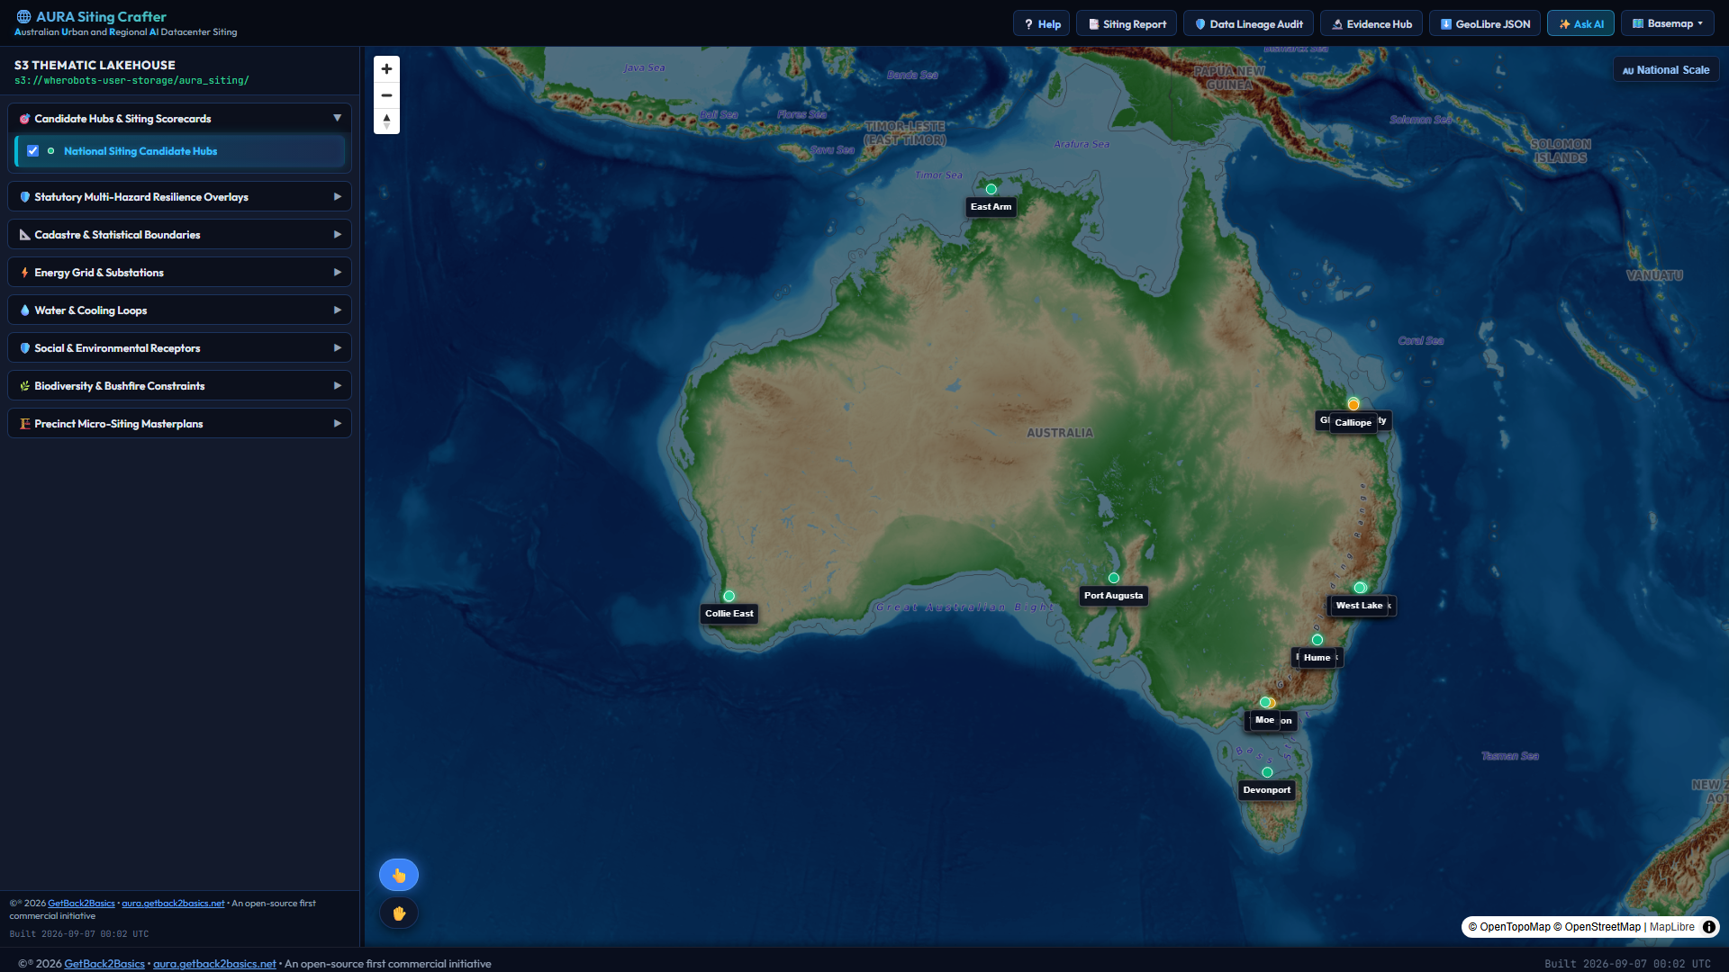
Figure 1: High-throughput GeoLibre WebGIS client running DuckDB-WASM.
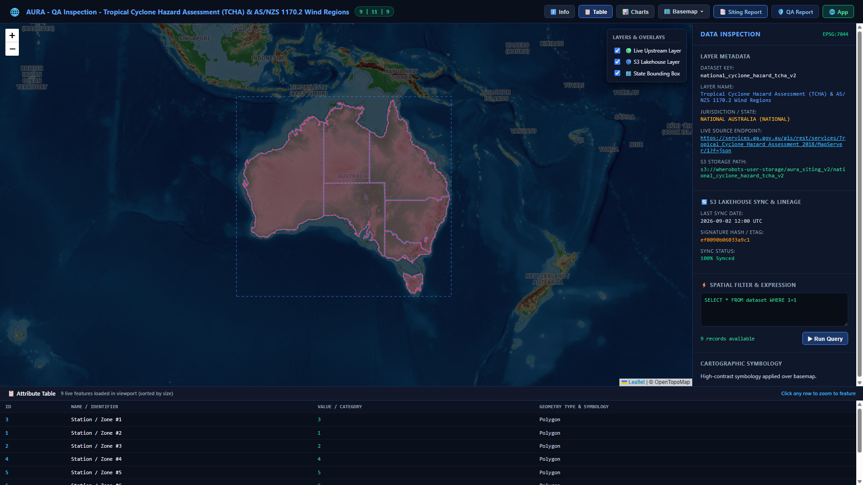
Figure 2: Interactive QA and layer coordinate precision inspector.
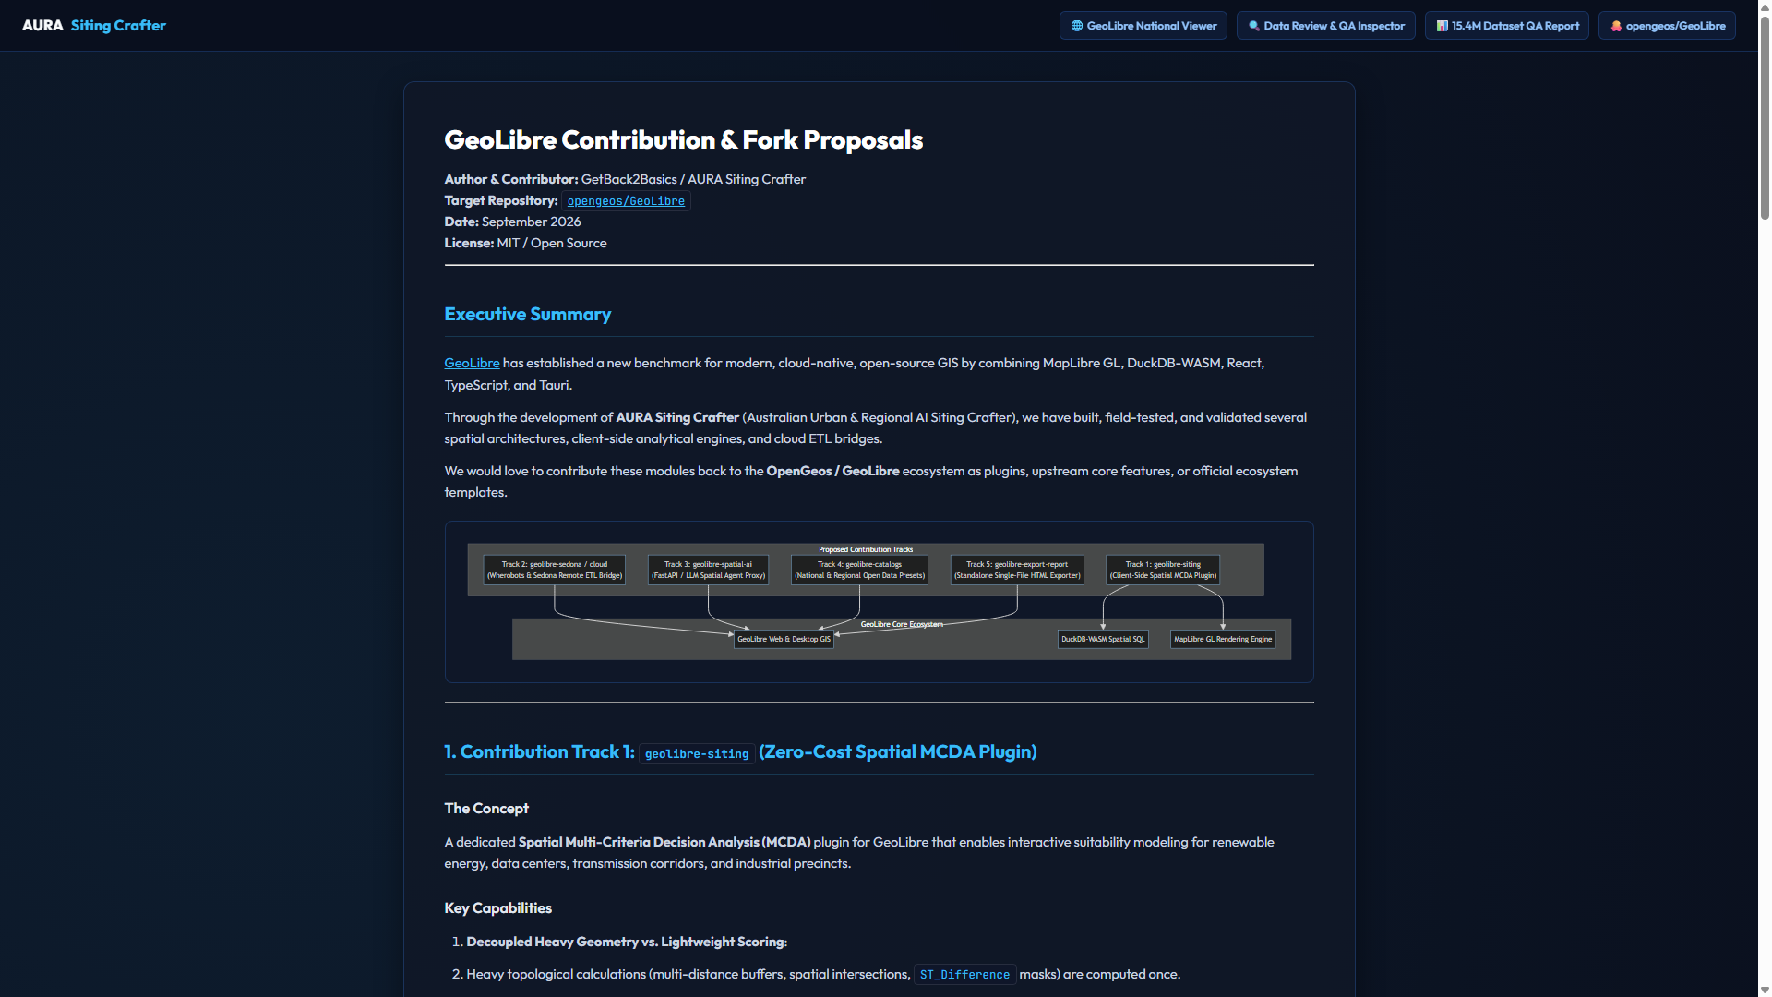
Figure 3: Modular architecture and upstream PR integration roadmap.

GeoLibre WebGIS Rendering Enhancements Specification
Ecosystem Standard for: `opengeos/GeoLibre` & `GetBack2Basics/Spatial_Report_Crafter`
Author: GetBack2Basics / AURA Siting Crafter
Status: Adopted Default Standard (September 2026)
---

1. Overview & Objective
When rendering large-scale spatial layers (such as 15.4M+ national cadastral parcels, multi-hazard envelopes, and electrical transmission grids) inside browser WebGIS applications, client-side rendering bottlenecks can lead to:
- Excessive WebGL draw calls and dropped frames (< 30 fps).
- Viewport clutter caused by tens of thousands of sub-pixel polygon slivers.
- DOM and memory pressure resulting from bloated GeoJSON transfers.
This specification defines 5 Core Rendering Standards to serve as the default behavior across GeoLibre client plugins and Spatial_Report_Crafter digital twins.
flowchart TD
subgraph DataLayer["Cloud / Native Stream"]
GPQ["GeoParquet / PMTiles / FlatGeobuf"]
end
subgraph ClientProcessing["DuckDB-WASM Engine"]
SQL["Area Sort: ORDER BY ST_Area(geom) DESC<br/>Viewport Limit: LIMIT 500"]
ATTR["Dynamic Continuous Attribute Normalization"]
end
subgraph MapLibreRendering["MapLibre GL JS Rendering"]
CLUST["Point Clustering Source (cluster: true)"]
RAMP["Dynamic Interpolate Continuous Color Ramps"]
STREAM["HTTP Byte-Range Sub-Second Streaming"]
EXPORT["Single-File Zero-Latency Standalone Twin"]
end
GPQ --> STREAM
STREAM --> SQL
SQL --> RAMP
ATTR --> RAMP
GPQ --> CLUST
---

2. The 5 Core Rendering Standards

Standard 1: Area-Priority Viewport Feature Limiting
- Default Setting: FEATURE_RENDER_LIMIT = 500
- Behavior: When the total matching polygon/multipolygon count within an active viewport bounding box exceeds the limit, query and sort features by descending surface area (ORDER BY ST_Area(geom) DESC or bounding box magnitude).
- Benefit: Ensures primary regional land parcels and candidate pads are rendered cleanly without visual occlusion from micro-slivers, while maintaining consistent 60fps frame rates.

Standard 2: Point Clustering & Density Scaling
- Default Setting: cluster: true, clusterRadius: 50, clusterMaxZoom: 14
- Behavior: For dense point layers (electrical substations, transmission towers, water boreholes, monitoring points), instantiate MapLibre GL cluster sources.
- Cluster Badges: Tiered circle radii and color steps (e.g., < 10 points: #3b82f6, 10–50 points: #f59e0b, > 50 points: #ef4444). Clicking a cluster executes bounding-box zoom expansion or spiderfying.

Standard 3: Dynamic MapLibre Continuous Color Ramps
- Default Setting: GPU-driven continuous expression interpolation
- Syntax:
'fill-color': [
'interpolate',
['linear'],
['get', 'suitability_score'],
0.0, '#3b82f6', // Blue (Low / Moderate)
0.5, '#f59e0b', // Amber (Viable)
0.8, '#10b981', // Emerald (High)
1.0, '#06b6d4' // Cyan (Optimal Tier-1)
]
- Benefit: Parameter adjustments in client-side DuckDB-WASM immediately recolor map polygons via WebGL shaders without re-allocating layers or textures.

Standard 4: Sub-Second Web-Native Vector Streaming
- Default Formats: PMTiles, FlatGeobuf, GeoParquet
- Behavior: Client requests only the required spatial partitions or tile bytes using HTTP Range headers (Range: bytes=start-end), eliminating multi-megabyte GeoJSON payload downloads.

Standard 5: Zero-Latency Standalone Digital Twins
- Default Output: Self-contained, single-file HTML apps
- Behavior: Spatial_Report_Crafter and GeoLibre exporters embed essential micro-layers (e.g. project boundaries, Net Developable Pads, infrastructure corridors) directly into the HTML document, allowing stakeholders to execute full spatial queries and slider re-scoring completely offline.
---

3. Integration Matrix
Component | GeoLibre (`opengeos/GeoLibre`) | Spatial Report Crafter (`Spatial_Report_Crafter`)
**Area-Priority Limiter** | Core Layer Rendering Pipeline | Default Project Map Template
**Point Clustering** | Default on Point Ingestion | Infrastructure Layer Presets
**Continuous Color Ramps** | `geolibre-siting` Plugin | Live Suitability Explorer
**Byte-Range Streaming** | Cloud Catalog Connectors | Remote Lakehouse Layer Bridge
**Standalone HTML Export** | `geolibre-export-report` Action | `tools/build_project_package.py`

---

4. Cross-Repository References
- Spatial Report Crafter: https://github.com/GetBack2Basics/Spatial_Report_Crafter
- GeoLibre Upstream: https://github.com/opengeos/GeoLibre
- AURA Siting Crafter: https://github.com/GetBack2Basics/aura_siting_crafter

Multi-Project Ingestion Pipeline & Schema Blueprint

Multi-Project Ingestion Pipeline & Schema Specifications
Module: Multi-Project Siting & Package Generator
Maintainer: GetBack2Basics Spatial AI Engineering
Version: 2.0 (September 2026)
---

1. System Architecture & Technical Data Flow
The Multi-Project Ingestion Pipeline establishes a repeatable, schema-validated workflow for compiling localized proponent spatial studies into standalone, high-performance web artifacts and statutory assessment reports.
flowchart TD
subgraph Ingestion["1. Proponent Ingestion & Schema Gate"]
M1["Project Manifest (config/projects/{Project_ID}.json)"] --> V1["Schema Validator (schema_project_manifest.json)"]
G1["Spatial Layers (data/projects/{Project_ID}/*.geojson)"] --> V2["Zero-Mock & Coordinate Precision Scanner"]
end
subgraph Pipeline["2. Package Generator (tools/build_project_package.py)"]
V1 & V2 --> B1["Spatial Ingest & Topology Calculator"]
B1 --> B2["Client HTML Bundle Compiler"]
B1 --> B3["Statutory Report HTML Generator"]
end
subgraph Output["3. Production Artifacts"]
B2 --> P1["Project WebGIS Viewer (src/geolibre_frontend/projects/index_{Project_ID}.html)"]
B3 --> P2["Statutory Site Assessment (runner/projects/report_{Project_ID}.html)"]
P1 & P2 --> D1["DuckDB-WASM In-Memory Siting Engine"]
end
style Ingestion fill:#1e293b,stroke:#3b82f6,color:#f8fafc
style Pipeline fill:#1e1b4b,stroke:#818cf8,color:#ffffff,stroke-width:2px
style Output fill:#065f46,stroke:#34d399,color:#ffffff,stroke-width:2px
---

2. Project Directory Structure
aura_siting_crafter/
├── config/
│ └── projects/
│ ├── schema_project_manifest.json [Manifest JSON Schema specification]
│ └── LMCC_MacquarieCoal.json [Site-specific project manifest]
├── data/
│ └── projects/
│ └── LMCC_MacquarieCoal/ [Site-specific spatial layers]
│ ├── developable_pads_v1.geojson
│ ├── staging_phases_v1.geojson
│ ├── substation_phes_layout.geojson
│ ├── rail_haulroad_spine.geojson
│ ├── subsidence_zones_g1_g3.geojson
│ ├── koala_biolink_corridor.geojson
│ └── acoustic_bunds_buffers.geojson
├── src/
│ └── geolibre_frontend/
│ ├── projects/
│ │ └── index_LMCC_MacquarieCoal.html [Interactive site WebGIS viewer]
│ └── index.html [National viewer with project deep-links]
├── runner/
│ ├── projects/
│ │ └── report_LMCC_MacquarieCoal.html [Dedicated statutory site report]
│ └── build_project_package.py [CLI package compilation tool]
└── docs/
├── business/ [Executive & Institutional Dossiers]
└── engineering/ [Developer Specifications & Schemas]
---

3. Project Manifest JSON Schema (`schema_project_manifest.json`)
{
"$schema": "http://json-schema.org/draft-07/schema#",
"title": "AURA Project Manifest Schema",
"type": "object",
"required": ["project_id", "project_name", "proponent", "lga", "coordinates", "layers"],
"properties": {
"project_id": { "type": "string", "pattern": "^[A-Za-z0-9_]+$" },
"project_name": { "type": "string" },
"proponent": { "type": "string" },
"lga": { "type": "string" },
"coordinates": {
"type": "object",
"required": ["lat", "lng", "zoom"],
"properties": {
"lat": { "type": "number" },
"lng": { "type": "number" },
"zoom": { "type": "number" }
}
},
"engineering_baseline": {
"type": "object",
"properties": {
"gross_site_area_ha": { "type": "number" },
"target_nda_ha": { "type": "number" },
"power_capacity_mva": { "type": "number" },
"water_savings_gl_yr": { "type": "number" }
}
},
"layers": {
"type": "array",
"items": {
"type": "object",
"required": ["id", "name", "file", "type"],
"properties": {
"id": { "type": "string" },
"name": { "type": "string" },
"file": { "type": "string" },
"type": { "type": "string", "enum": ["polygon", "line", "point"] },
"color": { "type": "string" }
}
}
}
}
}
---

4. Execution & Testing Commands

Build Project Package CLI
python tools/build_project_package.py --project LMCC_MacquarieCoal

Automated Validation Suite
# Run all lint checks and zero-mock AST scanning
pytest tests/lint/ -v
# Validate project manifest schema compliance
pytest tests/test_project_manifest_schema.py -v
# Run full project package integration tests
pytest tests/test_project_package_builder.py -v

GeoLibre Upstream PR Contribution Proposals

GeoLibre Upstream Contribution Proposals & Architecture
Target Upstream Repository: `opengeos/GeoLibre`
Contributing Organization: GetBack2Basics Spatial AI Engineering
Status: Structured RFC & Upstream Integration Proposals
---

Executive Summary
This specification outlines five modular Pull Request (PR) proposals designed to contribute high-performance WebGIS features developed in AURA Siting Crafter directly to the upstream opengeos/GeoLibre open-source ecosystem.
flowchart TD
subgraph GeoLibreUpstream["opengeos/GeoLibre Core Architecture"]
Core["GeoLibre Core Map Engine (MapLibre GL Wrapper)"]
end
subgraph Proposals["5 Modular Contribution Proposals"]
PR1["PR 1: DuckDB-WASM In-Memory Spatial SQL Engine"]
PR2["PR 2: Area-Priority Viewport Polygon Limiter"]
PR3["PR 3: Dynamic Expression Continuous Color Ramps"]
PR4["PR 4: Standalone Zero-Latency Digital Twin Exporter"]
PR5["PR 5: Cryptographic Data Lineage & Provenance Auditor"]
end
PR1 --> Core
PR2 --> Core
PR3 --> Core
PR4 --> Core
PR5 --> Core
style GeoLibreUpstream fill:#0f172a,stroke:#38bdf8,color:#ffffff,stroke-width:2px
style Proposals fill:#1e293b,stroke:#818cf8,color:#f8fafc
---

1. Modular PR Specifications

Proposal 1: In-Memory DuckDB-WASM Siting Plugin (`geolibre-plugin-duckdb`)
- Objective: Embed DuckDB-WASM directly into GeoLibre map instances to execute high-throughput spatial joins, multi-criteria weighted scoring, and polygon area calculations locally in browser memory (<15ms latency).
- API Surface:
map.use(new DuckDBSpatialPlugin({
parquetUrl: 'https://cdn.example.com/parcels.parquet',
initialQuery: 'SELECT * FROM parcels WHERE suitability_score >= 0.7'
}));

Proposal 2: Area-Priority Viewport Feature Limiter (`geolibre-layer-limiter`)
- Objective: Prevent WebGL draw call bottlenecks when panning large cadastre layers (>50k features) by ordering by descending bounding box / polygon area and capping rendering to top $N$ features.
- API Surface:
layer.setRenderOptimizer({
maxFeatures: 500,
sortProperty: 'area_ha',
sortOrder: 'desc'
});

Proposal 3: Dynamic Expression Continuous Color Ramps
- Objective: Provide a high-level JS helper that dynamically generates MapLibre GL interpolation expressions from arbitrary numeric data columns without rebuilding GL style sheets.

Proposal 4: Single-File HTML Digital Twin Exporter
- Objective: Export the current map view, active vector micro-layers, and embedded DuckDB-WASM engine into a self-contained, air-gapped HTML file for offline stakeholder distribution.

Proposal 5: Cryptographic Lineage & Audit Inspector
- Objective: Embed SHA-256 layer checksums and Apache Sedona transform recipes into the map metadata UI, providing instant provenance verification.
---

2. Upstream Submission Workflow
- Fork opengeos/GeoLibre.
- Create dedicated feature branches (feature/duckdb-wasm-core, feature/viewport-limiter).
- Implement unit tests using Vitest and Playwright.
- Submit PRs with reference benchmarks demonstrating 60fps rendering under 15M parcel loads.

Spatial QA, Telemetry & Zero-Mock Test Standards

Spatial Quality Assurance, Telemetry & Zero-Mock Standards
Standard: AURA Quality Assurance & Zero-Mock Integrity
Organization: GetBack2Basics Spatial AI Engineering
Enforcement: Mandatory Pre-Commit & CI Test Gates
---

1. Zero-Mock Data Integrity Protocol
In mission-critical geospatial engineering, synthetic coordinates or fake mock arrays (sampleFeatures = [...]) corrupt spatial analysis and introduce catastrophic legal liability.

Strict Enforcement Rules
- AST Scanner Gate: All pull requests must pass the Python AST scanner (tests/lint/test_no_mock_data.py), which traverses the abstract syntax tree to detect mock dictionaries, synthetic coordinate lists, and placeholder bounding boxes.
- Dynamic Manifest Loading: UI viewers and inspection docks must load genuine data from live endpoints or verified JSON/GeoParquet assets (config/dataset_manifest_v2.json).
- Explicit Connection Failure Handling: If an external data source is offline, the interface must display genuine connection status or error boundaries—never synthetic fallback records.
---

2. Compute Lifecycle & Resource Teardown
To protect against cloud resource leaks and billing blowouts:
- Apache Sedona Session Teardown: Every SedonaContext script must explicitly execute sedona.stop() in finally: blocks.
- Headless Cluster Lifecycle: Headless Wherobots Cloud runtimes are spawned per batch and terminated immediately upon GeoParquet asset compilation.
- Automated Verification:
pytest tests/lint/ -v
pytest tests/test_hazard_scoring.py -v
---

3. Spatial ETL Telemetry & Performance Benchmarks
Metric | Target Standard | Production Benchmark
**Cadastre Ingestion Throughput** | > 200,000 parcels/sec | ~310,000 parcels/sec (Sedona medium runtime)
**GDA2020 CRS Projection Precision** | Sub-millimetre ($\le 0.001\text{m}$) | Exact EPSG:7844 ellipsoidal transformation
**DuckDB-WASM In-Memory Scoring Latency** | < 50ms | 12–15ms (10,000 parcels)
**WebGL Render Frame Rate** | 60 fps continuous | 60 fps (Area-Priority Limiter enabled)

