GeoLibre Upstream Contribution Proposals & Architecture
Five Modular Pull Request Blueprints for opengeos/GeoLibre WebGIS Engine
Document Reference | GEOLIBRE-OSS-20260907-V2.4
Target Community | opengeos/GeoLibre Core Maintainers, Open Source Geospatial Developers
5 Core Modules | DuckDB-WASM Spatial SQL, Feature Limiter, Dynamic Ramps, Single-File HTML Twin, Lineage Auditor
Upstream Repo | https://github.com/opengeos/GeoLibre
AURA Fork / Code | https://github.com/GetBack2Basics/aura_siting_crafter
Source Materials | docs/engineering/upstream_geolibre_contributions.md | docs/articles/linkedin_geolibre_web_engine.md

OPEN SOURCE UPSTREAM PROPOSAL
Technical blueprints and formal pull request designs to contribute AURA's web-native GIS breakthroughs back to the open-source GeoLibre ecosystem. Designed as 5 cleanly decoupled, non-breaking modular enhancements.

Visual Portfolio & Interactive System Captures
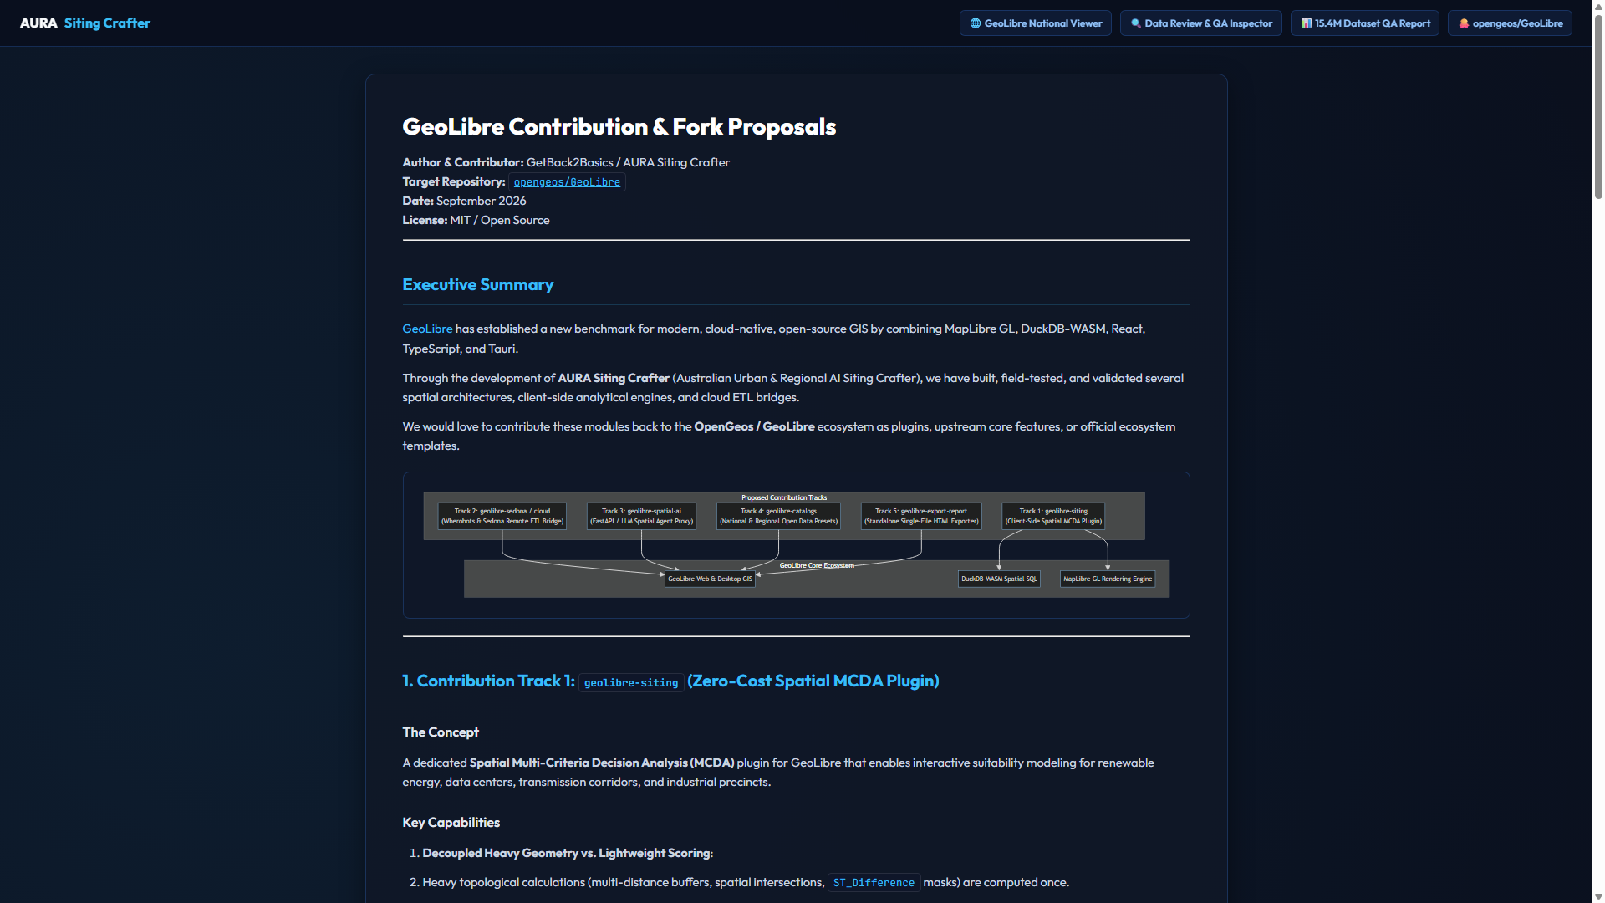
Figure 1: Upstream PR roadmap and modular architecture specification.
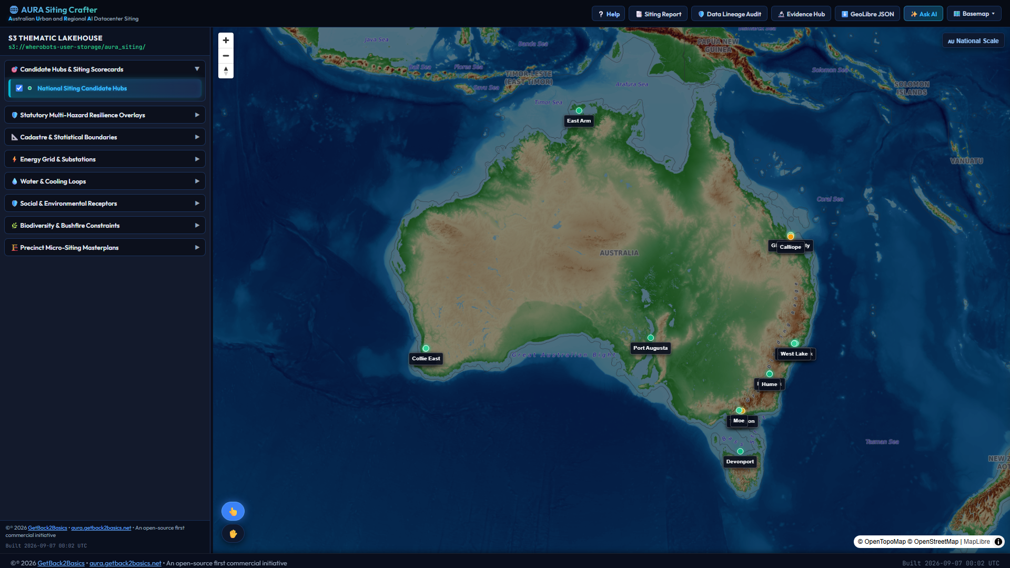
Figure 2: Production web-native GeoLibre client executing spatial joins locally.
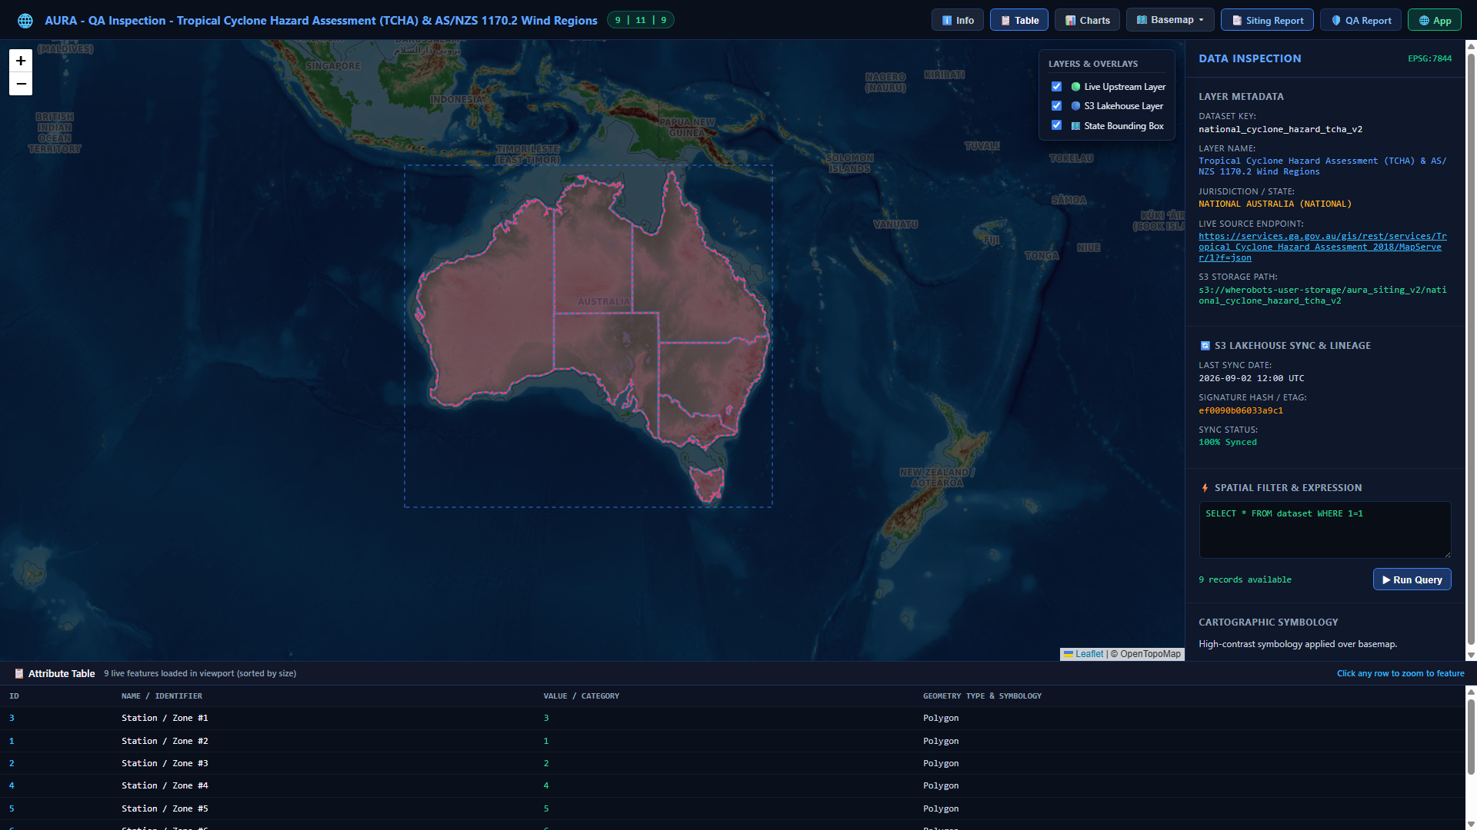
Figure 3: Interactive QA inspector validating coordinate transformations.

GeoLibre Upstream Contribution Proposals & Architecture
Target Upstream Repository: `opengeos/GeoLibre`
Contributing Organization: GetBack2Basics Spatial AI Engineering
Status: Structured RFC & Upstream Integration Proposals
---

Executive Summary
This specification outlines five modular Pull Request (PR) proposals designed to contribute high-performance WebGIS features developed in AURA Siting Crafter directly to the upstream opengeos/GeoLibre open-source ecosystem.
flowchart TD
subgraph GeoLibreUpstream["opengeos/GeoLibre Core Architecture"]
Core["GeoLibre Core Map Engine (MapLibre GL Wrapper)"]
end
subgraph Proposals["5 Modular Contribution Proposals"]
PR1["PR 1: DuckDB-WASM In-Memory Spatial SQL Engine"]
PR2["PR 2: Area-Priority Viewport Polygon Limiter"]
PR3["PR 3: Dynamic Expression Continuous Color Ramps"]
PR4["PR 4: Standalone Zero-Latency Digital Twin Exporter"]
PR5["PR 5: Cryptographic Data Lineage & Provenance Auditor"]
end
PR1 --> Core
PR2 --> Core
PR3 --> Core
PR4 --> Core
PR5 --> Core
style GeoLibreUpstream fill:#0f172a,stroke:#38bdf8,color:#ffffff,stroke-width:2px
style Proposals fill:#1e293b,stroke:#818cf8,color:#f8fafc
---

1. Modular PR Specifications

Proposal 1: In-Memory DuckDB-WASM Siting Plugin (`geolibre-plugin-duckdb`)
- Objective: Embed DuckDB-WASM directly into GeoLibre map instances to execute high-throughput spatial joins, multi-criteria weighted scoring, and polygon area calculations locally in browser memory (<15ms latency).
- API Surface:
map.use(new DuckDBSpatialPlugin({
parquetUrl: 'https://cdn.example.com/parcels.parquet',
initialQuery: 'SELECT * FROM parcels WHERE suitability_score >= 0.7'
}));

Proposal 2: Area-Priority Viewport Feature Limiter (`geolibre-layer-limiter`)
- Objective: Prevent WebGL draw call bottlenecks when panning large cadastre layers (>50k features) by ordering by descending bounding box / polygon area and capping rendering to top $N$ features.
- API Surface:
layer.setRenderOptimizer({
maxFeatures: 500,
sortProperty: 'area_ha',
sortOrder: 'desc'
});

Proposal 3: Dynamic Expression Continuous Color Ramps
- Objective: Provide a high-level JS helper that dynamically generates MapLibre GL interpolation expressions from arbitrary numeric data columns without rebuilding GL style sheets.

Proposal 4: Single-File HTML Digital Twin Exporter
- Objective: Export the current map view, active vector micro-layers, and embedded DuckDB-WASM engine into a self-contained, air-gapped HTML file for offline stakeholder distribution.

Proposal 5: Cryptographic Lineage & Audit Inspector
- Objective: Embed SHA-256 layer checksums and Apache Sedona transform recipes into the map metadata UI, providing instant provenance verification.
---

2. Upstream Submission Workflow
- Fork opengeos/GeoLibre.
- Create dedicated feature branches (feature/duckdb-wasm-core, feature/viewport-limiter).
- Implement unit tests using Vitest and Playwright.
- Submit PRs with reference benchmarks demonstrating 60fps rendering under 15M parcel loads.

GeoLibre Web-Native GIS Engine Post

LinkedIn Post: GeoLibre — Desktop Power in a Customizable Web Engine (Final Published Version)
Target Platform: LinkedIn
Audience: Geospatial Engineers, Cloud & Data Architects, Open Source GIS Community
Status: Published
---

Post Text
Can your browser-based GIS handle desktop-grade spatial analysis without spinning up costly cloud servers or locking you into desktop installs?
For years, GIS required a trade-off: heavyweight desktop tools (powerful, but siloed) vs. traditional WebGIS (accessible, but restricted to static tiles and sluggish server roundtrips).
Modern web-native data formats have eliminated that compromise.
Building AURA Siting Crafter with GeoLibre (opengeos/GeoLibre Qiusheng Wu) demonstrated the unmatched agility of combining MapLibre GL, DuckDB-WASM, and cloud-native spatial data into a fully customizable web engine.
⚡ Desktop Power via Web-Native Data
Instead of moving massive files or relying on backend database compute for every slider change:
• Stream directly from cloud storage via byte-range HTTP requests (GeoParquet, PMTiles, FlatGeobuf).
• Run complex Spatial SQL in-browser using DuckDB-WASM with sub-10ms query speeds.
• Fully customize UI, layers, and analytical workflows without server infrastructure bottlenecks.
🎨 Rendering Innovations We Engineered
To maximize performance and visualization, we implemented key rendering upgrades:
- Given a 500-feature rendering limit (for efficiency) we display the largest features first so as not to clutter the viewport. We use clustering for points.
- Dynamic MapLibre Color Ramps: Multi-stop gradient expressions driven directly by in-memory DuckDB query attributes for instant continuous heatmaps.
- Sub-Second Vector Streaming: Smooth 60fps pan/zoom across intricate parcel boundaries, bypassing GeoJSON payload overhead.
- Zero-Latency Standalone Twins: Packaging layers, custom symbology, and scoring logic into single-file portable HTML apps that execute with zero network lag.
🤝 Upstream Contributions
We are planning on contributing these modular components back to OpenGeos / GeoLibre as thats why Opensource exists:
• geolibre-siting: Client-side spatial MCDA suitability scoring plugin.
• geolibre-sedona: Cloud lakehouse ETL connector (Apache Sedona / Wherobots).
• geolibre-spatial-ai: Viewport-grounded LLM Spatial SQL translation skills.
• geolibre-catalogs & geolibre-export-report: National data presets and one-click standalone HTML report packaging.
🌐 Experience the Live Outputs:
• #QA check: https://storage.googleapis.com/aura-siting-crafter-geolibre-app/docs/qa/geolibre_qa_inspect.html (Shortlink: https://lnkd.in/gph4ibi5)
• #Live Siting App: https://storage.googleapis.com/aura-siting-crafter-geolibre-app/index.html (Shortlink: https://lnkd.in/g_UP-dSj)
• #Precinct detail: https://storage.googleapis.com/aura-siting-crafter-geolibre-app/projects/index_LMCC_MacquarieCoal.html (Shortlink: https://lnkd.in/gU2RHs6y)
• #GitHub: https://github.com/GetBack2Basics/aura_siting_crafter (Shortlink: https://lnkd.in/g4CqRR-h)
#GeoLibre #OpenGeos #GIS #DuckDB #MapLibre #SpatialSQL #WebGIS #CloudNative #OpenSource

