**Austin Snow**

* 1. **Persona** - John Doe - Student at UNH CEPS
  2. **User Story**: As a UNH student, I want to be able to exclude specific food groups when creating my plate so I don’t accidentally consume something I shouldn’t.
  3. **Steps/Interactions:**
     1. Open Web-App
        1. Show home screen
     2. Select Dining hall
        1. Show menu for specific dining hall
     3. Click “Create My FUNH Plate”
        1. Ping server to get menu and show menu
     4. Select food groups to exclude from list
        1. Remove food groups from available menu shown
     5. Select food items from menu to include in FUN-H plate
        1. Add food groups to FUN-H plate server
  4. **Definition of”done”:**
     1. Ability to exclude all food items with in a certain food group / certain specifications (for example: exclude all gluten options)
     2. Ability to allow only food options from a certain group / specifications (for example: allow only vegan food options)

Sequence Diagram:

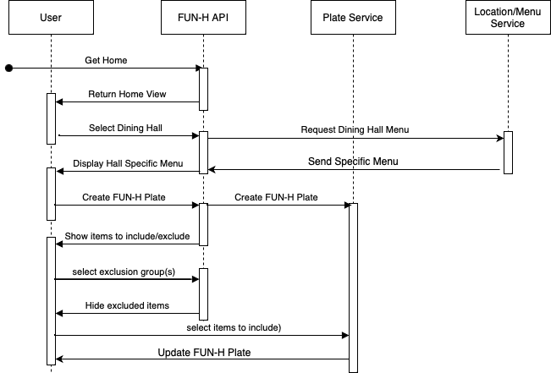

Architectural Diagram:

