Dartagnan Birnie

2/15/2023

Software Engineering

**EXPANDED USER STORY:**

Persona -

Dr. Steve, a older Professor at UNH

User Story -

As an older professor at UNH who has never used the dining halls before, I want to be able to plan out my meals to lessen the time on my feet with a friendly UI experience while also meeting my dietary standards.

Steps/Interactions -

1. Open Web-App
   1. Show home screen
2. Choose a dining hall.
   1. Show location of dining hall on campus
3. Click “Create My FUNH Plate”
   1. Ping server to get menu
4. After choosing “FUNH Plate”,
   1. Give Prompt to save selected plate
   2. Show contents and location of each chosen food (Main line, grill)

Definition of Done -

1. App is able to fully display not only the address of the dining hall, but a physical image in relation to the campus map as well.
2. After picking food, locations are displayed through a highlighted image and in text in regards to given choices.
3. After the plate is created, the option to save this FUNH plate for later usage is given.

Subtasks -

1. Pinging and receiving the dining hall database /menu when choosing at the beginning of the Create A Plate process.
2. Creating a plate database which can hold multiple plates for a specific user.

**ARCHITECTURAL DIAGRAM:**

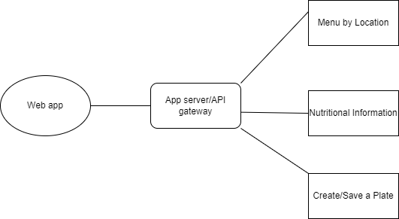

**SEQUENCE DIAGRAM:**

