University of Southeastern Philippines

*College of Agriculture and Related Sciences*

March 18, 2024

**To whom this may concern** Davao Del Norte State College Panabo City, Davao del Norte

Dear Sir/Ma’am, Greetings!

This pertains to the research study titled, “**TerraGuard: A Soil Nutrient Monitoring System using IoT Technologies**”, authored by **Ms. Charina Marie Malacao, Mr. Dexter Decierdo, Mr. Juluis O. Oranza, and Mr. Remar John F. Sibug**. The study establishes an information technology-based system that will generate fertilizer recommendation which may have great utility to various stakeholders.

The study uses database from the following source for there machine learning protocol:

Singh, Raul, 2023, "Crop recommendation data", https://doi.org/10.7910/DVN/4GBWFV, Harvard Dataverse, V1, UNF:6:HKmbh0pl7C18IfibcajWFg== [fileUNF]. <https://dataverse.harvard.edu/file.xhtml?fileId=6881146&version=1.0&toolType=PREVIEW#>

Based on the metadata, the information contained in the dataset includes primary macroelements [N, P, K (kg/ha), temperature, humidity, pH, rainfall, and associated crops. As far as the validity of the dataset is concerned, the undersigned finds the data within the acceptable normal values for fertilizer recommendations. The dataset also contained information that may be of great utility during the validation, hence is useful in the development of the software for this study.

Hope this helps in optimizing the utility of their developed software. I am still hopeful that this will be piloted, patented, and commercialized as our farmers need this most.

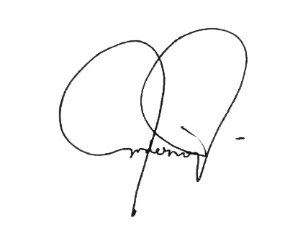If there are further concerns that the study needs, you can contact me at your most convenient means. Thank you.

Respectfully,

# DERNIE T. OLGUERA

Registered Agriculturist License No. 0023366

--------------------------------------------------------------------------------------------------------------------------------------------

**WE BUILD DREAMS WITHOUT LIMITS**

University of Southeastern Philippines Telephone: (082) 227-8192 local 610 Iñigo St., Bo. Obrero, Davao City Website: [www.usep.edu.ph](http://www.usep.edu.ph/) Philippines 8000 E-mail: [cars@usep.edu.ph](mailto:cars@usep.edu.ph)