NATURAL DENTAL LAB

Enterprise Architecture and
Detailed Design Specification
HLD, LLD, Security, Workflows, Setup, Deployment and Operations
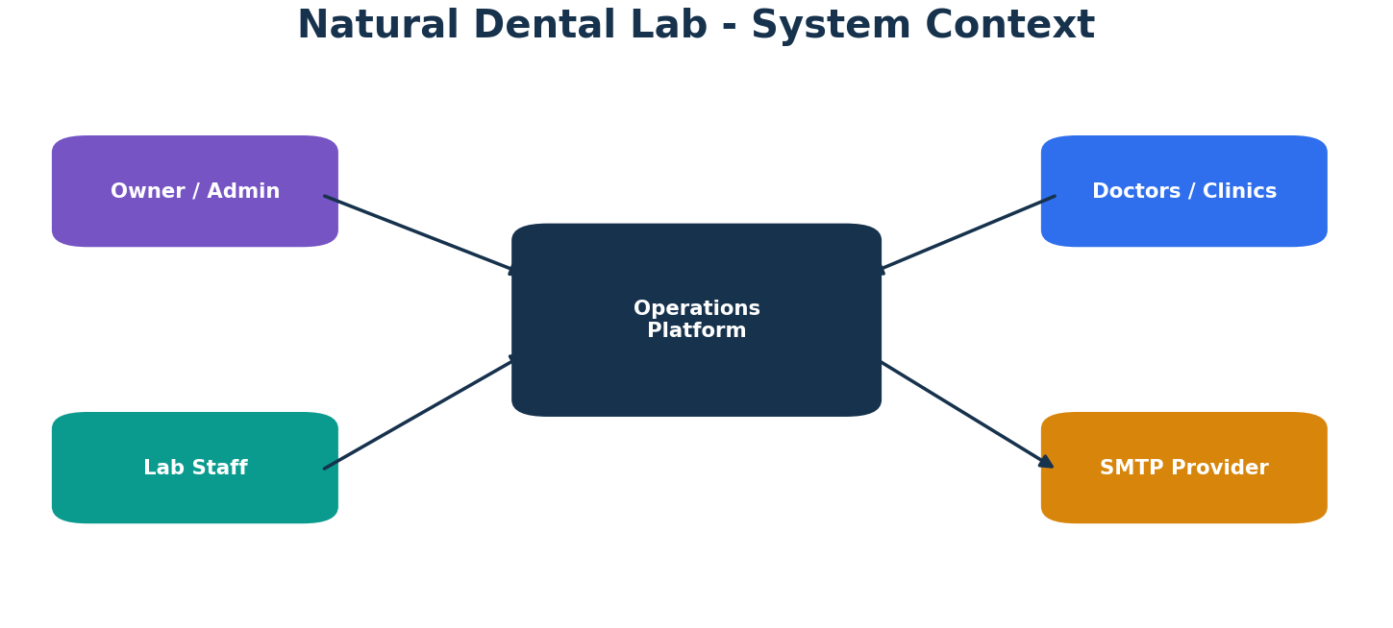

1. Executive Summary
Natural Dental Lab manufactures patient-specific dental prosthetic products for doctors and dental clinics. The platform manages doctors, product types, doctor-specific rate cards, multi-line laboratory cases, production units, billing, approval controls, secure users, SMTP notifications, and role-based dashboards.
The architecture separates Domain, Application, Infrastructure, and Web responsibilities. Case pricing is preserved as a historical snapshot. Cancelled cases remain auditable but do not contribute to active production or billing.
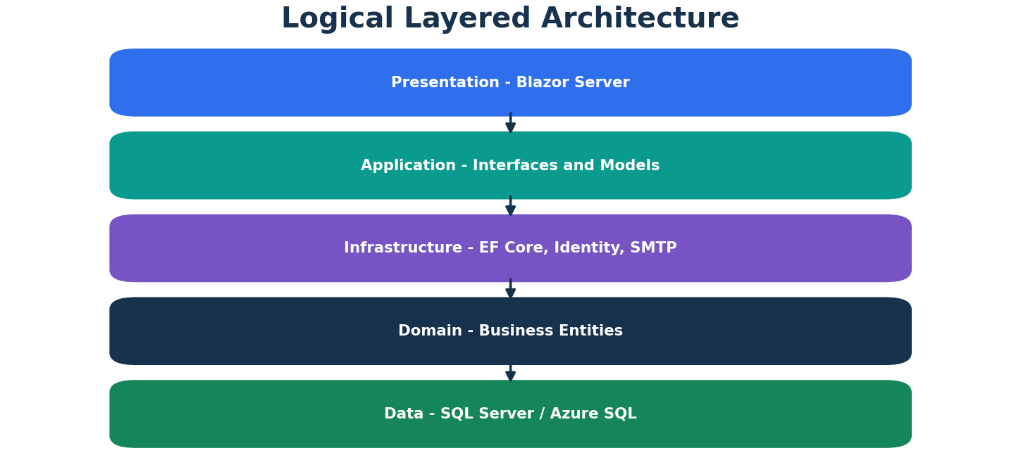
02 Logical Arch

2. High-Level Architecture
The Web project hosts Blazor Server pages, account components, middleware, routing and dependency injection. Application contains stable interfaces and DTOs. Infrastructure implements EF Core, Identity, SMTP and business services. Domain contains the persistent entities.

3. Roles and Security
Owner has full governance and can create Admin or Staff. Admin manages master data, rates, Staff, cases and assigned requests. Staff creates cases and submits controlled Edit or Cancellation requests. Authorization is enforced in both pages and services.
Area | Enterprise Rule
Authorization | Page and service checks
Secrets | User Secrets or Key Vault
Concurrency | SQL rowversion

4. Domain and Data Design
Doctor is the commercial customer. CaseType represents the manufactured dental product. DoctorRate stores doctor-specific pricing. Record stores one case line with selected teeth or arch, units, UnitRate and Amount. CaseApprovalRequest stores workflow history. EmailNotification stores SMTP audit.
Area | Enterprise Rule
Rate | Snapshot on Record
Case | Logical aggregate by CaseId
Deletion | Use cancellation/deactivation

5. Case and Billing Rules
Tooth-scope units equal the number of selected teeth. Arch-scope units equal one per arch line. Line Amount equals UnitRate multiplied by Units. Historical Record.UnitRate is never recalculated from the current rate card. Cancelled cases are excluded from active totals.
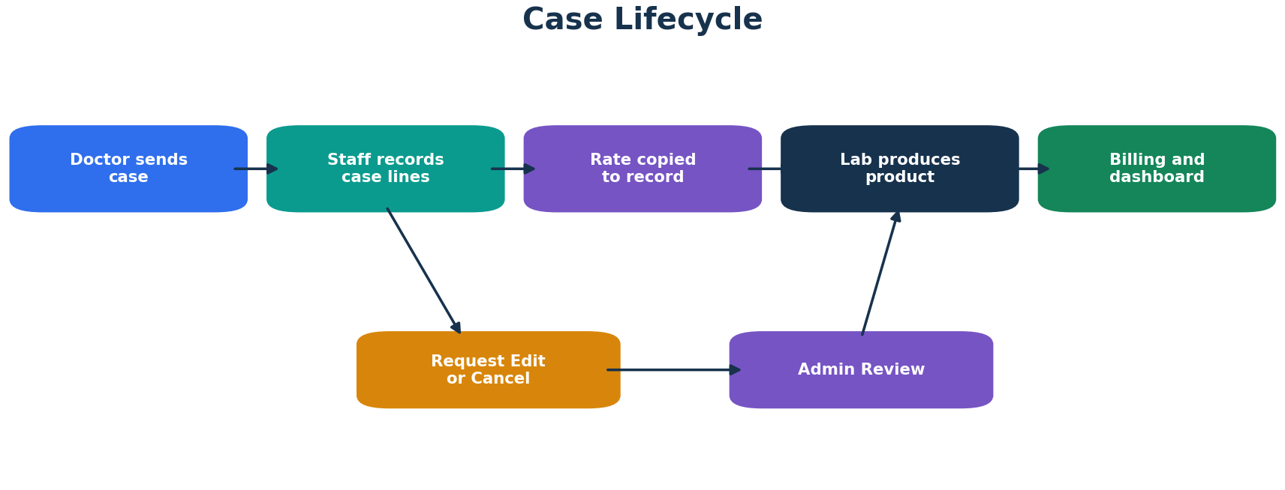
03 Case Workflow

6. Approval Workflow
Only one Pending or Approved request can exist per CaseId. Staff selects an active Admin. Pending can become Approved or Rejected. Approved Edit becomes Completed after the case is saved. Approved Cancellation becomes Completed after the case cancellation succeeds. Approved work is resumable by the assigned Admin or Owner.
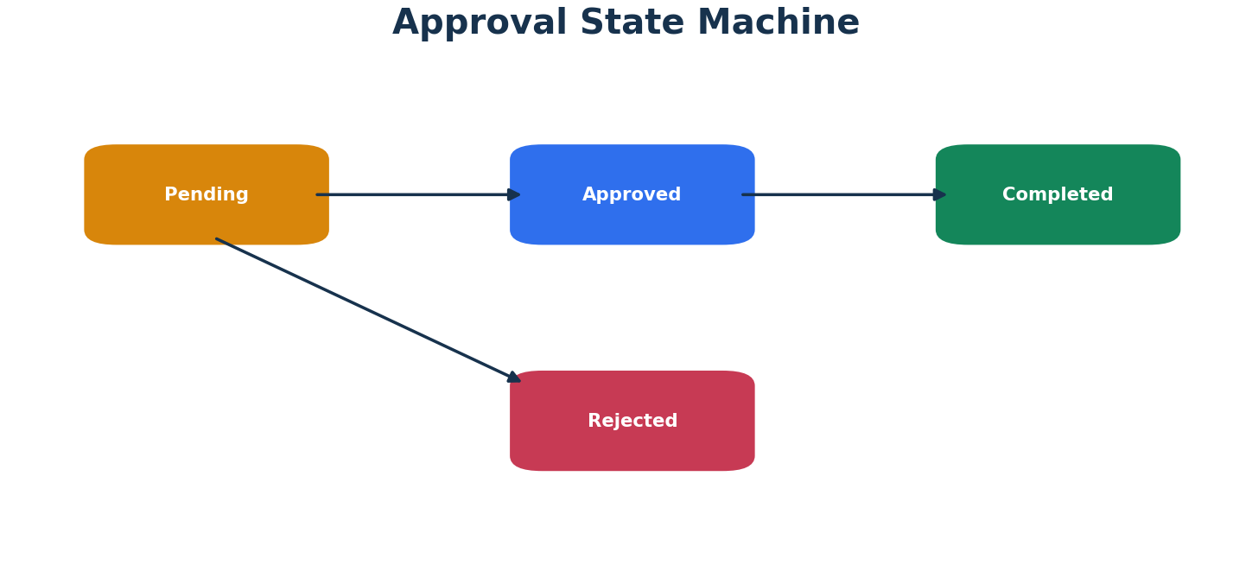
04 Approval State
Area | Enterprise Rule
Active | Pending or Approved
Closed | Completed, Rejected, Withdrawn
Assignment | Selected Admin; Owner recovery

7. Identity and Email
The application uses email as username. New users receive a generated temporary password and must change it before accessing business pages. Forgot Password uses Identity reset tokens. SMTP attempts are recorded as Pending, Sent or Failed and never roll back a valid business transaction.
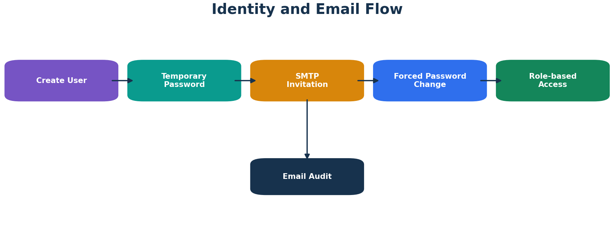
05 Identity Email

8. Dashboard
Owner and Admin see business-wide production and billing. Staff sees personal production and requests without organization-wide revenue. Metrics use DateOnly case dates and exclude cancelled records. Charts summarize daily units and product mix.

9. Database Deployment
EF migrations manage Identity customizations and EmailNotifications. Versioned SQL manages business tables, sequences, views and procedures. Existing manual Phase 2 objects are represented by an idempotent migration. Production uses reviewed migration scripts and controlled business-schema deployment.
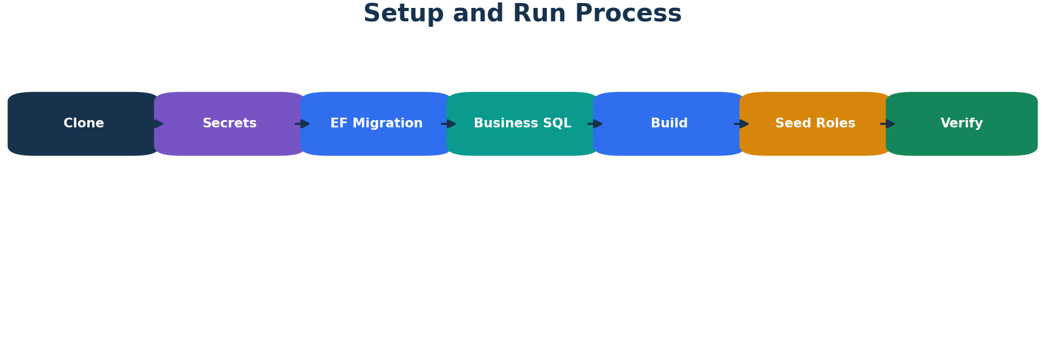
07 Setup

10. Setup and Run
Configure User Secrets, restore and build, apply Identity migrations, run business SQL in dependency order, start the application, verify role seeding, login as Owner, configure master data, and test SMTP. Production configuration uses App Service settings or Key Vault references.
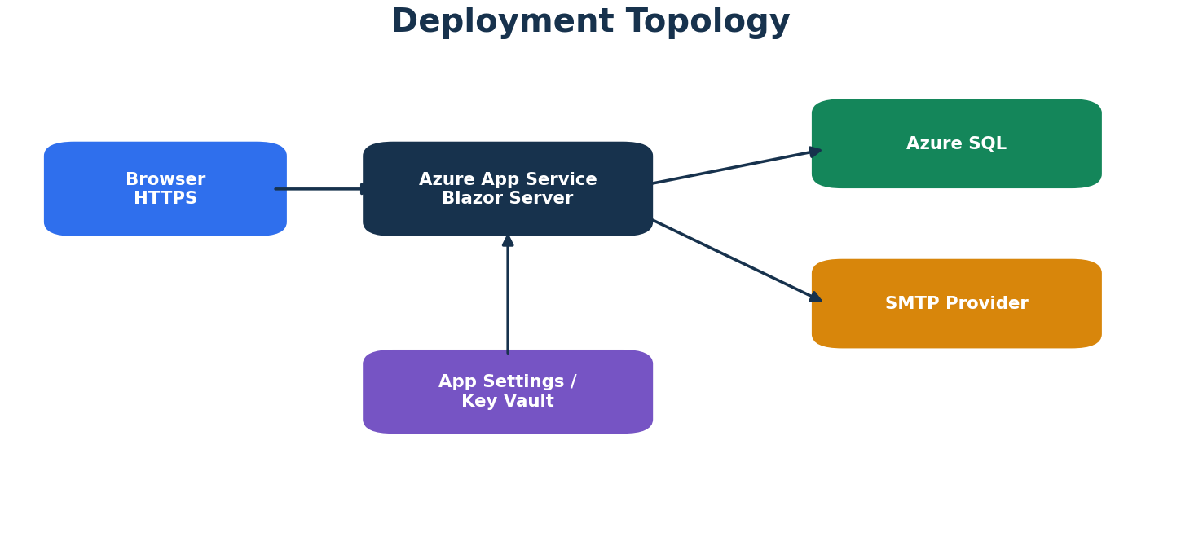
06 Deployment

11. Operations and Recovery
Monitor active approval backlog, failed email rows, dashboard totals, database backup health, and disabled users. SMTP failure is recoverable through resend. Approved Edit or Cancellation can be resumed. Root-route, dependency-injection, DateOnly and migration conflicts are documented in repository deployment guides.

12. Testing and Roadmap
Critical tests cover unit calculations, rate snapshots, deactivation cascade, concurrency, authorization, one-active-request behavior, email failure isolation, role-based dashboards, migrations and fresh-database setup. Future modules include doctor statements, PDF billing, production stages, dispatch, inventory and external doctor access.

Appendix A. Setup Commands
dotnet restore
dotnet build
dotnet ef database update --context ApplicationDbContext --project DentalLab.Web --startup-project DentalLab.Web
dotnet run --project DentalLab.Web

Appendix B. Configuration Keys
- ConnectionStrings:DefaultConnection
- BootstrapOwner:Email
- BootstrapOwner:Password
- Smtp:Host
- Smtp:Port
- Smtp:UserName
- Smtp:Password
- Smtp:FromEmail
- Smtp:FromName
- Smtp:Security

