Systems Overview Sketch



database

Server of webapplication

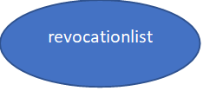 admin remote control (ssh)

hosts

network connection

firewall protectet

webapplication

Backup server

number of issued cetificates

number of revoked certificates

current serial number

issue new certificate

revoke certificate

update/change user information