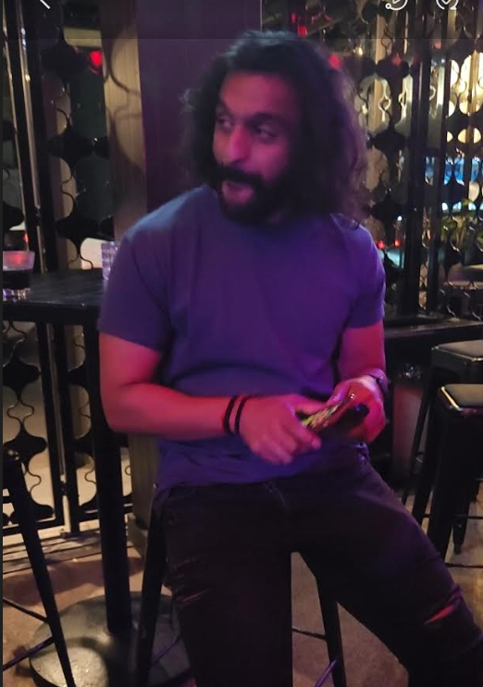

Instagram vs Reality