Fryer guide
The fryer is cleaned every night.
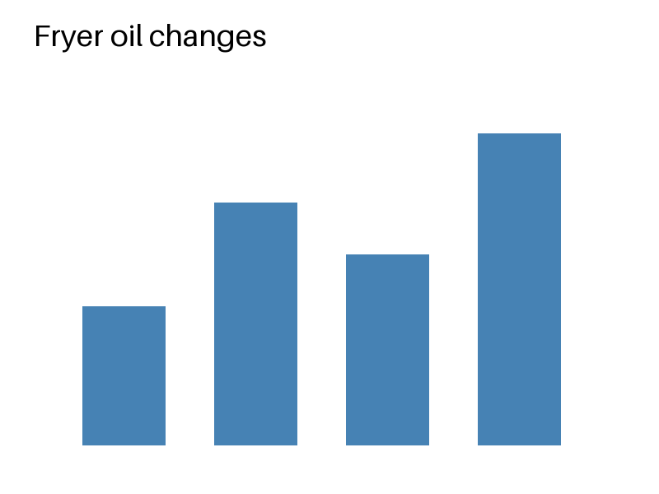
An icon marks every safety step: 
Week | Changes
1 | 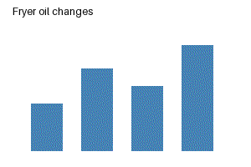
The same chart again, for the night shift:

