

Debre Berhan University
College of Computing
Department of Computer Science
Internship Report

Project Title: MICHUGEBEYA (e-commerce platform)

Hosting Company: ZERGAW CLOUD

Internee: Fasikaw Ayten
(ID): DBU1501198
Mentor: Sirage Z
Company Supervisor: Yared Mengistu

September, 2024
ZERGAW CLOUD, ICT PARK ADDIS ABABA

Part One:

Acknowledgements
I wish to express my sincere gratitude to all those who supported me during my internship at ZERGAW CLOUD. I am especially grateful to my company supervisor, the Website Development team, and all my colleagues who kindly shared their time, knowledge and expertise with me. I also thank my university supervisor for their guidance. Finally, I extend thanks to my family and friends for their continuous encouragement.

Executive Summary
This report presents my two-month internship experience at ZERGAW CLOUD in Addis Ababa, a leading local cloud service provider in Ethiopia, founded in 2019.
The company offers cloud infrastructure, cloud software, cloud security, broadband internet and demand-based ICT projects.
My work was in the Website Development section.I applied tools and techniques such as responsive front-end development.
During the internship I improved my practical skills (web development), upgraded my theoretical knowledg, and gained insight into entrepreneurship, work ethics and communication.
.

Part Two: Company Background

1. Short History
- It was originally founded in May 2019 under the name ZERGAW ISP.
- First internet provisioning began in September 2019.
- In March 2021 they opened their first cloud infrastructure site at Arada, Addis Ababa.
- In October 2022 they opened their first branch office at Legehâr. In November 2022 they entered into a strategic partnership with Ethio Telecom under the brand “ETZ” (Ethio Telecom-Zergaw).
- In February 2023 the company converted to a share company (new corporate structure) and began operating under the trade name ZERGAW CLOUD.
- By June 2023 they indicated having served “500+ enterprise clients”.
Thus, in a relatively short span (2019-2023) ZERGAW CLOUD has grown from an ISP to a full cloud services provider, establishing infrastructure, offices, and partnerships, aiming to address local needs in Ethiopia’s ICT & cloud market.

2. Main Products, Services and Technologies

Products & Services
- Cloud Infrastructure : Highly available and scalable cloud infrastructure that provides your business with the computing and storage resources you need to run your software systems in a cost and time efficient way.
- Cloud Software : A suite of software solutions that streamline your business operations, enhance efficiency, improve collaboration, and drive growth.
- Cloud Security : Contemporary security solutions to safeguard your business from any attack.
- Broadband Internet: For your Broadband Internet and VPN need at your premises to safely access internet services and your cloud infrastructure with quality speed.
- Demand-based ICT Projects:. We are tuned to tune our cloud, internet and other strategically aligned ICT services to your specific demand.

Technologies
- Hosting infrastructure in “reliable and secured locations of Ethiopia” connected to the national backbone network.
- Bare-metal server hardware with remote management interfaces (e.g., DELL iDRAC or HPE iLO). Scalable cloud servers (with SSD or HDD storage, dedicated resources) delivered over Internet or VPN.
- SaaS modules integrated with local payments (e.g., Telebirr), SMS VAS, etc. For example their ERP offering mentions integration with Telebirr and local electronic payments.

3. Main Customers / End-Users
- they have served over 500 businesses across sectors such as banking, microfinance, hospitality, entertainment, and government institutions.
- clients such as Wallet Microfinance Institution S.C., Amhara Bank, TSEDEY BANK S.C
Thus:
- The end-users include medium to large enterprise organizations (banks, microfinance institutions, government agencies) which have need for reliable infrastructure, software systems, and cloud services.
- They also serve smaller companies and possibly startups
- customers requiring connectivity and cloud hosting are also part of the customer base.
Overall, the company targets organizations that need cloud hosting, ERP and digital transformation services in the Ethiopian context.

4. Organizational Structure
- Founders: Co-Founders are Dr. Beneyam Berehanu (PhD) and Dr. Ephrem Teshale (PhD) as respectively CBDO and CTO.
- CEO: Addisu Kassaw
- Other senior managers: Miraf Kena (Customer & Partnership Manager), Eyerusalem Michael (Operations Manager), Nardos Endale (Finance Manager), Yared Mengistu (Software Engineer Team Leader)
a simplified organizational structure:
- Board or Shareholders – as it converted to a share company in 2023.
- Executive Management – CEO, CTO, CBDO.
- Departments – Customer & Partnerships; Operations; Finance; Technical/Engineering (software, infrastructure); Sales & Marketing; Support.
- Subsidiary / Office Locations – Headquarters in ICT Park (Addis Ababa), branch office at Legehâr, data-centre sites in Arada & Legehâr.

5. Workflows

Service Onboarding
- A customer (enterprise) approaches ZERGAW with a requirement (e.g., cloud server, ERP, storage).
- Technical team assesses customer needs – computing, storage, connectivity, security. The infrastructure is offered via scalable cloud servers or bare-metal as per requirement.
- Customer signs service agreement, chooses pay-as-you-go or subscription plan (they emphasise local payment options, local currency).
- Deployment: provisioning cloud servers, storage or software modules. The website indicates rapid deployment ("Short deployment time") and high availability.
- Handover and training/support to customer. Post-deployment, customer accesses their server/solution.

Service Operation & Maintenance
- Infrastructure monitoring: The cloud infrastructure operates from data centres connected to the national backbone network. Uptime is measured (99.95% availability).
- Customer support: 24/7 support is emphasised (for example cloud services page mentions 24/7 support).
- Scaling / modifications: Customers can scale computing/storage resources up or down as needed.
- Security and compliance: Security services and shared-responsibility model emphasised in cloud infrastructure descriptions.
- Billing & payments: Services are billed , likely via local currency, with customer support and finance teams handling the process.

Custom Projects
- For demand-based ICT projects: customer requirement gathering → design → development (software & infrastructure) → deployment → maintenance.

Internal Development & QA
- In-house software/web development team: they have web designers, developers, copywriters etc.
- Quality assurance and product engineering: Part of their value proposition emphasizes product improvements through testing, refinement.

Part Three: Internship Experience

Department / Section Worked In & Why
During my two-month internship, I was assigned to the Website Development section of ZERGAW CLOUD.
I selected this section because I have a keen interest in web-development and wished to gain practical experience building real-world web-projects

Work Tasks Executed
- Performed testing of websites for cross-device compatibility (desktop, tablet, mobile) and verified responsiveness.
- Participated in client-handover workflows: ensuring domain, SSL certificate installation, DNS configuration.

Systems Development, Tools & Techniques Used
- A CMS (content management system)
- Responsive front-end web technologies (HTML, CSS, JavaScript) to ensure websites work on every device (“Works on every device and platform”).

Major Challenges and Problems Faced
- Time constraints: As an intern, I had to adapt quickly and deliver components under tight deadlines.
- Cross-device compatibility: Ensuring fully responsive layout across a wide variety of devices (older browsers/devices common in the local market) required deeper testing than originally planned.

Measures & Proposed Solutions to Overcome Challenges
- For time constraints: I adopted a mini-iteration approach – breaking the website project into smaller deliverables (home page, responsive layout, CMS integration, content upload) so that parts could go live earlier and adjustments done afterward.
- For compatibility testing: I increased use of device emulators and actual device testing (older Android phones, tablets), and created a compatibility checklist for the locally common browsers/devices.

Improvement in Practical Skills
- I became comfortable with building responsive websites from scratch.
- I developed skills in performance optimization, cross-browser/device testing, SSL installation, domain/DNS configuration.

Upgrading Theoretical Knowledge
- I refreshed my understanding of responsive web design theory.
- I learnt more about service-level-agreements (SLA) and how deployment timelines, uptime, and scalability matter for website services tied to cloud infrastructure. For example, the company claims 99.95% availability for its infrastructure.

Team-Playing Skill Improvements.
- I learned to manage dependencies (e.g., design assets arriving before front-end coding, hosting team provisioning before deployment) and communicate status updates proactively.

Leadership Skill Improvements
- I observed the company’s management and learnt how a professional cloud/ICT service company sets direction, prioritizes value (affordability, localization, scalability) and leads the team.

Understanding Work Ethics, Company Psychology & Related Issues
- The company emphasizes affordability, quality, localization, security, scalability as core values.
- I observed how delivering quality.
- I learnt the importance of system-uptime, deployment speed and customer satisfaction, which are core for a cloud/hosting business operating in the local market.
- I also saw how a local cloud company in Ethiopia positions itself: focusing on local payments, local hosting, and matching local market needs (which changes the psychology of product-delivery compared to a global provider).

Entrepreneurship Skills
- I saw how ZERGAW CLOUD built a website-service product with pricing tiers (Basic, Standard, Premium) for different customer segments.
- I learned about scaling a service: how the website service can be hosted locally, delivered affordably, and scaled for more pages or advanced features — this gives ideas of how one might launch or expand a service in such a market.
- I also appreciated the importance of aligning technology services to local market constraints (e.g., payment in local currency, local hosting) which is vital for entrepreneurship in Ethiopia.

Recommendations & Conclusion
Recommendations:
- Formalize a mentorship/training program for interns, orienting them quickly into the company’s website service process-flow, tools and expectations.
- Introduce more automation in the hosting/deployment workflow (e.g., scripts to set up hosting, SSL, domain configuration) to reduce time and manual errors.
- Strengthen device-testing environments by maintaining a pool of locally common mobile devices/browsers so interns can test on real hardware rather than only emulators.
- Create a knowledge-base of previous website-projects (screenshots, challenges, lessons learnt) so future interns can leverage past experience.
Conclusion:
I entered the internship with theoretical knowledge of web-development and a desire to apply it in a real business context. I have improved my practical web-development capabilities, expanded my theoretical understanding of cloud-hosted services.

PART FOUR: PROJECT WORK
Summary of the Project
- The MICHUGEBEYA E-commerce Platform is a full-stack web application designed to facilitate online shopping and product management. The system provides a comprehensive solution for both customers and administrators, enabling seamless product browsing, ordering, and inventory management. The platform is built using modern web technologies with a separation of concerns architecture, consisting of a ReactJS frontend and a Node.js/Express backend, connected to a MongoDB Atlas database for data persistence.
- The application features a user-friendly interface that allows customers to browse products by categories, view detailed product information including user reviews, add items to a shopping cart, and complete purchases through a bank transfer payment system with receipt upload functionality or cash on delivery. The platform includes automated email notifications to keep customers informed about their order status throughout the purchase lifecycle.
- For administrators, the system provides a comprehensive dashboard for managing products, processing orders (approve or reject based on payment verification), viewing customer information, and moderating user comments. The application is designed with responsive web design principles, ensuring optimal viewing experiences across desktop, tablet, and mobile devices. Security features include user authentication with JWT tokens, password encryption using bcrypt, and role-based access control to differentiate between regular users and administrators.

Problem Statement and Justification(Based on Current/Existing System)
Traditional retail businesses and small-scale vendors face significant challenges in reaching broader customer bases beyond their physical locations. Many businesses still rely on manual, paper-based systems or basic spreadsheets for inventory management and order processing, leading to several critical issues:
The Current System
- Limited Market Reach: Physical stores are restricted to serving customers within their geographical proximity. Without an online presence, potential customers from other locations cannot access products, resulting in lost sales opportunities and limited business growth.
- Manual Processes: Many local businesses rely on social media or manual record-keeping, leading to errors and slow order fulfillment.
- Payment Barriers: Lack of integrated local payment gateways makes it difficult for customers to pay securely.
- Customer Communication Gaps: Keeping customers informed about order confirmations, approvals, or rejections requires manual effort through individual phone calls or messages. This approach is not scalable and often results in delayed or missed communications.
- Security Concerns: Tracking administrative actions and order statuses manually is prone to manipulation and lack of transparency.

Justification
MICHUGEBEYA automates the sales funnel, provides a transparent audit trail for admin actions, and implements a modern, responsive UI that ensures accessibility.

Objective of the Project
General Objective: To create a full-stack web application that enables businesses to sell products online while providing customers with a convenient, transparent, and secure shopping experience.
Specific Objectives:
- To develop a customer-facing interface that allows users to browse products, view detailed information, read reviews, and complete purchases seamlessly.
- To implement a shopping cart system that enables customers to add multiple items, view cart totals, and proceed to checkout efficiently.
- To create an order management workflow that includes bank transfer payment with receipt upload or cash on delivery, automated email notifications, and order tracking capabilities.
- To build an administrative dashboard that provides business owners with tools to manage products (add, edit, delete), process orders (approve/reject based on payment verification), view customer information, and moderate user-generated content.
- To integrate automated email notification services that inform customers about order confirmations, approvals, and rejections without manual intervention.
- To implement secure user authentication and authorization mechanisms that protect user data and ensure role-based access control.
- To design a responsive user interface that delivers optimal viewing and interaction experiences across various devices including desktops, tablets, and mobile phones.
- To establish a scalable database architecture that efficiently stores and retrieves product information, user data, orders, and comments.
- To provide real-time inventory management with accurate product availability information to prevent overselling.
- To create a platform foundation that can be extended with additional features such as multiple payment gateways, advanced analytics, and integration with third-party services.

Methodology
Fact Finding Techniques:
To gather requirements and understand user needs, the following fact-finding techniques were employed:
- Observation: Observed how traditional retail businesses manage products, process orders, and communicate with customers. Analyzed the pain points in manual processes including inventory tracking, order verification, and customer communication.
- Document Review: Examined existing order forms, inventory spreadsheets, and customer records to understand the data requirements and workflow of retail operations.
- Internet Research: Studied popular e-commerce platforms such as Amazon, eBay, and Shopify to identify best practices in user interface design, shopping cart functionality, and order management workflows.
- Interviews: Conducted discussions with small business owners to understand their specific needs, challenges with manual systems, and desired features for an online platform.
- Questionnaires: Distributed surveys to potential customers to gather insights on shopping preferences, payment methods, and expectations for online shopping experiences.

Tools, Languages, and Frameworks:
The MICHUGEBEYA platform was developed using the MERN stack architecture with the following technologies:
Frontend Technologies:
- ReactJS (v18.2.0): JavaScript library for building the user interface with component-based architecture.
- React Router DOM (v6.23.0): Client-side routing for navigation between pages without full page reloads.
- Vite (v5.0.8): Modern build tool providing fast development server and optimized production builds.
- Tailwind CSS (v3.4.1): Utility-first CSS framework for responsive design and styling.
- Axios (v1.6.2): HTTP client for making API requests to the backend.

Backend Technologies:
- Node.js: JavaScript runtime environment for server-side execution.
- Express (v4.22.1): Web application framework for building RESTful APIs.
- Mongoose (v7.8.8): Object Data Modeling (ODM) library for MongoDB integration.
- JSON Web Token (v9.0.3): Authentication mechanism for secure user sessions.
- bcryptjs (v2.4.3): Library for hashing and securing user passwords.
- Multer (v1.4.5): Middleware for handling multipart/form-data for file uploads.
- Nodemailer (v6.10.1): Module for sending automated emails.
- dotenv (v16.6.1): Module for managing environment variables.
- CORS (v2.8.5): Middleware for enabling Cross-Origin Resource Sharing.

Database:
- MongoDB: NoSQL document database for storing users, products, orders, and comments with flexible schema design.
- MongoDB Atlas: Cloud database service for hosting and managing the database.

Development Tools:
- Nodemon (v3.1.11): Utility that automatically restarts the server during development when file changes are detected.
- Git: Version control system for tracking code changes and collaboration.
- Visual Studio Code: Integrated development environment for code editing.
- Postman: API testing tool for verifying endpoint functionality.

Network Topology:
The MICHUGEBEYA platform follows a three-tier client-server architecture:
Presentation Layer (Client Tier):
- ReactJS application running in web browsers
- Communicates with the backend via HTTP/HTTPS requests
- Runs on Vite development server (default port 5173) during development
- Hosted on port 80/443 in production environments

Application Layer (Business Logic Tier):
- Node.js/Express server handling business logic
- RESTful API endpoints for CRUD operations
- Runs on port 5001 (configurable via environment variables)
- Implements authentication, authorization, and data validation
- Manages file uploads to local storage
- Sends automated emails through SMTP

Data Layer (Database Tier):
- MongoDB database hosted on MongoDB Atlas (cloud) or local installation
- Stores collections for users, products, orders, and comments
- Accessed by the backend via Mongoose ODM
- Default port 27017 for local MongoDB installations

Design Used:
The application follows modern software design principles and patterns:
Model-View-Controller (MVC) Architecture:
- Models: Mongoose schemas defining data structures (User, Product, Order, Comment)
- Views: React components rendering the user interface
- Controllers: Express route handlers processing requests and business logic

Results and Discussion
Results:
- Performance: Achieved fast load times and smooth transitions using React hooks and Vite.
- Reliability: Implemented robust error handling and transaction verification for orders.
- Responsiveness: The UI adapts elegantly from large desktops down to minimized windows (320px).
- Security: Successfully encrypted passwords and secured API endpoints with JWT (JSON Web Tokens).
Discussion:
Effectiveness in Solving Identified Problems:
- Market Reach: The online platform enables businesses to reach customers beyond geographical boundaries, expanding market potential significantly.
- Order Management: The automated system tracks orders from placement to completion, providing transparency and reducing errors.
- Payment Verification: The receipt upload or cash on delivery and admin review workflow streamlines payment confirmation.
- Customer Communication: Automated emails ensure timely, consistent communication without manual effort.

Screenshots of the Project
- Home Page: Displays the welcome message, MICHUGEBEYA logo, navigation menu, and "Shop Now" button inviting users to browse products.
- Products Page: Shows the product catalog with all available items displayed in a grid layout. Category filters allow customers to narrow down products by type. Each product card displays the product image, name, price, and an "Add to Cart" button.
- Checkout Page: Displays order summary and bank transfer payment or cash on delivery payment instructions. Provides a file upload field for customers to submit their bank transfer receipt or cash on delivery. Includes an "Place Order" button to submit the order.
- Login Page: Features a simple login form with email and password fields. Provides a link to the registration page for new users.
- Administrative Pages: Provides an overview of the system with navigation options to manage products, orders, and customers. May display summary statistics such as total products, pending orders, and registered users.
- Manage Orders Page: Displays all customer orders with details such as customer name, order items, total amount, uploaded receipt image or cash on delivery, and current order status.

Home Page:

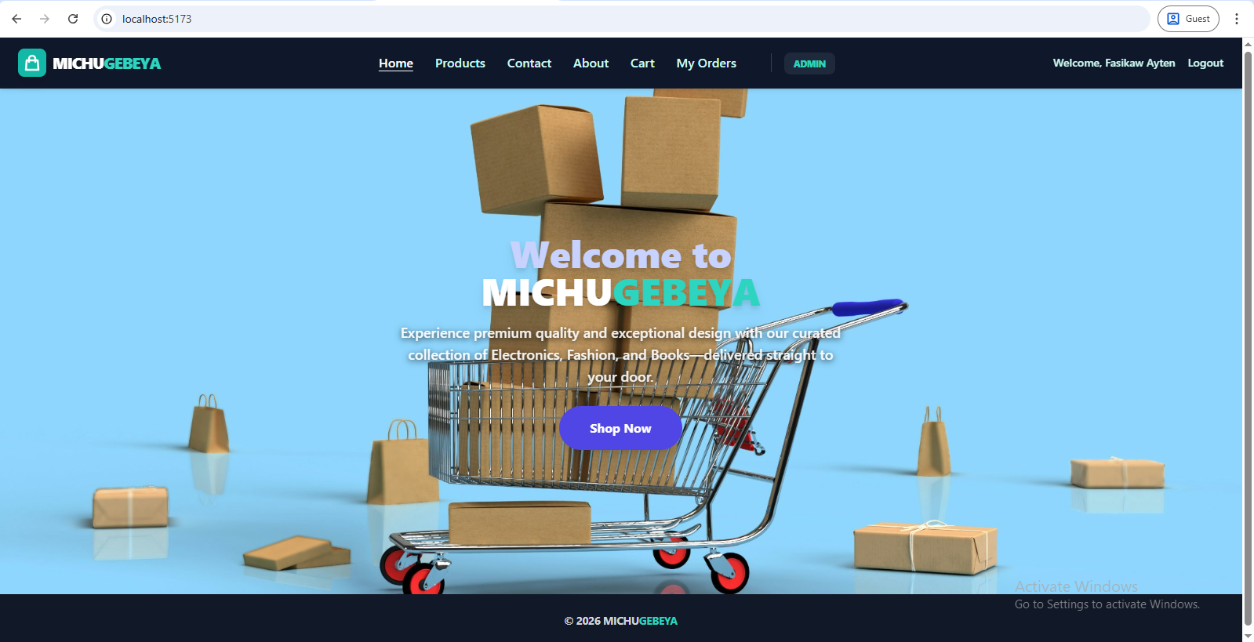

Products Page:
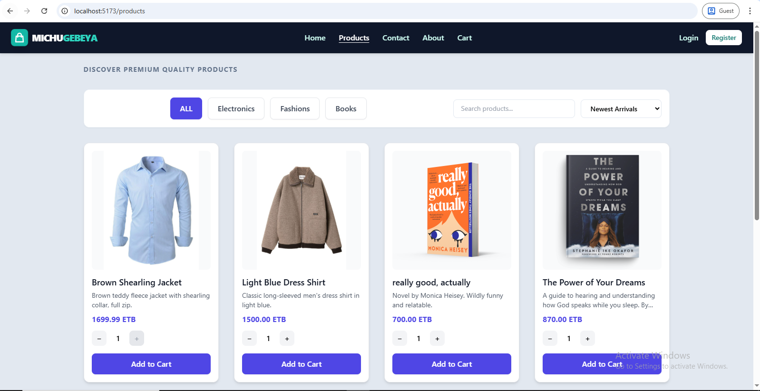

Checkout Page:

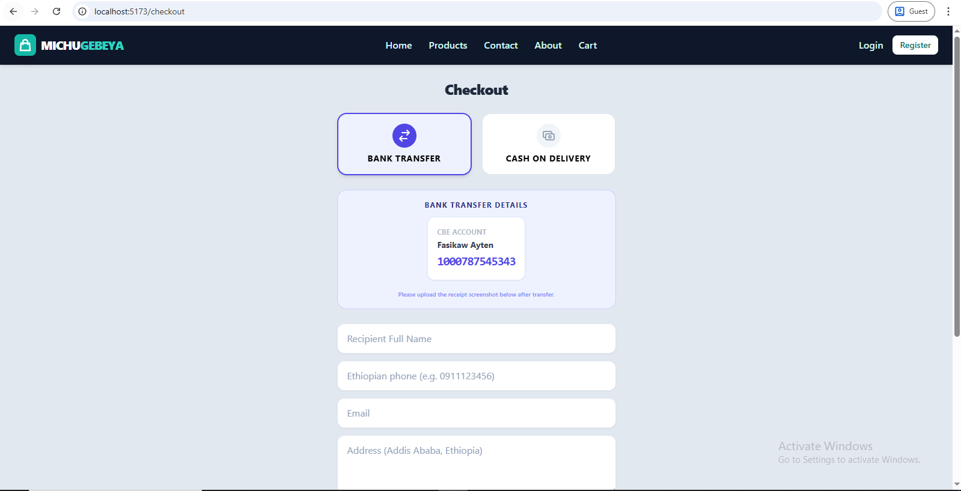
Log in Page:
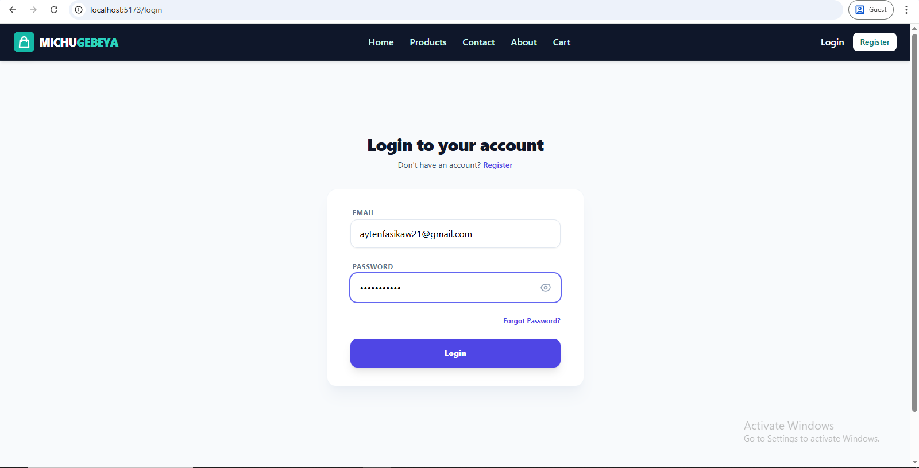

Admin Page:
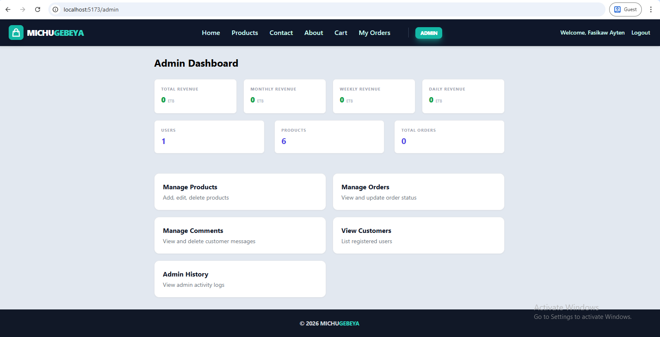

Manage Orders Page:
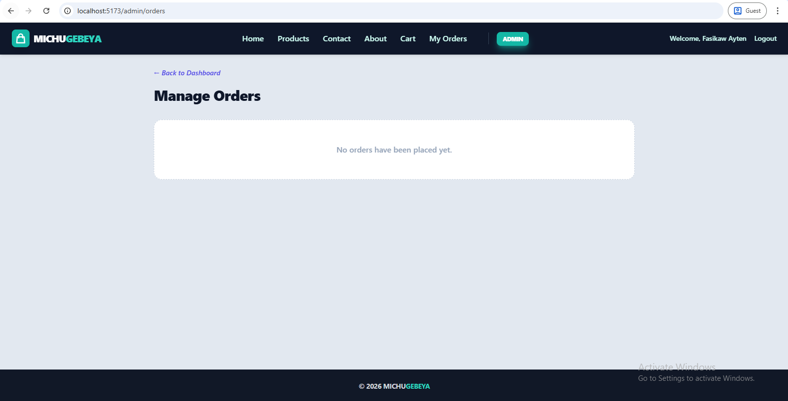

Conclusion and Recommendation
Conclusion:
MICHUGEBEYA successfully demonstrates that a modern, full-stack application can solve local commerce challenges. By combining the flexibility of the MERN stack with localized features like manual receipt verification or cash on delivery, the project provides a professional-grade platform tailored for the Ethiopian market.
Recommendation:
- Mobile App Development: Transitioning the platform into a native mobile app (React Native) for even better mobile engagement.
- AI Recommendations: Implementing machine learning algorithms to suggest products based on user browsing history.
- Multi-Vendor Support: Evolving the platform to allow multiple sellers to list their products.

Part Five:
General Conclusion and Recommendation

Conclusion:
- I was able to apply theoretical knowledge in a real business environment, engage with actual web-development tasks.
- Through the internship I improved my practical skills, enhanced my theoretical understanding, communication and entrepreneurial mindset, and grew in understanding of professional work ethics.
- Overall, the experience solidified my interest in pursuing work in web development. I feel more aware of how to operate in a real-world ICT enterprise environment.

Recommendations:
- Establish a structured onboarding for interns, including orientation to the company’s services, workflow, tools, and expectations, paired with a mentor in the website-development unit.
- For website-development projects, implement standard templates/checklists to reduce scope creep, ensure consistency, and speed up deployment. ‎
- Develop a knowledge-base documenting past website projects, common issues encountered, performance optimization techniques, client feedback. This supports continuous learning and allows new interns to leverage previous work.
- Create periodic review sessions (monthly or after each major project) where interns reflect on what went well, what could be improved, lessons learnt. This builds a culture of continuous improvement.

