# Model Card

## Model Description

**Input:** Two X values between zero and one for n data points, Y value from Dummy function.

**Output:** Best Y value from different acquisition functions

**Model Architecture:** We make use of PyTorch ‘SingleTaskGP’ and ‘ExactMarginalLogLikelihood’.

## Performance

Given our dummy function contains noise, we show how using ‘Noisy expected improvement’ acquisition function leads to the best results (highest best Y):

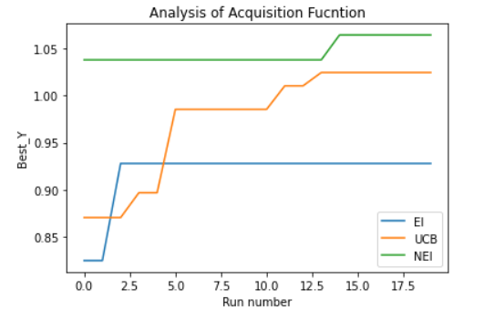d

## Limitations

Model results will vary with each run.

## Trade-offs

Ideally we could have increased the number of acquisition functions we are testing.