Debre Berhan University, School of Computing
II Yr / II SEM -- Computer Science / Information Technology

UNIT - VI
File Management
1. Introduction
- The file system permits users to create and collections called files, with desirable properties.
- Long term existence → Files are stored on disk or secondary storage and do not disappear when a user logs off.
- Sharable between processes →Files have names and can have associated access permissions that permit controlled sharing.
- Structure → Depending on the file system, a file can have an internal structure that is convenient for particular applications.
File naming
Many Operating Systems support two-part file names, with the two parts separated by a period, as prog.c. The part following the period is called the file extension and usually indicates something about the file.

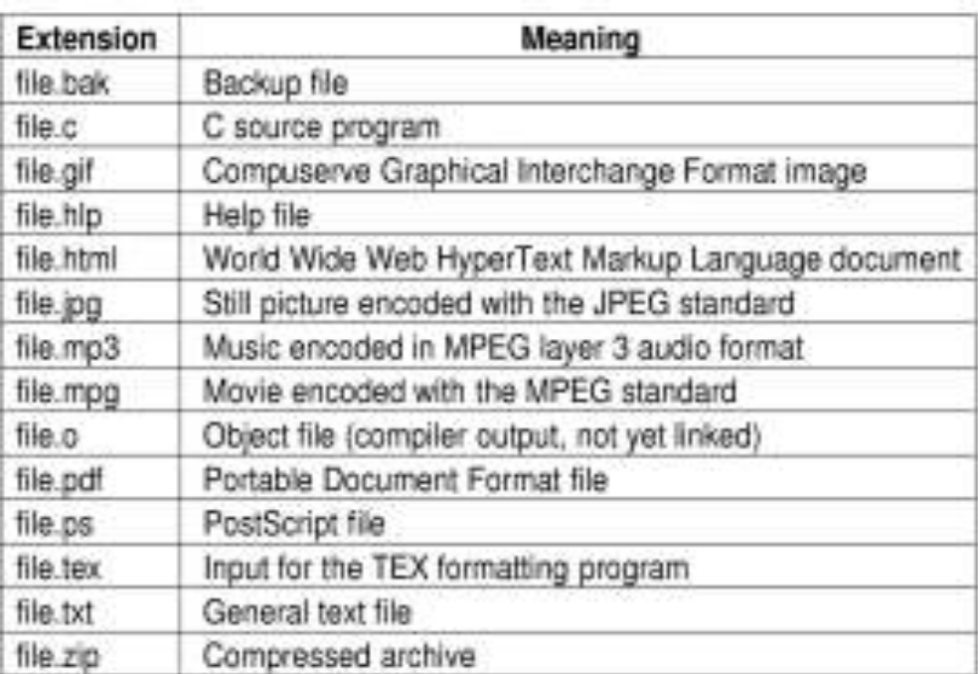

File Operations
1. Create → The file is created with no data. The purpose of the call is to announce that the file is coming and to set some of the attributes.
2. Delete → When the file is no longer needed, it has to be deleted to free up disk space. There is always a system call for this purpose.
3. Open → Before using a file, a process must open it. The purpose of the open call is to allow the system to fetch the attributes and list of disk addresses into main memory for rapid access on latter caller.
4. Close → When all the access are finished, the attributes and disk addresses are no longer needed, so the file should be closed to free up internal table space. Many systems encourage this by imposing a maximum number of open files on processes. A disk is written in blocks, and closing a file forces writing of the file’s last block, even though that block may not be entirely full not.
5. Read → Data are read from file. Usually, the bytes come from the current position. The caller must specify how much data are needed and must also provide a buffer to put them in.
6. Write → Data are written to the file again, usually at the current position. If the current position is the end of the file, the file’s size increases. If the current position is in the middle of the file, existing data are overwritten and lost forever.
7. Append → This call is a restricted in the form of write. It can only add data to the end of the file. Systems that provide a minimal set of system calls do not generally have append, but many systems provide multiple ways of doing the same thing, and these systems sometimes have append.
8. Seek → For random access files, a method is needed to specify from where to take the data. One common approach is a system call, seek, that repositions the file pointer to a specific place in the file. After this call has completed, data can be read from, or written to, that position.
9. Get Attributes → Processes often need to read file attributes to do their work. For example, the UNIX make program is commonly used to manage software development projects consisting of many source files. When make is called, it examines the modification times of the entire source and objects files and arranges for the minimum number of compilations required to bringing everything up to date. To do its job, it must look at the attributes, namely the modification times.
10. Set Attributes → Some of the attributes are user settable and can be changed after the file has been created. This system call makes that possible. The protection mode information is an obvious example. Most of the flags also fall in this category.
11. Rename → It frequently happens that a user needs to change the name of an existing file. This system call makes that possible. It is not always strictly necessary, because the file can usually be copied to a new file with the new name, and the old file then deleted.

File Structure

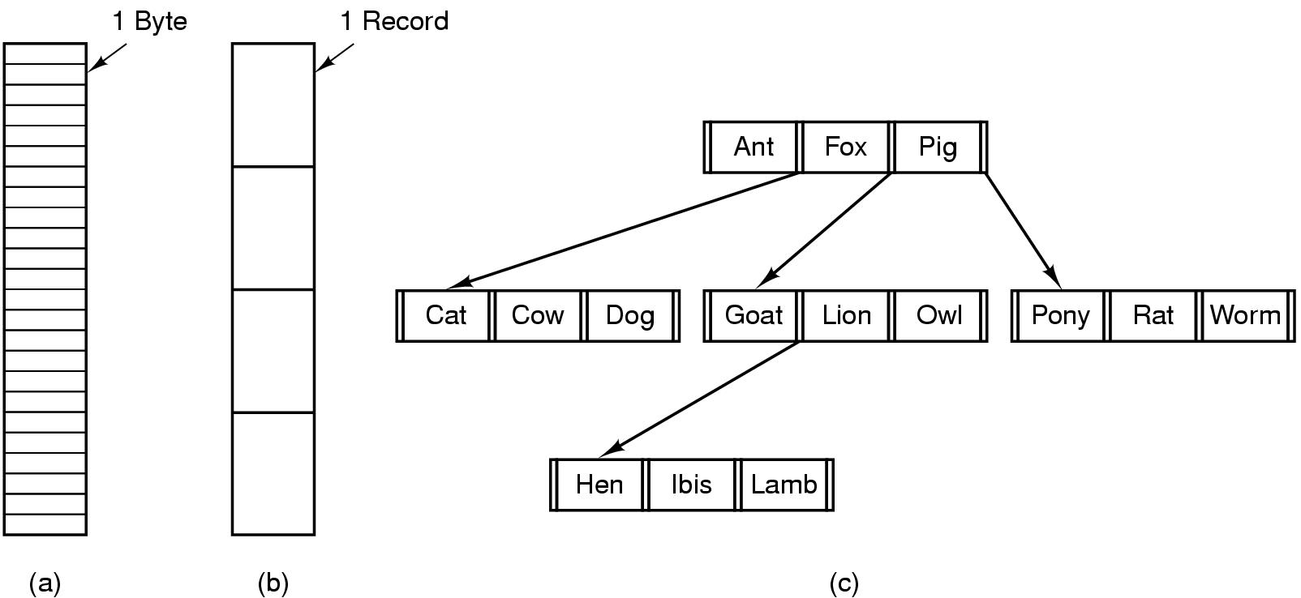

- Three kinds of files
Byte sequence
- UNIX and MS-DOS use byte sequence.
- Meaning on the bytes is imposed by user programs.
- Provides maximum flexibility but minimal support.
- Advantages to users who want to define their own semantics on files.
Record sequence
- Each file of a fixed length record.
- Card readers and line printer based records.
- Used in database.
Tree
- Used in some mainframes.
- Used for searching.

File System Implementation

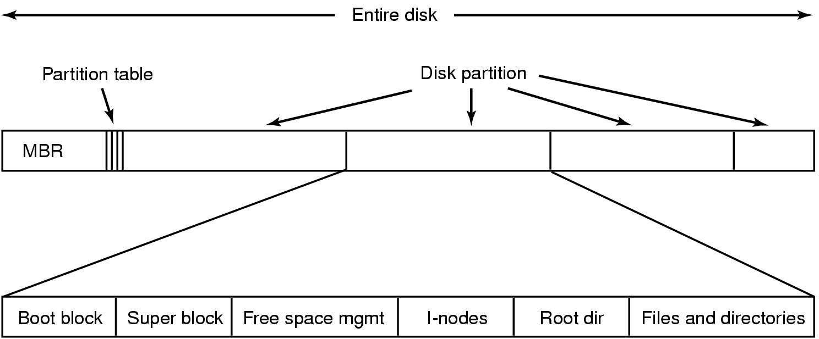

A possible file system layout
Boot block → Occupies the beginning of the file system, typically the first sector.
→ May contain the bootstrap code.
→ Only one boot block needed for initialization but every file system has a possibly empty boot block.
Super block → Size of the file system.
→ Maximum number of files it can store.
Free space management → Location of the free space.
I-node list → List of i-nodes following the superblock.
→ Kernel references i-nodes by indexing into the i-node list.
Root i-node: I-node by which the directory structure of the file system is accessible after execution of the mount system call.

Data blocks →Start at the end of the i-node list.
→Contain file data and administrative data.
→An allocated data block can belong to one and only one file in the file system.

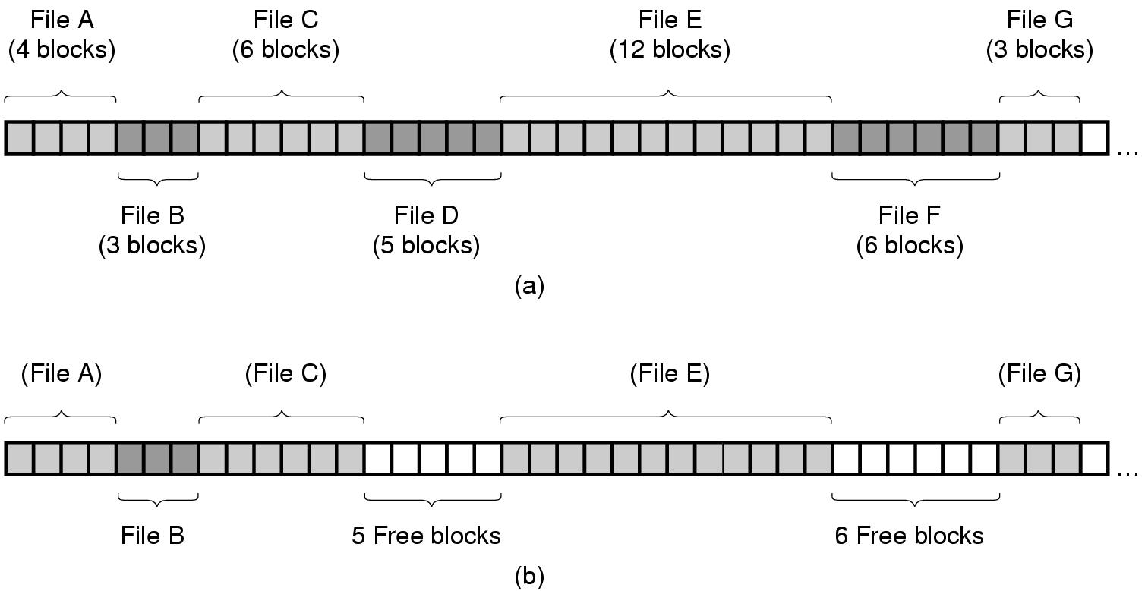

- File system manages files, allocating files space, administering free space, controlling access to files, and retrieving data for users.
- Processes interact with the file system using a set of system calls.
(a) Contiguous allocation of disk space for 7 files
(b) State of the disk after files D and E have been removed
- Linked list allocation.
- Indexed allocation.

File Access
- Sequential access
  - Read all bytes/records from the beginning sequentially.
  - Cannot jump around, could rewind or back up.
  - Convenient when medium is magnetic tape, rather than disk.
- Random access
  - Bytes/records read in any order.
  - Essential for data base systems.
  - Read can be (Move file marker (seek), then read or Read and then move file marker.) like magnetic disk.
Shared Files
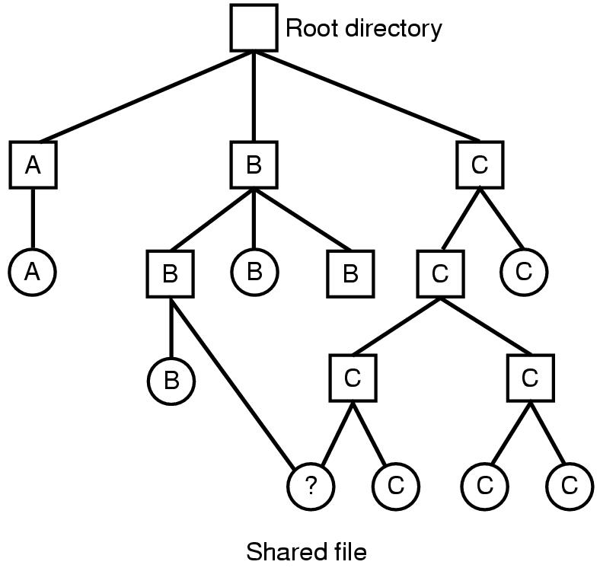

File system containing a shared file

- Sharing of files on multi-user systems is desirable.
- Sharing may be done through a protection scheme.
- On distributed systems, files may be shared across a network.
- Network File System (NFS) is a common distributed file-sharing method.

Directories
Single-Level Directory Systems
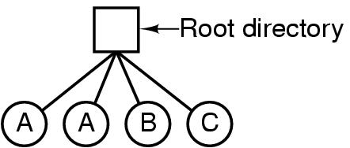
A single level directory system contains 4 files
                - Owned by 3 different people, A, B, and C
                - Used in most primitive systems.
                - May not be appropriate for any large multiuser system.

Two-Level Directory Systems

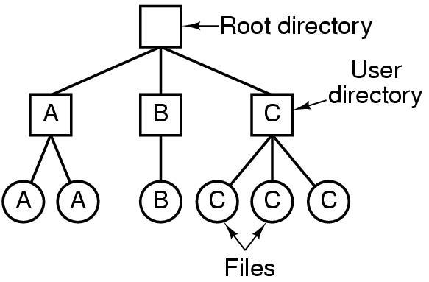
- Letters indicate owners of the directories and files.
- Eliminates name confusion across users.
- May not be satisfactory if users have many files.

Hierarchical Directory Systems
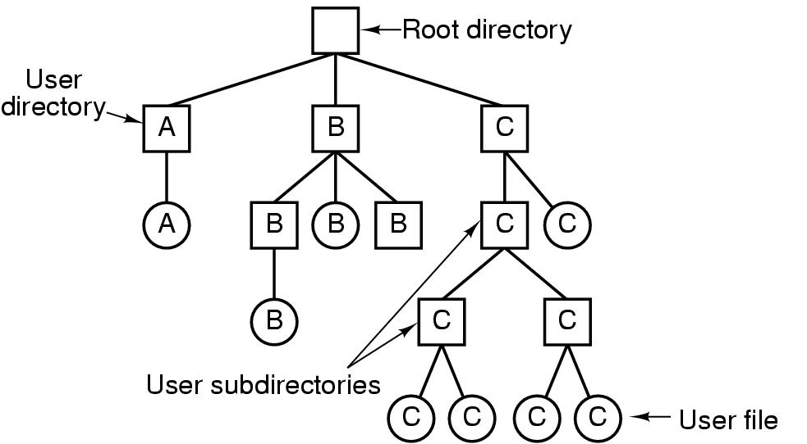

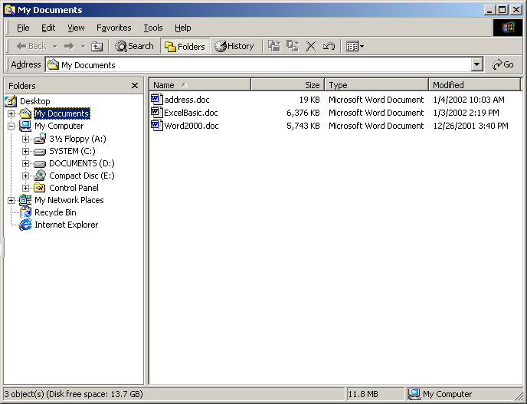

Right Pane:
Folder Content
Left Pane:
Folder Hierarchy

- Tree like structure.
- Root directory sits at the top of the tree; all directories spring out of the root.
- Allows logical grouping of files.
- Every process can have its own working directory to avoid affecting other processes.
- Used in most of the modern systems.

Domain Structure
Process operates within a protection domain. It also specifies the resources which it may use. A protection domain is a collection of access rights, each of which is a pair of <object-identifier, right-set>. Domain elements can change as objects are created, deleted. A process executes in a protection domain at a given point in time. Domain does not need to be disjoint.

User Authentication
Authentication deals with the problem of verifying the identity of a user before permitting access to the requested resource. The main types of authentication needed in the operating system are as follows.
Passwords → Correct identification at the time of login is crucial to the functioning of a secure system because all access control decisions and accounting functions are based on this identity.
A password could be associated with each resource. To provide good security, a password based authentication system must have mechanisms for the following.
- Keep password secret.
- Making password difficult to guess.
- Limiting damages done by a compromised password.
- Identifying and discouraging unauthorized user logins.
Password Vulnerability (susceptibility) → Passwords are extremely common. Passwords can often be guessed. Use of mechanisms to keep passwords secret does not guarantee that the system security can not be broken. Some techniques that may be used to make the task of guessing a password difficult are as follows.
- Longer passwords.
- Salting the password table.
- System assistance in password selection.
For example 3-digit password provides 1000 variations whereas a 4-digit password provides 10,000 variations.
Encrypted Passwords → Instead of storing the names and passwords in plain text form, they are encrypted and stored in cipher text form in the table. In this case, instead of directly using a user specified name and password for table lookup, they are first encrypted and then the results are used for table lookup.
One Time passwords → Set of paired passwords solve the problem of password sniffing. When a session begins, the system randomly selects and presents one part of a password pair, user must supply the other part. One time passwords are among the only ways to prevent improper authentication due to password exposure.

Program Threats
Trojan horse → Trojan horse is a virus that’s disguised as a legitimate or harmless program that sometimes carries within itself the mean to allow the programs creator to secretly access the users system.
Trap Door → (Secret undocumented entry point into a program used to grant access without normal methods of access authentication) Trap door can be caused by a flow in the system design or they can be installed by a system programmer for future use. Trap doors including backdoor passwords are unspecified and non documented entry points to the system.
System Threats
Operating system provides a means for processes to spawn other processes. The two common methods for achieving the misuse are worms and viruses.
Viruses → A virus is any unauthorized program that is designed to gain access to a computer system. Viruses need other programs to spread. Due its spreading nature, a virus can cause severe damage to a system. Virus attacks are active type Trojan horse attacks. Precautions to prevent virus problems.
- Buying software only from respectable store.
- Avoid uploading of free software from public domain.
- Avoid borrowing programs from someone whose security standards are less.
Worms → A worm is like a virus. It replicates itself but is a self contained, self propagating program. Worms are programs that spread from one computer to another in a computer network. They spread by taking advantage of the way in which resources are shared on a computer network. A worm program may perform destructive activity after arrival at a network node.
  - A virus is a program fragment whereas a worm is a complete program in itself.
  - Virus does not exist independently. It resides in host program, runs only when the host program runs. A worm can exist independently and execute independently.
  - A virus spreads from one program to another whereas a worm spreads from one computer to another in a network.

Malicious Programs
Malicious program provides on overall taxonomy if software threats. Threat can be divided into two categories those that need a host program and those that are independent.
Malicious
Programs

Needs Host Programs
Independent

Trapdoors
Logic
Bombs
Trojan
Horses
Viruses
Bacteria
Worms

Security Systems and Facilities
For improving system security, system must scan periodically. These scan can be done when the computer has relatively little use, so they will have less effect than logging scanning for security can check a variety of aspects.
- Easy to guess passwords.
- Long running processes.
- Un-authorised privileged programs.
- Improper directory protections on both user and system directories.
- Improper protections on system data files.
- Hidden network daemons/hackers.
- Changes to system programs detected with checksum values.

UNIT-VI. File Management
1. File System Structure
2. File System Implementation, File Sharing
3. Directory Structure
4. Domain Protection, Authentication and Threats
5. Security Systems and Facilities

