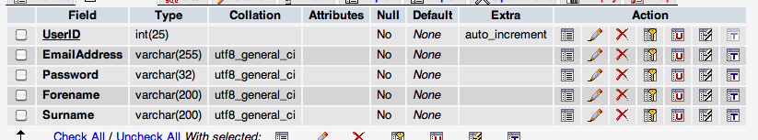

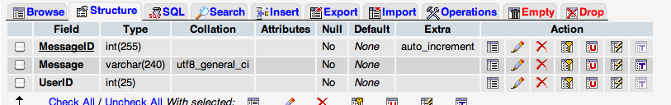

<?php include('config.php'); ?>

<!DOCTYPE html PUBLIC "-//W3C//DTD XHTML 1.1//EN" "http://www.w3.org/TR/xhtml11/DTD/xhtml11.dtd">

<html>

<head>

<title>Alpha</title>

<link rel="stylesheet" href="style.css" type="text/css" />

</head>

<body>

<?php

// Logged IN

if(!empty($_SESSION['LoggedIn']) && !empty($_SESSION['Email'])) {

// Post to Database

if(!empty($_POST['message']))

{

$message = mysql_real_escape_string($_POST['message']);

$postmessage = mysql_query("INSERT INTO Wall (Message, UserID) VALUES('".$message."', '".$_SESSION['UserID']."')");

}

// Collet Latest Posts

$result = mysql_query('SELECT Message, UserID

FROM Wall

ORDER BY MessageID DESC

LIMIT 20') or die('Invalid query: ' . mysql_error());

// Collet Post User

$query = mysql_query('SELECT Forename, Surname FROM Users INNER JOIN Wall ON Users.UserID = Wall.UserID;') or die('Invalid query: ' . mysql_error());

?>

<div id ="container">

<div id="insideleft">

<ul>

<li><a href="index.php">Home</a></li>

<li><a href="profile.php">Edit Profile</a></li>

<li><a href="wall.php">Community Wall</a></li>

<li><a href="logout.php">Logout</a></li>

</ul>

</div>

<div id="insideright">

<h1>Community Wall</h1>

<br />

<form method="post" action="wall.php" name="wallpost" id="wallpost">

<label for="message" class="message">Message: </label> <input type="text" name="message" id="message" class="message"/>

<input type="submit" name="messagesub" id="messagesub" value="Post" /><br /><br />

</fieldset>

</form>

<?php while ($row = mysql_fetch_assoc($result)) { ?>

<p></p>

<p><?=stripslashes($row['Message'])?></p><br />

<?php

} ?>

</div>

</div>

<?php

}

//else {echo "<meta http-equiv='refresh' content='0;index.php'>";}

?>

</body>

</html>

CREATE TABLE user(

id INT(11) NOT NULL AUTO_INCREMENT,

username VARCHAR(50) NOT NULL,

password VARCHAR(20) NOT NULL,

PRIMARY KEY (id)

);

CREATE TABLE items(

i_id INT(11) NOT NULL AUTO_INCREMENT,

name TINYTEXT NOT NULL,

price DECIMAL(8,2) NOT NULL,

PRIMARY KEY (i_id)

);

CREATE TABLE user_purchase(

i_id INT(11) NOT NULL,

name TINYTEXT NOT NULL,

id INT(11) NOT NULL,

FOREIGN KEY (i_id) REFERENCES items(i_id),

FOREIGN KEY (name) REFERENCES items(name),

FOREIGN KEY (id) REFERENCES user(id)

);

CREATE TABLE reviewing  
(  
reviewingid INTEGER ,  
papername text,  
reviewername text,   
PRIMARY KEY(reviewingid)   
);  
  
CREATE TABLE score  
(  
reviewingid integer,  
questionnumber integer,  
score integer,  
FOREIGN KEY (reviewingid) REFERENCES reviewing (reviewingid) on delete cascade  
);

CREATE TABLE post(  
id INT PRIMARY KEY,  
title VARCHAR(100),  
dateissued TIMESTAMP,  
datecreated TIMESTAMP,  
datemodified TIMESTAMP,  
content TEXT,  
);  
  
-- Date of publication   
CREATE TABLE publish(  
id INT,  
datepublish TIMESTAMP,  
urldest VARCAHR(100),  
postid int REFERENCES post(id)  
);