* Start program
* Prompt the user to enter the total number of students.
* Read and store the input as 'total_students' variable.
* Prompt the user to enter the name, age, and grade of each student, one by one.
* Create an empty list called 'students_list' to store the student information.
* Loop 'total_students' times to collect information for each student.
* For each iteration, read and store the student's name, age, and grade as 'name', 'age', and 'grade' variables.
* Create a dictionary called 'student_dict' to store the student's information.
* Add 'name', 'age', and 'grade' as keys in the 'student_dict', with their corresponding values.
* Append 'student_dict' to 'students_list' to store the student's information in the list.
* Repeat steps 6-9 for all students.
* Print the list of students with their information.
* Calculate the average age and average grade of all students by iterating through 'students_list'.
* Sum the ages and grades of all students.
* Divide the total age sum by 'total_students' to get the average age, and store it as 'avg_age'.
* Divide the total grade sum by 'total_students' to get the average grade, and store it as 'avg_grade'.
* Print the calculated average age and average grade.
* End the program.

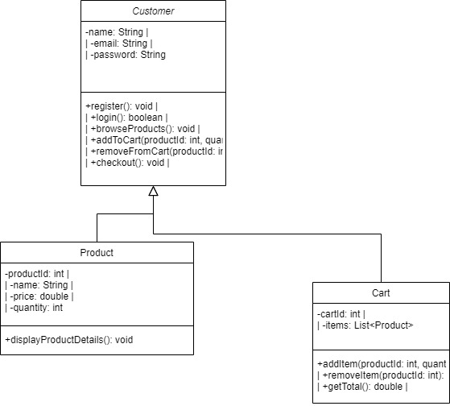

* What have you learned?
* I learned how to look for data In a ragged array and pass that information to a method
* What did you struggle with?
* I struggled with the ragged array. Because I just couldn’t get the ragged array to pass through my loop but I finally got it to work
* What will you do differently on your next project?
* Give myself more time and try to use more studs in my code
* What parts of the project you were successful at, and what parts (if any) you were not successful at?
* I was sucessful with all of it