* Start
* Display message: "Welcome to the inventory system!"
* Initialize inventory array with empty elements
* Loop while user wants to add items
* Display message: "Enter item name:"
* Read item name from user
* Display message: "Enter item quantity:"
* Read item quantity from user
* Add item and quantity to inventory array
* Display inventory array
* Display message: "Do you want to add more items? (+/-)"
* Read user response
* Loop while user wants to remove items
* Display inventory array
* Display message: "Enter item name to remove:"
* Read item name from user
* If item exists in inventory array
* Display message: "Enter quantity to remove:"
* Read quantity to remove from user
* If quantity to remove <= item quantity
* Subtract quantity to remove from item quantity
* Display inventory array
* Else display message: "Quantity to remove is greater than item quantity!"
* Else display message: "Item not found in inventory!"
* Display message: "Do you want to remove more items? (+/-)"
* Read user response
* Display message: "Thank you for using the inventory system!"
* End

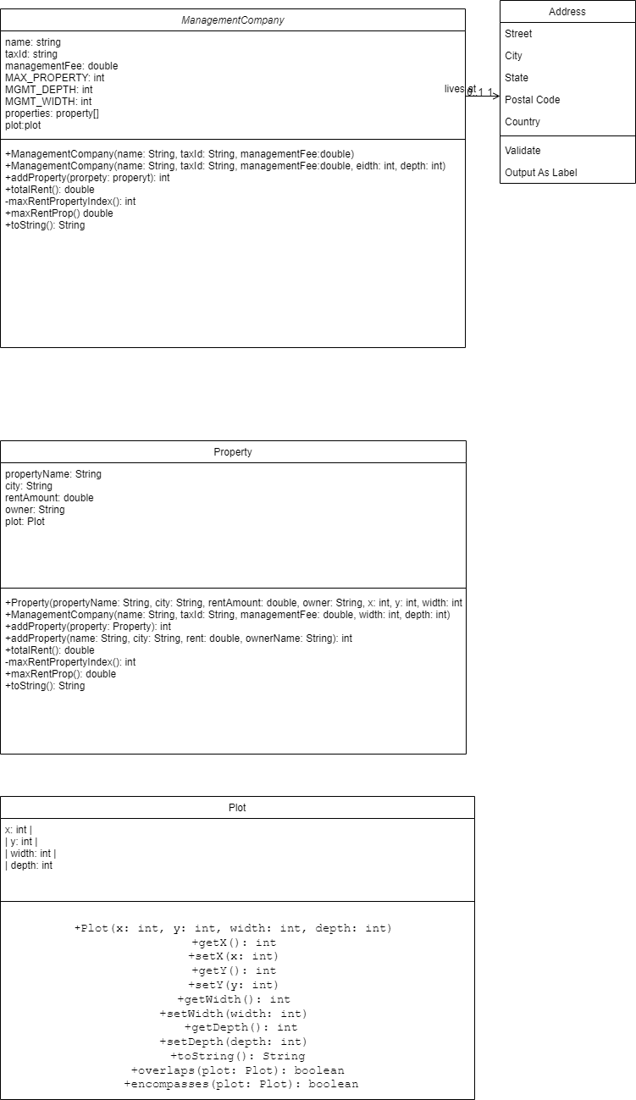

* Learning Experience: highlight your lessons learned and learning experience from working on this project.
* What have you learned?

I learned how to pass information using arrays and from one class to another

* What did you struggle with?

The excessive passign in this assignment was like none I have ever seen

* What will you do differently on your next project?

Give myself more time to slowly do each method

* Include what parts of the project you were successful at, and what parts (if any) you were not successful at.

None

**Grading Rubric**

See attachment: CMSC203 Assignment 4 Rubric.xlsx

Assignment 4 Check List (include Yes/No or N/A for each item)

|  |  |  |  |
| --- | --- | --- | --- |
| **#** |  | **Y/N or N/A** | **Comments** |
|  | **Assignment files:** |  |  |
|  | * FirstInitialLastName_ Assignment 4_Moss.zip | **Y** |  |
|  | * FirstInitialLastName_Assignment4_Complete.zip | **Y** |  |
|  | **Program compiles** | **Y** |  |
|  | **Program runs with desired outputs related to a Test Plan** | **Y** |  |
|  | **Documentation file:** |  |  |
|  | * Comprehensive Test Plan | **Y** |  |
|  | * Screenshots for each Junit Test | **Y** |  |
|  | * Screenshots for each Test case listed in the Test Plan | **Y** |  |
|  | * Screenshots of your GitHub account with submitted Assignment# (if required) | **Y** |  |
|  | * UML Diagram | **Y** |  |
|  | * Algorithms/Pseudocode | **Y** |  |
|  | * Flowchart (if required) | **Y** |  |
|  | * Lessons Learned | **Y** |  |
|  | * Checklist is completed and included in the Documentation | Y |  |