**Objectives:**

* To learn about the insertion sort.
* To learn about the selection sort.

**Write a program showing the use of insertion sort.**

#include <iostream>

using namespace std;

void insertionSort(int arr[], int n)

{

int i, key, j;

for (i = 1; i < n; i++)

{

key = arr[i];

j = i - 1;

while (j >= 0 && arr[j] > key)

{

arr[j + 1] = arr[j];

j = j - 1;

}

arr[j + 1] = key;

}

}

void printArray(int arr[], int n)

{

int i;

for (i = 0; i < n; i++)

cout << arr[i] << " ";

cout << endl;

}

int main()

{

int arr[] = { 12, 11, 13, 5, 6 };

int n = sizeof(arr) / sizeof(arr[0]);

printf("Before Sorting:\n");

printArray(arr,n);

insertionSort(arr, n);

printf("\nAfter Sorting:\n");

printArray(arr, n);

return 0;

}

**Program Output**

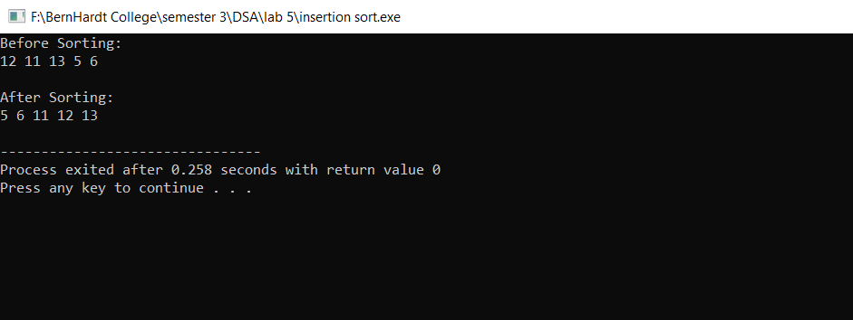

**Write a program showing the use of selection sort.**

#include <iostream>

using namespace std;

void swap(int *xp, int *yp)

{

int temp = *xp;

*xp = *yp;

*yp = temp;

}

void selectionSort(int arr[], int n)

{

int i, j, min_idx;

for (i = 0; i < n-1; i++)

{

min_idx = i;

for (j = i+1; j < n; j++)

if (arr[j] < arr[min_idx])

min_idx = j;

swap(&arr[min_idx], &arr[i]);

}

}

void printArray(int arr[], int size)

{

int i;

for (i=0; i < size; i++)

cout << arr[i] << " ";

cout << endl;

}

int main()

{

int arr[] = {64, 25, 12, 22, 11};

int n = sizeof(arr)/sizeof(arr[0]);

cout << "Unsorted array: \n";

printArray(arr, n);

selectionSort(arr, n);

cout << "\nSorted array: \n";

printArray(arr, n);

return 0;

}

**Program Output**

