**Objectives**

* To learn about the insertion on linked list.
* To learn about tree traversal.

**Write a program to show the insertion in linked list.**

#include <stdio.h>

#include <stdlib.h>

#include <conio.h>

/* Node Stucture */

typedef struct node_t {

int data;

struct node_t *next;

} Node;

/* Function Declarations */

Node * insert_top(int, Node *);

Node * insert_bottom(int, Node *);

Node * insert_after(int, int, Node *);

Node * insert_before(int, int, Node *);

void print(Node *);

int count(Node *);

/* Add a new node to the top of a list */

Node * insert_top(int num, Node *head) {

Node *new_node;

new_node = (Node *) malloc(sizeof(Node));

new_node->data = num;

new_node->next= head;

head = new_node;

return head;

}

/* Add a new node to the bottom of a list */

Node * insert_bottom(int num, Node *head) {

Node *current_node = head;

Node *new_node;

while ( current_node != NULL && current_node->next != NULL) {

current_node = current_node->next;

}

new_node = (Node *) malloc(sizeof(Node));

new_node->data = num;

new_node->next= NULL;

if (current_node != NULL)

current_node->next = new_node;

else

head = new_node;

return head;}

/* Add a new node after an element in the list */

Node * insert_after(int num, int prev_num, Node *head) {

Node *current_node = head;

Node *new_node;

while ( current_node->data != prev_num) {

current_node = current_node->next;

}

new_node = (Node *) malloc(sizeof(Node));

new_node->data = num;

new_node->next= current_node->next;

current_node->next = new_node;

return head;

}

/* Add a new node before an element in the list */

Node * insert_before(int num, int next_num, Node *head) {

Node *current_node = head;

Node *new_node;

while ( current_node->next->data != next_num) {

current_node = current_node->next;

}

new_node = (Node *) malloc(sizeof(Node));

new_node->data = num;

new_node->next= current_node->next;

current_node->next = new_node;

return head;

}

/* Print all the elements in the linked list */

void print(Node *head) {

Node *current_node = head;

while ( current_node != NULL) {

printf("%d ", current_node->data);

current_node = current_node->next;

}

}

/* Program main */

int main()

{

Node *head = NULL;

int num, prev_num, next_num;

int option;

char * temp;

char ch;

/* Display Menu */

while(1) {

printf("\n ***********************************\n");

printf(" * Linked list operations: *\n");

printf(" * 1. Insert at the top of list *\n");

printf(" * 2. Insert at bottom of list *\n");

printf(" * 3. Insert after an element *\n");

printf(" * 4. Insert before an element *\n");

printf(" * 5. Show all elements *\n");

printf(" * 6. Quit *\n");

printf(" ***********************************\n");

printf("Choose an option [1-5] : ");

if (scanf("%d", &option) != 1) {

printf(" *Error: Invalid input. Try again.\n");

scanf("%s", &temp); /*clear input buffer */

continue;

}

switch (option) {

case 1: /* Add to top*/

printf(" Enter a number to insert : ");

if (scanf("%d", &num) != 1) {

printf(" *Error: Invalid input.\n");

scanf("%s", &temp); /*clear input buffer */

continue;

}

head = insert_top(num, head);

printf("Number %d added to the top of the list", num);

printf("\nPress any key to continue...");

getch();

break;

case 2: /* add to bottom */

printf(" Enter a number to insert : ");

if (scanf("%d", &num) != 1) {

printf(" *Error: Invalid input. \n");

scanf("%s", &temp);

continue;

}

head = insert_bottom(num, head);

printf("%d added to the bottom of the list", num);

printf("\nPress any key to continue...");

getch();

break;

case 3: /* Insert After */

printf(" Enter a number to insert : ");

if (scanf("%d", &num) != 1) {

printf(" *Error: Invalid input.\n");

scanf("%s", &temp);

continue;

}

printf(" After which number do you want to insert : ");

if (scanf("%d", &prev_num) != 1) {

printf(" *Error: Invalid input.\n");

scanf("%s", &temp);

continue;

}

if (head != NULL) {

head = insert_after(num, prev_num, head);

printf("%d is inserted after %d", num, prev_num);

}else {

printf("The list is empty", num, prev_num);

}

printf("\nPress any key to continue...");

getch();

break;

case 4: /* Insert Before */

printf(" Enter a number to insert : ");

if (scanf("%d", &num) != 1) {

printf(" *Error: Invalid input. \n");

scanf("%s", &temp);

continue;

}

printf(" Before which number do you want to insert : ");

if (scanf("%d", &prev_num) != 1) {

printf(" *Error: Invalid input.\n");

scanf("%s", &temp);

continue;

}

if (head != NULL) {

head = insert_before(num, prev_num, head);

printf("Number %d inserted before %d", num, prev_num);

}else {

printf("The list is empty", num, prev_num);

}

printf("\nPress any key to continue...");

getch();

break;

case 5: /* Show all elements */

printf("\nElements in the list: \n [ ");

print(head);

printf("]\n\nPress any key to continue...");

getch();

break;

case 6: /* Exit */

return(0);

break;

default:

printf("Invalid Option. Please Try again.");

getch();

}printf("\n"); /* End of Switch */

} /* End of While */

return(0);

}

**Program Output**

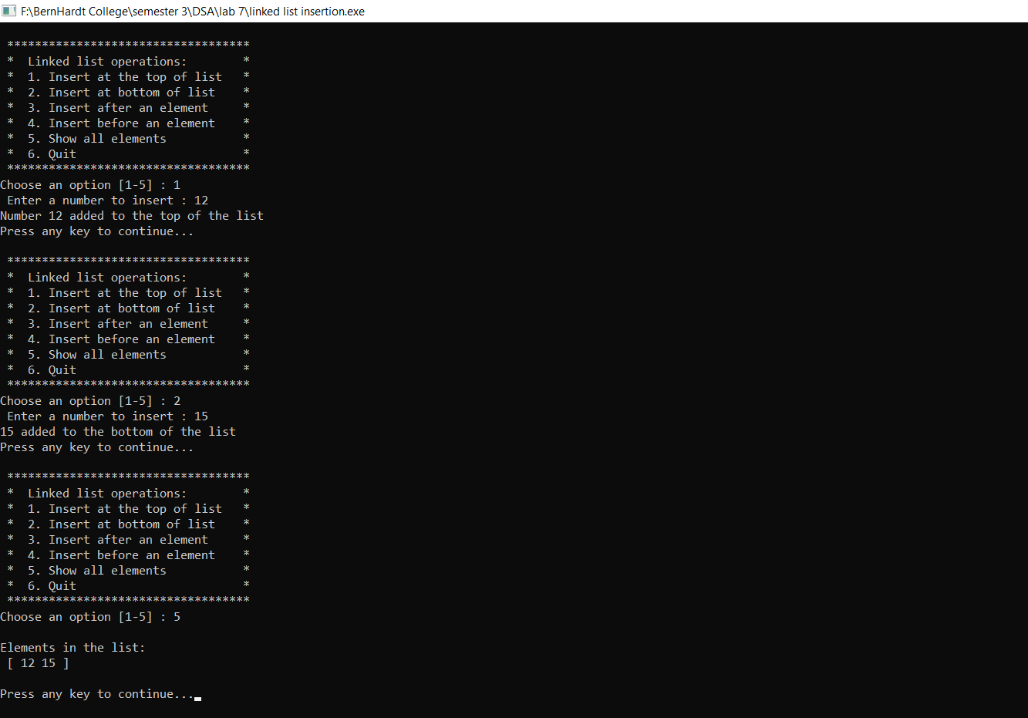

**Write a program showing the concept of tree traversal.**

#include <stdio.h>

#include <stdlib.h>

/* 1

/ \

2 3

/\ /\

4 5 6 7

*/

/* A binary tree node has data, pointer to left child

and a pointer to right child */

struct node

{

int data;

struct node* left;

struct node* right;

};

/* Helper function that allocates a new node with the

given data and NULL left and right pointers. */

struct node* newNode(int data)

{

struct node* node = (struct node*)malloc(sizeof(struct node));

node->data = data;

node->left = NULL;

node->right = NULL;

return(node);

}

/* Given a binary tree, print its nodes according to the

"bottom-up" postorder traversal. */

void printPostorder(struct node* node)

{

if (node == NULL)

return;

// first recur on left subtree

printPostorder(node->left);

// then recur on right subtree

printPostorder(node->right);

// now deal with the node

printf("%d ", node->data);

}

/* Given a binary tree, print its nodes in inorder*/

void printInorder(struct node* node)

{

if (node == NULL)

return;

/* first recur on left child */

printInorder(node->left);

/* then print the data of node */

printf("%d ", node->data);

/* now recur on right child */

printInorder(node->right);

}

/* Given a binary tree, print its nodes in preorder*/

void printPreorder(struct node* node)

{

if (node == NULL)

return;

/* first print data of node */

printf("%d ", node->data);

/* then recur on left sutree */

printPreorder(node->left);

/* now recur on right subtree */

printPreorder(node->right);

}

int main()

{

struct node *root = newNode(1);

root->left = newNode(2);

root->right = newNode(3);

root->left->left = newNode(4);

root->left->right = newNode(5);

root->right->left= newNode(6);

root->right->right= newNode(7);

printf("Preorder traversal of binary tree is \n");

printPreorder(root);

printf("\nInorder traversal of binary tree is \n");

printInorder(root);

printf("\nPostorder traversal of binary tree is \n");

printPostorder(root);

getchar();

return 0;}

**Program Output**

