# Coding Challenge (27-06-2025)

-BY GETSY JACINTH

Total Duration: 2 Hours

Sections:

1. Python Programming & OOP (40 mins)  
2. Data Structures & Algorithms (30 mins)  
3. SQL with Python Integration (30 mins)  
4. Version Control with Git (10 mins)  
5. Bonus/Stretch Task: Unit Testing with PyUnit (10 mins)

## Section 1: Python Programming & OOP (40 mins)

Q1. Functional Coding Challenge – Movie Booking System (20 mins)  
- Show available movies (stored in a list)  
- Allow user to select movie & number of tickets  
- Calculate and show total amount (use a dictionary to store movie:price)  
- Use functions for showing movies, booking logic, and calculating amount

**CODE:**

**movies = ["Jawan", "Interstellar", "Dune", "Barbie"]**

**movie_prices = {"Jawan": 250, "Interstellar": 300, "Dune": 280, "Barbie": 260}**

**def show_movies():**

**for idx, movie in enumerate(movies, 1):**

**print(f"{idx}. {movie} - Rs.{movie_prices[movie]}")**

**def calculate_amount(movie, tickets):**

**return movie_prices[movie] * tickets**

**def book_movie():**

**show_movies()**

**choice = int(input("Enter movie number: "))**

**movie = movies[choice - 1]**

**tickets = int(input("Enter number of tickets: "))**

**total = calculate_amount(movie, tickets)**

**print(f"Total amount for {tickets} tickets of {movie}: Rs.{total}")**

**if __name__ == "__main__":**

**book_movie()**

**OUTPUT:**

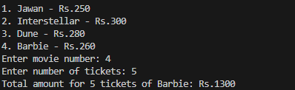

Q2. OOP Implementation – Library Management (20 mins)  
- Create classes Book, Library, and User  
- Library contains a collection of books  
- User can borrow/return/view books  
- Use class, constructor, inheritance, method overriding

**CODE:**

**class Book:**

**def __init__(self, title):**

**self.title = title**

**self.is_borrowed = False**

**class Library:**

**def __init__(self):**

**self.books = [Book("Python 101"), Book("DSA "), Book("OOP")]**

**def show_books(self):**

**for book in self.books:**

**status = "Available" if not book.is_borrowed else "Borrowed"**

**print(f"{book.title} - {status}")**

**def borrow_book(self, book_title):**

**for book in self.books:**

**if book.title == book_title and not book.is_borrowed:**

**book.is_borrowed = True**

**print(f"You borrowed {book.title}")**

**return**

**print("Book not available")**

**def return_book(self, book_title):**

**for book in self.books:**

**if book.title == book_title and book.is_borrowed:**

**book.is_borrowed = False**

**print(f"You returned {book.title}")**

**return**

**print("Invalid return")**

**class User(Library):**

**def __init__(self, name):**

**super().__init__()**

**self.name = name**

**def show_books(self):**

**print(f"{self.name}'s Library View:")**

**super().show_books()**

**user = User("Alice")**

**user.show_books()**

**user.borrow_book("Python 101")**

**user.show_books()**

**user.return_book("Python 101")**

**user.show_books()**

**OUTPUT SCREEENSHOT:**

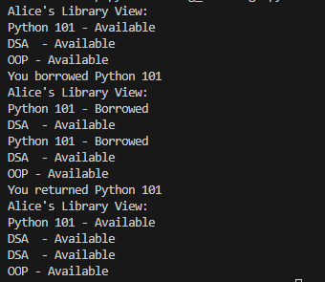

## Section 2: Data Structures & Algorithms (30 mins)

Q3. Algorithm Problem – Minimize Coins (Greedy) (15 mins)  
- Find minimum number of coins needed for a given amount  
- Denominations: [1, 2, 5, 10, 20, 50, 100, 200, 500]

**CODE:**

**def minimize_coins(amount):**

**denominations = [500, 200, 100, 50, 20, 10, 5, 2, 1]**

**result = []**

**for coin in denominations:**

**while amount >= coin:**

**amount -= coin**

**result.append(coin)**

**print(f"Coins used: {result}")**

**print(f"Total coins: {len(result)}")**

**amount = int(input("Enter amount: "))**

**minimize_coins(amount)**

**OUTPUT:**

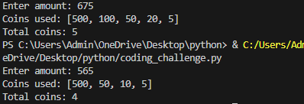

Q4. Data Structure Usage (15 mins)  
- Stack: Evaluate postfix expression '231*+9-'

**CODE:**

**def evaluate_postfix(expression):**

**stack = []**

**for char in expression:**

**if char.isdigit():**

**stack.append(int(char))**

**else:**

**b = stack.pop()**

**a = stack.pop()**

**if char == '+':**

**stack.append(a + b)**

**elif char == '-':**

**stack.append(a - b)**

**elif char == '*':**

**stack.append(a * b)**

**elif char == '/':**

**stack.append(a // b)**

**print(f"Result: {stack[0]}")**

**expression = '231*+9-'**

**evaluate_postfix(expression)**

**OUTPUT SCREENSHOT:**



- Linked List class: append(), display(), reverse()

**CODE:**

**class Node:**

**def __init__(self, data):**

**self.data = data**

**self.next = None**

**class LinkedList:**

**def __init__(self):**

**self.head = None**

**def append(self, data):**

**new_node = Node(data)**

**if not self.head:**

**self.head = new_node**

**return**

**temp = self.head**

**while temp.next:**

**temp = temp.next**

**temp.next = new_node**

**def display(self):**

**temp = self.head**

**while temp:**

**print(temp.data, end=' ')**

**temp = temp.next**

**print()**

**def reverse(self):**

**prev = None**

**current = self.head**

**while current:**

**next_node = current.next**

**current.next = prev**

**prev = current**

**current = next_node**

**self.head = prev**

**ll = LinkedList()**

**ll.append(10)**

**ll.append(20)**

**ll.append(30)**

**ll.display()**

**ll.reverse()**

**ll.display()**

**OUPUT SCREENSHOT:**



## Section 3: SQL with Python Integration (30 mins)

Q5. SQL + Python – Student Scores Table  
- Create table StudentScores(name VARCHAR, subject VARCHAR, marks INT)  
- Insert sample data  
- Use Python to display records, show average marks, list students scoring <40

**CODE:**

**import sqlite3**

**conn = sqlite3.connect(":memory:")**

**cursor = conn.cursor()**

**cursor.execute("""**

**CREATE TABLE StudentScores(**

**name TEXT,**

**subject TEXT,**

**marks INTEGER**

**)**

**""")**

**sample_data = [**

**("Vijay", "Math", 85),**

**("Varun", "Math", 35),**

**("Latha", "Science", 72),**

**("David", "Science", 25),**

**("Eve", "English", 90),**

**("Frank", "English", 38)**

**]**

**cursor.executemany("INSERT INTO StudentScores VALUES (?, ?, ?)", sample_data)**

**conn.commit()**

**print("All Records:")**

**for row in cursor.execute("SELECT * FROM StudentScores"):**

**print(row)**

**cursor.execute("SELECT AVG(marks) FROM StudentScores")**

**avg_marks = cursor.fetchone()[0]**

**print(f"\nAverage Marks: {avg_marks}")**

**print("\nStudents scoring less than 40:")**

**for row in cursor.execute("SELECT * FROM StudentScores WHERE marks < 40"):**

**print(row)**

**conn.close()**

**OUTPUT SCREENSHOT:**

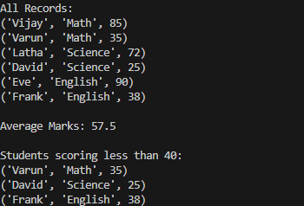

## Section 4: Version Control with Git (10 mins)

Q6. Git Challenge  
- Initialize Git repository  
- Create and switch to branch feature/students  
- Add and commit your Python code  
- Merge feature/students into main  
- Provide Git commands

**COMMANDS AND OUTPUT SCREENSHOT:**

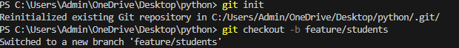 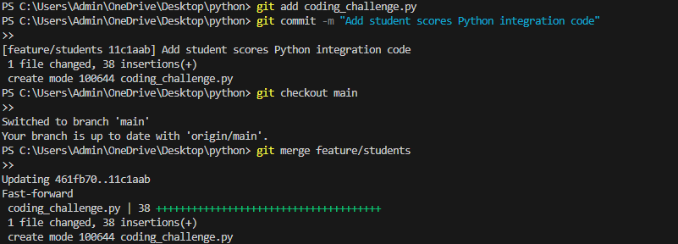

## Bonus Section: PyUnit Test Case (10 mins)

Q7. PyUnit test cases for Q1 (Booking System)  
- 1 test case for calculate_amount()  
- 1 test case for booking() using mocks if needed  
- Use unittest.TestCase, setUp(), tearDown()

**CODE:**

**import unittest**

**import coding_challenge**

**class TestBookingSystem(unittest.TestCase):**

**def setUp(self):**

**self.movie_prices = coding_challenge.movie_prices**

**def tearDown(self):**

**self.movie_prices = None**

**def test_calculate_amount(self):**

**amount = coding_challenge.calculate_amount("Jawan", 2)**

**self.assertEqual(amount, 500)**

**amount = coding_challenge.calculate_amount("Interstellar", 0)**

**self.assertEqual(amount, 0)**

**def test_booking_logic(self):**

**# Simulate the internal logic: get price and calculate**

**movie = "Dune"**

**tickets = 3**

**expected_total = self.movie_prices[movie] * tickets**

**actual_total = coding_challenge.calculate_amount(movie, tickets)**

**self.assertEqual(actual_total, expected_total)**

**if __name__ == '__main__':**

**unittest.main()**

**OUTPUT SCREENSHOT;**

