# Python Coding Task (20-06-2025)

-**BY GETSY JACINTH**

Time: 30 Minutes

Level: Intermediate

## Q1. Understanding Access Specifiers

Create a class `Student` with the following properties:  
  
Class Requirements:  
1. `name` → Public attribute   
2. `_roll_number` → Protected attribute   
3. `__marks` → Private attribute   
  
Implement the following methods:  
- Constructor to initialize all attributes.  
- `display_details()` → Public method to display all attribute values.  
- `_update_roll_number(new_roll)` → Protected method to update roll number.  
- `__update_marks(new_marks)` → Private method to update marks.  
- `access_private_method(new_marks)` → Public method that uses the private method `__update_marks`.

Code:

class Student:

    def __init__(self, name, roll_number, marks):

        self.name = name                    # Public

        self._roll_number = roll_number     # Protected

        self.__marks = marks                # Private

    def display_details(self):

        print(f"Name: {self.name}")

        print(f"Roll Number: {self._roll_number}")

        print(f"Marks: {self.__marks}")

    def _update_roll_number(self, new_roll):

        self._roll_number = new_roll

        print(f"Updated Roll Number (Protected): {self._roll_number}")

    def __update_marks(self, new_marks):

        self.__marks = new_marks

        print(f"Updated Marks (Private): {self.__marks}")

    def access_private_method(self, new_marks):

        self.__update_marks(new_marks)

s = Student("Alice", 101, 95)

s.display_details()

s._update_roll_number(202)

s.access_private_method(88)

s.display_details()

Output screenshot:

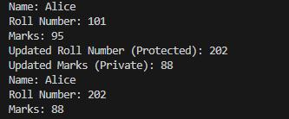

## Q2. Demonstrate Access

In the main section:  
- Create an object of the `Student` class.  
- Modify and print the `name` directly.  
- Modify and print the `_roll_number` directly.  
- Try accessing `__marks` directly and observe the result.

Code:

s = Student("Alice", 101, 95)

# Modify and print public attribute

s.name = "Alicia"

print("Modified Name (Public):", s.name)

# Modify and print protected attribute

s._roll_number = 202

print("Modified Roll Number (Protected):", s._roll_number)

# Try to access private attribute directly

try:

print("Attempting to access __marks directly:", s.__marks)

except AttributeError as e:

print("Error accessing __marks directly:", e)

# Display full details using class method

s.display_details()

output screenshot:

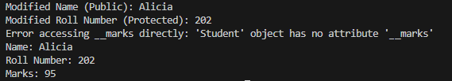

## Q3. Inheritance and Access Control

Create a subclass `Topper` that inherits from `Student` and includes:  
- A method `try_access()` that attempts to access `_roll_number` and `__marks` from the subclass.  
- Show what works and what doesn't.

Code:

class Topper(Student):

def __init__(self, name, roll_number, marks):

super().__init__(name, roll_number, marks)

def try_access(self):

print("Accessing Protected Attribute from Subclass:", self._roll_number)

try:

print("Trying to access Private Attribute from Subclass:", self.__marks)

except AttributeError as e:

print("Error accessing __marks from subclass:", e)

# Create Topper object and call method

t = Topper("Bob", 301, 99)

t.try_access()

Output Screenshot:



## Q4. Use of Name Mangling

Demonstrate how to access the private attribute `__marks` using name mangling technique from outside the class.

Code:

# Access private __marks using name mangling

print("Accessing __marks using name mangling:", s._Student__marks)

# Update private __marks using name mangling

s._Student__marks = 88

print("Modified __marks using name mangling:", s._Student__marks)

# Confirm with display method

s.display_details()

Output screenshot:

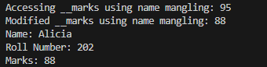

## Q5. Reflection

Answer the following short questions:  
1. Why can’t private members be accessed directly?

Answer: Because private members are name-mangled in Python to avoid accidental modification and to enforce encapsulation

2. What is the purpose of using protected members in class design?

Answer: Protected members allow access within the class and its subclasses, providing a controlled way to allow extension without exposing the attribute to the outside world.

3. How does name mangling help with private members in Python?  
Answer: It prevents accidental access or overrides by internally renaming private attributes with a pattern _ClassName__attribute, thus offering a layer of protection without complete restriction.