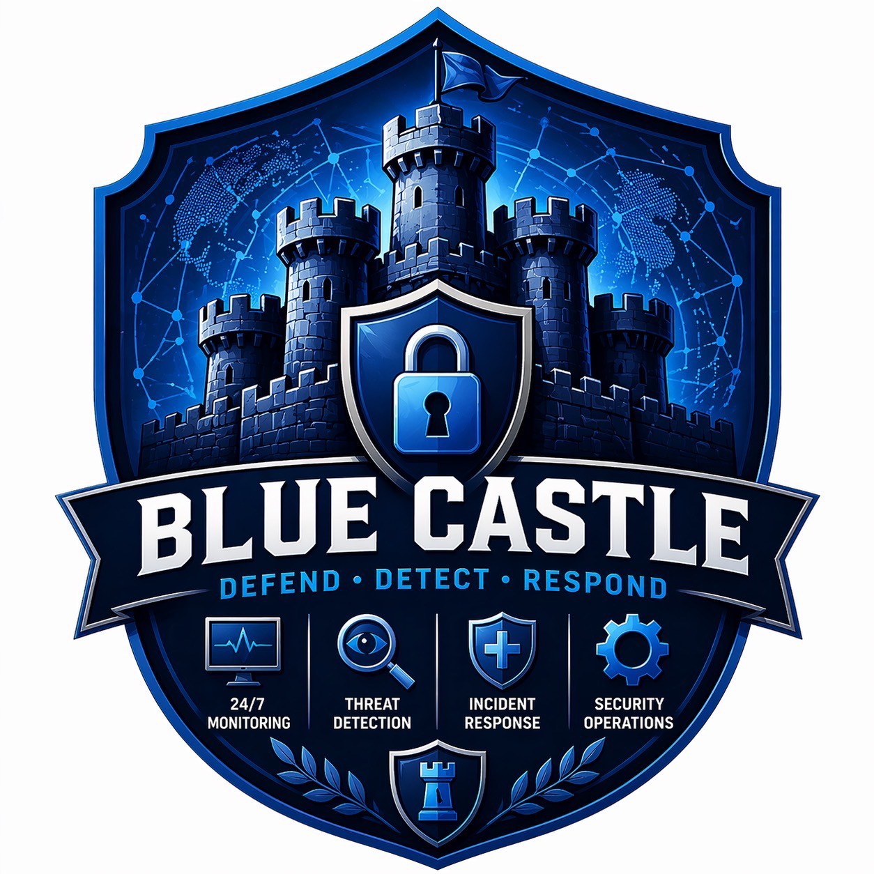
PLAIN-LANGUAGE GUIDE
SOC Ticketing System
Features, roles, and case workflow explained for everyone
Blue Castle Security Operations
Prepared 19 June 2026
Purpose This guide explains what the web application does, who uses each part, and how a report becomes a completed case. No technical background is required.

How to use this guide
Read the first three sections for a quick understanding of the system. The later sections describe each screen and supporting feature in more detail. Menu names are shown exactly as users see them, with English explanations where the menu is in Thai.
In one sentence The system receives security alerts and reports, turns them into trackable cases, sends each case to the right people, and keeps a complete record until the case is closed.

Inside this guide
- 1. What the system helps the organization do
- 2. Who uses the system
- 3. Key words in everyday language
- 4. The complete case journey
- 5. What each menu and screen provides
- 6. Communication, safety, and accountability
- 7. Practical examples and quick reminders
- Appendix: status names translated into plain language

1. What the system helps the organization do
The SOC Ticketing System is a shared workspace for handling possible cyber-security issues. It replaces scattered messages and spreadsheets with one controlled process. Each report receives a ticket number, an owner, a current status, supporting evidence, and a history of every important action.
- Bring automated Wazuh alerts and manually reported concerns into one place.
- Prevent two analysts from unknowingly working on the same new alert.
- Separate harmless Events from actionable Incidents using consistent language.
- Route an Incident to Tier 2, a System Admin, or the SOC Manager at the correct time.
- Track investigation findings, countermeasures, verification, approvals, and closure.
- Highlight urgent cases with an Emergency marker and time-sensitive SLA warnings.
- Give managers a visual overview while limiting every user to the information and actions appropriate to their role.

2. Who uses the system
What a person can see and do depends on their assigned role. This keeps the process clear and protects sensitive case information.
Role | Main responsibility | Typical actions
SOC Tier 1 | Receives new alerts and opens cases. | Claims new work, creates tickets, classifies Event or Incident, selects the route, reviews returned work, and verifies containment.
SOC Tier 2 | Provides a second opinion on escalated tickets. | Reviews and edits ticket information, then either closes it as an Event or confirms an Incident and returns it to Tier 1.
System Admin | Investigates and carries out technical containment. | Sees assigned tickets, records investigation findings and countermeasures, then returns the ticket to Tier 1.
SOC Manager | Performs final verification when required. | Sees tickets routed for manager verification and verifies them for closure.
System Owner | Follows cases affecting their system or department. | Views owned tickets, status and statistics, receives notifications, and can mark visible tickets as Emergency.
Superuser | Maintains the application and supports all roles. | Has system-wide access for administration, support, and exceptional recovery.

Important Users do not choose any action they want. The screen only shows actions allowed for that person's role and the ticket's current stage.

3. Key words in everyday language
Alert: A warning from a monitoring tool such as Wazuh. It is a signal that needs human review, not proof that an attack occurred.
Triage: The first review used to understand what was reported and decide whether a ticket should be created.
Ticket: The official case record. It has a unique number and holds the details, people involved, evidence, status, and history.
Event: Activity that has been reviewed and does not require incident containment. The case can be closed.
Incident: A confirmed or sufficiently credible security issue that requires investigation and action.
Containment: Steps taken to stop the issue from spreading or causing further harm, such as blocking access or isolating a device.
Emergency: A prominent urgent marker. It helps teams filter and prioritize the ticket and sends a contained Incident to manager verification.
SLA: The expected response time. The system measures whether a ticket was raised within four hours of the reported detection time.
IoC: An Indicator of Compromise: a clue such as an IP address, domain, web address, or file fingerprint that may be linked to suspicious activity.

4. The complete case journey
Simple view An alert or report becomes a Tier 1 ticket. An Event closes, while an Incident is investigated and verified. Manager verification is added when required, then the case closes.
- A new item arrives. It may come automatically from Wazuh or be entered manually after a phone call, email, or internal report.
- Tier 1 claims the item. Claiming shows that one analyst is handling it. The analyst can create a ticket or release it back to the queue with a reason.
- Tier 1 creates one complete ticket. The analyst records the general information, affected system, severity, evidence, recommended actions, and the Event/Incident classification on a single page.
- An Event closes. If the activity is an Event, the ticket closes without entering the containment process.
- An Incident is routed. Tier 1 either assigns it directly to a System Admin or sends it to Tier 2 for a second opinion.
- Tier 2 makes one of two decisions. Tier 2 can mark it as an Event and close it, or confirm the Incident and return it to Tier 1. Tier 2 cannot create a new ticket or assign the System Admin.
- Tier 1 sends the Incident to a System Admin. After any Tier 2 review, Tier 1 selects the responsible System Admin and records the review note.
- The System Admin investigates and responds. The admin records findings and countermeasures, then returns the ticket to Tier 1.
- Tier 1 verifies containment. If the issue is not contained, the ticket returns to the System Admin. If it is contained, Tier 1 either closes it or sends it to the SOC Manager, depending on the system's routing rule.
- The SOC Manager closes manager-routed work. Critical or Emergency tickets require this final verification before closure.

Emergency handling
The Emergency marker is visible on ticket details and lists. All roles can use it on tickets they are allowed to see, with one safeguard: a Tier 1 analyst can enable it only after the ticket has been escalated to Tier 2 at least once. The marker can still be changed after a ticket is closed, and every change is recorded.
Manager routing By default, a Critical Incident or any Emergency Incident must be verified by the SOC Manager. Other contained Incidents can be closed by Tier 1 unless the configured severity threshold changes.

5. What each menu and screen provides

Dashboard
The Dashboard gives SOC staff and managers a quick operational picture. It includes:
- Total, active, closed, and recently resolved ticket counts.
- SLA breach counts and a short list of cases needing prompt attention.
- Work waiting for the System Admin, SOC team, or SOC Manager.
- A visual pipeline showing how many tickets are at each stage.
- Event versus Incident proportions, issue types, categories, and a six-month trend.
- Links to recent active tickets for quick follow-up.

Wazuh Triage
This Tier 1 queue receives alerts from the Wazuh monitoring platform. Alerts can be filtered by rule level, which is an indicator of technical seriousness.
- Claim: reserve the alert so other analysts know it is being handled.
- Create Ticket: add a category and note, then continue to the ticket form with useful alert details already filled in.
- Release: return the alert to the shared queue. A reason is required and retained.

Manual Triage
This queue is for reports that did not arrive from Wazuh, such as a phone call, email, user report, or external organization. A new item records its source, reference, description, source IP, and notes. It follows the same Claim, Create Ticket, and reason-required Release pattern as Wazuh Triage.

Escalation Queue
This is the Tier 2 work list. It contains tickets that Tier 1 has classified as Incidents but wants Tier 2 to review. Emergency tickets can be filtered and placed first. Opening a ticket provides editable general information and exactly two decisions: Event and close, or Incident and return to Tier 1.

เปิดเคสใหม่ (Open New Case)
Tier 1 creates the whole case on one page. Sections appear in a natural order, and the final decision area changes according to Event or Incident. The form can preserve an unfinished draft in the user's browser.
- Source alert, detection date and time, reference number, and severity.
- Category, source type, detailed issue, and plain-language case summary.
- Affected device or service, IP and MAC address, asset type, spread, and system owner.
- Suspicious destination and other IoCs, including domains, hashes, and web addresses.
- MITRE ATT&CK phase, which provides a standard way to describe attacker behavior.
- Evidence files, recommended actions, and precautions.
- Event/Incident classification and, for an Incident, the route to System Admin or Tier 2.

Active Incidents
The active ticket list is the main work register. Users can search by ticket number, system, IP address, or description; filter by status, severity, and Emergency; and sort by SLA, urgency, newest, or oldest. Emergency and breached tickets are highlighted.
Role-specific lists: System Admins see assigned tickets, System Owners see their own systems, and SOC Managers see tickets waiting for manager verification. SOC staff have broader operational visibility.

Ticket detail workspace
Opening a ticket brings together the current facts, work history, and role-specific next step. The page can show:
- Severity, current status, Event/Incident classification, and Emergency badge.
- Affected system, addresses, category, description, IoCs, recommended actions, and precautions.
- Investigation findings and countermeasures returned by the System Admin.
- The responsible Tier 1 analyst, System Admin, and System Owner.
- Evidence attachments and a time-stamped audit trail.
- Smaller Investigation or Countermeasure tasks that can be assigned and tracked separately.
- Only the workflow actions that the signed-in person is allowed to perform.

ประวัติ Ticket (Ticket History)
Closed Events and completed Incidents move to Ticket History. Users can search by ticket number and filter by outcome, severity, Emergency, approver, and date range. This provides a dependable record without mixing completed work into the active queue.

ประวัติการ Triage Alert (Triage History)
SOC users can review processed Wazuh alerts by Event or Incident, rule level, analyst, and date. The page shows how long triage took and whether it met the four-hour target. A closed Event alert can be reopened when new information makes another review appropriate.

ค้นหา IOC (Search IoC / Ticket)
A single search can find ticket numbers, IP addresses, suspicious destinations, domains, file fingerprints, descriptions, references, and relevant triage records. This helps staff answer a simple question: 'Have we seen this indicator before?' An IP lookup can also return public network ownership information when the external lookup service is available.

My Tickets
System Owners receive a simplified portal showing only tickets connected to their systems or department. It includes total, active, closed, and SLA-breach counts, plus active and recently closed lists. Owners can filter and sort by Emergency and open a ticket for full details.

Administration
Authorized administrators can manage users, roles, reference data, Wazuh records, and email notification templates through the administration area. Access to this area depends on separate administrative permission.

6. Communication, safety, and accountability

Automatic notifications
- The System Owner can be emailed when a ticket is created and when it closes.
- The assigned System Admin can be emailed when containment work is required or returned for correction.
- The Tier 1 analyst can be emailed when the System Admin submits findings and countermeasures.
- Notification wording can be maintained through editable templates; if sending fails, the on-screen workflow still completes and a warning is shown.

Evidence and attachments
Users can attach screenshots, logs, documents, spreadsheets, archives, and other evidence when creating or updating a ticket. Each file is limited to 25 MB. Downloads require login and permission to see the parent ticket, and files are delivered as downloads rather than opened as active web content.

Audit and sign-off
- Every workflow transition creates a time-stamped log with the person, status, and note.
- Emergency changes are also logged, including the old and new value.
- Tier 1 verification and final approval record who signed off and when.
- Concurrent claim checks reduce duplicate work and prevent one user from acting on another user's claimed item.
- Closed tickets cannot re-enter the normal workflow, although authorized users may still adjust the Emergency marker for record accuracy.

Privacy and access control
A user must sign in. SOC users have operational visibility, while System Admins and System Owners see only tickets assigned or linked to them. The server rechecks permission for every action, even when a button is not shown on the page. Sensitive downloads are protected in the same way.

7. Practical examples and quick reminders

Example A: harmless activity
A Wazuh alert is caused by an approved maintenance job. Tier 1 claims the alert, creates a ticket, records the evidence, classifies it as an Event, and closes the case. The result appears in ticket and triage history.

Example B: confirmed Incident handled directly
Tier 1 receives a credible report, creates an Incident ticket, and assigns the correct System Admin. The admin records findings and countermeasures. Tier 1 verifies that containment worked. A non-Critical, non-Emergency case can then close without manager verification.

Example C: uncertain and urgent case
Tier 1 creates an Incident ticket and sends it to Tier 2. Tier 2 confirms the Incident and returns it. Tier 1 assigns a System Admin and, because the case is urgent, enables Emergency. After containment, Tier 1 must send it to the SOC Manager, who verifies and closes it.

What each user should remember
- Claim new triage work before acting on it.
- Use Release only when work should return to the shared queue, and give a useful reason.
- Classify on the ticket: Event means close; Incident means investigate and contain.
- Write clear notes because they become part of the permanent case record.
- Use Emergency for genuine urgency, not as a general priority shortcut.
- Follow the action shown on screen; the system will route the ticket according to policy.
The system supports judgment; it does not replace it People still decide what the evidence means and what technical response is appropriate. The application makes those decisions visible, controlled, and auditable.

Appendix: status names in plain language
Users normally see translated status labels in the interface. This reference explains the business meaning of each lifecycle stage.
Status shown in the system | Plain-language meaning
New | The ticket has just been created and is being routed.
Escalated to Tier 2 | Tier 2 must review the information and classification.
Waiting for Tier 1 review | Tier 2 confirmed an Incident and returned it for admin assignment.
Waiting for containment | The assigned System Admin must investigate and act.
Containment reported | The System Admin returned findings and countermeasures; Tier 1 must verify.
Waiting for manager | The Incident requires final SOC Manager verification.
Approved / closed | The Incident has completed the required verification and is closed.
Closed Event | The reviewed activity was an Event and required no Incident containment.

Quick feature checklist
- Role-based login and menus
- Automated Wazuh intake and manual intake
- Claim and reason-required release
- Single-page ticket creation with draft recovery
- Event/Incident classification and controlled routing
- Tier 2 second opinion and editable review
- System Admin findings and countermeasures
- Tier 1 and SOC Manager verification
- Emergency badges, controls, filters, sorting, and manager routing
- SLA indicators, dashboards, histories, search, and IP lookup
- Protected evidence attachments and linked subtasks
- Email notifications, audit trail, and recorded sign-offs
- System Owner self-service portal and administration tools

