# בין תיאוריה למעשה, הכנה לאתגרי עולם המחשוב

מגישים: יחזקאל אריאל 315608430

גאולה שלומי 203634696

We will start from my previous knowledge before we start this project. After wefinished are courses in Web Development and Databases and SQL, we had a basic knowledge that include:

Setup Server with Springboot.

Build Basic SPA with react.

basic knowledge in SQL and PLsql.

then run the backend(java):

press the triangle button

To run the frontend (react) follow this command (in the terminal in the root folder of the project):

Cd frontend

Npm install

Npm start

Then go to localhost:3000.

That knowledge was not enough to start this project. We had to learn more about building a REST Api with Spring. In Web development course we built MVC Server that returns HTML pages to the client instead of REST Api that uses CRUD (create, read, update, and delete) operations. To learn more about the technology and best practices we use ChatGPT and Stackoverflow for that.

The first step was to learn what are the best practices to start the project, so we asked ChatGPT.

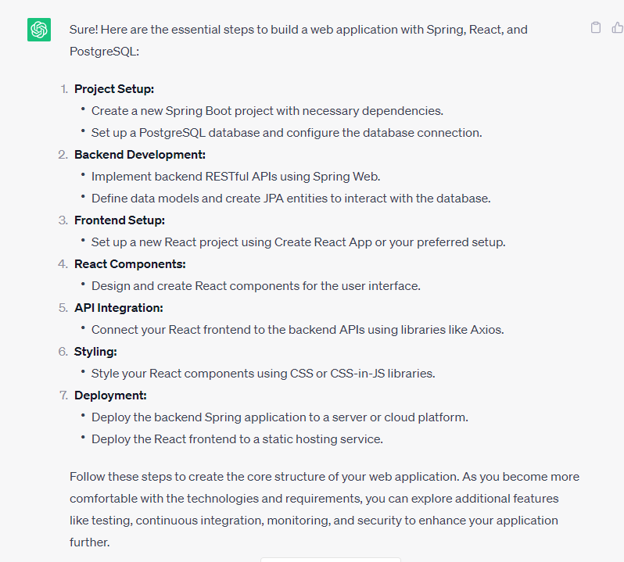

For start we installed PostgreSQL on the computer and run the SQL server. Then to understand the difference between the MySQL server that we used in Web Development course we asked ChatGPT about the differenceA screenshot of a computer

From the answer we understood that the differences are not significant, but the answer does not include information about “hebernate” that we used in the course, so we asked him “Can it work to hebernate?”

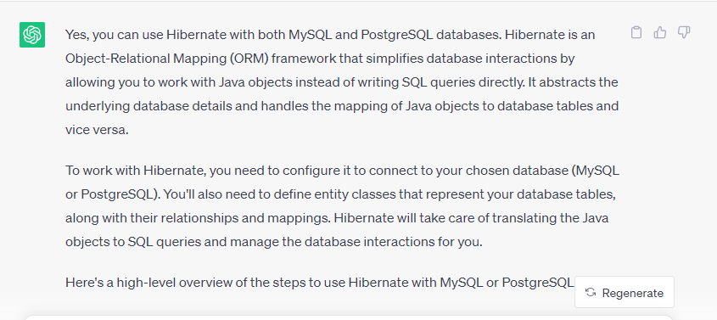

From all the information we got we understood that we have the basic knowledge to start building the API

In the very begging one of our bugs was the Infamous "CORS ERROR”

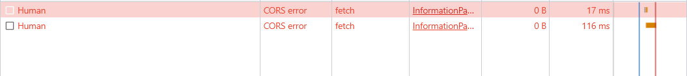

We knew that the solution is simple, but we did not know how to define it in Spring, so we asked ChatGPT.

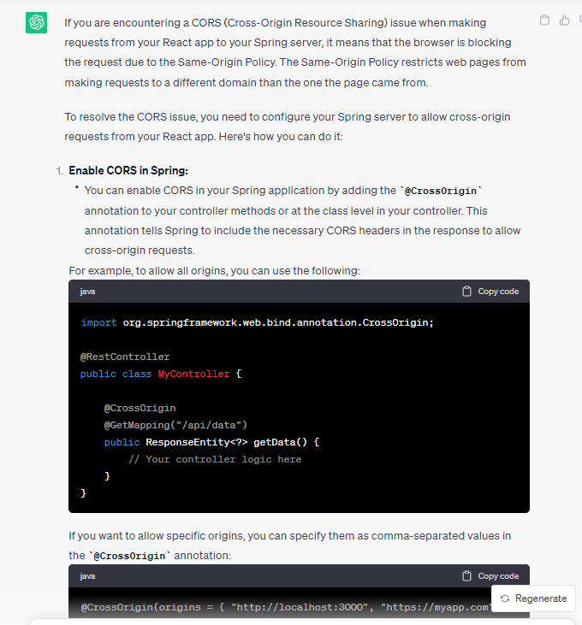

The answer was helpful, and we got rid of this bug.

After building a simple GET metho we thought about what will be the best practice for filtering.

If it better to filter on the server side or client side the answer of ChatGPT was:

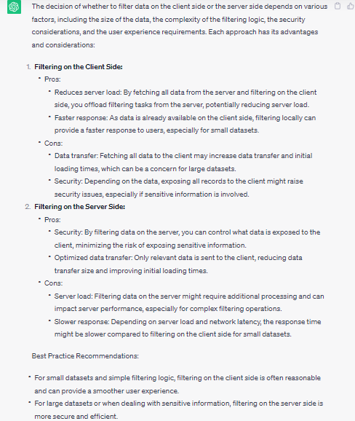

We decided to do it on the client side and start to build the client side and with help from ChatGPT 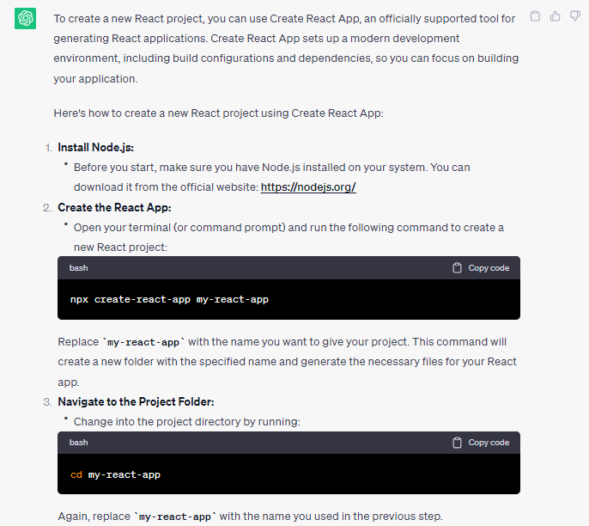

.

Our knowledge was enough to build all the client side, but we had some bugs that we did not handle before for example:

This warning came from a select element in this time we look for the solution in Stackoverflow.

and we found this solution:

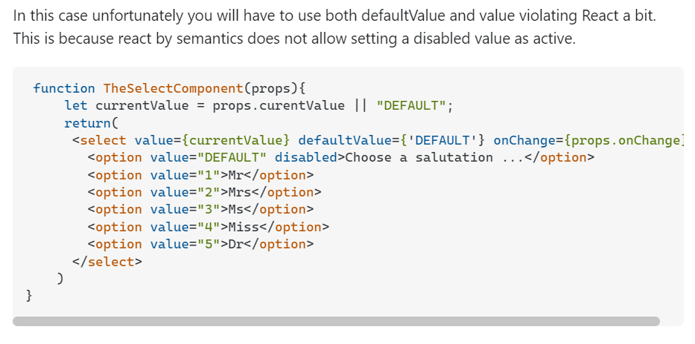

Another bug that we faced with is the method “useEffect” course us an infinite loop of calls.

The solution was to set a specific state for the useEffect.

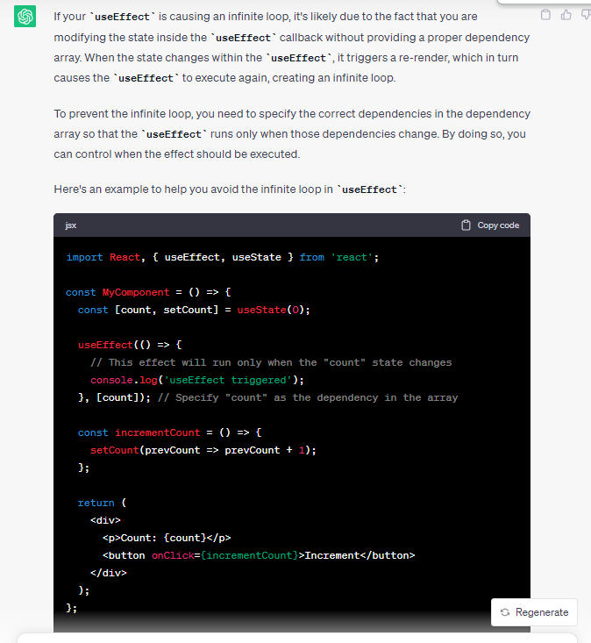

Those were parts of the bugs we decided to elaborate on, because the way we solved them taught us new ways to solve problems in software development and can help you to solve your problems.

Conclusions

ChatGPT has been an asset in web application development. Its guidance, code snippets, and insights have accelerated the process, improved documentation, and facilitated decision-making.

Integrating ChatGPT into the web development process has proven to be a valuable and empowering experience. By leveraging the capabilities of ChatGPT, developers can unlock new opportunities for creativity and innovation in building web applications. However, it is essential to acknowledge that AI models are not a replacement for human expertise and judgment but rather a powerful tool to complement and augment the development process.

but it's essential to remember that human expertise remains crucial in the development journey.