Where a UML Association Loses Half Its Meaning
Full case materials, both XMI export variants and all six figures at full resolution, are published at gevorgbaradat.github.io/k5-framework - open to check against, not just to look at.
A UML association carries two directions, and they belong to different layers.
Navigation is structural. It says which element knows about the other inside the model: from which end you can reach the other. It is a fact about how the model is built.
Name reading direction is semantic. It says how the relationship is to be read and understood: in which direction its meaning is to be interpreted. It is not a fact about the model's internals. It is the model's instruction to whoever reads it.
The two are independent. A model may set either, both, or neither. This piece follows the second one, from the diagram where it carries meaning down to the storage where it is supposed to live, and shows where it stops.
This piece is also a specimen of a method, and it is worth saying so before the case itself starts. K5 does not invent its own diagramming notation from nothing. It integrates existing, popular modelling frameworks one at a time, and customises only where the native framework leaves a conceptual gap that K5's own purposes require closed. What follows works through that process for exactly one framework - the UML class diagram - end to end, using one small, precisely diagnosed defect as the vehicle. The metamodel in §3 is the result of that customisation: not UML transcribed, but the class-diagram fragment of UML extended at the one place standard UML leaves ungoverned.
The defect is small. The anatomy is unusually clear.

1. A fragment of a domain model
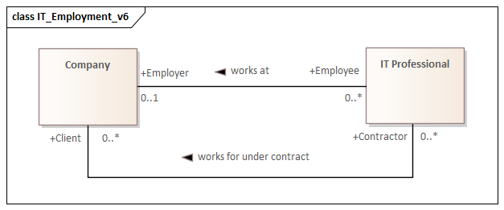
Figure 1. IT_Employment_v6. Values are real, taken from a working model.
View this diagram online →
This is not an illustration of UML syntax. It is a fragment of a domain knowledge model: a claim about how employment works in the domain being described. There are two associations here, because the same pair of classes stands in two different relationships, employment and contracting, each with its own roles and its own reading. The first one is enough to make the argument. The second behaves identically throughout.
Read the first one in formal text and the claim becomes explicit:
An IT Professional, in the role of Employee, works at zero or one Company, which stands in the role of Employer. A Company may have zero or more IT Professionals in that role.
Now notice what fixed the word order. Not the geometry of the diagram, not which class sits on the left. It was the small marker on the association name: the only element on the diagram that says which of the two classes opens the sentence.
One more thing needs stating about Figure 1 itself, because §4 leans on it directly: nothing here is hidden, simplified, or chosen for the reader’s convenience. Every element the model contains is on the diagram, and nothing is on the diagram that the model does not contain.
2. The same model, one marker reversed
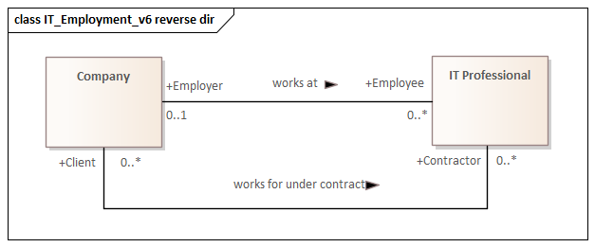
Figure 2. IT_Employment_v6 reverse dir. Identical to Figure 1 in every element: same classes, same association names, same roles, same multiplicities, same navigation. Only the name markers are reversed.
View this diagram online →
Read it the same way and the model now says:
A Company works at an IT Professional.
Which is false. Not stylistically awkward: wrong about the world.
Nothing changed except the direction in which the name is to be interpreted, and the model went from a true statement to a false one. Whatever that marker is, it carries truth value.
There is a third state worth naming, though it needs no figure: the marker can be absent. Then the model says there is a named relationship here and declines to say how to read it. That refusal is itself information. It tells the reader, human or machine, that this part of the model is undecided rather than decided one way: a stated absence, not a silent one. A reader that cannot tell the two apart will eventually report certainty it does not have.
So the marker distinguishes three positions: this is true, the opposite is true, this is not yet settled.
3. What the metamodel says the marker is
Before claiming that a marker carries truth value, it helps to be precise about what kind of thing it is.
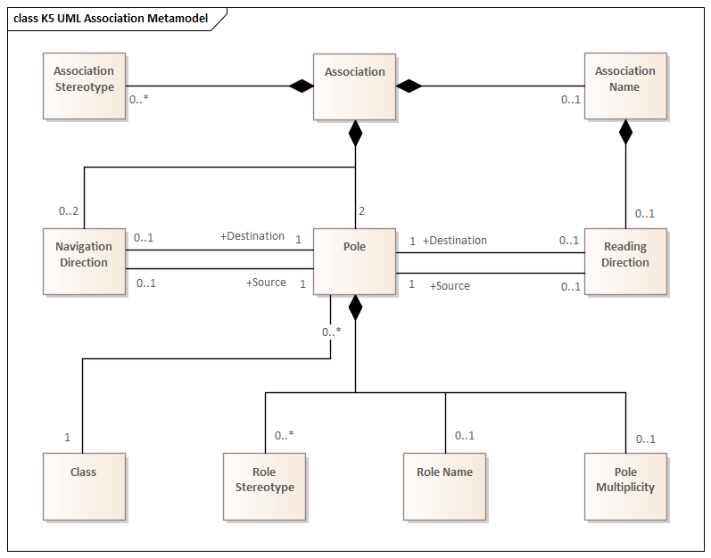
Figure 3. K5 UML Association Metamodel. Two things here are not obvious at a glance. First, Pole is the association end as a first-class element: it owns the class reference, the role name, the role stereotype, and the multiplicity. Second, Navigation Direction and Reading Direction are separate elements, each pointing at Poles as Source and Destination, and they are owned by different parents.
View this diagram online →
This is the customisation named in the opening: standard UML leaves the reading direction ungoverned as model content (§4 sets out exactly how loosely), so K5 gives it an explicit home in the metamodel instead of leaving it to travel as an informal drawing convention.
The ownership chain is the point. Navigation Direction is owned by the Association. Reading Direction is owned by the Association Name, which is in turn owned by the Association.
That difference is not arbitrary. Navigation is a property of the relationship itself, so it hangs off the relationship. Reading direction is a property of the relationship's name, because a name is the thing that gets read, and reading has a direction only if there is something to read.
The multiplicities say the same thing more precisely. An Association owns up to two Navigation Directions, because each end can be made navigable independently: that is where the four states come from. An Association Name owns at most one Reading Direction, because a name cannot be read both ways at once: that is where the three states come from. The asymmetry claimed at the top of this piece is not an observation about practice. It is written into the metamodel.
Either way, both are model content. Neither is a diagram annotation, within this metamodel. §4 turns to what the wider UML specification itself has actually committed to on that boundary, which is less than this metamodel assumes at first glance.
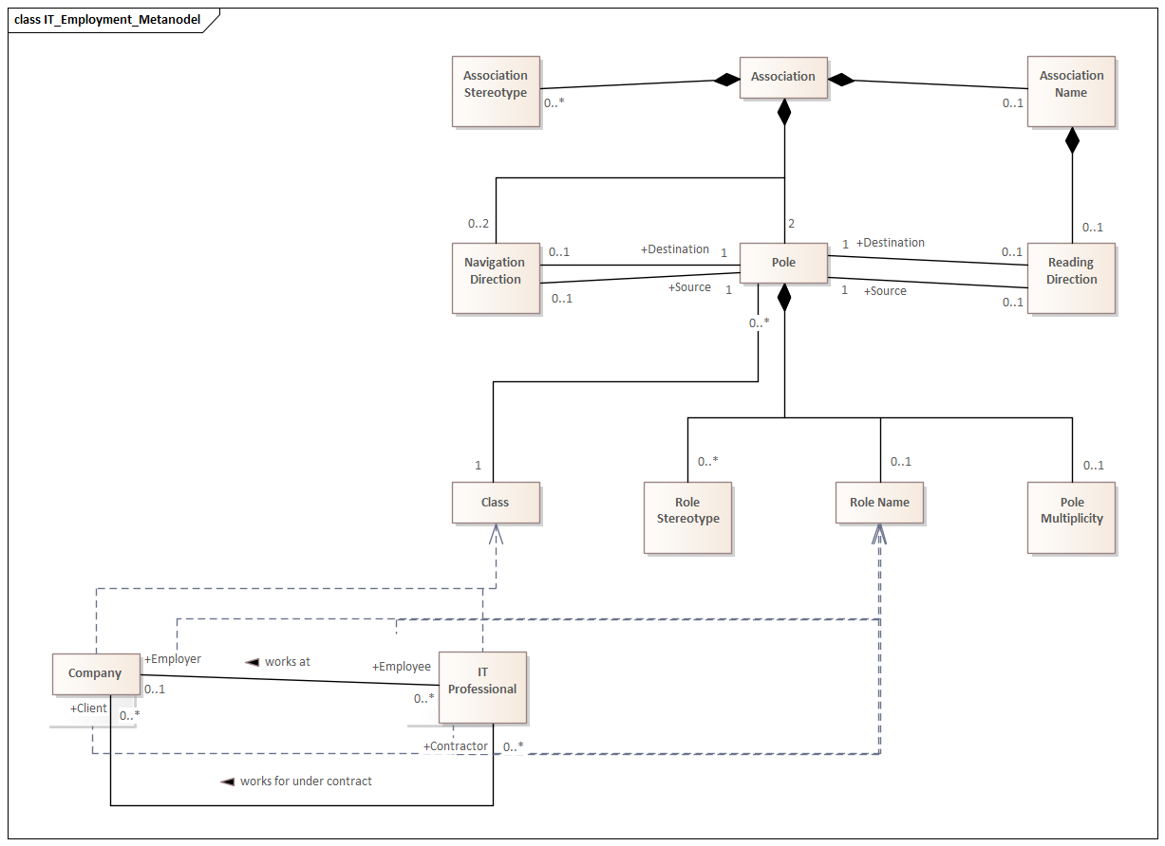
Figure 4. IT_Employment_Metamodel. The domain fragment from Figure 1 traced to the metamodel above it: classes to Class, role names to Role Name. The metamodel is shown in full here for context, but only the traced portion carries the argument.
View this diagram online →
Figure 4 closes the chain. Every element on the domain diagram is an instance of something the metamodel defines, including the marker. Losing the marker is therefore losing model content, not formatting: content relative to the K5 metamodel this article uses. Whether the OMG's own metamodel agrees is a separate question, and §4 takes it up directly, before the storage layer in §5 shows the consequence.
4. Model, diagram, and the layers in between
K5’s treatment of this case rests on a distinction that this section states explicitly, because the rest of the argument depends on it: a model and a diagram are not the same kind of thing, and a diagram earns its content only by being a faithful projection of a model that exists independently of it. The closing remark to Figure 1 already put this to work: nothing on that diagram is curated, so reading the diagram and reading the model come to the same thing. That equivalence had to be earned by construction, not assumed, and it is what makes Figure 1 usable as evidence for a claim about the model rather than merely about one picture of it.
The UML ecosystem itself has held this distinction unevenly. The interchange format UML has relied on since its earliest XMI based tooling carried model elements, classes, associations, their properties, but not how those elements are laid out and drawn on a diagram. That gap is documented in the literature responding to the OMG's own Diagram Interchange RFP: a second, separate specification whose entire purpose was letting a diagram's visual content travel alongside the model it depicts, since the base export format had never carried it in the first place. That specification, published years after the base metamodel, was never widely adopted. A successor effort, Diagram Definition, exists specifically to address its shortcomings. None of this is minor. The model/diagram boundary this article leans on is one K5 states cleanly and enforces by construction, not one UML's own tooling ecosystem has ever reliably enforced for its users, across decades of its own standardisation history.
The reason to insist on the boundary, rather than treat it as a nicety, is K5’s own governing principle for how meaning moves between layers: an element’s meaning is grounded by the layer beneath it, the layer that defines what the element is before anything built on top of it can use it. The metamodel in Figure 3 grounds the model in Figure 1: it settles what an Association, a Pole, a Reading Direction are, before the model can assert that a particular one exists between Company and IT Professional. The model, in turn, grounds everything drawn from it. The diagram is what the model looks like once projected onto a canvas, not a second, independent source of content standing beside it. Lose sight of that ordering and a diagram starts to look like something that can hold content the model itself does not, which is exactly the crack this article’s defect climbs through.
That ordering does not stop at the diagram. What actually exists once a diagram is drawn in Sparx is not one thing but a small family of realisations, and naming all of them matters, because §5 and §6 depend on knowing which is which.
Internal. t_diagram holds the diagram itself. t_diagramobjects places each model element on it, with position and size. t_diagramlinks records how each connector is drawn, including, as §5 shows, the one field that should never have ended up there. None of this is reachable except through Sparx’s own interface, or its database directly. It is not an export. It is the tool’s live internal state.
External. From that internal state, Sparx can produce several genuinely different artefacts, and they are not interchangeable. A rasterised export, PNG or similar, freezes the picture and nothing else. Sparx's native SVG export keeps the picture as vector shapes: still a picture, not a model. The custom SVG export built for this project's companion work (§6) goes further: every shape carries the model content behind it as browsable metadata, so the file is a picture that also knows what it is a picture of. Two further formats move whole packages between Sparx projects rather than single diagrams: a native project-export format, and an extended XMI that carries not only the model but the diagrams and the object-browser structure alongside it, while still keeping, inside itself, the plain XMI core that any conformant third-party tool can read, ignoring the Sparx specific sections it does not recognise.
Five artefacts, one diagram, and only the first of them, the internal state, is where this article’s defect was actually found. Everything downstream inherits whatever that internal state got wrong, which is exactly why the defect is invisible on the diagram itself (Figure 1 renders correctly) and only shows up once something reads past it.
One methodological note belongs here rather than at the end. Every diagram in this article, and every diagram behind the K5 materials it draws on, was built in Sparx itself. Across this piece, the tool is not only the object under examination. It is also the instrument that made the examination possible. §6 returns to that pairing directly.

5. Where the model actually lives
Sparx Enterprise Architect stores its models in a relational database, and it helps to look at how the two directions are implemented there, because they are implemented very differently.
The two diagrams that follow are placed on landscape pages so the table detail stays legible.
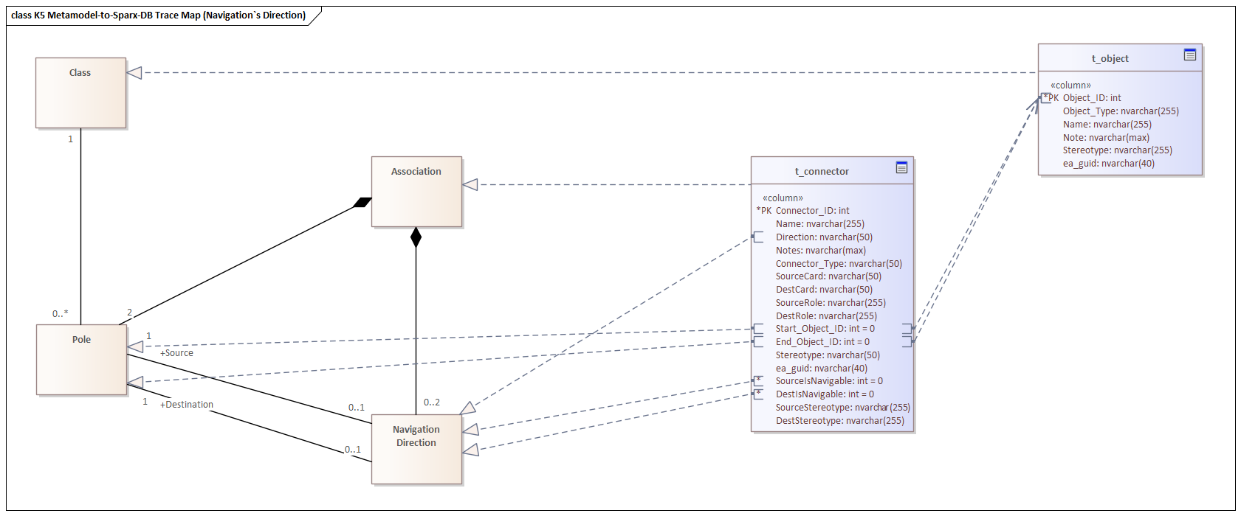
Figure 5. K5 Metamodel-to-Sparx-DB Trace Map (Navigation's Direction). Each metamodel element sits beside the field that realizes it, so the tables and the metamodel line up one to one.
View this diagram online →
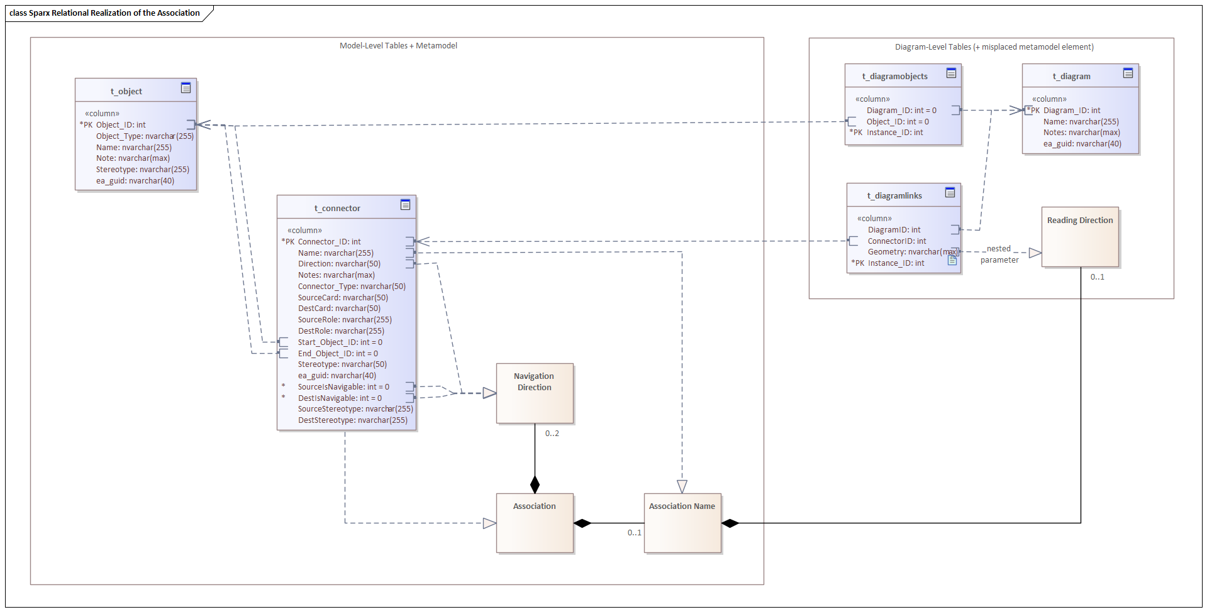
Figure 6. Sparx Relational Realization of the Association. The full picture, in two frames. The finding of this article is stated in the caption of the right hand frame.
View this diagram online →
Navigation is handled correctly. It lands among the model-level tables, together with the connector, the ends, the roles, the multiplicities and the association name. Everything there belongs at the model level by right: these are facts about the model itself, the same across every diagram that shows the association. This is the tool-neutral core, what should outlive the tool and open without it.
The left frame is the model level, as above. The right frame holds the diagram-level tables named in §4: the ones that store a diagram as a projection, a view onto part of the model rather than the model itself. Each row there is tied to one diagram. Layout, geometry, label placement and visibility live there, and may legitimately differ from one diagram to the next.
Those tables belong at the diagram level by right. That is genuinely how a diagram-as-projection is stored, and there is nothing wrong with it.
What marks the boundary is not the tables. It is the one metamodel element that landed among them: the reading direction of the association name.
It is stored not as model content but as one parameter inside a larger set of settings describing how the association's name is displayed on a diagram: its position, its offsets, its appearance. The direction of interpretation was filed with the formatting.
But reading direction is part of the statement the association makes. Section 2 showed exactly that: reverse it and the model asserts something false. So its metamodel element should belong among the model-level tables, beside the name it qualifies - and does not. A model-level concept, realised at the projection level, is precisely where UML's own boundary between notation and model semantics lands inside Sparx: not a defect Sparx introduced, but one it inherited and has implemented faithfully. Peter Lieber, at Sparx, confirms the principle directly: UML itself defines reading direction as notation, not model semantics, so what follows is best read throughout as an inherited UML and interoperability boundary, not an architectural fault of the tool.
Two consequences follow, and the second is worse.
The interpretation does not survive leaving the tool. Export the model to an interchange format, a graph pipeline, a query channel, and the association arrives with its classes, roles, multiplicities and navigation intact, and with no indication of how its name is to be read. Figures 1 and 2, which assert opposite things about the world, arrive identical.
The interpretation is not even a property of the association. It is a property of one projection of it. The same association placed on a second diagram may carry a different reading direction, or none at all, and copying it to a new diagram does not bring the marker along. So a model can assert one reading on one diagram and no reading on another, and nothing will register that as an inconsistency, because there is no single place where the two assertions would meet.
An element the K5 metamodel defines as belonging to the association's name is implemented as belonging to a picture of it.
The specific mechanism behind that inherited boundary is worth stating rather than smoothed over. The reading direction triangle appears in the UML specification's Notation clause, not in its abstract syntax: navigableOwnedEnd and memberEnd are metamodel properties, and metamodel properties are what an interchange file serializes. Reading direction, as far as this reading of the specification goes, is not a metamodel property in standard UML, which would mean a conformant XMI export has, strictly, nowhere to put it, and §4's history of Diagram Interchange is the same split one level up: UML's own tooling has never firmly agreed that model content and notation travel together. (This specific reading of the abstract syntax has not been checked line by line against the OMG text. The general principle behind it, that UML treats reading direction as notation rather than model semantics, does not rest on that reading alone: it is confirmed independently by Sparx itself, not merely inferred here.) Two mechanisms already exist for content of exactly this kind, tool-specific or notation-only, without waiting for a metamodel change anywhere: XMI's own xmi:Extension block, and the separate UML Diagram Interchange specification named in §4, which is the standard's own home for notation. Either would let a tool keep the marker as model content today.

6. In defence of the tool
A word is owed to Sparx at this point, because the preceding section reads as an indictment and it is not meant as one.
Every system of this size carries rough edges, inherited ones included. What separates tools is not the absence of them but what they let you do about them. Very few let you trace an inherited boundary this precisely, and fewer still let you then document it, at this level of detail, using the tool itself. Every figure in this article was made in Sparx: the domain fragment, the metamodel, the traceability from one to the other, the database structure, and the two frames that state the finding. The tool documented this inherited boundary in its own data, the same instrument and object pairing named in §4.
Two capabilities make that possible, and neither is common.
Direct SQL access to the model store. The model is not sealed behind an interface that decides in advance which questions may be asked. You can go into the database and perform data analysis on the model itself: query it, aggregate across it, compare states of it, find things nobody thought to expose. This article exists because of that. The boundary is invisible from the interface and obvious from a query.
Breadth of notation, and what that breadth permits. Sparx does not merely support many visual modelling standards. What looks like a diagramming trick is not one: the traceability connectors joining elements across notations are full relationships at the level of Sparx's own internal, consolidated model, where separately built models in different notations and modelling frameworks are linked to each other as model content, not as diagram decoration. Showing that on a diagram, elements from entirely different standards sitting on one canvas, connected, is simply the same model-to-diagram projection this piece has been tracing throughout, applied to cross-framework traceability instead of to one association. Figure 6 is exactly that: metamodel classes and database tables on the same canvas, joined, because the underlying model already holds the connection, not because the diagram invented it. Most tools would demand two diagrams, two files, and a human holding the correspondence in their head.
The second capability is what produced the problem described above. Coverage that wide, accumulated across decades of standards that were never designed to fit together, leads inevitably to seams: places where two notations, or a notation and its storage, do not quite line up, and the modeller has to work around them or customise past them. That is the price of the coverage, and it is a real price. It is being paid for something: there is still nothing on the market that matches this range of functional capability.
7. A path that does not require fixing Sparx, or UML
Sections 5 and 6 describe where the interpretation is lost and why the tool is not to be blamed lightly for losing it. This section describes how a modeller can stop losing it today, inside Enterprise Architect, without waiting for either Sparx or the OMG to change anything.
The simplest step is a Tagged Value on the connector itself, readingDirection = SourceToTarget, or the reverse, set once, at the model level. That alone moves the interpretation into the model: it becomes visible to EA’s own API, to SQL queries against the model store, to XMI and other exports, and to graph pipelines and AI-based model analysis downstream. The diagram marker can stay exactly where it is, purely visual, no longer the only place the fact lives.
A more disciplined version defines the same thing through an MDG profile: a stereotype such as «semanticAssociation» carrying a readingDirection property. This is cleaner than an informal tag, because it makes the semantic extension explicit, a declared addition to standard UML, rather than an implicit change to what an ordinary association is taken to mean. It also travels well: the extended project-export format described in §4 already carries tool-specific content between Sparx projects without disturbing the plain XMI core underneath it, exactly the channel a tagged value or a stereotype property needs. No new mechanism has to be invented for it.
Either way, the direction of synchronisation matters. The model-level property should be the single source of truth, with a small Add-In keeping the diagram marker consistent with it on every diagram where the connector appears: model semantics flowing to diagram representation, not the reverse, and not an informal convention a modeller has to remember to maintain by hand across every diagram a connector happens to land on.
None of this resolves the standards question raised in §5: whether UML's own abstract syntax should carry a reading-direction property at all. That is a question for the OMG, not for a single tool's users. It removes the practical cost of the gap identified above immediately, and without a single change to the Sparx schema.
8. Why this is worth more than a bug report
It is a clean instance of a general failure. Meaning that ends up in the presentation layer survives only as long as the presentation does. Every export is a lossy channel for it. The model outlives the tool; what was stored in the drawing does not. Whether the layer that lost it first is a specific tool’s database or the specification the tool implements does not change this consequence. It only changes who is best placed to fix it.
It is invisible from inside the tool. Open the diagram and the marker is there, doing its job perfectly. The loss appears only when something other than the diagram reads the model: another tool, a graph pipeline, an AI agent. That is precisely the class of defect that matters more now than it did five years ago, because the number of non-human readers of enterprise models has risen sharply.
It generalises beyond UML. I have since found the same duality in a place with no UML in sight: the vertical dependency relations of a five-level knowledge framework I have been building. The dependency has one unambiguous structural direction, upper level to lower, because the need for grounding originates above. But the name of that dependency reads in two legitimate directions depending on which end is the subject: this element is understood in the context of that one, reading down along the dependency, or this element grounds that one, reading up against it. One relationship, two valid readings, and only one of them is asserted at a time.
The phenomenon is not an artefact of a notation or of one vendor's schema. Any directed relation between meanings has both a structural direction and an interpretive one, and any store that keeps the first while dropping the second keeps half of what was said.
A closing note on where this came from
The metamodel in Figure 3 is not a neutral transcription of the UML specification. It is a fragment of K5, the five-level knowledge modelling framework mentioned above, turned on UML itself. And the distinction this whole piece rests on, between a structural direction and an interpretive one, was not something I first noticed in a tool and then generalised. It came the other way round. K5 formalises semantic context as a structural grounding dependency between modelling levels, and it was that formalisation which made the missing element visible in the first place.
So this analysis is at once an application of the framework and a specimen of it: the defect was found by looking at a tool through K5, and what turned up was one more instance of the very relation K5 is built on. That symmetry is worth noting rather than leaning on. One instance, found by looking for it with a framework built to expect it, is a reason to keep watching for others, not yet a demonstration that they are everywhere.
The full case materials, both XMI export variants and all six figures at full resolution, are published at gevorgbaradat.github.io/k5-framework - open to check against, not just to look at.
A companion piece with the full technical detail, including the storage format, the exact encoding, and a normalised schema that would hold both directions correctly, is in preparation and will be published separately.

