Table of Contents

# 1 GFA_Renamer: Utility for renaming consecutive image files based on a set of names

This  is a small utility script written for my internship.  
While I have tested it extensively and can try to maintain it if users require, understand that there are things which will fall outside the scope of this program.

Simply drag a folder containing ordered image files onto the GUI and follow the Instructions.

## 1.1 THE GUI

Below you can see an overview on the two main GUIs:

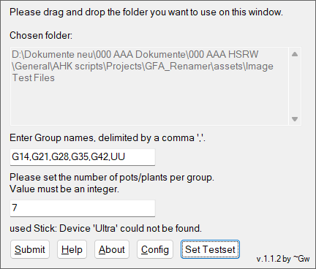

Main GUI Overview

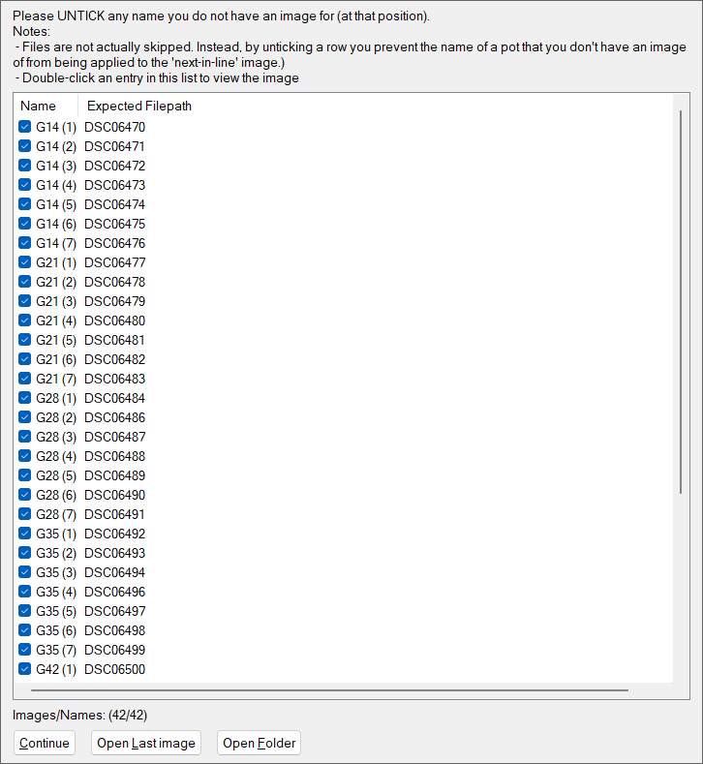

Plant-Name Exclusion GUI: Use this to untick NAMES which do not line up with the expected File. Double-click an image to open the image file itself - do so ify ou want to verify the files being named correctly

Plant-Name Exclusion GUI: Use this to untick NAMES which do not line up with the expected File. Double-click an image to open the image file itself - do so ify ou want to verify the files being named correctly

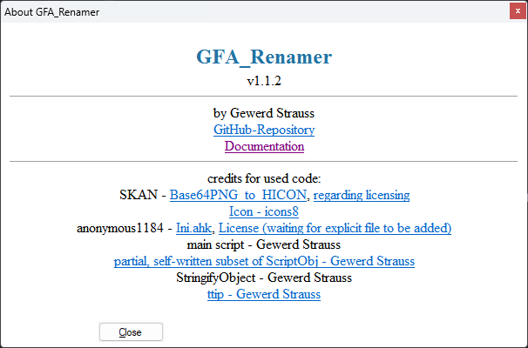

About-Window containing links to the Github-Repository, its documentation, as well as links to all code credited to others - and their licensing requirements, if applicable.

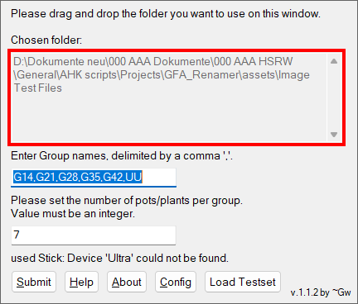

Field outlining the folder which the script operates upon. This also delimites the area upon which the user should drop the folder for selecting it.

Then enter the required group names and number of pots per group and confirm your choices.

The image files in that folder will then be duplicated into a subfolder GFAR_WD, wherein they will be renamed according to the information provided.

The script additionally provides a log file stating

1. The number of expected files
2. The number of renamed files, and
3. For every file its original and new filename.

The original files will never be altered directly as a precaution. It is the user’s responsibility to decide to delete the original backup files.

## 1.2 How to deal with missing images / NEW

## 1.3 How to deal with missing images / DEPRECATED

OUTDATED - WAIT FOR UPDATE

In cases where a certain group has fewer images than the other - as could be the case if you loose a single pot at some point due to damage - simply select the image of the **NEXT** pot and create a copy by pressing Duplicate to shift frame.

If we assume that the image for G14D2 is missing *initially*, aka in the image above the file DSC06472 actually contains the image of G14D3, select DSC06472 and press on Duplicate to shift frame.

The result will look something like this:

Example:

You have a group of plants which get watered at half the normal volume for 14 days, and every group has 7 pots.

The pot G14D4 (14 Days at reduced water supply, then back up to normal) was removed because it got dropped a day before.

In this case, all groups have seven images, but the G14-Group only has six. Thus, imagine you have the following images to work with:

| Number | Filename | plant label |
| --- | --- | --- |
| 1 | DSC10111.JPG | G14D1 |
| 2 | DSC10112.JPG | G14D2 |
| 3 | DSC10113.JPG | G14D3 |
| 4 | DSC10114.JPG | G14D5 |
| 5 | DSC10115.JPG | G14D6 |
| 6 | DSC10116.JPG | G14D7 |

In this example, DSC10111-DSC10113 are G14D1-G14D3,and DSC10114-DSC10116 are G14D5-G14D7. Thus, the image for G14D5 is missing. If you just run the program, you would falsely rename all files beyond DSC10113 because there would be a frame shift.

To prevent this, create a copy of DSC10113 - it is important thaqt you copy the image of the pot *immediately before the one that is missing*:

| Number | Filename | plant label |
| --- | --- | --- |
| 1 | DSC10111.JPG | G14D1 |
| 2 | DSC10112.JPG | G14D2 |
| 3 | DSC10113.JPG | G14D3 |
| 4 | DSC10113 - Copy.JPG | Placeholder for the missing G14D4 |
| 5 | DSC10114.JPG | G14D5 |
| 6 | DSC10115.JPG | G14D6 |
| 7 | DSC10116.JPG | G14D7 |

Because the script will read images in the folder based on their name, this method ensures the gap is filled appropriately.

This repository contains a sample set in the folder assets\Image Test Files. It contains the raw images, as well as the resulting output in the subfolder GFAR_WD. To use the test-set, use the button Set Testset. A message will pop up notifying you if the testset is loaded.  
*Note that if the testset folder does no longer exist, the program will attempt to download it from the program’s github repository. Be aware that this may be blocked by Firewalls, computer settings or a lack of internet connection.*

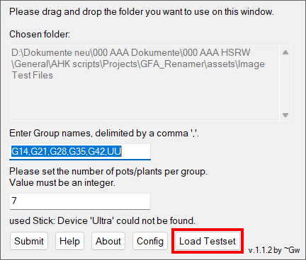

Press this button to load the included testset. This is intended for debugging only; the resulting output files will be deleted at each