我安装的版本：

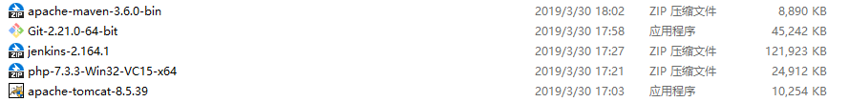

1. ~~首先，安装jdk，git和maven~~

~~Maven安装方法~~[~~https://www.cnblogs.com/liuhongfeng/p/5057827.html~~](https://www.cnblogs.com/liuhongfeng/p/5057827.html)

1. **开始配置tomcat**

安装tomcat8.5，安装时注意：端口8080和jenkins冲突，换一个端口，下面的用户名和密码需要填一下并记住

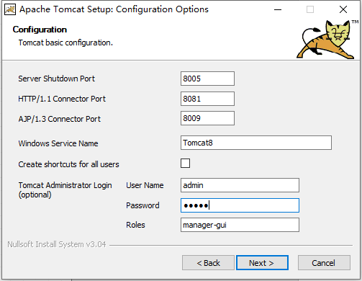

安装完成后等服务启动，访问localhost:8081，出现下面的页面说明成功了：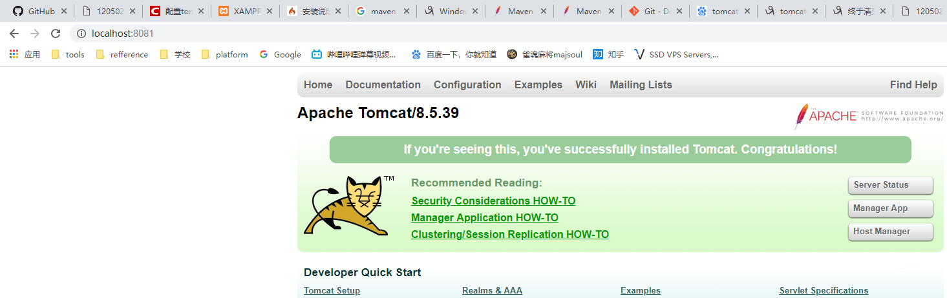

1. **开始配置php**

解压php，并把文件夹拷贝到tomcat中

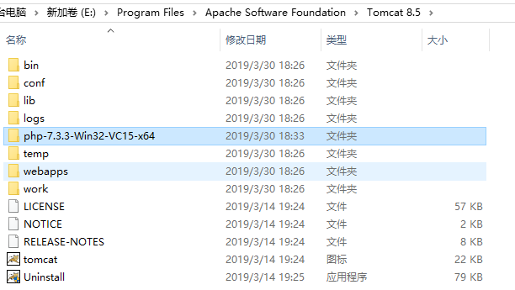

找到里面的php.ini-development，复制一份改成php.ini，打开并找到里面的下面一段配置，改成：（注意分号）

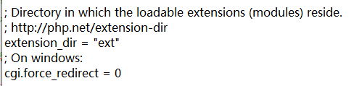

找到tomcat/conf/context.xml，改成：

<?xml version="1.0" encoding="UTF-8"?>

<!--

Licensed to the Apache Software Foundation (ASF) under one or more

contributor license agreements. See the NOTICE file distributed with

this work for additional information regarding copyright ownership.

The ASF licenses this file to You under the Apache License, Version 2.0

(the "License"); you may not use this file except in compliance with

the License. You may obtain a copy of the License at

http://www.apache.org/licenses/LICENSE-2.0

Unless required by applicable law or agreed to in writing, software

distributed under the License is distributed on an "AS IS" BASIS,

WITHOUT WARRANTIES OR CONDITIONS OF ANY KIND, either express or implied.

See the License for the specific language governing permissions and

limitations under the License.

-->

<!-- The contents of this file will be loaded for each web application -->

<Context privileged="true">

<!-- Default set of monitored resources. If one of these changes, the -->

<!-- web application will be reloaded. -->

<WatchedResource>WEB-INF/web.xml</WatchedResource>

<WatchedResource>WEB-INF/tomcat-web.xml</WatchedResource>

<WatchedResource>${catalina.base}/conf/web.xml</WatchedResource>

<!-- Uncomment this to disable session persistence across Tomcat restarts -->

<!--

<Manager pathname="" />

-->

</Context>

打开conf下的web.xml，添加下面的servlet：

<servlet>

<servlet-name>php</servlet-name>

<servlet-class>org.apache.catalina.servlets.CGIServlet</servlet-class>

<init-param>

<param-name>clientInputTimeout</param-name>

<param-value>200</param-value>

</init-param>

<init-param>

<param-name>debug</param-name>

<param-value>0</param-value>

</init-param>

<init-param>

<param-name>executable</param-name>

<!--php下载解压/安装的路径-->

<param-value>E:\Program Files\Apache Software Foundation\Tomcat 8.5\php-7.3.3-Win32-VC15-x64\php-cgi.exe</param-value>

</init-param>

<init-param>

<param-name>passShellEnvironment</param-name>

<param-value>true</param-value>

</init-param>

<init-param>

<param-name>cgiPathPrefix</param-name>

<param-value></param-value>

</init-param>

<load-on-startup>5</load-on-startup>

</servlet>

<servlet-mapping>

<servlet-name>php</servlet-name>

<url-pattern>/*</url-pattern>

</servlet-mapping>

打开webapps\ROOT，新建一个index.php，填写<?php phpinfo()?>保存

访问localhost:8081/index.php，看到下面的页面说明配置成功

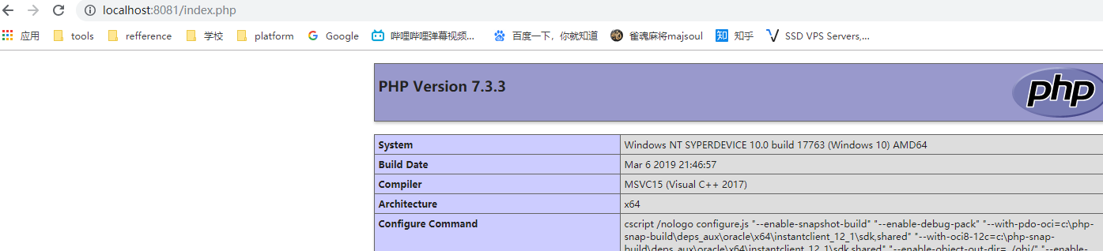

1. **配置jenkins项目**

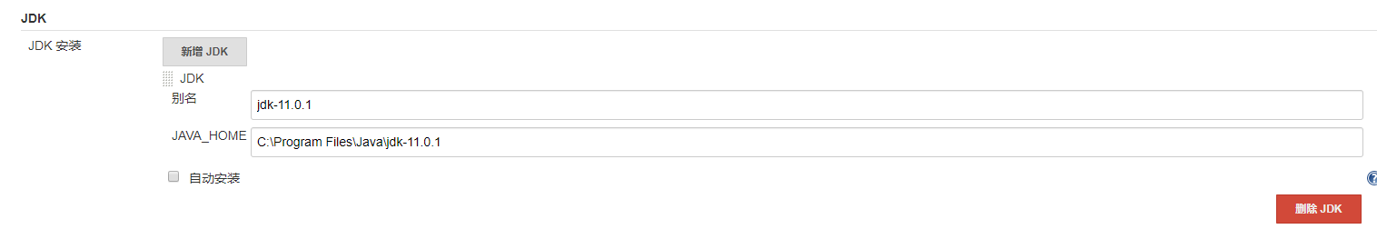打开jenkins，进入配置-全局工具配置，填写jdk，git，maven，保存并应用

1. 在插件管理里安装这个插件

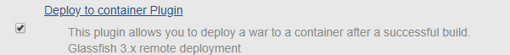

1. 新建一个项目填写以下属性：

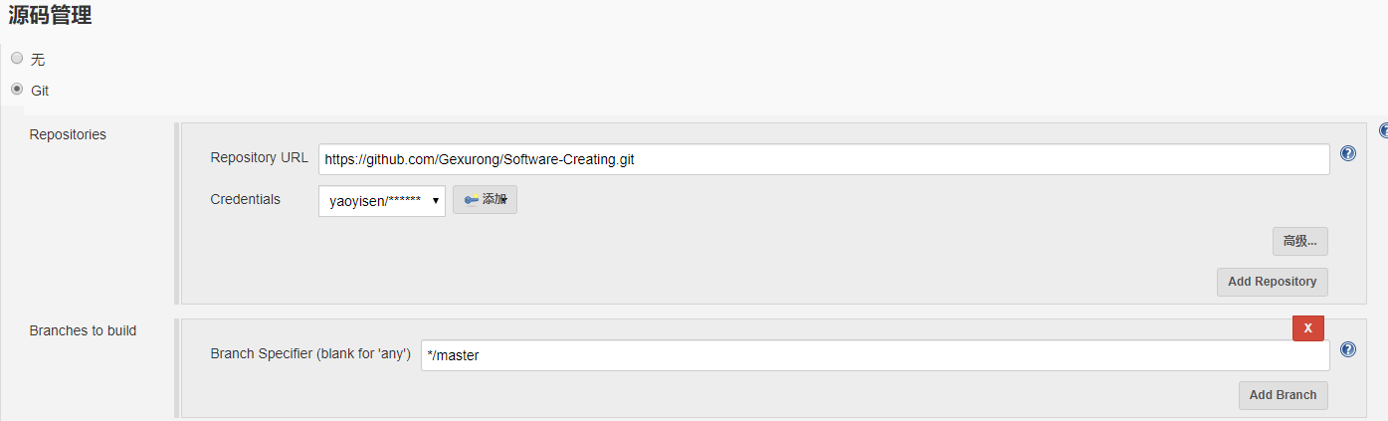

证书填自己的GitHub用户名和密码

保存后点击立即构建就可以pull下来代码

Jenkins默认workspace：C:\Users\用户名\.jenkins

1. **~~Jenkins直接发布（我没成功，手动copy到tomcat文件夹下吧）~~**

~~填写构建后操作：~~

~~

