Website

**Strategies Implemented:**

* We use Google Trends to increase everyday traffic to our website by highlighting hot news. These trends are updated every  day Based on 3 categories of news selection which is four hours, twenty-four hours, and forty-eight hours, and they are displayed in our trending news area on three slides.
* Our site uses image formats such as AVIF and WebP for faster loading times which helps in making the site lighter.
* To improve connectivity, we offer outbound links to social media platforms such as Facebook, Instagram, and blogs, as well as inbound links to our own content.
* We use descriptive text in links which improves SEO by replacing generic terms like "click here" or "learn more."
* Using simple animations, light colors, and clear text improves the site's visual appeal and user experience, while also reducing load times.
* We optimize content with SEO keywords for better visibility and relevancy.

**Website Analysis**

**On-page Optimization:**

* We use meta tags in a simple language, tried using medium competition SEO keywords in our contents,
* We use images only in the avif and webp format inorder to increase our loading speed of the site.
* We generally use upto 4-5 SEO keywords so that we make sure that we don’t overuse the keywords in our content, using medium competition SEO keywords in our contents.
* We have 3 different pages which act as our internal links.
* In the trending news section, we use keywords rich titles for our content.
* We have integrated our page with our social media pages in order to get a throw a better reach on our site.

**Off-page optimization:**

* We have some quality backlinks in our site which plays a vital role in our site architecture.
* We use Instagram, Facebook, Blogger to promote our content in them and we make sure to mention our brand name in hashtags as (#indore_dil_me)
* We have also reached out to some of the influencers and some even commented on our posts. This made us increase our strength of digital presence.

**Website Performance test:**

We have performed website performance test in Light House in which we scored 98. Since we only used specific format of images in our site it helped us in a great way to reach this performance level and our SEO strategy of choosing the trendy topic and stuffing keywords in the content helped us maintain a good score in SEO and best practices.

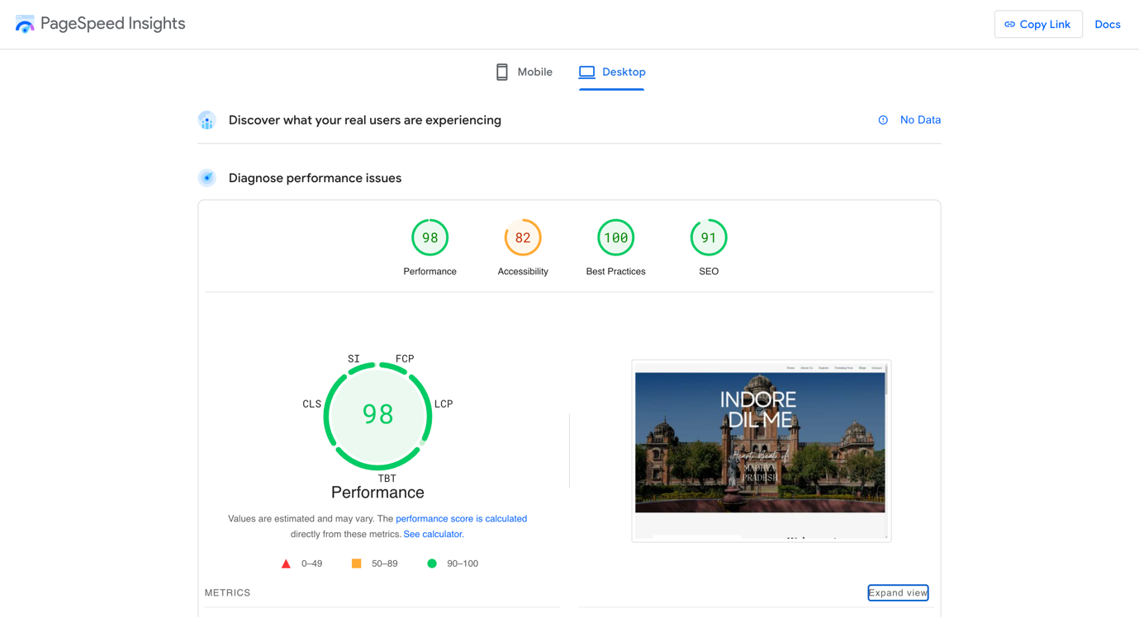

**Broken Link verification:**

We have given many outbound links in our site especially in the food page. So, we performed broken link test through (ahrefs) and we achieved 100% unbroken links in our site. Since we monitor our site everyday it helped us prevented from keeping any broken links in our site.

*Ahrefs results:*

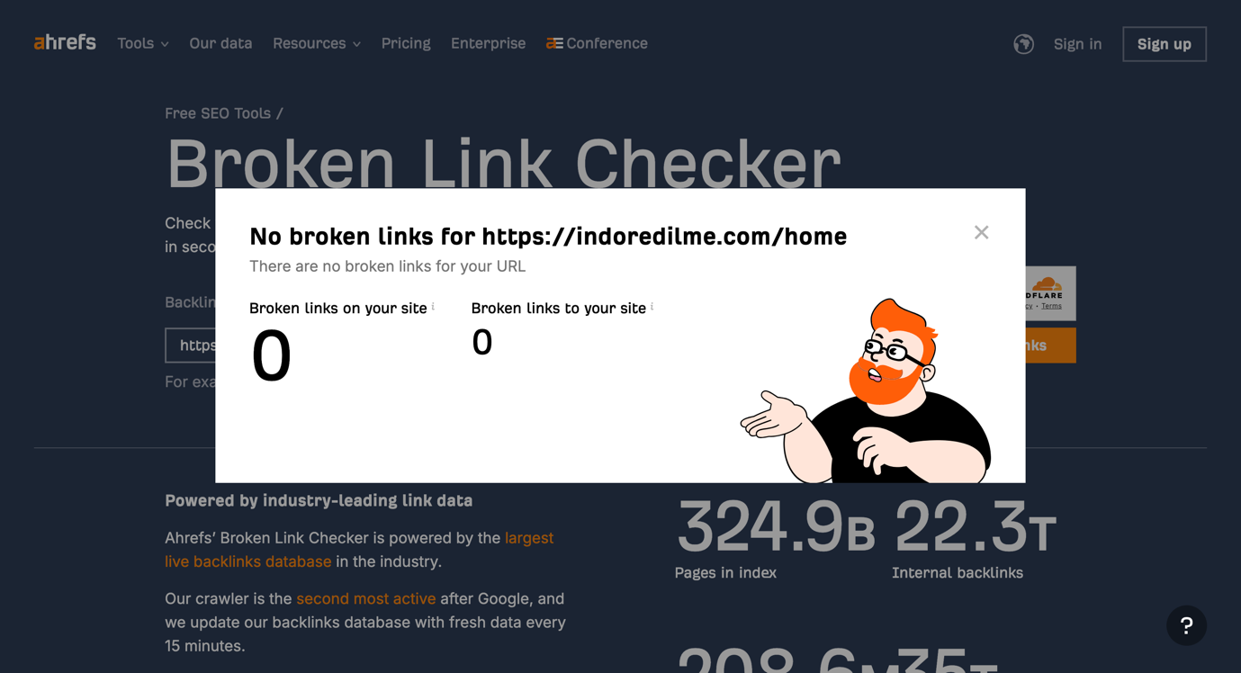

**Website Speed test:**

We also performed website speed test to measure the loading speed of the contents in our page and we received a speed index of 1.0 in light house and 928ms of load time at Pingdom with a performance grade A.

*Light House results:*

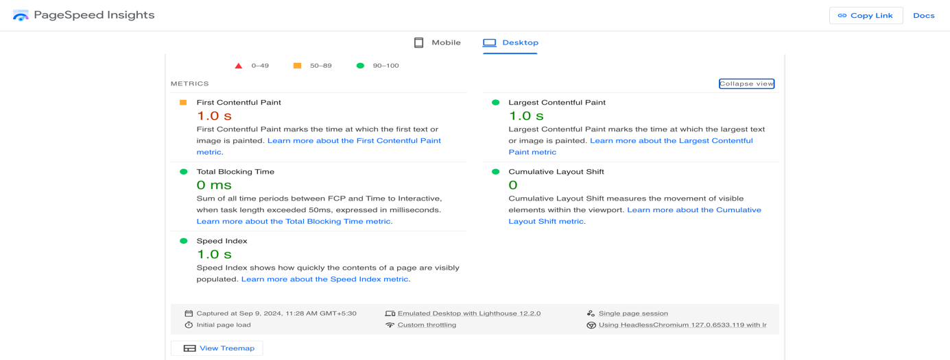

*Pingdom results:*

**Mobile Friendliness test:**

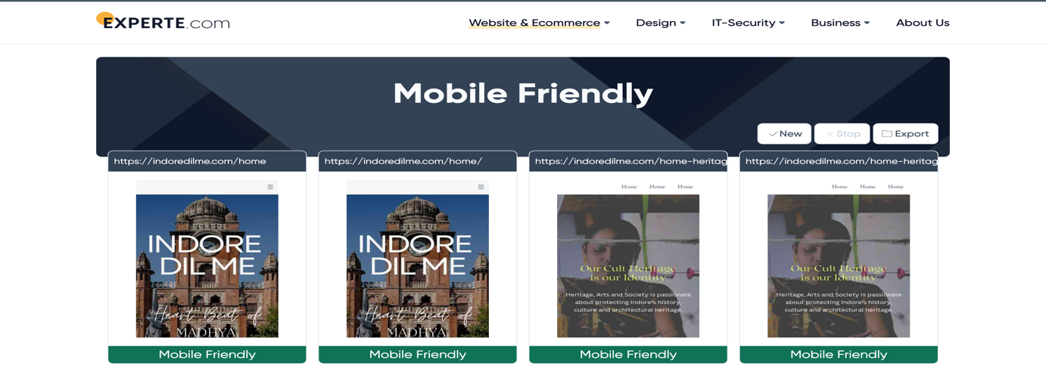

**Overview of website traffic**

Views for the site:

We had an all-time high of 34 people visiting our site in one day.

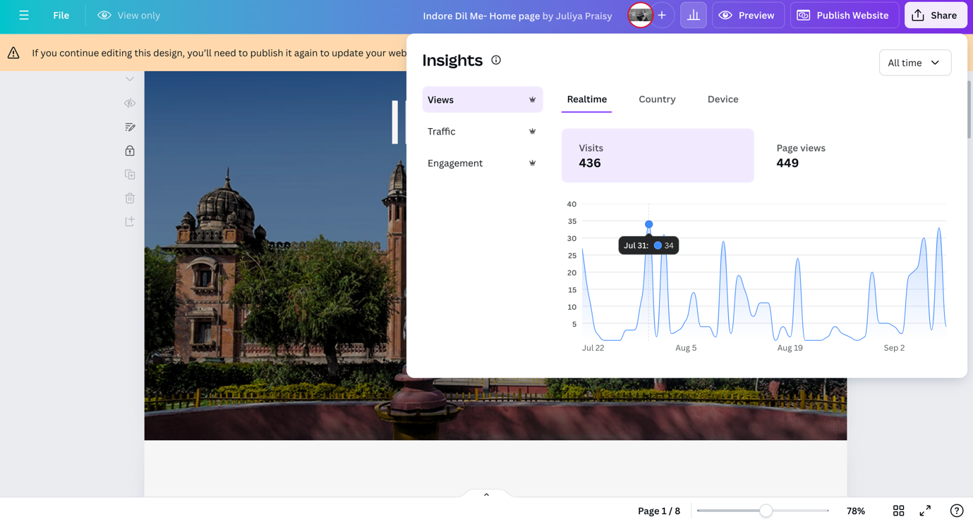

Since we post some international news in the trending news segment we were also able to drive the global audience to our site.

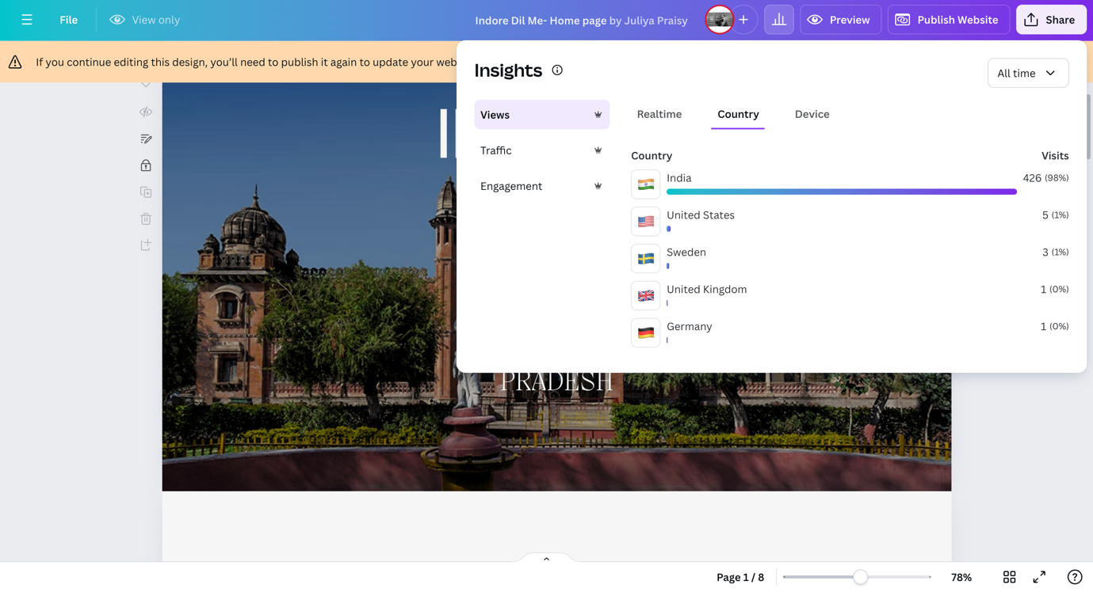

Here are our site results for views on cross screen.

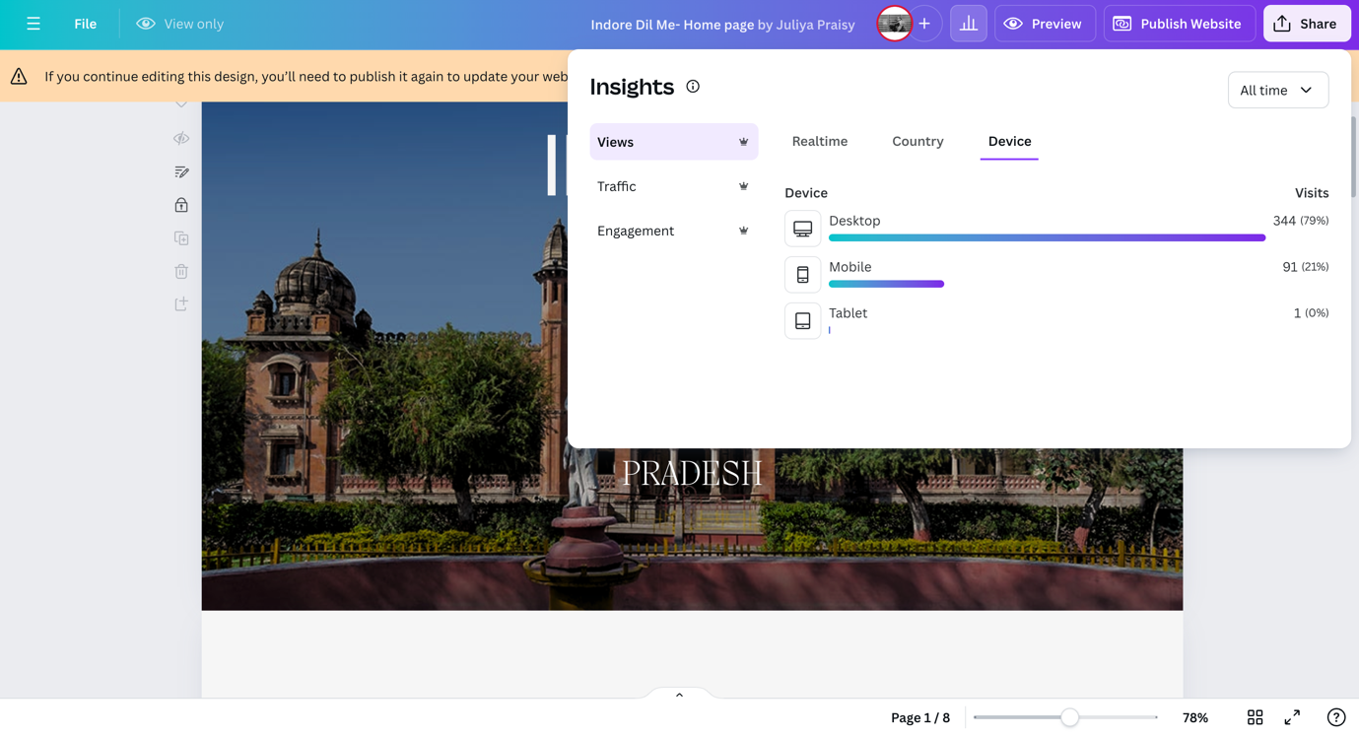

Traffic Results:

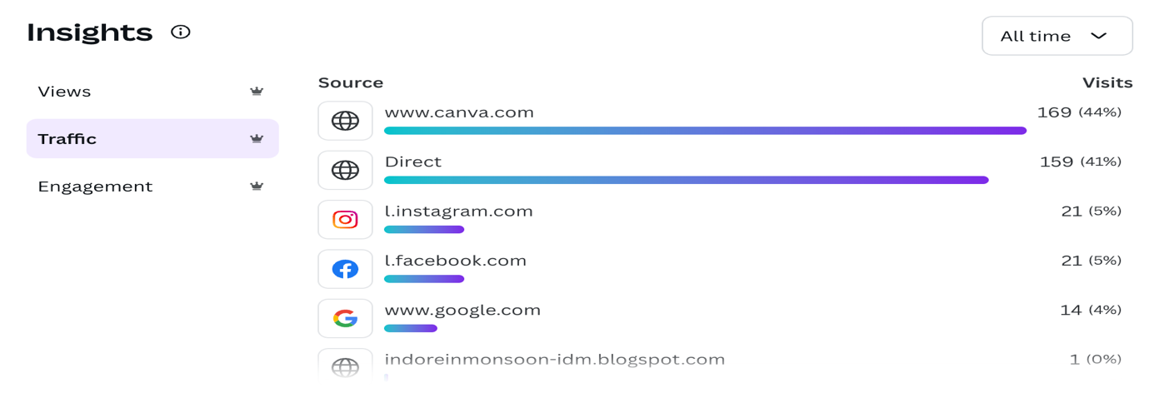

Engagement Results:

**Ad Publishing:**

We discovered a free ad publishing site which is known as classifiedads.com. we made a descriptive ad and posted it there in order to gain attraction for our site.

