CASCADE

# ▣  Ontology Layers

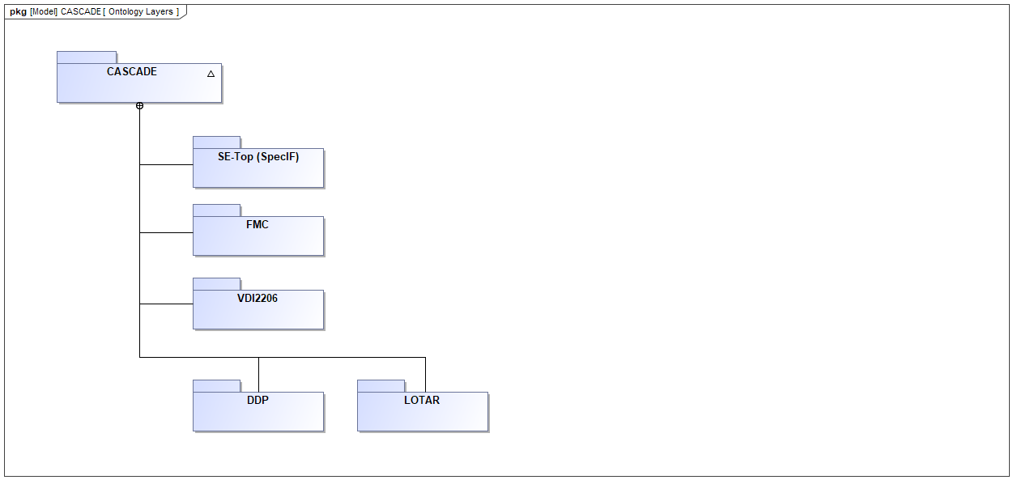

#### Properties

|  |  |
| --- | --- |
| *Element Type* | uml:Diagram |
| *Notation* | SysML Package Diagram |

#### Statements

|  |  |  |
| --- | --- | --- |
| ▣  Ontology Layers | *shows* | ⬚  DDP  ⬚  LOTAR  ⬚  SE-Top (SpecIF)  ⬚  FMC  ⬚  VDI2206 |

# ⬚  SE-Top (SpecIF)

#### Properties

|  |  |
| --- | --- |
| *Element Type* | Package |

#### Statements

|  |  |  |
| --- | --- | --- |
| ▣  Ontology Layers | *shows* | ⬚  SE-Top (SpecIF) |
| ⬚  SE-Top (SpecIF) | *has part* | ▣  SpecIF  Resource  Statement  SpecIF:ResourceClass  SpecIF:StatementClass  SpecIF:Node  SpecIF:File  Property  SpecIF:PropertyClass  SpecIF:DataType |

### ▣  SpecIF

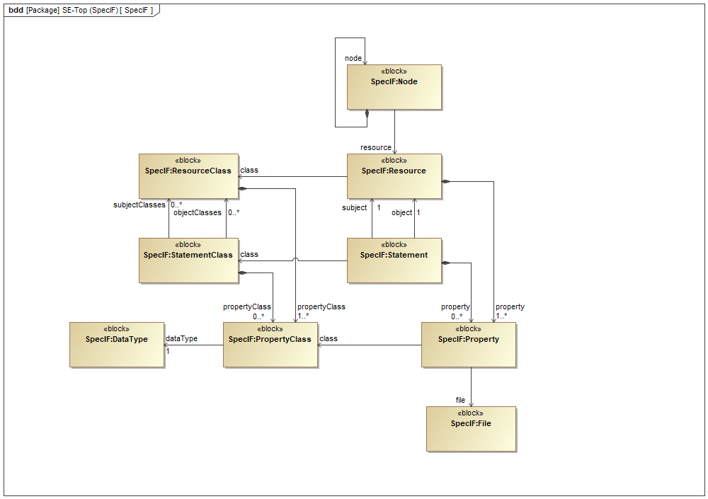

#### Properties

|  |  |
| --- | --- |
| *Element Type* | uml:Diagram |
| *Notation* | SysML Block Definition Diagram |

#### Statements

|  |  |  |
| --- | --- | --- |
| ▣  SpecIF | *shows* | property  SpecIF:File  object  file  Property  resource  subject  dataType  SpecIF:DataType  SpecIF:PropertyClass  objectClasses  propertyClass  node  class  SpecIF:Node  Statement  SpecIF:StatementClass  Resource  SpecIF:ResourceClass  subjectClasses |
| ⬚  SE-Top (SpecIF) | *has part* | ▣  SpecIF |

### Resource

#### Properties

|  |  |
| --- | --- |
| *Element Type* | uml:Class |

#### Statements

|  |  |  |
| --- | --- | --- |
| ▣  SpecIF | *shows* | Resource |
| ⬚  SE-Top (SpecIF) | *has part* | Resource |
| Resource | *associated with* | class |
| Resource | *owns a* | property |
| subject  object  resource | *is a* | Resource |

### Statement

#### Properties

|  |  |
| --- | --- |
| *Element Type* | uml:Class |

#### Statements

|  |  |  |
| --- | --- | --- |
| ▣  SpecIF | *shows* | Statement |
| ⬚  SE-Top (SpecIF) | *has part* | Statement |
| Statement | *associated with* | subject  object  class |
| Statement | *owns a* | property |

### SpecIF:ResourceClass

#### Properties

|  |  |
| --- | --- |
| *Element Type* | uml:Class |

#### Statements

|  |  |  |
| --- | --- | --- |
| ▣  FMC Diagrams and Model Elements  ▣  FMC Relations  ▣  SpecIF | *shows* | SpecIF:ResourceClass |
| ⬚  SE-Top (SpecIF) | *has part* | SpecIF:ResourceClass |
| SpecIF:ResourceClass | *owns a* | propertyClass |
| ▣  Model Diagram  SpecIF:Model_Element  class  objectClasses  subjectClasses | *is a* | SpecIF:ResourceClass |

### SpecIF:StatementClass

#### Properties

|  |  |
| --- | --- |
| *Element Type* | uml:Class |

#### Statements

|  |  |  |
| --- | --- | --- |
| ▣  FMC Relations  ▣  SpecIF | *shows* | SpecIF:StatementClass |
| ⬚  SE-Top (SpecIF) | *has part* | SpecIF:StatementClass |
| SpecIF:StatementClass | *associated with* | objectClasses  subjectClasses |
| SpecIF:StatementClass | *owns a* | propertyClass |
| contains  modifies  FMC:requests  FMC:succeeds  FMC:communicates  class | *is a* | SpecIF:StatementClass |

### SpecIF:Node

#### Properties

|  |  |
| --- | --- |
| *Element Type* | uml:Class |

#### Statements

|  |  |  |
| --- | --- | --- |
| ▣  SpecIF | *shows* | SpecIF:Node |
| ⬚  SE-Top (SpecIF) | *has part* | SpecIF:Node |
| SpecIF:Node | *associated with* | resource |
| SpecIF:Node | *owns a* | node |
| node | *is a* | SpecIF:Node |

### SpecIF:File

#### Properties

|  |  |
| --- | --- |
| *Element Type* | uml:Class |

#### Statements

|  |  |  |
| --- | --- | --- |
| ▣  SpecIF | *shows* | SpecIF:File |
| ⬚  SE-Top (SpecIF) | *has part* | SpecIF:File |
| file | *is a* | SpecIF:File |

### Property

#### Properties

|  |  |
| --- | --- |
| *Element Type* | uml:Class |

#### Statements

|  |  |  |
| --- | --- | --- |
| ▣  SpecIF | *shows* | Property |
| ⬚  SE-Top (SpecIF) | *has part* | Property |
| Property | *associated with* | file  class |
| property | *is a* | Property |

### SpecIF:PropertyClass

#### Properties

|  |  |
| --- | --- |
| *Element Type* | uml:Class |

#### Statements

|  |  |  |
| --- | --- | --- |
| ▣  SpecIF | *shows* | SpecIF:PropertyClass |
| ⬚  SE-Top (SpecIF) | *has part* | SpecIF:PropertyClass |
| SpecIF:PropertyClass | *associated with* | dataType |
| propertyClass  class | *is a* | SpecIF:PropertyClass |

### SpecIF:DataType

#### Properties

|  |  |
| --- | --- |
| *Element Type* | uml:Class |

#### Statements

|  |  |  |
| --- | --- | --- |
| ▣  SpecIF | *shows* | SpecIF:DataType |
| ⬚  SE-Top (SpecIF) | *has part* | SpecIF:DataType |
| dataType | *is a* | SpecIF:DataType |

# ⬚  FMC

#### Properties

|  |  |
| --- | --- |
| *Element Type* | Package |

#### Statements

|  |  |  |
| --- | --- | --- |
| ▣  Ontology Layers | *shows* | ⬚  FMC |
| ⬚  FMC | *has part* | ▣  FMC Diagrams and Model Elements  ▣  FMC Relations  ■  Actor  ●  State  ⬧  Event  ▣  FMC Block Diagram  ▣  FMC Petri Net  ▣  FMC:Entity_Relationship_Diagram  ▣  UML Class Diagram  ▣  UML Activity Diagram  contains  FMC:writes  FMC:reads  modifies  FMC:requests  ▣  Model Diagram  SpecIF:Model_Element  FMC:succeeds  FMC:communicates  FMC:sends  FMC:receives |

### ▣  FMC Diagrams and Model Elements

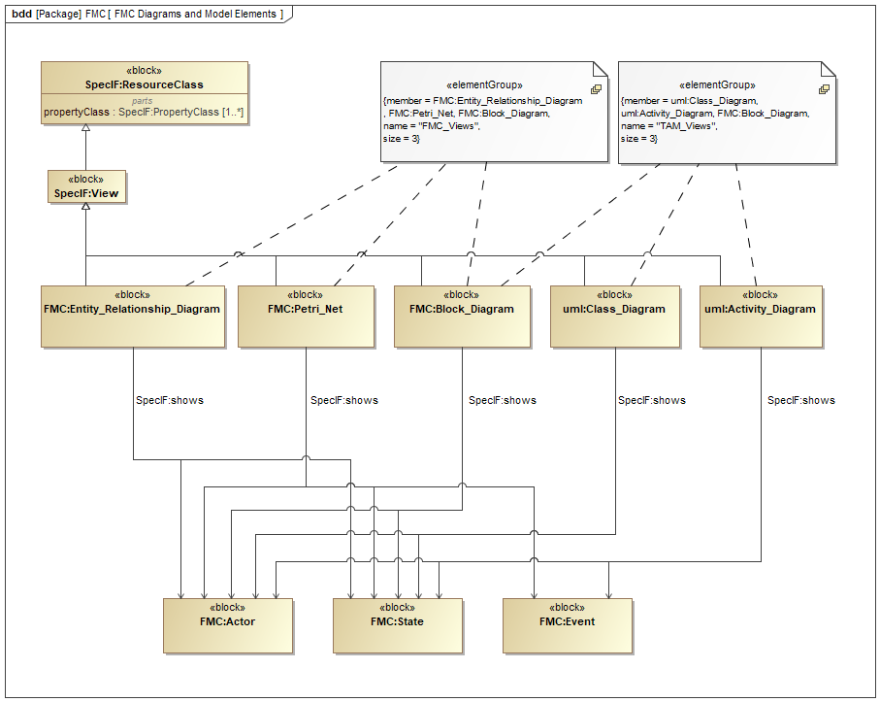

#### Properties

|  |  |
| --- | --- |
| *Element Type* | uml:Diagram |
| *Notation* | SysML Block Definition Diagram |

#### Statements

|  |  |  |
| --- | --- | --- |
| ▣  FMC Diagrams and Model Elements | *shows* | ▣  FMC Block Diagram  ▣  FMC:Entity_Relationship_Diagram  ⬧  Event  ▣  UML Class Diagram  ▣  FMC Petri Net  ▣  UML Activity Diagram  ●  State  SpecIF:ResourceClass  ■  Actor  ▣  Model Diagram  propertyClass |
| ⬚  FMC | *has part* | ▣  FMC Diagrams and Model Elements |

### ▣  FMC Relations

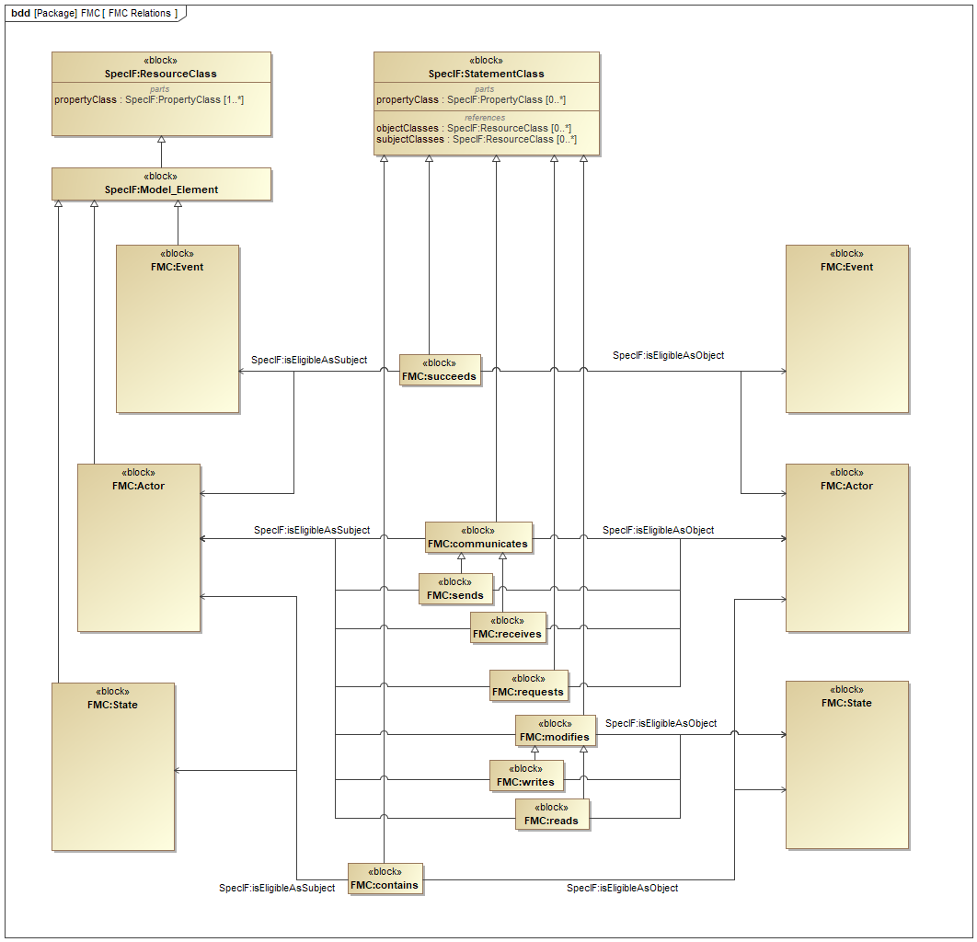

#### Properties

|  |  |
| --- | --- |
| *Element Type* | uml:Diagram |
| *Notation* | SysML Block Definition Diagram |

#### Statements

|  |  |  |
| --- | --- | --- |
| ▣  FMC Relations | *shows* | FMC:writes  FMC:succeeds  contains  objectClasses  propertyClass  SpecIF:Model_Element  modifies  subjectClasses  ⬧  Event  FMC:sends  FMC:receives  SpecIF:StatementClass  ●  State  FMC:communicates  SpecIF:ResourceClass  ■  Actor  FMC:requests  FMC:reads |
| ⬚  FMC | *has part* | ▣  FMC Relations |

### ■  Actor

#### Properties

|  |  |
| --- | --- |
| *Element Type* | uml:Class |

#### Statements

|  |  |  |
| --- | --- | --- |
| ▣  FMC Diagrams and Model Elements  ▣  FMC Relations  ▣  Mechatronic_System_and_its_Environment | *shows* | ■  Actor |
| ⬚  FMC | *has part* | ■  Actor |
| ▣  FMC Block Diagram  ▣  FMC Petri Net  ▣  FMC:Entity_Relationship_Diagram  ▣  UML Class Diagram  ▣  UML Activity Diagram  contains  contains  FMC:writes  FMC:reads  modifies  FMC:requests  FMC:requests  FMC:succeeds  FMC:succeeds  FMC:communicates  FMC:communicates  FMC:sends  FMC:sends  FMC:receives  FMC:receives | *associated with* | ■  Actor |
| ■  Human  ■  System | *is a* | ■  Actor |
| ■  Actor | *is a* | SpecIF:Model_Element |

### ●  State

#### Properties

|  |  |
| --- | --- |
| *Element Type* | uml:Class |

#### Statements

|  |  |  |
| --- | --- | --- |
| ▣  FMC Diagrams and Model Elements  ▣  FMC Relations  ▣  Mechatronic_System_and_its_Environment | *shows* | ●  State |
| ⬚  FMC | *has part* | ●  State |
| ▣  FMC Block Diagram  ▣  FMC Petri Net  ▣  FMC:Entity_Relationship_Diagram  ▣  UML Class Diagram  ▣  UML Activity Diagram  contains  contains  FMC:writes  FMC:reads  modifies | *associated with* | ●  State |
| ●  Energy  ●  Information  ●  Material | *is a* | ●  State |
| ●  State | *is a* | SpecIF:Model_Element |

### ⬧  Event

#### Properties

|  |  |
| --- | --- |
| *Element Type* | uml:Class |

#### Statements

|  |  |  |
| --- | --- | --- |
| ▣  FMC Diagrams and Model Elements  ▣  FMC Relations | *shows* | ⬧  Event |
| ⬚  FMC | *has part* | ⬧  Event |
| ▣  FMC Petri Net  ▣  UML Activity Diagram  FMC:succeeds  FMC:succeeds | *associated with* | ⬧  Event |
| ⬧  Event | *is a* | SpecIF:Model_Element |

### ▣  FMC Block Diagram

#### Properties

|  |  |
| --- | --- |
| *Element Type* | uml:Class |

#### Statements

|  |  |  |
| --- | --- | --- |
| ▣  FMC Diagrams and Model Elements | *shows* | ▣  FMC Block Diagram |
| ⬚  FMC | *has part* | ▣  FMC Block Diagram |
| ▣  FMC Block Diagram | *associated with* | ■  Actor  ●  State |
| ▣  FMC Block Diagram | *is a* | ▣  Model Diagram |

### ▣  FMC Petri Net

#### Properties

|  |  |
| --- | --- |
| *Element Type* | uml:Class |

#### Statements

|  |  |  |
| --- | --- | --- |
| ▣  FMC Diagrams and Model Elements | *shows* | ▣  FMC Petri Net |
| ⬚  FMC | *has part* | ▣  FMC Petri Net |
| ▣  FMC Petri Net | *associated with* | ■  Actor  ●  State  ⬧  Event |
| ▣  FMC Petri Net | *is a* | ▣  Model Diagram |

### ▣  FMC:Entity_Relationship_Diagram

#### Properties

|  |  |
| --- | --- |
| *Element Type* | uml:Class |

#### Statements

|  |  |  |
| --- | --- | --- |
| ▣  FMC Diagrams and Model Elements | *shows* | ▣  FMC:Entity_Relationship_Diagram |
| ⬚  FMC | *has part* | ▣  FMC:Entity_Relationship_Diagram |
| ▣  FMC:Entity_Relationship_Diagram | *associated with* | ●  State  ■  Actor |
| ▣  FMC:Entity_Relationship_Diagram | *is a* | ▣  Model Diagram |

### ▣  UML Class Diagram

#### Properties

|  |  |
| --- | --- |
| *Element Type* | uml:Class |

#### Statements

|  |  |  |
| --- | --- | --- |
| ▣  FMC Diagrams and Model Elements | *shows* | ▣  UML Class Diagram |
| ⬚  FMC | *has part* | ▣  UML Class Diagram |
| ▣  UML Class Diagram | *associated with* | ■  Actor  ●  State |
| ▣  UML Class Diagram | *is a* | ▣  Model Diagram |

### ▣  UML Activity Diagram

#### Properties

|  |  |
| --- | --- |
| *Element Type* | uml:Class |

#### Statements

|  |  |  |
| --- | --- | --- |
| ▣  FMC Diagrams and Model Elements | *shows* | ▣  UML Activity Diagram |
| ⬚  FMC | *has part* | ▣  UML Activity Diagram |
| ▣  UML Activity Diagram | *associated with* | ■  Actor  ●  State  ⬧  Event |
| ▣  UML Activity Diagram | *is a* | ▣  Model Diagram |

### contains

#### Properties

|  |  |
| --- | --- |
| *Element Type* | uml:Class |

#### Statements

|  |  |  |
| --- | --- | --- |
| ▣  FMC Relations | *shows* | contains |
| ⬚  FMC | *has part* | contains |
| contains | *associated with* | ■  Actor  ●  State  ●  State  ■  Actor |
| contains | *is a* | SpecIF:StatementClass |

### FMC:writes

#### Properties

|  |  |
| --- | --- |
| *Element Type* | uml:Class |

#### Statements

|  |  |  |
| --- | --- | --- |
| ▣  FMC Relations | *shows* | FMC:writes |
| ⬚  FMC | *has part* | FMC:writes |
| FMC:writes | *associated with* | ■  Actor  ●  State |
| FMC:writes | *is a* | modifies |

### FMC:reads

#### Properties

|  |  |
| --- | --- |
| *Element Type* | uml:Class |

#### Statements

|  |  |  |
| --- | --- | --- |
| ▣  FMC Relations | *shows* | FMC:reads |
| ⬚  FMC | *has part* | FMC:reads |
| FMC:reads | *associated with* | ■  Actor  ●  State |
| FMC:reads | *is a* | modifies |

### modifies

#### Properties

|  |  |
| --- | --- |
| *Element Type* | uml:Class |

#### Statements

|  |  |  |
| --- | --- | --- |
| ▣  FMC Relations | *shows* | modifies |
| ⬚  FMC | *has part* | modifies |
| modifies | *associated with* | ■  Actor  ●  State |
| FMC:writes  FMC:reads | *is a* | modifies |
| modifies | *is a* | SpecIF:StatementClass |

### FMC:requests

#### Properties

|  |  |
| --- | --- |
| *Element Type* | uml:Class |

#### Statements

|  |  |  |
| --- | --- | --- |
| ▣  FMC Relations | *shows* | FMC:requests |
| ⬚  FMC | *has part* | FMC:requests |
| FMC:requests | *associated with* | ■  Actor  ■  Actor |
| FMC:requests | *is a* | SpecIF:StatementClass |

### ▣  Model Diagram

#### Properties

|  |  |
| --- | --- |
| *Element Type* | uml:Class |

#### Statements

|  |  |  |
| --- | --- | --- |
| ▣  FMC Diagrams and Model Elements | *shows* | ▣  Model Diagram |
| ⬚  FMC | *has part* | ▣  Model Diagram |
| ▣  FMC Block Diagram  ▣  FMC Petri Net  ▣  FMC:Entity_Relationship_Diagram  ▣  UML Class Diagram  ▣  UML Activity Diagram | *is a* | ▣  Model Diagram |
| ▣  Model Diagram | *is a* | SpecIF:ResourceClass |

### SpecIF:Model_Element

#### Properties

|  |  |
| --- | --- |
| *Element Type* | uml:Class |

#### Statements

|  |  |  |
| --- | --- | --- |
| ▣  FMC Relations | *shows* | SpecIF:Model_Element |
| ⬚  FMC | *has part* | SpecIF:Model_Element |
| ■  Actor  ●  State  ⬧  Event | *is a* | SpecIF:Model_Element |
| SpecIF:Model_Element | *is a* | SpecIF:ResourceClass |

### FMC:succeeds

#### Properties

|  |  |
| --- | --- |
| *Element Type* | uml:Class |

#### Statements

|  |  |  |
| --- | --- | --- |
| ▣  FMC Relations | *shows* | FMC:succeeds |
| ⬚  FMC | *has part* | FMC:succeeds |
| FMC:succeeds | *associated with* | ■  Actor  ■  Actor  ⬧  Event  ⬧  Event |
| FMC:succeeds | *is a* | SpecIF:StatementClass |

### FMC:communicates

#### Properties

|  |  |
| --- | --- |
| *Element Type* | uml:Class |

#### Statements

|  |  |  |
| --- | --- | --- |
| ▣  FMC Relations | *shows* | FMC:communicates |
| ⬚  FMC | *has part* | FMC:communicates |
| FMC:communicates | *associated with* | ■  Actor  ■  Actor |
| FMC:sends  FMC:receives | *is a* | FMC:communicates |
| FMC:communicates | *is a* | SpecIF:StatementClass |

### FMC:sends

#### Properties

|  |  |
| --- | --- |
| *Element Type* | uml:Class |

#### Statements

|  |  |  |
| --- | --- | --- |
| ▣  FMC Relations | *shows* | FMC:sends |
| ⬚  FMC | *has part* | FMC:sends |
| FMC:sends | *associated with* | ■  Actor  ■  Actor |
| FMC:sends | *is a* | FMC:communicates |

### FMC:receives

#### Properties

|  |  |
| --- | --- |
| *Element Type* | uml:Class |

#### Statements

|  |  |  |
| --- | --- | --- |
| ▣  FMC Relations | *shows* | FMC:receives |
| ⬚  FMC | *has part* | FMC:receives |
| FMC:receives | *associated with* | ■  Actor  ■  Actor |
| FMC:receives | *is a* | FMC:communicates |

# ⬚  VDI2206

#### Properties

|  |  |
| --- | --- |
| *Element Type* | Package |

#### Statements

|  |  |  |
| --- | --- | --- |
| ▣  Ontology Layers | *shows* | ⬚  VDI2206 |
| ⬚  VDI2206 | *has part* | ▣  Mechatronic_System_Design  ▣  Mechatronic_System_and_its_Environment  ■  Actuator  ■  Mechatronic_System  ■  Human  ●  Actuator_Information  ■  Basic_System  ■  Communication_System  ■  Cyber-Physical_System  ●  Electrical_Energy  ■  Environment  ●  Energy  Function  ●  Information  ■  Information_Processing  ●  Material  ■  Programmable_Mechatronic_System  ↯  Requirement  ■  Sensor  ●  Sensor_Information  ■  Simple_Mechatronic_System  ■  System  ●  Water |

### ▣  Mechatronic_System_Design

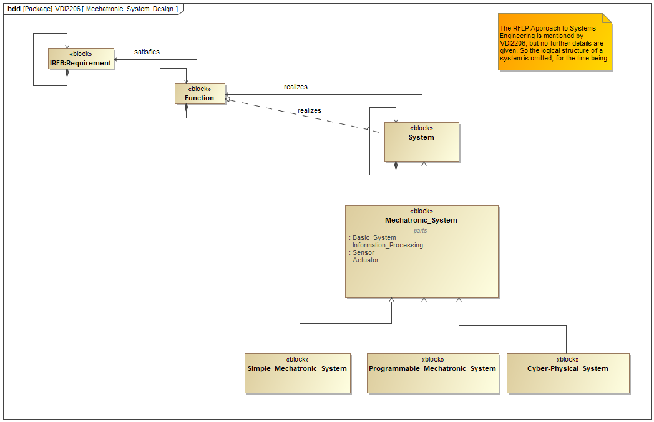

#### Properties

|  |  |
| --- | --- |
| *Element Type* | uml:Diagram |
| *Notation* | SysML Block Definition Diagram |

#### Statements

|  |  |  |
| --- | --- | --- |
| ▣  Mechatronic_System_Design | *shows* | ■  Cyber-Physical_System  ■  System  ■  Simple_Mechatronic_System  ■  Mechatronic_System  ■  Programmable_Mechatronic_System  Function  ↯  Requirement  ■  Basic_System  ■  Information_Processing  ■  Sensor  ■  Actuator |
| ⬚  VDI2206 | *has part* | ▣  Mechatronic_System_Design |

### ▣  Mechatronic_System_and_its_Environment

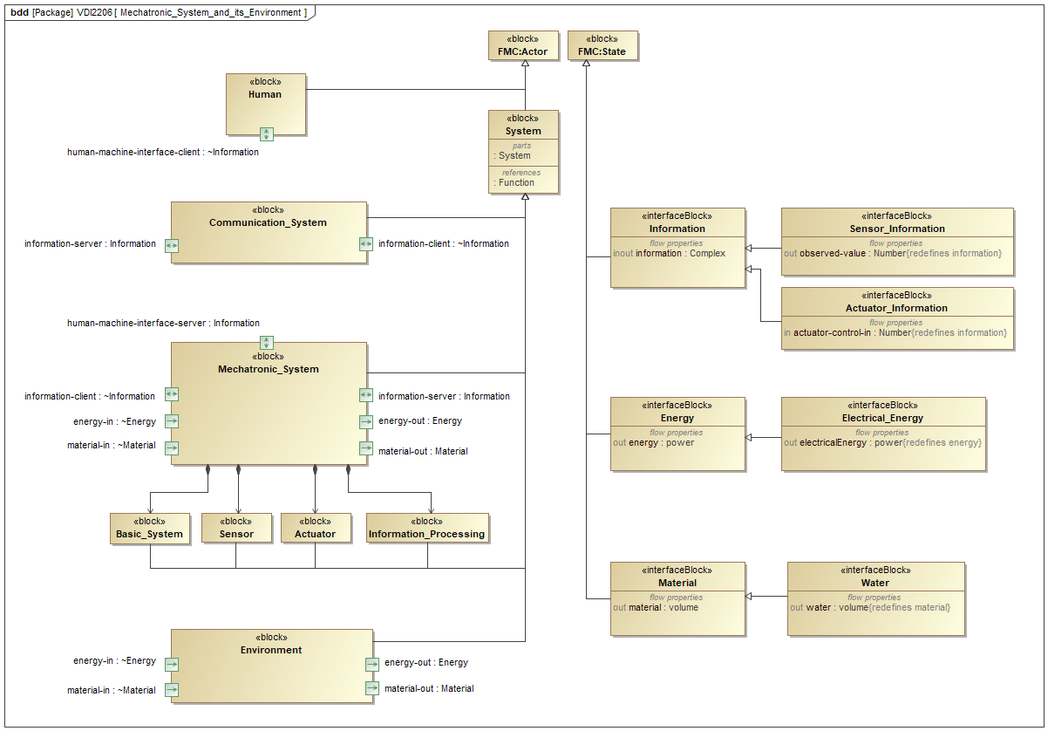

#### Properties

|  |  |
| --- | --- |
| *Element Type* | uml:Diagram |
| *Notation* | SysML Block Definition Diagram |

#### Statements

|  |  |  |
| --- | --- | --- |
| ▣  Mechatronic_System_and_its_Environment | *shows* | ●  Sensor_Information  ■  material-in  ●  Material  ■  human-machine-interface-server  ■  System  ■  Actuator  electricalEnergy  ■  Information_Processing  ■  Mechatronic_System  ●  Information  ■  Basic_System  ■  energy-out  ■  material-out  ■  Communication_System  ■  information-client  ■  human-machine-interface-client  ■  energy-in  ●  Actuator_Information  ■  information-server  energy  ●  Energy  ●  Water  ■  Environment  ●  State  ■  Human  ●  Electrical_Energy  ■  Actor  ■  Sensor  Function |
| ⬚  VDI2206 | *has part* | ▣  Mechatronic_System_and_its_Environment |

### ■  Actuator

#### Properties

|  |  |
| --- | --- |
| *Element Type* | uml:Class |

#### Statements

|  |  |  |
| --- | --- | --- |
| ▣  Mechatronic_System_and_its_Environment  ▣  Mechatronic_System_Design  ▣  Components_and_Connections | *shows* | ■  Actuator |
| ⬚  VDI2206 | *has part* | ■  Actuator |
| ■  Actuator | *has part* | ■  energy-in  ■  actuator-control-in  ■  actuator-energy-out |
| ■  Mechatronic_System | *owns a* | ■  Actuator |
| ■  Actuator | *is a* | ■  System |

### ■  Mechatronic_System

#### Properties

|  |  |
| --- | --- |
| *Element Type* | uml:Class |

#### Statements

|  |  |  |
| --- | --- | --- |
| ▣  Mechatronic_System_Design  ▣  Mechatronic_System_and_its_Environment | *shows* | ■  Mechatronic_System |
| ⬚  VDI2206 | *has part* | ■  Mechatronic_System |
| ■  Mechatronic_System | *has part* | ▣  Components_and_Connections  ■  material-out  ■  material-in  ■  energy-out  ■  energy-in  ■  information-client  ■  information-server  ■  human-machine-interface-server |
| ■  Mechatronic_System | *owns a* | ■  Basic_System  ■  Information_Processing  ■  Sensor  ■  Actuator |
| ■  Cyber-Physical_System  ■  Programmable_Mechatronic_System  ■  Simple_Mechatronic_System | *is a* | ■  Mechatronic_System |
| ■  Mechatronic_System | *is a* | ■  System |

### ▣  Components_and_Connections

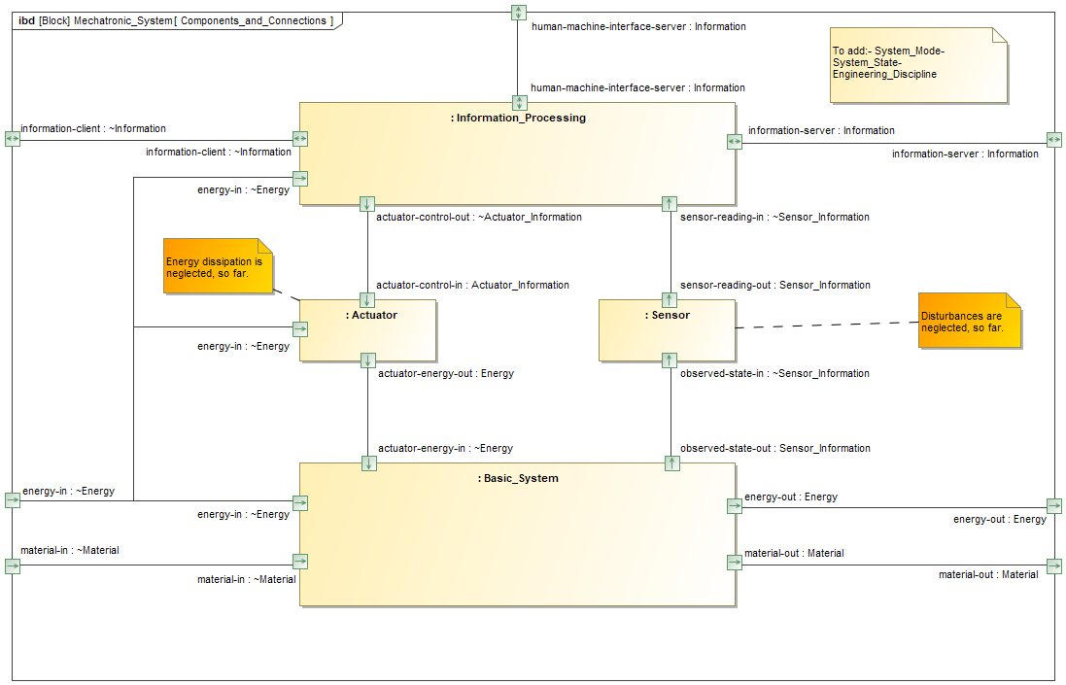

#### Properties

|  |  |
| --- | --- |
| *Element Type* | uml:Diagram |
| *Notation* | SysML Internal Block Diagram |

#### Statements

|  |  |  |
| --- | --- | --- |
| ▣  Components_and_Connections | *shows* | ■  energy-out  ■  material-in  ■  sensor-reading-in  ■  sensor-reading-out  ■  human-machine-interface-server  ■  actuator-energy-in  ■  actuator-control-in  ■  material-out  ■  information-client  ■  energy-in  ■  observed-state-in  ■  observed-state-out  ■  actuator-energy-out  ■  information-server  ■  actuator-control-out  ■  Basic_System  ■  Information_Processing  ■  Sensor  ■  Actuator |
| ■  Mechatronic_System | *has part* | ▣  Components_and_Connections |

### ■  Human

#### Properties

|  |  |
| --- | --- |
| *Element Type* | uml:Class |

#### Statements

|  |  |  |
| --- | --- | --- |
| ▣  Mechatronic_System_and_its_Environment | *shows* | ■  Human |
| ⬚  VDI2206 | *has part* | ■  Human |
| ■  Human | *has part* | ■  human-machine-interface-client |
| ■  Human | *is a* | ■  Actor |

### ●  Actuator_Information

#### Properties

|  |  |
| --- | --- |
| *Element Type* | uml:Class |

#### Statements

|  |  |  |
| --- | --- | --- |
| ▣  Mechatronic_System_and_its_Environment | *shows* | ●  Actuator_Information |
| ⬚  VDI2206 | *has part* | ●  Actuator_Information |
| ●  Actuator_Information | *is a* | ●  Information |

### ■  Basic_System

#### Properties

|  |  |
| --- | --- |
| *Element Type* | uml:Class |

#### Statements

|  |  |  |
| --- | --- | --- |
| ▣  Mechatronic_System_and_its_Environment  ▣  Mechatronic_System_Design  ▣  Components_and_Connections | *shows* | ■  Basic_System |
| ⬚  VDI2206 | *has part* | ■  Basic_System |
| ■  Basic_System | *has part* | ■  material-in  ■  material-out  ■  energy-out  ■  energy-in  ■  observed-state-out  ■  actuator-energy-in |
| ■  Mechatronic_System | *owns a* | ■  Basic_System |
| ■  Basic_System | *is a* | ■  System |

### ■  Communication_System

#### Properties

|  |  |
| --- | --- |
| *Element Type* | uml:Class |

#### Statements

|  |  |  |
| --- | --- | --- |
| ▣  Mechatronic_System_and_its_Environment | *shows* | ■  Communication_System |
| ⬚  VDI2206 | *has part* | ■  Communication_System |
| ■  Communication_System | *has part* | ■  information-client  ■  information-server |
| ■  Communication_System | *is a* | ■  System |

### ■  Cyber-Physical_System

#### Properties

|  |  |
| --- | --- |
| *Element Type* | uml:Class |

#### Statements

|  |  |  |
| --- | --- | --- |
| ▣  Mechatronic_System_Design | *shows* | ■  Cyber-Physical_System |
| ⬚  VDI2206 | *has part* | ■  Cyber-Physical_System |
| ■  Cyber-Physical_System | *is a* | ■  Mechatronic_System |

### ●  Electrical_Energy

#### Properties

|  |  |
| --- | --- |
| *Element Type* | uml:Class |

#### Statements

|  |  |  |
| --- | --- | --- |
| ▣  Mechatronic_System_and_its_Environment | *shows* | ●  Electrical_Energy |
| ⬚  VDI2206 | *has part* | ●  Electrical_Energy |
| ●  Electrical_Energy | *associated with* | electricalEnergy |
| ●  Electrical_Energy | *is a* | ●  Energy |

### ■  Environment

#### Properties

|  |  |
| --- | --- |
| *Element Type* | uml:Class |

#### Statements

|  |  |  |
| --- | --- | --- |
| ▣  Mechatronic_System_and_its_Environment | *shows* | ■  Environment |
| ⬚  VDI2206 | *has part* | ■  Environment |
| ■  Environment | *has part* | ■  energy-out  ■  material-out  ■  energy-in  ■  material-in |
| ■  Environment | *is a* | ■  System |

### ●  Energy

#### Properties

|  |  |
| --- | --- |
| *Element Type* | uml:Class |

#### Statements

|  |  |  |
| --- | --- | --- |
| ▣  Mechatronic_System_and_its_Environment | *shows* | ●  Energy |
| ⬚  VDI2206 | *has part* | ●  Energy |
| ●  Energy | *associated with* | energy |
| ●  Electrical_Energy | *is a* | ●  Energy |
| ●  Energy | *is a* | ●  State |

### Function

#### Properties

|  |  |
| --- | --- |
| *Element Type* | uml:Class |

#### Statements

|  |  |  |
| --- | --- | --- |
| ▣  Mechatronic_System_Design  ▣  Mechatronic_System_and_its_Environment | *shows* | Function |
| ⬚  VDI2206 | *has part* | Function |
| ■  System | *associated with* | Function |
| Function | *associated with* | ↯  Requirement |
| Function | *owns a* | Function |

### ●  Information

#### Properties

|  |  |
| --- | --- |
| *Element Type* | uml:Class |

#### Statements

|  |  |  |
| --- | --- | --- |
| ▣  Mechatronic_System_and_its_Environment | *shows* | ●  Information |
| ⬚  VDI2206 | *has part* | ●  Information |
| ●  Actuator_Information  ●  Sensor_Information | *is a* | ●  Information |
| ●  Information | *is a* | ●  State |

### ■  Information_Processing

#### Properties

|  |  |
| --- | --- |
| *Element Type* | uml:Class |

#### Statements

|  |  |  |
| --- | --- | --- |
| ▣  Mechatronic_System_and_its_Environment  ▣  Mechatronic_System_Design  ▣  Components_and_Connections | *shows* | ■  Information_Processing |
| ⬚  VDI2206 | *has part* | ■  Information_Processing |
| ■  Information_Processing | *has part* | ■  human-machine-interface-server  ■  actuator-control-out  ■  sensor-reading-in  ■  information-client  ■  information-server  ■  energy-in |
| ■  Mechatronic_System | *owns a* | ■  Information_Processing |
| ■  Information_Processing | *is a* | ■  System |

### ●  Material

#### Properties

|  |  |
| --- | --- |
| *Element Type* | uml:Class |

#### Statements

|  |  |  |
| --- | --- | --- |
| ▣  Mechatronic_System_and_its_Environment | *shows* | ●  Material |
| ⬚  VDI2206 | *has part* | ●  Material |
| ●  Water | *is a* | ●  Material |
| ●  Material | *is a* | ●  State |

### ■  Programmable_Mechatronic_System

#### Properties

|  |  |
| --- | --- |
| *Element Type* | uml:Class |

#### Statements

|  |  |  |
| --- | --- | --- |
| ▣  Mechatronic_System_Design | *shows* | ■  Programmable_Mechatronic_System |
| ⬚  VDI2206 | *has part* | ■  Programmable_Mechatronic_System |
| ■  Programmable_Mechatronic_System | *is a* | ■  Mechatronic_System |

### ↯  Requirement

#### Properties

|  |  |
| --- | --- |
| *Element Type* | uml:Class |

#### Statements

|  |  |  |
| --- | --- | --- |
| ▣  Mechatronic_System_Design | *shows* | ↯  Requirement |
| ⬚  VDI2206 | *has part* | ↯  Requirement |
| Function | *associated with* | ↯  Requirement |
| ↯  Requirement | *owns a* | ↯  Requirement |

### ■  Sensor

#### Properties

|  |  |
| --- | --- |
| *Element Type* | uml:Class |

#### Statements

|  |  |  |
| --- | --- | --- |
| ▣  Mechatronic_System_and_its_Environment  ▣  Mechatronic_System_Design  ▣  Components_and_Connections | *shows* | ■  Sensor |
| ⬚  VDI2206 | *has part* | ■  Sensor |
| ■  Sensor | *has part* | ■  sensor-reading-out  ■  observed-state-in |
| ■  Mechatronic_System | *owns a* | ■  Sensor |
| ■  Sensor | *is a* | ■  System |

### ●  Sensor_Information

#### Properties

|  |  |
| --- | --- |
| *Element Type* | uml:Class |

#### Statements

|  |  |  |
| --- | --- | --- |
| ▣  Mechatronic_System_and_its_Environment | *shows* | ●  Sensor_Information |
| ⬚  VDI2206 | *has part* | ●  Sensor_Information |
| ●  Sensor_Information | *is a* | ●  Information |

### ■  Simple_Mechatronic_System

#### Properties

|  |  |
| --- | --- |
| *Element Type* | uml:Class |

#### Statements

|  |  |  |
| --- | --- | --- |
| ▣  Mechatronic_System_Design | *shows* | ■  Simple_Mechatronic_System |
| ⬚  VDI2206 | *has part* | ■  Simple_Mechatronic_System |
| ■  Simple_Mechatronic_System | *is a* | ■  Mechatronic_System |

### ■  System

#### Properties

|  |  |
| --- | --- |
| *Element Type* | uml:Class |

#### Statements

|  |  |  |
| --- | --- | --- |
| ▣  Mechatronic_System_Design  ▣  Mechatronic_System_and_its_Environment | *shows* | ■  System |
| ⬚  VDI2206 | *has part* | ■  System |
| ■  System | *owns a* | ■  System |
| ■  System | *associated with* | Function |
| ■  Actuator  ■  Mechatronic_System  ■  Basic_System  ■  Communication_System  ■  Environment  ■  Information_Processing  ■  Sensor | *is a* | ■  System |
| ■  System | *is a* | ■  Actor |

### ●  Water

#### Properties

|  |  |
| --- | --- |
| *Element Type* | uml:Class |

#### Statements

|  |  |  |
| --- | --- | --- |
| ▣  Mechatronic_System_and_its_Environment | *shows* | ●  Water |
| ⬚  VDI2206 | *has part* | ●  Water |
| ●  Water | *is a* | ●  Material |

# ⬚  DDP

#### Properties

|  |  |
| --- | --- |
| *Element Type* | Package |

#### Statements

|  |  |  |
| --- | --- | --- |
| ▣  Ontology Layers | *shows* | ⬚  DDP |

# ⬚  LOTAR

#### Properties

|  |  |
| --- | --- |
| *Element Type* | Package |

#### Statements

|  |  |  |
| --- | --- | --- |
| ▣  Ontology Layers | *shows* | ⬚  LOTAR |

# Model Elements (Glossary)

#### Properties

|  |  |
| --- | --- |
| *Element Type* | Model Elements (Glossary) |

### ■  Actuator

#### Properties

|  |  |
| --- | --- |
| *Element Type* | uml:Class |

#### Statements

|  |  |  |
| --- | --- | --- |
| ▣  Mechatronic_System_and_its_Environment  ▣  Mechatronic_System_Design  ▣  Components_and_Connections | *shows* | ■  Actuator |
| ⬚  VDI2206 | *has part* | ■  Actuator |
| ■  Actuator | *has part* | ■  energy-in  ■  actuator-control-in  ■  actuator-energy-out |
| ■  Mechatronic_System | *owns a* | ■  Actuator |
| ■  Actuator | *is a* | ■  System |

### ■  actuator-control-in

#### Properties

|  |  |
| --- | --- |
| *Element Type* | uml:Port |

#### Statements

|  |  |  |
| --- | --- | --- |
| ▣  Components_and_Connections | *shows* | ■  actuator-control-in |
| ■  Actuator | *has part* | ■  actuator-control-in |

### ■  actuator-control-out

#### Properties

|  |  |
| --- | --- |
| *Element Type* | uml:Port |

#### Statements

|  |  |  |
| --- | --- | --- |
| ▣  Components_and_Connections | *shows* | ■  actuator-control-out |
| ■  Information_Processing | *has part* | ■  actuator-control-out |

### ■  actuator-energy-in

#### Properties

|  |  |
| --- | --- |
| *Element Type* | uml:Port |

#### Statements

|  |  |  |
| --- | --- | --- |
| ▣  Components_and_Connections | *shows* | ■  actuator-energy-in |
| ■  Basic_System | *has part* | ■  actuator-energy-in |

### ■  actuator-energy-out

#### Properties

|  |  |
| --- | --- |
| *Element Type* | uml:Port |

#### Statements

|  |  |  |
| --- | --- | --- |
| ▣  Components_and_Connections | *shows* | ■  actuator-energy-out |
| ■  Actuator | *has part* | ■  actuator-energy-out |

### ●  Actuator_Information

#### Properties

|  |  |
| --- | --- |
| *Element Type* | uml:Class |

#### Statements

|  |  |  |
| --- | --- | --- |
| ▣  Mechatronic_System_and_its_Environment | *shows* | ●  Actuator_Information |
| ⬚  VDI2206 | *has part* | ●  Actuator_Information |
| ●  Actuator_Information | *is a* | ●  Information |

### ■  Basic_System

#### Properties

|  |  |
| --- | --- |
| *Element Type* | uml:Class |

#### Statements

|  |  |  |
| --- | --- | --- |
| ▣  Mechatronic_System_and_its_Environment  ▣  Mechatronic_System_Design  ▣  Components_and_Connections | *shows* | ■  Basic_System |
| ⬚  VDI2206 | *has part* | ■  Basic_System |
| ■  Basic_System | *has part* | ■  material-in  ■  material-out  ■  energy-out  ■  energy-in  ■  observed-state-out  ■  actuator-energy-in |
| ■  Mechatronic_System | *owns a* | ■  Basic_System |
| ■  Basic_System | *is a* | ■  System |

### class

#### Properties

|  |  |
| --- | --- |
| *Element Type* | uml:Class |

#### Statements

|  |  |  |
| --- | --- | --- |
| ▣  SpecIF | *shows* | class |
| Resource  Statement  Property | *associated with* | class |
| class | *is a* | SpecIF:ResourceClass  SpecIF:StatementClass  SpecIF:PropertyClass |

### ■  Communication_System

#### Properties

|  |  |
| --- | --- |
| *Element Type* | uml:Class |

#### Statements

|  |  |  |
| --- | --- | --- |
| ▣  Mechatronic_System_and_its_Environment | *shows* | ■  Communication_System |
| ⬚  VDI2206 | *has part* | ■  Communication_System |
| ■  Communication_System | *has part* | ■  information-client  ■  information-server |
| ■  Communication_System | *is a* | ■  System |

### ■  Cyber-Physical_System

#### Properties

|  |  |
| --- | --- |
| *Element Type* | uml:Class |

#### Statements

|  |  |  |
| --- | --- | --- |
| ▣  Mechatronic_System_Design | *shows* | ■  Cyber-Physical_System |
| ⬚  VDI2206 | *has part* | ■  Cyber-Physical_System |
| ■  Cyber-Physical_System | *is a* | ■  Mechatronic_System |

### dataType

#### Properties

|  |  |
| --- | --- |
| *Element Type* | uml:Class |

#### Statements

|  |  |  |
| --- | --- | --- |
| ▣  SpecIF | *shows* | dataType |
| SpecIF:PropertyClass | *associated with* | dataType |
| dataType | *is a* | SpecIF:DataType |

### ⬚  DDP

#### Properties

|  |  |
| --- | --- |
| *Element Type* | Package |

#### Statements

|  |  |  |
| --- | --- | --- |
| ▣  Ontology Layers | *shows* | ⬚  DDP |

### ●  Electrical_Energy

#### Properties

|  |  |
| --- | --- |
| *Element Type* | uml:Class |

#### Statements

|  |  |  |
| --- | --- | --- |
| ▣  Mechatronic_System_and_its_Environment | *shows* | ●  Electrical_Energy |
| ⬚  VDI2206 | *has part* | ●  Electrical_Energy |
| ●  Electrical_Energy | *associated with* | electricalEnergy |
| ●  Electrical_Energy | *is a* | ●  Energy |

### electricalEnergy

#### Properties

|  |  |
| --- | --- |
| *Element Type* | uml:Class |

#### Statements

|  |  |  |
| --- | --- | --- |
| ▣  Mechatronic_System_and_its_Environment | *shows* | electricalEnergy |
| ●  Electrical_Energy | *associated with* | electricalEnergy |

### ●  Energy

#### Properties

|  |  |
| --- | --- |
| *Element Type* | uml:Class |

#### Statements

|  |  |  |
| --- | --- | --- |
| ▣  Mechatronic_System_and_its_Environment | *shows* | ●  Energy |
| ⬚  VDI2206 | *has part* | ●  Energy |
| ●  Energy | *associated with* | energy |
| ●  Electrical_Energy | *is a* | ●  Energy |
| ●  Energy | *is a* | ●  State |

### energy

#### Properties

|  |  |
| --- | --- |
| *Element Type* | uml:Class |

#### Statements

|  |  |  |
| --- | --- | --- |
| ▣  Mechatronic_System_and_its_Environment | *shows* | energy |
| ●  Energy | *associated with* | energy |

### ■  energy-in

#### Properties

|  |  |
| --- | --- |
| *Element Type* | uml:Port |

#### Statements

|  |  |  |
| --- | --- | --- |
| ▣  Mechatronic_System_and_its_Environment  ▣  Components_and_Connections | *shows* | ■  energy-in |
| ■  Actuator  ■  Mechatronic_System  ■  Basic_System  ■  Environment  ■  Information_Processing | *has part* | ■  energy-in |

### ■  energy-out

#### Properties

|  |  |
| --- | --- |
| *Element Type* | uml:Port |

#### Statements

|  |  |  |
| --- | --- | --- |
| ▣  Mechatronic_System_and_its_Environment  ▣  Components_and_Connections | *shows* | ■  energy-out |
| ■  Mechatronic_System  ■  Basic_System  ■  Environment | *has part* | ■  energy-out |

### ■  Environment

#### Properties

|  |  |
| --- | --- |
| *Element Type* | uml:Class |

#### Statements

|  |  |  |
| --- | --- | --- |
| ▣  Mechatronic_System_and_its_Environment | *shows* | ■  Environment |
| ⬚  VDI2206 | *has part* | ■  Environment |
| ■  Environment | *has part* | ■  energy-out  ■  material-out  ■  energy-in  ■  material-in |
| ■  Environment | *is a* | ■  System |

### file

#### Properties

|  |  |
| --- | --- |
| *Element Type* | uml:Class |

#### Statements

|  |  |  |
| --- | --- | --- |
| ▣  SpecIF | *shows* | file |
| Property | *associated with* | file |
| file | *is a* | SpecIF:File |

### ⬚  FMC

#### Properties

|  |  |
| --- | --- |
| *Element Type* | Package |

#### Statements

|  |  |  |
| --- | --- | --- |
| ▣  Ontology Layers | *shows* | ⬚  FMC |
| ⬚  FMC | *has part* | ▣  FMC Diagrams and Model Elements  ▣  FMC Relations  ■  Actor  ●  State  ⬧  Event  ▣  FMC Block Diagram  ▣  FMC Petri Net  ▣  FMC:Entity_Relationship_Diagram  ▣  UML Class Diagram  ▣  UML Activity Diagram  contains  FMC:writes  FMC:reads  modifies  FMC:requests  ▣  Model Diagram  SpecIF:Model_Element  FMC:succeeds  FMC:communicates  FMC:sends  FMC:receives |

### ■  Actor

#### Properties

|  |  |
| --- | --- |
| *Element Type* | uml:Class |

#### Statements

|  |  |  |
| --- | --- | --- |
| ▣  FMC Diagrams and Model Elements  ▣  FMC Relations  ▣  Mechatronic_System_and_its_Environment | *shows* | ■  Actor |
| ⬚  FMC | *has part* | ■  Actor |
| ▣  FMC Block Diagram  ▣  FMC Petri Net  ▣  FMC:Entity_Relationship_Diagram  ▣  UML Class Diagram  ▣  UML Activity Diagram  contains  contains  FMC:writes  FMC:reads  modifies  FMC:requests  FMC:requests  FMC:succeeds  FMC:succeeds  FMC:communicates  FMC:communicates  FMC:sends  FMC:sends  FMC:receives  FMC:receives | *associated with* | ■  Actor |
| ■  Human  ■  System | *is a* | ■  Actor |
| ■  Actor | *is a* | SpecIF:Model_Element |

### ▣  FMC Block Diagram

#### Properties

|  |  |
| --- | --- |
| *Element Type* | uml:Class |

#### Statements

|  |  |  |
| --- | --- | --- |
| ▣  FMC Diagrams and Model Elements | *shows* | ▣  FMC Block Diagram |
| ⬚  FMC | *has part* | ▣  FMC Block Diagram |
| ▣  FMC Block Diagram | *associated with* | ■  Actor  ●  State |
| ▣  FMC Block Diagram | *is a* | ▣  Model Diagram |

### FMC:communicates

#### Properties

|  |  |
| --- | --- |
| *Element Type* | uml:Class |

#### Statements

|  |  |  |
| --- | --- | --- |
| ▣  FMC Relations | *shows* | FMC:communicates |
| ⬚  FMC | *has part* | FMC:communicates |
| FMC:communicates | *associated with* | ■  Actor  ■  Actor |
| FMC:sends  FMC:receives | *is a* | FMC:communicates |
| FMC:communicates | *is a* | SpecIF:StatementClass |

### contains

#### Properties

|  |  |
| --- | --- |
| *Element Type* | uml:Class |

#### Statements

|  |  |  |
| --- | --- | --- |
| ▣  FMC Relations | *shows* | contains |
| ⬚  FMC | *has part* | contains |
| contains | *associated with* | ■  Actor  ●  State  ●  State  ■  Actor |
| contains | *is a* | SpecIF:StatementClass |

### ▣  FMC:Entity_Relationship_Diagram

#### Properties

|  |  |
| --- | --- |
| *Element Type* | uml:Class |

#### Statements

|  |  |  |
| --- | --- | --- |
| ▣  FMC Diagrams and Model Elements | *shows* | ▣  FMC:Entity_Relationship_Diagram |
| ⬚  FMC | *has part* | ▣  FMC:Entity_Relationship_Diagram |
| ▣  FMC:Entity_Relationship_Diagram | *associated with* | ●  State  ■  Actor |
| ▣  FMC:Entity_Relationship_Diagram | *is a* | ▣  Model Diagram |

### ⬧  Event

#### Properties

|  |  |
| --- | --- |
| *Element Type* | uml:Class |

#### Statements

|  |  |  |
| --- | --- | --- |
| ▣  FMC Diagrams and Model Elements  ▣  FMC Relations | *shows* | ⬧  Event |
| ⬚  FMC | *has part* | ⬧  Event |
| ▣  FMC Petri Net  ▣  UML Activity Diagram  FMC:succeeds  FMC:succeeds | *associated with* | ⬧  Event |
| ⬧  Event | *is a* | SpecIF:Model_Element |

### modifies

#### Properties

|  |  |
| --- | --- |
| *Element Type* | uml:Class |

#### Statements

|  |  |  |
| --- | --- | --- |
| ▣  FMC Relations | *shows* | modifies |
| ⬚  FMC | *has part* | modifies |
| modifies | *associated with* | ■  Actor  ●  State |
| FMC:writes  FMC:reads | *is a* | modifies |
| modifies | *is a* | SpecIF:StatementClass |

### ▣  FMC Petri Net

#### Properties

|  |  |
| --- | --- |
| *Element Type* | uml:Class |

#### Statements

|  |  |  |
| --- | --- | --- |
| ▣  FMC Diagrams and Model Elements | *shows* | ▣  FMC Petri Net |
| ⬚  FMC | *has part* | ▣  FMC Petri Net |
| ▣  FMC Petri Net | *associated with* | ■  Actor  ●  State  ⬧  Event |
| ▣  FMC Petri Net | *is a* | ▣  Model Diagram |

### FMC:reads

#### Properties

|  |  |
| --- | --- |
| *Element Type* | uml:Class |

#### Statements

|  |  |  |
| --- | --- | --- |
| ▣  FMC Relations | *shows* | FMC:reads |
| ⬚  FMC | *has part* | FMC:reads |
| FMC:reads | *associated with* | ■  Actor  ●  State |
| FMC:reads | *is a* | modifies |

### FMC:receives

#### Properties

|  |  |
| --- | --- |
| *Element Type* | uml:Class |

#### Statements

|  |  |  |
| --- | --- | --- |
| ▣  FMC Relations | *shows* | FMC:receives |
| ⬚  FMC | *has part* | FMC:receives |
| FMC:receives | *associated with* | ■  Actor  ■  Actor |
| FMC:receives | *is a* | FMC:communicates |

### FMC:requests

#### Properties

|  |  |
| --- | --- |
| *Element Type* | uml:Class |

#### Statements

|  |  |  |
| --- | --- | --- |
| ▣  FMC Relations | *shows* | FMC:requests |
| ⬚  FMC | *has part* | FMC:requests |
| FMC:requests | *associated with* | ■  Actor  ■  Actor |
| FMC:requests | *is a* | SpecIF:StatementClass |

### FMC:sends

#### Properties

|  |  |
| --- | --- |
| *Element Type* | uml:Class |

#### Statements

|  |  |  |
| --- | --- | --- |
| ▣  FMC Relations | *shows* | FMC:sends |
| ⬚  FMC | *has part* | FMC:sends |
| FMC:sends | *associated with* | ■  Actor  ■  Actor |
| FMC:sends | *is a* | FMC:communicates |

### ●  State

#### Properties

|  |  |
| --- | --- |
| *Element Type* | uml:Class |

#### Statements

|  |  |  |
| --- | --- | --- |
| ▣  FMC Diagrams and Model Elements  ▣  FMC Relations  ▣  Mechatronic_System_and_its_Environment | *shows* | ●  State |
| ⬚  FMC | *has part* | ●  State |
| ▣  FMC Block Diagram  ▣  FMC Petri Net  ▣  FMC:Entity_Relationship_Diagram  ▣  UML Class Diagram  ▣  UML Activity Diagram  contains  contains  FMC:writes  FMC:reads  modifies | *associated with* | ●  State |
| ●  Energy  ●  Information  ●  Material | *is a* | ●  State |
| ●  State | *is a* | SpecIF:Model_Element |

### FMC:succeeds

#### Properties

|  |  |
| --- | --- |
| *Element Type* | uml:Class |

#### Statements

|  |  |  |
| --- | --- | --- |
| ▣  FMC Relations | *shows* | FMC:succeeds |
| ⬚  FMC | *has part* | FMC:succeeds |
| FMC:succeeds | *associated with* | ■  Actor  ■  Actor  ⬧  Event  ⬧  Event |
| FMC:succeeds | *is a* | SpecIF:StatementClass |

### FMC:writes

#### Properties

|  |  |
| --- | --- |
| *Element Type* | uml:Class |

#### Statements

|  |  |  |
| --- | --- | --- |
| ▣  FMC Relations | *shows* | FMC:writes |
| ⬚  FMC | *has part* | FMC:writes |
| FMC:writes | *associated with* | ■  Actor  ●  State |
| FMC:writes | *is a* | modifies |

### Function

#### Properties

|  |  |
| --- | --- |
| *Element Type* | uml:Class |

#### Statements

|  |  |  |
| --- | --- | --- |
| ▣  Mechatronic_System_Design  ▣  Mechatronic_System_and_its_Environment | *shows* | Function |
| ⬚  VDI2206 | *has part* | Function |
| ■  System | *associated with* | Function |
| Function | *associated with* | ↯  Requirement |
| Function | *owns a* | Function |

### ■  Human

#### Properties

|  |  |
| --- | --- |
| *Element Type* | uml:Class |

#### Statements

|  |  |  |
| --- | --- | --- |
| ▣  Mechatronic_System_and_its_Environment | *shows* | ■  Human |
| ⬚  VDI2206 | *has part* | ■  Human |
| ■  Human | *has part* | ■  human-machine-interface-client |
| ■  Human | *is a* | ■  Actor |

### ■  human-machine-interface-client

#### Properties

|  |  |
| --- | --- |
| *Element Type* | uml:Port |

#### Statements

|  |  |  |
| --- | --- | --- |
| ▣  Mechatronic_System_and_its_Environment | *shows* | ■  human-machine-interface-client |
| ■  Human | *has part* | ■  human-machine-interface-client |

### ■  human-machine-interface-server

#### Properties

|  |  |
| --- | --- |
| *Element Type* | uml:Port |

#### Statements

|  |  |  |
| --- | --- | --- |
| ▣  Mechatronic_System_and_its_Environment  ▣  Components_and_Connections | *shows* | ■  human-machine-interface-server |
| ■  Mechatronic_System  ■  Information_Processing | *has part* | ■  human-machine-interface-server |

### ●  Information

#### Properties

|  |  |
| --- | --- |
| *Element Type* | uml:Class |

#### Statements

|  |  |  |
| --- | --- | --- |
| ▣  Mechatronic_System_and_its_Environment | *shows* | ●  Information |
| ⬚  VDI2206 | *has part* | ●  Information |
| ●  Actuator_Information  ●  Sensor_Information | *is a* | ●  Information |
| ●  Information | *is a* | ●  State |

### ■  information-client

#### Properties

|  |  |
| --- | --- |
| *Element Type* | uml:Port |

#### Statements

|  |  |  |
| --- | --- | --- |
| ▣  Mechatronic_System_and_its_Environment  ▣  Components_and_Connections | *shows* | ■  information-client |
| ■  Mechatronic_System  ■  Communication_System  ■  Information_Processing | *has part* | ■  information-client |

### ■  information-server

#### Properties

|  |  |
| --- | --- |
| *Element Type* | uml:Port |

#### Statements

|  |  |  |
| --- | --- | --- |
| ▣  Mechatronic_System_and_its_Environment  ▣  Components_and_Connections | *shows* | ■  information-server |
| ■  Mechatronic_System  ■  Communication_System  ■  Information_Processing | *has part* | ■  information-server |

### ■  Information_Processing

#### Properties

|  |  |
| --- | --- |
| *Element Type* | uml:Class |

#### Statements

|  |  |  |
| --- | --- | --- |
| ▣  Mechatronic_System_and_its_Environment  ▣  Mechatronic_System_Design  ▣  Components_and_Connections | *shows* | ■  Information_Processing |
| ⬚  VDI2206 | *has part* | ■  Information_Processing |
| ■  Information_Processing | *has part* | ■  human-machine-interface-server  ■  actuator-control-out  ■  sensor-reading-in  ■  information-client  ■  information-server  ■  energy-in |
| ■  Mechatronic_System | *owns a* | ■  Information_Processing |
| ■  Information_Processing | *is a* | ■  System |

### ↯  Requirement

#### Properties

|  |  |
| --- | --- |
| *Element Type* | uml:Class |

#### Statements

|  |  |  |
| --- | --- | --- |
| ▣  Mechatronic_System_Design | *shows* | ↯  Requirement |
| ⬚  VDI2206 | *has part* | ↯  Requirement |
| Function | *associated with* | ↯  Requirement |
| ↯  Requirement | *owns a* | ↯  Requirement |

### ⬚  LOTAR

#### Properties

|  |  |
| --- | --- |
| *Element Type* | Package |

#### Statements

|  |  |  |
| --- | --- | --- |
| ▣  Ontology Layers | *shows* | ⬚  LOTAR |

### ●  Material

#### Properties

|  |  |
| --- | --- |
| *Element Type* | uml:Class |

#### Statements

|  |  |  |
| --- | --- | --- |
| ▣  Mechatronic_System_and_its_Environment | *shows* | ●  Material |
| ⬚  VDI2206 | *has part* | ●  Material |
| ●  Water | *is a* | ●  Material |
| ●  Material | *is a* | ●  State |

### ■  material-in

#### Properties

|  |  |
| --- | --- |
| *Element Type* | uml:Port |

#### Statements

|  |  |  |
| --- | --- | --- |
| ▣  Mechatronic_System_and_its_Environment  ▣  Components_and_Connections | *shows* | ■  material-in |
| ■  Mechatronic_System  ■  Basic_System  ■  Environment | *has part* | ■  material-in |

### ■  material-out

#### Properties

|  |  |
| --- | --- |
| *Element Type* | uml:Port |

#### Statements

|  |  |  |
| --- | --- | --- |
| ▣  Mechatronic_System_and_its_Environment  ▣  Components_and_Connections | *shows* | ■  material-out |
| ■  Mechatronic_System  ■  Basic_System  ■  Environment | *has part* | ■  material-out |

### ■  Mechatronic_System

#### Properties

|  |  |
| --- | --- |
| *Element Type* | uml:Class |

#### Statements

|  |  |  |
| --- | --- | --- |
| ▣  Mechatronic_System_Design  ▣  Mechatronic_System_and_its_Environment | *shows* | ■  Mechatronic_System |
| ⬚  VDI2206 | *has part* | ■  Mechatronic_System |
| ■  Mechatronic_System | *has part* | ▣  Components_and_Connections  ■  material-out  ■  material-in  ■  energy-out  ■  energy-in  ■  information-client  ■  information-server  ■  human-machine-interface-server |
| ■  Mechatronic_System | *owns a* | ■  Basic_System  ■  Information_Processing  ■  Sensor  ■  Actuator |
| ■  Cyber-Physical_System  ■  Programmable_Mechatronic_System  ■  Simple_Mechatronic_System | *is a* | ■  Mechatronic_System |
| ■  Mechatronic_System | *is a* | ■  System |

### node

#### Properties

|  |  |
| --- | --- |
| *Element Type* | uml:Class |

#### Statements

|  |  |  |
| --- | --- | --- |
| ▣  SpecIF | *shows* | node |
| SpecIF:Node | *owns a* | node |
| node | *is a* | SpecIF:Node |

### object

#### Properties

|  |  |
| --- | --- |
| *Element Type* | uml:Class |

#### Statements

|  |  |  |
| --- | --- | --- |
| ▣  SpecIF | *shows* | object |
| Statement | *associated with* | object |
| object | *is a* | Resource |

### objectClasses

#### Properties

|  |  |
| --- | --- |
| *Element Type* | uml:Class |

#### Statements

|  |  |  |
| --- | --- | --- |
| ▣  FMC Relations  ▣  SpecIF | *shows* | objectClasses |
| SpecIF:StatementClass | *associated with* | objectClasses |
| objectClasses | *is a* | SpecIF:ResourceClass |

### ■  observed-state-in

#### Properties

|  |  |
| --- | --- |
| *Element Type* | uml:Port |

#### Statements

|  |  |  |
| --- | --- | --- |
| ▣  Components_and_Connections | *shows* | ■  observed-state-in |
| ■  Sensor | *has part* | ■  observed-state-in |

### ■  observed-state-out

#### Properties

|  |  |
| --- | --- |
| *Element Type* | uml:Port |

#### Statements

|  |  |  |
| --- | --- | --- |
| ▣  Components_and_Connections | *shows* | ■  observed-state-out |
| ■  Basic_System | *has part* | ■  observed-state-out |

### ■  Programmable_Mechatronic_System

#### Properties

|  |  |
| --- | --- |
| *Element Type* | uml:Class |

#### Statements

|  |  |  |
| --- | --- | --- |
| ▣  Mechatronic_System_Design | *shows* | ■  Programmable_Mechatronic_System |
| ⬚  VDI2206 | *has part* | ■  Programmable_Mechatronic_System |
| ■  Programmable_Mechatronic_System | *is a* | ■  Mechatronic_System |

### property

#### Properties

|  |  |
| --- | --- |
| *Element Type* | uml:Class |

#### Statements

|  |  |  |
| --- | --- | --- |
| ▣  SpecIF | *shows* | property |
| Resource  Statement | *owns a* | property |
| property | *is a* | Property |

### propertyClass

#### Properties

|  |  |
| --- | --- |
| *Element Type* | uml:Class |

#### Statements

|  |  |  |
| --- | --- | --- |
| ▣  FMC Diagrams and Model Elements  ▣  FMC Relations  ▣  SpecIF | *shows* | propertyClass |
| SpecIF:ResourceClass  SpecIF:StatementClass | *owns a* | propertyClass |
| propertyClass | *is a* | SpecIF:PropertyClass |

### resource

#### Properties

|  |  |
| --- | --- |
| *Element Type* | uml:Class |

#### Statements

|  |  |  |
| --- | --- | --- |
| ▣  SpecIF | *shows* | resource |
| SpecIF:Node | *associated with* | resource |
| resource | *is a* | Resource |

### ⬚  SE-Top (SpecIF)

#### Properties

|  |  |
| --- | --- |
| *Element Type* | Package |

#### Statements

|  |  |  |
| --- | --- | --- |
| ▣  Ontology Layers | *shows* | ⬚  SE-Top (SpecIF) |
| ⬚  SE-Top (SpecIF) | *has part* | ▣  SpecIF  Resource  Statement  SpecIF:ResourceClass  SpecIF:StatementClass  SpecIF:Node  SpecIF:File  Property  SpecIF:PropertyClass  SpecIF:DataType |

### ■  Sensor

#### Properties

|  |  |
| --- | --- |
| *Element Type* | uml:Class |

#### Statements

|  |  |  |
| --- | --- | --- |
| ▣  Mechatronic_System_and_its_Environment  ▣  Mechatronic_System_Design  ▣  Components_and_Connections | *shows* | ■  Sensor |
| ⬚  VDI2206 | *has part* | ■  Sensor |
| ■  Sensor | *has part* | ■  sensor-reading-out  ■  observed-state-in |
| ■  Mechatronic_System | *owns a* | ■  Sensor |
| ■  Sensor | *is a* | ■  System |

### ■  sensor-reading-in

#### Properties

|  |  |
| --- | --- |
| *Element Type* | uml:Port |

#### Statements

|  |  |  |
| --- | --- | --- |
| ▣  Components_and_Connections | *shows* | ■  sensor-reading-in |
| ■  Information_Processing | *has part* | ■  sensor-reading-in |

### ■  sensor-reading-out

#### Properties

|  |  |
| --- | --- |
| *Element Type* | uml:Port |

#### Statements

|  |  |  |
| --- | --- | --- |
| ▣  Components_and_Connections | *shows* | ■  sensor-reading-out |
| ■  Sensor | *has part* | ■  sensor-reading-out |

### ●  Sensor_Information

#### Properties

|  |  |
| --- | --- |
| *Element Type* | uml:Class |

#### Statements

|  |  |  |
| --- | --- | --- |
| ▣  Mechatronic_System_and_its_Environment | *shows* | ●  Sensor_Information |
| ⬚  VDI2206 | *has part* | ●  Sensor_Information |
| ●  Sensor_Information | *is a* | ●  Information |

### ■  Simple_Mechatronic_System

#### Properties

|  |  |
| --- | --- |
| *Element Type* | uml:Class |

#### Statements

|  |  |  |
| --- | --- | --- |
| ▣  Mechatronic_System_Design | *shows* | ■  Simple_Mechatronic_System |
| ⬚  VDI2206 | *has part* | ■  Simple_Mechatronic_System |
| ■  Simple_Mechatronic_System | *is a* | ■  Mechatronic_System |

### SpecIF:DataType

#### Properties

|  |  |
| --- | --- |
| *Element Type* | uml:Class |

#### Statements

|  |  |  |
| --- | --- | --- |
| ▣  SpecIF | *shows* | SpecIF:DataType |
| ⬚  SE-Top (SpecIF) | *has part* | SpecIF:DataType |
| dataType | *is a* | SpecIF:DataType |

### SpecIF:File

#### Properties

|  |  |
| --- | --- |
| *Element Type* | uml:Class |

#### Statements

|  |  |  |
| --- | --- | --- |
| ▣  SpecIF | *shows* | SpecIF:File |
| ⬚  SE-Top (SpecIF) | *has part* | SpecIF:File |
| file | *is a* | SpecIF:File |

### SpecIF:Model_Element

#### Properties

|  |  |
| --- | --- |
| *Element Type* | uml:Class |

#### Statements

|  |  |  |
| --- | --- | --- |
| ▣  FMC Relations | *shows* | SpecIF:Model_Element |
| ⬚  FMC | *has part* | SpecIF:Model_Element |
| ■  Actor  ●  State  ⬧  Event | *is a* | SpecIF:Model_Element |
| SpecIF:Model_Element | *is a* | SpecIF:ResourceClass |

### SpecIF:Node

#### Properties

|  |  |
| --- | --- |
| *Element Type* | uml:Class |

#### Statements

|  |  |  |
| --- | --- | --- |
| ▣  SpecIF | *shows* | SpecIF:Node |
| ⬚  SE-Top (SpecIF) | *has part* | SpecIF:Node |
| SpecIF:Node | *associated with* | resource |
| SpecIF:Node | *owns a* | node |
| node | *is a* | SpecIF:Node |

### Property

#### Properties

|  |  |
| --- | --- |
| *Element Type* | uml:Class |

#### Statements

|  |  |  |
| --- | --- | --- |
| ▣  SpecIF | *shows* | Property |
| ⬚  SE-Top (SpecIF) | *has part* | Property |
| Property | *associated with* | file  class |
| property | *is a* | Property |

### SpecIF:PropertyClass

#### Properties

|  |  |
| --- | --- |
| *Element Type* | uml:Class |

#### Statements

|  |  |  |
| --- | --- | --- |
| ▣  SpecIF | *shows* | SpecIF:PropertyClass |
| ⬚  SE-Top (SpecIF) | *has part* | SpecIF:PropertyClass |
| SpecIF:PropertyClass | *associated with* | dataType |
| propertyClass  class | *is a* | SpecIF:PropertyClass |

### Resource

#### Properties

|  |  |
| --- | --- |
| *Element Type* | uml:Class |

#### Statements

|  |  |  |
| --- | --- | --- |
| ▣  SpecIF | *shows* | Resource |
| ⬚  SE-Top (SpecIF) | *has part* | Resource |
| Resource | *associated with* | class |
| Resource | *owns a* | property |
| subject  object  resource | *is a* | Resource |

### SpecIF:ResourceClass

#### Properties

|  |  |
| --- | --- |
| *Element Type* | uml:Class |

#### Statements

|  |  |  |
| --- | --- | --- |
| ▣  FMC Diagrams and Model Elements  ▣  FMC Relations  ▣  SpecIF | *shows* | SpecIF:ResourceClass |
| ⬚  SE-Top (SpecIF) | *has part* | SpecIF:ResourceClass |
| SpecIF:ResourceClass | *owns a* | propertyClass |
| ▣  Model Diagram  SpecIF:Model_Element  class  objectClasses  subjectClasses | *is a* | SpecIF:ResourceClass |

### Statement

#### Properties

|  |  |
| --- | --- |
| *Element Type* | uml:Class |

#### Statements

|  |  |  |
| --- | --- | --- |
| ▣  SpecIF | *shows* | Statement |
| ⬚  SE-Top (SpecIF) | *has part* | Statement |
| Statement | *associated with* | subject  object  class |
| Statement | *owns a* | property |

### SpecIF:StatementClass

#### Properties

|  |  |
| --- | --- |
| *Element Type* | uml:Class |

#### Statements

|  |  |  |
| --- | --- | --- |
| ▣  FMC Relations  ▣  SpecIF | *shows* | SpecIF:StatementClass |
| ⬚  SE-Top (SpecIF) | *has part* | SpecIF:StatementClass |
| SpecIF:StatementClass | *associated with* | objectClasses  subjectClasses |
| SpecIF:StatementClass | *owns a* | propertyClass |
| contains  modifies  FMC:requests  FMC:succeeds  FMC:communicates  class | *is a* | SpecIF:StatementClass |

### ▣  Model Diagram

#### Properties

|  |  |
| --- | --- |
| *Element Type* | uml:Class |

#### Statements

|  |  |  |
| --- | --- | --- |
| ▣  FMC Diagrams and Model Elements | *shows* | ▣  Model Diagram |
| ⬚  FMC | *has part* | ▣  Model Diagram |
| ▣  FMC Block Diagram  ▣  FMC Petri Net  ▣  FMC:Entity_Relationship_Diagram  ▣  UML Class Diagram  ▣  UML Activity Diagram | *is a* | ▣  Model Diagram |
| ▣  Model Diagram | *is a* | SpecIF:ResourceClass |

### subject

#### Properties

|  |  |
| --- | --- |
| *Element Type* | uml:Class |

#### Statements

|  |  |  |
| --- | --- | --- |
| ▣  SpecIF | *shows* | subject |
| Statement | *associated with* | subject |
| subject | *is a* | Resource |

### subjectClasses

#### Properties

|  |  |
| --- | --- |
| *Element Type* | uml:Class |

#### Statements

|  |  |  |
| --- | --- | --- |
| ▣  FMC Relations  ▣  SpecIF | *shows* | subjectClasses |
| SpecIF:StatementClass | *associated with* | subjectClasses |
| subjectClasses | *is a* | SpecIF:ResourceClass |

### ■  System

#### Properties

|  |  |
| --- | --- |
| *Element Type* | uml:Class |

#### Statements

|  |  |  |
| --- | --- | --- |
| ▣  Mechatronic_System_Design  ▣  Mechatronic_System_and_its_Environment | *shows* | ■  System |
| ⬚  VDI2206 | *has part* | ■  System |
| ■  System | *owns a* | ■  System |
| ■  System | *associated with* | Function |
| ■  Actuator  ■  Mechatronic_System  ■  Basic_System  ■  Communication_System  ■  Environment  ■  Information_Processing  ■  Sensor | *is a* | ■  System |
| ■  System | *is a* | ■  Actor |

### ▣  UML Activity Diagram

#### Properties

|  |  |
| --- | --- |
| *Element Type* | uml:Class |

#### Statements

|  |  |  |
| --- | --- | --- |
| ▣  FMC Diagrams and Model Elements | *shows* | ▣  UML Activity Diagram |
| ⬚  FMC | *has part* | ▣  UML Activity Diagram |
| ▣  UML Activity Diagram | *associated with* | ■  Actor  ●  State  ⬧  Event |
| ▣  UML Activity Diagram | *is a* | ▣  Model Diagram |

### ▣  UML Class Diagram

#### Properties

|  |  |
| --- | --- |
| *Element Type* | uml:Class |

#### Statements

|  |  |  |
| --- | --- | --- |
| ▣  FMC Diagrams and Model Elements | *shows* | ▣  UML Class Diagram |
| ⬚  FMC | *has part* | ▣  UML Class Diagram |
| ▣  UML Class Diagram | *associated with* | ■  Actor  ●  State |
| ▣  UML Class Diagram | *is a* | ▣  Model Diagram |

### ⬚  VDI2206

#### Properties

|  |  |
| --- | --- |
| *Element Type* | Package |

#### Statements

|  |  |  |
| --- | --- | --- |
| ▣  Ontology Layers | *shows* | ⬚  VDI2206 |
| ⬚  VDI2206 | *has part* | ▣  Mechatronic_System_Design  ▣  Mechatronic_System_and_its_Environment  ■  Actuator  ■  Mechatronic_System  ■  Human  ●  Actuator_Information  ■  Basic_System  ■  Communication_System  ■  Cyber-Physical_System  ●  Electrical_Energy  ■  Environment  ●  Energy  Function  ●  Information  ■  Information_Processing  ●  Material  ■  Programmable_Mechatronic_System  ↯  Requirement  ■  Sensor  ●  Sensor_Information  ■  Simple_Mechatronic_System  ■  System  ●  Water |

### ●  Water

#### Properties

|  |  |
| --- | --- |
| *Element Type* | uml:Class |

#### Statements

|  |  |  |
| --- | --- | --- |
| ▣  Mechatronic_System_and_its_Environment | *shows* | ●  Water |
| ⬚  VDI2206 | *has part* | ●  Water |
| ●  Water | *is a* | ●  Material |