Small Autonomous Vehicle (SmAV)

# ▣  RFLP Profile

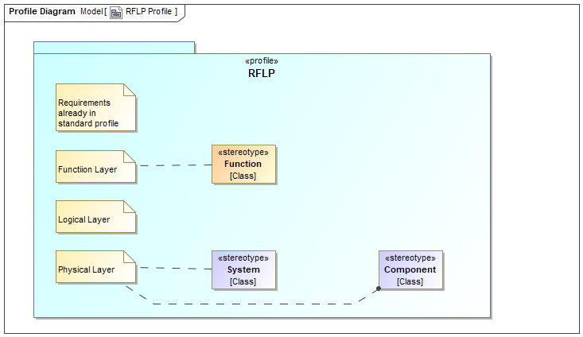

#### Properties

|  |  |
| --- | --- |
| *Element Type* | uml:Diagram |
| *Notation* | Profile Diagram |

# ▣  Original Requirement Specification

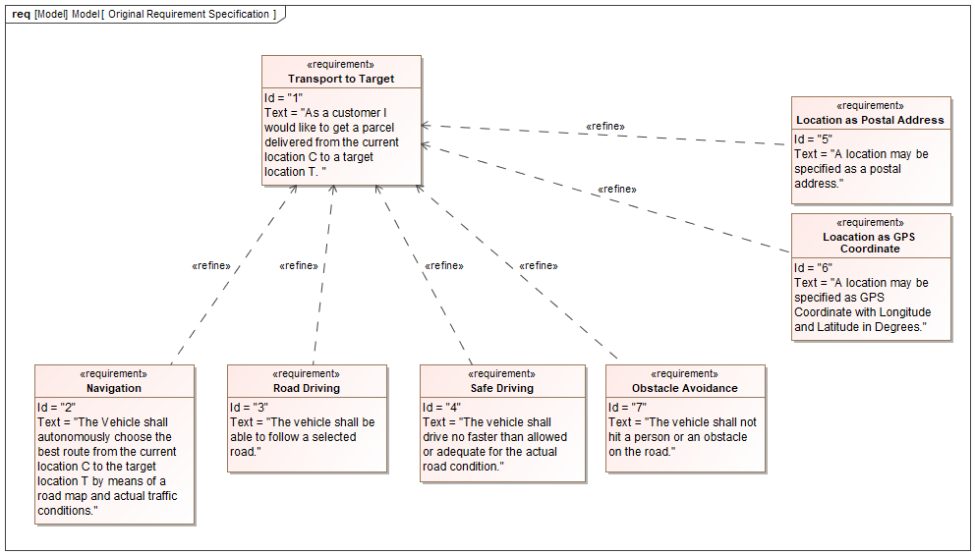

#### Properties

|  |  |
| --- | --- |
| *Element Type* | uml:Diagram |
| *Notation* | Requirement Diagram |

#### Statements

|  |  |  |
| --- | --- | --- |
| ▣  Original Requirement Specification | *shows* | Road Driving  Safe Driving  Navigation  Obstacle Avoidance  Transport to Target  Loacation as GPS Coordinate  Location as Postal Address |

### Transport to Target

#### Properties

|  |  |
| --- | --- |
| *Element Type* | sysml:Requirement |

#### Statements

|  |  |  |
| --- | --- | --- |
| Navigation  Road Driving  Safe Driving  Obstacle Avoidance  Loacation as GPS Coordinate  Location as Postal Address | *refines* | Transport to Target |
| ▣  Original Requirement Specification | *shows* | Transport to Target |

### Navigation

#### Properties

|  |  |
| --- | --- |
| *Element Type* | sysml:Requirement |

#### Statements

|  |  |  |
| --- | --- | --- |
| Navigation | *refines* | Transport to Target |
| Navigate | *satisfies* | Navigation |
| ▣  Original Requirement Specification  ▣  Functional Decomposition | *shows* | Navigation |

### Road Driving

#### Properties

|  |  |
| --- | --- |
| *Element Type* | sysml:Requirement |

#### Statements

|  |  |  |
| --- | --- | --- |
| Road Driving | *refines* | Transport to Target |
| Follow the Road | *satisfies* | Road Driving |
| ▣  Original Requirement Specification  ▣  Functional Decomposition | *shows* | Road Driving |

### Safe Driving

#### Properties

|  |  |
| --- | --- |
| *Element Type* | sysml:Requirement |

#### Statements

|  |  |  |
| --- | --- | --- |
| Safe Driving | *refines* | Transport to Target |
| Select an adequate Speed | *satisfies* | Safe Driving |
| ▣  Original Requirement Specification  ▣  Functional Decomposition | *shows* | Safe Driving |

### Obstacle Avoidance

#### Properties

|  |  |
| --- | --- |
| *Element Type* | sysml:Requirement |

#### Statements

|  |  |  |
| --- | --- | --- |
| Obstacle Avoidance | *refines* | Transport to Target |
| ▣  Original Requirement Specification | *shows* | Obstacle Avoidance |

### Location as Postal Address

#### Properties

|  |  |
| --- | --- |
| *Element Type* | sysml:Requirement |

#### Statements

|  |  |  |
| --- | --- | --- |
| Location as Postal Address | *refines* | Transport to Target |
| ▣  Original Requirement Specification | *shows* | Location as Postal Address |

### Loacation as GPS Coordinate

#### Properties

|  |  |
| --- | --- |
| *Element Type* | sysml:Requirement |

#### Statements

|  |  |  |
| --- | --- | --- |
| Loacation as GPS Coordinate | *refines* | Transport to Target |
| ▣  Original Requirement Specification | *shows* | Loacation as GPS Coordinate |

# ▣  Functional Decomposition

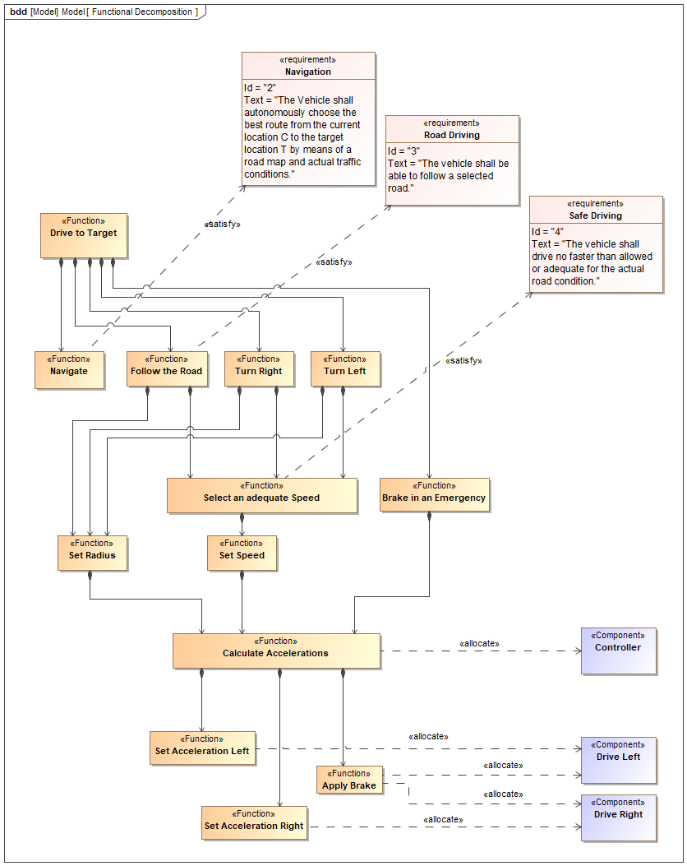

#### Properties

|  |  |
| --- | --- |
| *Element Type* | uml:Diagram |
| *Notation* | SysML Block Definition Diagram |

#### Statements

|  |  |  |
| --- | --- | --- |
| ▣  Functional Decomposition | *shows* | Controller  Follow the Road  Set Acceleration Right  Calculate Accelerations  Turn Right  Drive to Target  Navigate  Brake in an Emergency  Safe Driving  Navigation  Turn Left  Set Radius  Set Acceleration Left  Drive Right  Road Driving  Set Speed  Select an adequate Speed  Drive Left  Apply Brake |

### Drive to Target

Manoevre the vehicle from the current position to the selected target.

#### Properties

|  |  |
| --- | --- |
| *Element Type* | RFLP:Function |

#### Statements

|  |  |  |
| --- | --- | --- |
| Drive to Target | *has part* | Navigate  Follow the Road  Brake in an Emergency  Turn Right  Turn Left |
| ▣  Functional Decomposition | *shows* | Drive to Target |

### Navigate

Select a path to get from the current position to the target.

#### Properties

|  |  |
| --- | --- |
| *Element Type* | RFLP:Function |

#### Statements

|  |  |  |
| --- | --- | --- |
| Drive to Target | *has part* | Navigate |
| Navigate | *satisfies* | Navigation |
| ▣  Functional Decomposition | *shows* | Navigate |

### Follow the Road

Keep the vehicle on the selected road.

#### Properties

|  |  |
| --- | --- |
| *Element Type* | RFLP:Function |

#### Statements

|  |  |  |
| --- | --- | --- |
| Drive to Target | *has part* | Follow the Road |
| Follow the Road | *has part* | Set Radius  Select an adequate Speed |
| Follow the Road | *satisfies* | Road Driving |
| ▣  Functional Decomposition | *shows* | Follow the Road |

### Select an adequate Speed

Taking into account road condition and weather, select a safe speed.

#### Properties

|  |  |
| --- | --- |
| *Element Type* | RFLP:Function |

#### Statements

|  |  |  |
| --- | --- | --- |
| Turn Left  Turn Right  Follow the Road | *has part* | Select an adequate Speed |
| Select an adequate Speed | *has part* | Set Speed |
| Select an adequate Speed | *satisfies* | Safe Driving |
| ▣  Functional Decomposition | *shows* | Select an adequate Speed |

### Brake in an Emergency

Take the vehicle to a full stop in the shortest time possible without loosing control over the trajectory.

#### Properties

|  |  |
| --- | --- |
| *Element Type* | RFLP:Function |

#### Statements

|  |  |  |
| --- | --- | --- |
| Drive to Target | *has part* | Brake in an Emergency |
| Brake in an Emergency | *has part* | Calculate Accelerations |
| ▣  Functional Decomposition | *shows* | Brake in an Emergency |

### Set Radius

The (autonomous) driver's steering command (steering wheel position).

#### Properties

|  |  |
| --- | --- |
| *Element Type* | RFLP:Function |

#### Statements

|  |  |  |
| --- | --- | --- |
| Turn Left  Turn Right  Follow the Road | *has part* | Set Radius |
| Set Radius | *has part* | Calculate Accelerations |
| ▣  Functional Decomposition | *shows* | Set Radius |

### Set Speed

The (autonomous) driver's speed command (gas pedal position).

#### Properties

|  |  |
| --- | --- |
| *Element Type* | RFLP:Function |

#### Statements

|  |  |  |
| --- | --- | --- |
| Select an adequate Speed | *has part* | Set Speed |
| Set Speed | *has part* | Calculate Accelerations |
| ▣  Functional Decomposition | *shows* | Set Speed |

### Set Acceleration Left

#### Properties

|  |  |
| --- | --- |
| *Element Type* | RFLP:Function |

#### Statements

|  |  |  |
| --- | --- | --- |
| Calculate Accelerations | *has part* | Set Acceleration Left |
| Set Acceleration Left | *is allocated to* | Drive Left |
| ▣  Functional Decomposition | *shows* | Set Acceleration Left |

### Set Acceleration Right

#### Properties

|  |  |
| --- | --- |
| *Element Type* | RFLP:Function |

#### Statements

|  |  |  |
| --- | --- | --- |
| Calculate Accelerations | *has part* | Set Acceleration Right |
| Set Acceleration Right | *is allocated to* | Drive Right |
| ▣  Functional Decomposition | *shows* | Set Acceleration Right |

### Calculate Accelerations

#### Properties

|  |  |
| --- | --- |
| *Element Type* | RFLP:Function |

#### Statements

|  |  |  |
| --- | --- | --- |
| Set Radius  Set Speed  Brake in an Emergency | *has part* | Calculate Accelerations |
| Calculate Accelerations | *has part* | Set Acceleration Left  Set Acceleration Right  Apply Brake |
| Calculate Accelerations | *is allocated to* | Controller |
| ▣  Functional Decomposition | *shows* | Calculate Accelerations |

### Turn Right

Take a right turn at a road intersection. Observe the traffic entering the same lane and avoid a collision, if another vehicle does not observe the priority rules.

#### Properties

|  |  |
| --- | --- |
| *Element Type* | RFLP:Function |

#### Statements

|  |  |  |
| --- | --- | --- |
| Drive to Target | *has part* | Turn Right |
| Turn Right | *has part* | Set Radius  Select an adequate Speed |
| ▣  Functional Decomposition | *shows* | Turn Right |

### Turn Left

Take a left turn in a road intersection. Observe the priority rules and avoid traffic on the two lanes you are crossing.

#### Properties

|  |  |
| --- | --- |
| *Element Type* | RFLP:Function |

#### Statements

|  |  |  |
| --- | --- | --- |
| Drive to Target | *has part* | Turn Left |
| Turn Left | *has part* | Select an adequate Speed  Set Radius |
| ▣  Functional Decomposition | *shows* | Turn Left |

### Apply Brake

#### Properties

|  |  |
| --- | --- |
| *Element Type* | RFLP:Function |

#### Statements

|  |  |  |
| --- | --- | --- |
| Calculate Accelerations | *has part* | Apply Brake |
| Apply Brake | *is allocated to* | Drive Left  Drive Right |
| ▣  Functional Decomposition | *shows* | Apply Brake |

# ▣  Physical Decomposition

#### Properties

|  |  |
| --- | --- |
| *Element Type* | uml:Diagram |
| *Notation* | SysML Block Definition Diagram |

#### Statements

|  |  |  |
| --- | --- | --- |
| ▣  Physical Decomposition | *shows* | Controller  Support Front  Drive Right  Body  Chassis  Collision Alarm Sensor  LEGO Mindstorms Set  Support Rear  Track Sensor  LEGO Mindstorms Vehicle  Drive Left |

## LEGO Mindstorms Set

The wheel with motor and brake on the left side. The motor can accelerate and decelerate. The motor controller is "4-quadrant" and can supply electrical current for recharging the batteries.

#### Properties

|  |  |
| --- | --- |
| *Element Type* | Package |

#### Statements

|  |  |  |
| --- | --- | --- |
| LEGO Mindstorms Set | *contains* | LEGO Mindstorms Vehicle  Chassis  Body  Drive Left  Support Front  Support Rear  Controller  Track Sensor  Collision Alarm Sensor  Drive Right |
| ▣  Physical Decomposition | *shows* | LEGO Mindstorms Set |

### LEGO Mindstorms Vehicle

#### Properties

|  |  |
| --- | --- |
| *Element Type* | RFLP:System |

#### Statements

|  |  |  |
| --- | --- | --- |
| LEGO Mindstorms Set | *contains* | LEGO Mindstorms Vehicle |
| LEGO Mindstorms Vehicle | *has part* | Chassis  Body  Drive Left  Support Front  Support Rear  Controller  Track Sensor  Collision Alarm Sensor  Drive Right |
| ▣  Physical Decomposition | *shows* | LEGO Mindstorms Vehicle |

### Chassis

#### Properties

|  |  |
| --- | --- |
| *Element Type* | RFLP:Component |

#### Statements

|  |  |  |
| --- | --- | --- |
| LEGO Mindstorms Set | *contains* | Chassis |
| LEGO Mindstorms Vehicle | *has part* | Chassis |
| ▣  Physical Decomposition | *shows* | Chassis |

### Body

#### Properties

|  |  |
| --- | --- |
| *Element Type* | RFLP:Component |

#### Statements

|  |  |  |
| --- | --- | --- |
| LEGO Mindstorms Set | *contains* | Body |
| LEGO Mindstorms Vehicle | *has part* | Body |
| ▣  Physical Decomposition | *shows* | Body |

### Drive Left

The wheel with motor and brake on the left side. The motor can accelerate and decelerate. The motor controller is "4-quadrant" and can supply electrical current for recharging the batteries.

#### Properties

|  |  |
| --- | --- |
| *Element Type* | RFLP:Component |

#### Statements

|  |  |  |
| --- | --- | --- |
| LEGO Mindstorms Set | *contains* | Drive Left |
| LEGO Mindstorms Vehicle | *has part* | Drive Left |
| Set Acceleration Left  Apply Brake | *is allocated to* | Drive Left |
| ▣  Physical Decomposition  ▣  Functional Decomposition | *shows* | Drive Left |

### Support Front

#### Properties

|  |  |
| --- | --- |
| *Element Type* | RFLP:Component |

#### Statements

|  |  |  |
| --- | --- | --- |
| LEGO Mindstorms Set | *contains* | Support Front |
| LEGO Mindstorms Vehicle | *has part* | Support Front |
| ▣  Physical Decomposition | *shows* | Support Front |

### Support Rear

#### Properties

|  |  |
| --- | --- |
| *Element Type* | RFLP:Component |

#### Statements

|  |  |  |
| --- | --- | --- |
| LEGO Mindstorms Set | *contains* | Support Rear |
| LEGO Mindstorms Vehicle | *has part* | Support Rear |
| ▣  Physical Decomposition | *shows* | Support Rear |

### Controller

#### Properties

|  |  |
| --- | --- |
| *Element Type* | RFLP:Component |

#### Statements

|  |  |  |
| --- | --- | --- |
| LEGO Mindstorms Set | *contains* | Controller |
| LEGO Mindstorms Vehicle | *has part* | Controller |
| Calculate Accelerations | *is allocated to* | Controller |
| ▣  Physical Decomposition  ▣  Functional Decomposition | *shows* | Controller |

### Track Sensor

#### Properties

|  |  |
| --- | --- |
| *Element Type* | RFLP:Component |

#### Statements

|  |  |  |
| --- | --- | --- |
| LEGO Mindstorms Set | *contains* | Track Sensor |
| LEGO Mindstorms Vehicle | *has part* | Track Sensor |
| ▣  Physical Decomposition | *shows* | Track Sensor |

### Collision Alarm Sensor

#### Properties

|  |  |
| --- | --- |
| *Element Type* | RFLP:Component |

#### Statements

|  |  |  |
| --- | --- | --- |
| LEGO Mindstorms Set | *contains* | Collision Alarm Sensor |
| LEGO Mindstorms Vehicle | *has part* | Collision Alarm Sensor |
| ▣  Physical Decomposition | *shows* | Collision Alarm Sensor |

### Drive Right

The wheel with motor and brake on the right side. The motor can accelerate and decelerate. The motor controller is "4-quadrant" and can supply electrical current for recharging the batteries.

#### Properties

|  |  |
| --- | --- |
| *Element Type* | RFLP:Component |

#### Statements

|  |  |  |
| --- | --- | --- |
| LEGO Mindstorms Set | *contains* | Drive Right |
| LEGO Mindstorms Vehicle | *has part* | Drive Right |
| Set Acceleration Right  Apply Brake | *is allocated to* | Drive Right |
| ▣  Physical Decomposition  ▣  Functional Decomposition | *shows* | Drive Right |

# Model Elements (Glossary)

#### Properties

|  |  |
| --- | --- |
| *Element Type* | Model Elements (Glossary) |

### Apply Brake

#### Properties

|  |  |
| --- | --- |
| *Element Type* | RFLP:Function |

#### Statements

|  |  |  |
| --- | --- | --- |
| Calculate Accelerations | *has part* | Apply Brake |
| Apply Brake | *is allocated to* | Drive Left  Drive Right |
| ▣  Functional Decomposition | *shows* | Apply Brake |

### Body

#### Properties

|  |  |
| --- | --- |
| *Element Type* | RFLP:Component |

#### Statements

|  |  |  |
| --- | --- | --- |
| LEGO Mindstorms Set | *contains* | Body |
| LEGO Mindstorms Vehicle | *has part* | Body |
| ▣  Physical Decomposition | *shows* | Body |

### Brake in an Emergency

Take the vehicle to a full stop in the shortest time possible without loosing control over the trajectory.

#### Properties

|  |  |
| --- | --- |
| *Element Type* | RFLP:Function |

#### Statements

|  |  |  |
| --- | --- | --- |
| Drive to Target | *has part* | Brake in an Emergency |
| Brake in an Emergency | *has part* | Calculate Accelerations |
| ▣  Functional Decomposition | *shows* | Brake in an Emergency |

### Calculate Accelerations

#### Properties

|  |  |
| --- | --- |
| *Element Type* | RFLP:Function |

#### Statements

|  |  |  |
| --- | --- | --- |
| Set Radius  Set Speed  Brake in an Emergency | *has part* | Calculate Accelerations |
| Calculate Accelerations | *has part* | Set Acceleration Left  Set Acceleration Right  Apply Brake |
| Calculate Accelerations | *is allocated to* | Controller |
| ▣  Functional Decomposition | *shows* | Calculate Accelerations |

### Chassis

#### Properties

|  |  |
| --- | --- |
| *Element Type* | RFLP:Component |

#### Statements

|  |  |  |
| --- | --- | --- |
| LEGO Mindstorms Set | *contains* | Chassis |
| LEGO Mindstorms Vehicle | *has part* | Chassis |
| ▣  Physical Decomposition | *shows* | Chassis |

### Collision Alarm Sensor

#### Properties

|  |  |
| --- | --- |
| *Element Type* | RFLP:Component |

#### Statements

|  |  |  |
| --- | --- | --- |
| LEGO Mindstorms Set | *contains* | Collision Alarm Sensor |
| LEGO Mindstorms Vehicle | *has part* | Collision Alarm Sensor |
| ▣  Physical Decomposition | *shows* | Collision Alarm Sensor |

### Controller

#### Properties

|  |  |
| --- | --- |
| *Element Type* | RFLP:Component |

#### Statements

|  |  |  |
| --- | --- | --- |
| LEGO Mindstorms Set | *contains* | Controller |
| LEGO Mindstorms Vehicle | *has part* | Controller |
| Calculate Accelerations | *is allocated to* | Controller |
| ▣  Physical Decomposition  ▣  Functional Decomposition | *shows* | Controller |

### Drive Left

The wheel with motor and brake on the left side. The motor can accelerate and decelerate. The motor controller is "4-quadrant" and can supply electrical current for recharging the batteries.

#### Properties

|  |  |
| --- | --- |
| *Element Type* | RFLP:Component |

#### Statements

|  |  |  |
| --- | --- | --- |
| LEGO Mindstorms Set | *contains* | Drive Left |
| LEGO Mindstorms Vehicle | *has part* | Drive Left |
| Set Acceleration Left  Apply Brake | *is allocated to* | Drive Left |
| ▣  Physical Decomposition  ▣  Functional Decomposition | *shows* | Drive Left |

### Drive Right

The wheel with motor and brake on the right side. The motor can accelerate and decelerate. The motor controller is "4-quadrant" and can supply electrical current for recharging the batteries.

#### Properties

|  |  |
| --- | --- |
| *Element Type* | RFLP:Component |

#### Statements

|  |  |  |
| --- | --- | --- |
| LEGO Mindstorms Set | *contains* | Drive Right |
| LEGO Mindstorms Vehicle | *has part* | Drive Right |
| Set Acceleration Right  Apply Brake | *is allocated to* | Drive Right |
| ▣  Physical Decomposition  ▣  Functional Decomposition | *shows* | Drive Right |

### Drive to Target

Manoevre the vehicle from the current position to the selected target.

#### Properties

|  |  |
| --- | --- |
| *Element Type* | RFLP:Function |

#### Statements

|  |  |  |
| --- | --- | --- |
| Drive to Target | *has part* | Navigate  Follow the Road  Brake in an Emergency  Turn Right  Turn Left |
| ▣  Functional Decomposition | *shows* | Drive to Target |

### Follow the Road

Keep the vehicle on the selected road.

#### Properties

|  |  |
| --- | --- |
| *Element Type* | RFLP:Function |

#### Statements

|  |  |  |
| --- | --- | --- |
| Drive to Target | *has part* | Follow the Road |
| Follow the Road | *has part* | Set Radius  Select an adequate Speed |
| Follow the Road | *satisfies* | Road Driving |
| ▣  Functional Decomposition | *shows* | Follow the Road |

## LEGO Mindstorms Set

The wheel with motor and brake on the left side. The motor can accelerate and decelerate. The motor controller is "4-quadrant" and can supply electrical current for recharging the batteries.

#### Properties

|  |  |
| --- | --- |
| *Element Type* | Package |

#### Statements

|  |  |  |
| --- | --- | --- |
| LEGO Mindstorms Set | *contains* | LEGO Mindstorms Vehicle  Chassis  Body  Drive Left  Support Front  Support Rear  Controller  Track Sensor  Collision Alarm Sensor  Drive Right |
| ▣  Physical Decomposition | *shows* | LEGO Mindstorms Set |

### LEGO Mindstorms Vehicle

#### Properties

|  |  |
| --- | --- |
| *Element Type* | RFLP:System |

#### Statements

|  |  |  |
| --- | --- | --- |
| LEGO Mindstorms Set | *contains* | LEGO Mindstorms Vehicle |
| LEGO Mindstorms Vehicle | *has part* | Chassis  Body  Drive Left  Support Front  Support Rear  Controller  Track Sensor  Collision Alarm Sensor  Drive Right |
| ▣  Physical Decomposition | *shows* | LEGO Mindstorms Vehicle |

### Loacation as GPS Coordinate

#### Properties

|  |  |
| --- | --- |
| *Element Type* | sysml:Requirement |

#### Statements

|  |  |  |
| --- | --- | --- |
| Loacation as GPS Coordinate | *refines* | Transport to Target |
| ▣  Original Requirement Specification | *shows* | Loacation as GPS Coordinate |

### Location as Postal Address

#### Properties

|  |  |
| --- | --- |
| *Element Type* | sysml:Requirement |

#### Statements

|  |  |  |
| --- | --- | --- |
| Location as Postal Address | *refines* | Transport to Target |
| ▣  Original Requirement Specification | *shows* | Location as Postal Address |

### Navigate

Select a path to get from the current position to the target.

#### Properties

|  |  |
| --- | --- |
| *Element Type* | RFLP:Function |

#### Statements

|  |  |  |
| --- | --- | --- |
| Drive to Target | *has part* | Navigate |
| Navigate | *satisfies* | Navigation |
| ▣  Functional Decomposition | *shows* | Navigate |

### Navigation

#### Properties

|  |  |
| --- | --- |
| *Element Type* | sysml:Requirement |

#### Statements

|  |  |  |
| --- | --- | --- |
| Navigation | *refines* | Transport to Target |
| Navigate | *satisfies* | Navigation |
| ▣  Original Requirement Specification  ▣  Functional Decomposition | *shows* | Navigation |

### Obstacle Avoidance

#### Properties

|  |  |
| --- | --- |
| *Element Type* | sysml:Requirement |

#### Statements

|  |  |  |
| --- | --- | --- |
| Obstacle Avoidance | *refines* | Transport to Target |
| ▣  Original Requirement Specification | *shows* | Obstacle Avoidance |

### Road Driving

#### Properties

|  |  |
| --- | --- |
| *Element Type* | sysml:Requirement |

#### Statements

|  |  |  |
| --- | --- | --- |
| Road Driving | *refines* | Transport to Target |
| Follow the Road | *satisfies* | Road Driving |
| ▣  Original Requirement Specification  ▣  Functional Decomposition | *shows* | Road Driving |

### Safe Driving

#### Properties

|  |  |
| --- | --- |
| *Element Type* | sysml:Requirement |

#### Statements

|  |  |  |
| --- | --- | --- |
| Safe Driving | *refines* | Transport to Target |
| Select an adequate Speed | *satisfies* | Safe Driving |
| ▣  Original Requirement Specification  ▣  Functional Decomposition | *shows* | Safe Driving |

### Select an adequate Speed

Taking into account road condition and weather, select a safe speed.

#### Properties

|  |  |
| --- | --- |
| *Element Type* | RFLP:Function |

#### Statements

|  |  |  |
| --- | --- | --- |
| Turn Left  Turn Right  Follow the Road | *has part* | Select an adequate Speed |
| Select an adequate Speed | *has part* | Set Speed |
| Select an adequate Speed | *satisfies* | Safe Driving |
| ▣  Functional Decomposition | *shows* | Select an adequate Speed |

### Set Acceleration Left

#### Properties

|  |  |
| --- | --- |
| *Element Type* | RFLP:Function |

#### Statements

|  |  |  |
| --- | --- | --- |
| Calculate Accelerations | *has part* | Set Acceleration Left |
| Set Acceleration Left | *is allocated to* | Drive Left |
| ▣  Functional Decomposition | *shows* | Set Acceleration Left |

### Set Acceleration Right

#### Properties

|  |  |
| --- | --- |
| *Element Type* | RFLP:Function |

#### Statements

|  |  |  |
| --- | --- | --- |
| Calculate Accelerations | *has part* | Set Acceleration Right |
| Set Acceleration Right | *is allocated to* | Drive Right |
| ▣  Functional Decomposition | *shows* | Set Acceleration Right |

### Set Radius

The (autonomous) driver's steering command (steering wheel position).

#### Properties

|  |  |
| --- | --- |
| *Element Type* | RFLP:Function |

#### Statements

|  |  |  |
| --- | --- | --- |
| Turn Left  Turn Right  Follow the Road | *has part* | Set Radius |
| Set Radius | *has part* | Calculate Accelerations |
| ▣  Functional Decomposition | *shows* | Set Radius |

### Set Speed

The (autonomous) driver's speed command (gas pedal position).

#### Properties

|  |  |
| --- | --- |
| *Element Type* | RFLP:Function |

#### Statements

|  |  |  |
| --- | --- | --- |
| Select an adequate Speed | *has part* | Set Speed |
| Set Speed | *has part* | Calculate Accelerations |
| ▣  Functional Decomposition | *shows* | Set Speed |

### Support Front

#### Properties

|  |  |
| --- | --- |
| *Element Type* | RFLP:Component |

#### Statements

|  |  |  |
| --- | --- | --- |
| LEGO Mindstorms Set | *contains* | Support Front |
| LEGO Mindstorms Vehicle | *has part* | Support Front |
| ▣  Physical Decomposition | *shows* | Support Front |

### Support Rear

#### Properties

|  |  |
| --- | --- |
| *Element Type* | RFLP:Component |

#### Statements

|  |  |  |
| --- | --- | --- |
| LEGO Mindstorms Set | *contains* | Support Rear |
| LEGO Mindstorms Vehicle | *has part* | Support Rear |
| ▣  Physical Decomposition | *shows* | Support Rear |

### Track Sensor

#### Properties

|  |  |
| --- | --- |
| *Element Type* | RFLP:Component |

#### Statements

|  |  |  |
| --- | --- | --- |
| LEGO Mindstorms Set | *contains* | Track Sensor |
| LEGO Mindstorms Vehicle | *has part* | Track Sensor |
| ▣  Physical Decomposition | *shows* | Track Sensor |

### Transport to Target

#### Properties

|  |  |
| --- | --- |
| *Element Type* | sysml:Requirement |

#### Statements

|  |  |  |
| --- | --- | --- |
| Navigation  Road Driving  Safe Driving  Obstacle Avoidance  Loacation as GPS Coordinate  Location as Postal Address | *refines* | Transport to Target |
| ▣  Original Requirement Specification | *shows* | Transport to Target |

### Turn Left

Take a left turn in a road intersection. Observe the priority rules and avoid traffic on the two lanes you are crossing.

#### Properties

|  |  |
| --- | --- |
| *Element Type* | RFLP:Function |

#### Statements

|  |  |  |
| --- | --- | --- |
| Drive to Target | *has part* | Turn Left |
| Turn Left | *has part* | Select an adequate Speed  Set Radius |
| ▣  Functional Decomposition | *shows* | Turn Left |

### Turn Right

Take a right turn at a road intersection. Observe the traffic entering the same lane and avoid a collision, if another vehicle does not observe the priority rules.

#### Properties

|  |  |
| --- | --- |
| *Element Type* | RFLP:Function |

#### Statements

|  |  |  |
| --- | --- | --- |
| Drive to Target | *has part* | Turn Right |
| Turn Right | *has part* | Set Radius  Select an adequate Speed |
| ▣  Functional Decomposition | *shows* | Turn Right |