CoCoML Class-Diagram with Stereotypes

# ▣  Class-Diagram_with_Stereotypes

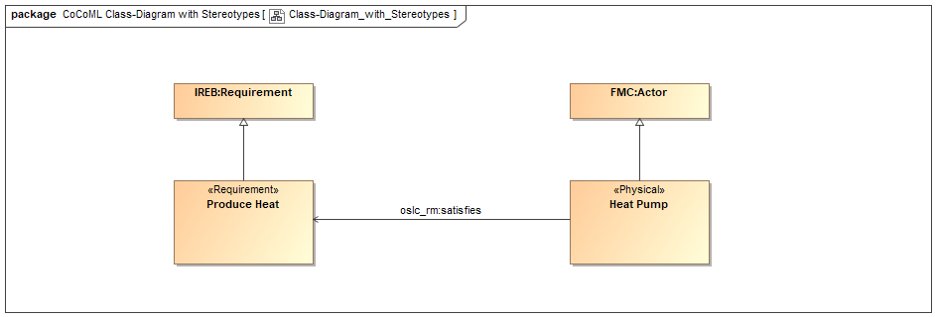

#### Properties

|  |  |
| --- | --- |
| *Element Type* | Model Diagram |
| *Notation* | Class Diagram |

#### Statements

|  |  |  |
| --- | --- | --- |
| ▣  Class-Diagram_with_Stereotypes | *shows* | ↯  Produce Heat  Requirement  Actor  ■  Heat Pump |

# ↯  Produce Heat

#### Properties

|  |  |
| --- | --- |
| *Element Type* | RFLP:Requirement |

#### Statements

|  |  |  |
| --- | --- | --- |
| ■  Heat Pump | *satisfies* | ↯  Produce Heat |
| ↯  Produce Heat | *specializes* | Requirement |
| ▣  Class-Diagram_with_Stereotypes | *shows* | ↯  Produce Heat |

# ■  Heat Pump

#### Properties

|  |  |
| --- | --- |
| *Element Type* | RFLP:Physical |

#### Statements

|  |  |  |
| --- | --- | --- |
| ■  Heat Pump | *satisfies* | ↯  Produce Heat |
| ■  Heat Pump | *specializes* | Actor |
| ▣  Class-Diagram_with_Stereotypes | *shows* | ■  Heat Pump |

# Actor

#### Properties

|  |  |
| --- | --- |
| *Element Type* | Class |

#### Statements

|  |  |  |
| --- | --- | --- |
| ■  Heat Pump | *specializes* | Actor |
| ▣  Class-Diagram_with_Stereotypes | *shows* | Actor |

# Requirement

#### Properties

|  |  |
| --- | --- |
| *Element Type* | Class |

#### Statements

|  |  |  |
| --- | --- | --- |
| ↯  Produce Heat | *specializes* | Requirement |
| ▣  Class-Diagram_with_Stereotypes | *shows* | Requirement |

# Model Elements (Glossary)

#### Properties

|  |  |
| --- | --- |
| *Element Type* | Model Elements (Glossary) |

### Actor

#### Properties

|  |  |
| --- | --- |
| *Element Type* | Class |

#### Statements

|  |  |  |
| --- | --- | --- |
| ■  Heat Pump | *specializes* | Actor |
| ▣  Class-Diagram_with_Stereotypes | *shows* | Actor |

### ■  Heat Pump

#### Properties

|  |  |
| --- | --- |
| *Element Type* | RFLP:Physical |

#### Statements

|  |  |  |
| --- | --- | --- |
| ■  Heat Pump | *satisfies* | ↯  Produce Heat |
| ■  Heat Pump | *specializes* | Actor |
| ▣  Class-Diagram_with_Stereotypes | *shows* | ■  Heat Pump |

### Requirement

#### Properties

|  |  |
| --- | --- |
| *Element Type* | Class |

#### Statements

|  |  |  |
| --- | --- | --- |
| ↯  Produce Heat | *specializes* | Requirement |
| ▣  Class-Diagram_with_Stereotypes | *shows* | Requirement |

### ↯  Produce Heat

#### Properties

|  |  |
| --- | --- |
| *Element Type* | RFLP:Requirement |

#### Statements

|  |  |  |
| --- | --- | --- |
| ■  Heat Pump | *satisfies* | ↯  Produce Heat |
| ↯  Produce Heat | *specializes* | Requirement |
| ▣  Class-Diagram_with_Stereotypes | *shows* | ↯  Produce Heat |