CoCoML Class Diagram

# ▣  UML_Class_Diagram_(native)

A directed association in UML means that only one side knows about the other. In SpecIF every association is a statement with subject, predicate and object, hence directed like RDF statements. When translating a UML/SysML class diagram to SpecIF and further on to OWL/RDF:

* In case of a composition and aggregation, the class with the rhombus is the subject and the arrow is ignored.
* In case of a general association, the arrow is interpreted as the direction according to RDF. Thus, the arrow póints from subject to object.

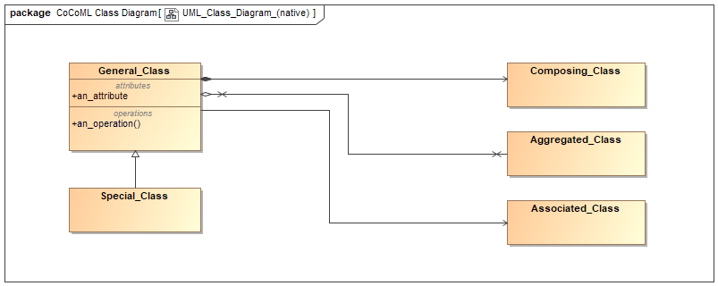

#### Properties

|  |  |
| --- | --- |
| *Element Type* | uml:Diagram |
| *Notation* | Class Diagram |

#### Statements

|  |  |  |
| --- | --- | --- |
| ▣  UML_Class_Diagram_(native) | *shows* | Special_Class  ●  an_attribute  Composing_Class  Aggregated_Class  General_Class  Associated_Class  ■  an_operation |

# General_Class

A general class.

#### Properties

|  |  |
| --- | --- |
| *Element Type* | uml:Class |

#### Statements

|  |  |  |
| --- | --- | --- |
| General_Class | *has part* | ●  an_attribute  ■  an_operation  Aggregated_Class  Composing_Class |
| General_Class | *associated with* | Associated_Class |
| Special_Class | *specializes* | General_Class |
| ▣  UML_Class_Diagram_(native) | *shows* | General_Class |

### ●  an_attribute

#### Properties

|  |  |
| --- | --- |
| *Element Type* | uml:Property |

#### Statements

|  |  |  |
| --- | --- | --- |
| General_Class | *has part* | ●  an_attribute |
| ▣  UML_Class_Diagram_(native) | *shows* | ●  an_attribute |

### ■  an_operation

#### Properties

|  |  |
| --- | --- |
| *Element Type* | uml:Operation |

#### Statements

|  |  |  |
| --- | --- | --- |
| General_Class | *has part* | ■  an_operation |
| ▣  UML_Class_Diagram_(native) | *shows* | ■  an_operation |

# Special_Class

#### Properties

|  |  |
| --- | --- |
| *Element Type* | uml:Class |

#### Statements

|  |  |  |
| --- | --- | --- |
| Special_Class | *specializes* | General_Class |
| ▣  UML_Class_Diagram_(native) | *shows* | Special_Class |

# Composing_Class

A class for components of a class.

#### Properties

|  |  |
| --- | --- |
| *Element Type* | uml:Class |

#### Statements

|  |  |  |
| --- | --- | --- |
| General_Class | *has part* | Composing_Class |
| ▣  UML_Class_Diagram_(native) | *shows* | Composing_Class |

# Aggregated_Class

#### Properties

|  |  |
| --- | --- |
| *Element Type* | uml:Class |

#### Statements

|  |  |  |
| --- | --- | --- |
| General_Class | *has part* | Aggregated_Class |
| ▣  UML_Class_Diagram_(native) | *shows* | Aggregated_Class |

# Associated_Class

#### Properties

|  |  |
| --- | --- |
| *Element Type* | uml:Class |

#### Statements

|  |  |  |
| --- | --- | --- |
| General_Class | *associated with* | Associated_Class |
| ▣  UML_Class_Diagram_(native) | *shows* | Associated_Class |

# Model Elements (Glossary)

#### Properties

|  |  |
| --- | --- |
| *Element Type* | Model Elements (Glossary) |

### Aggregated_Class

#### Properties

|  |  |
| --- | --- |
| *Element Type* | uml:Class |

#### Statements

|  |  |  |
| --- | --- | --- |
| General_Class | *has part* | Aggregated_Class |
| ▣  UML_Class_Diagram_(native) | *shows* | Aggregated_Class |

### ●  an_attribute

#### Properties

|  |  |
| --- | --- |
| *Element Type* | uml:Property |

#### Statements

|  |  |  |
| --- | --- | --- |
| General_Class | *has part* | ●  an_attribute |
| ▣  UML_Class_Diagram_(native) | *shows* | ●  an_attribute |

### ■  an_operation

#### Properties

|  |  |
| --- | --- |
| *Element Type* | uml:Operation |

#### Statements

|  |  |  |
| --- | --- | --- |
| General_Class | *has part* | ■  an_operation |
| ▣  UML_Class_Diagram_(native) | *shows* | ■  an_operation |

### Associated_Class

#### Properties

|  |  |
| --- | --- |
| *Element Type* | uml:Class |

#### Statements

|  |  |  |
| --- | --- | --- |
| General_Class | *associated with* | Associated_Class |
| ▣  UML_Class_Diagram_(native) | *shows* | Associated_Class |

### Composing_Class

A class for components of a class.

#### Properties

|  |  |
| --- | --- |
| *Element Type* | uml:Class |

#### Statements

|  |  |  |
| --- | --- | --- |
| General_Class | *has part* | Composing_Class |
| ▣  UML_Class_Diagram_(native) | *shows* | Composing_Class |

### General_Class

A general class.

#### Properties

|  |  |
| --- | --- |
| *Element Type* | uml:Class |

#### Statements

|  |  |  |
| --- | --- | --- |
| General_Class | *has part* | ●  an_attribute  ■  an_operation  Aggregated_Class  Composing_Class |
| General_Class | *associated with* | Associated_Class |
| Special_Class | *specializes* | General_Class |
| ▣  UML_Class_Diagram_(native) | *shows* | General_Class |

### Special_Class

#### Properties

|  |  |
| --- | --- |
| *Element Type* | uml:Class |

#### Statements

|  |  |  |
| --- | --- | --- |
| Special_Class | *specializes* | General_Class |
| ▣  UML_Class_Diagram_(native) | *shows* | Special_Class |