FUNCTIONAL ARCHITECTURES
Working group OF
GESELLSCHAFT FÜR
SYSTEMS ENGINEERING e.V.
How to set up a SysML v2
pilot installation
on Ubuntu

Jesko Lamm, Axel Berres, Tim Weilkiens
fas@gfse.de

Copyright 2023 Gesellschaft für Systems Engineering e.V. (GfSE)
Licensed under the Apache License, Version 2.0 (the "License"); you may not use this file except in compliance with the License. You may obtain a copy of the License at http://www.apache.org/licenses/LICENSE-2.0
Unless required by applicable law or agreed to in writing, software distributed under the License is distributed on an "AS IS" BASIS, WITHOUT WARRANTIES OR CONDITIONS OF ANY KIND, either express or implied.
See the License for the specific language governing permissions and limitations under the License.

Table of contents
Table of contents 3
Scope and Preconditions 4
Preparation of Ubuntu 4
Preconditions 4
Preparation 5
Docker Installation and Postgres setup 5
Remove Docker container 5
Java Installation 5
sbt Installation 5
Providing a local SysML2 API service 6
Trying it out 7
Install the SysML v2 reference implementation 8

Scope and Preconditions
The purpose of this how-to is to show local installation and use of SysML v2 open source pilot implementation. This is a necessary step to create, test and use a working architecture plugin for SysML v2. This document is for Ubuntu operating systems. However, a separate document is also available for Windows.
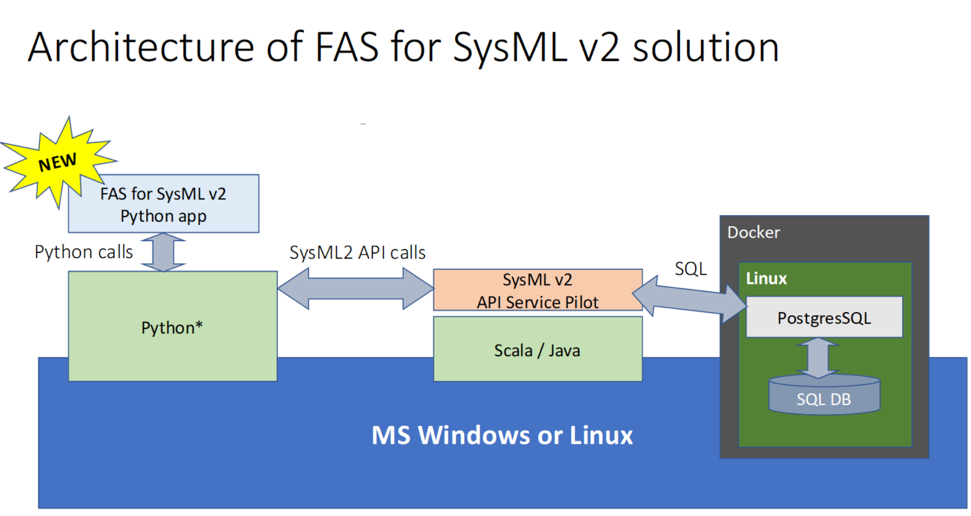
This document describes how to set up the pilot environment as shown below to use or contribute to the development of the FAS plugin for SysML v2. The document refers to the manuals available on the GitHub pages of the SysML v2 pilot implementation. The manuals are combined into one how-to. In addition, there are notes based on our experiences during the implementation.
Figure 1 Pilot environment for SysML v2

Preparation of Ubuntu
One consideration for computers with low RAM is the use of swap space. To ensure sufficient swap space, the following instructions will configure 16 GB of swap space. After setting up the swap space, the computer must be restarted.
sudo rm /swapfile
sudo fallocate -l 16G /swapfile
sudo chmod 600 /swapfile
sudo mkswap /swapfile
sudo swapon /swapfile

Preconditions
Before starting to set up the environment, some programs must be installed. Furthermore, the source code for the SysML v2 Pilot implementation is required. The following list describes the programs that must be installed:
- Docker (https://www.docker.com/)
=> This should be installed from Ubuntu's package sources

- Java JDK or OpenJDK 11 (https://openjdk.org/)
=> This should be installed from Ubuntu's package source

- Scala’s Simple Build Tool `sbt` (https://www.scala-sbt.org/index.html)
=> This should be installed according to the Debian-based instructions on its home page


Reshuffle the installation order is recommended. The installation of the SysML reference installation requires most memory. Run it first, in order to have RAM that will later be occupied by docker.

Preparation
To provide a unique environment, docker was chosen to set up the database backend. The following instructions show the installation and startup instructions to run a PostgresSQL database in a docker container.

Docker Installation and Postgres setup
Run the following commands in a terminal window, as far as not done earlier on your Ubuntu installation:
sudo apt-get install docker.io
If the docker daemon is not started:
sudo dockerd
(to be repeated on each boot)
sudo docker pull postgres
sudo docker run --name sysml2-postgres -p 5432:5432 -e POSTGRES_PASSWORD=mysecretpassword -e POSTGRES_DB=sysml2 -d postgres
And on next boot (if not configured to run automatically):
sudo docker start sysml2-postgres
For the assumed pilot use, the password has to be exactly as shown in the screenshot above. Do not change it for use of the pilot implementation – but remember it is NOT for production use.

Remove Docker container
A Docker container can be removed with the following command.
sudo docker rm sysml2-postgres

Java Installation
If Java JDK 11 is not installed, install it - for example like this.
sudo apt-get install openjdk-11-jdk

sbt Installation
If sbt is not installed, install it according to https://www.scala-sbt.org/index.html, this means
sudo apt-get install curl

echo "deb https://repo.scala-sbt.org/scalasbt/debian all main" | sudo tee /etc/apt/sources.list.d/sbt.list
echo "deb https://repo.scala-sbt.org/scalasbt/debian /" | sudo tee /etc/apt/sources.list.d/sbt_old.list
curl -sL "https://keyserver.ubuntu.com/pks/lookup?op=get&search=0x2EE0EA64E40A89B84B2DF73499E82A75642AC823" | sudo apt-key add
sudo apt-get update
sudo apt-get install sbt

Providing a local SysML2 API service
Clone the required resources available from https://github.com/Systems-Modeling/SysML-v2-API-Services. After cloning, follow the following steps.
If you do not know how to clone from git, use the “Download” button to download a ZIP archive with latest branch content. Then extract it.


From now on each step may take some time, be patient it is a pilot implementation.

In PowerShell, switch to the local copy of the SysML v2 API Services folder. Then take the following steps:
sbt clean
- if the clean was successful, now that project can be created
- during this step the content of the directory ~/.sbt/1.0/plugins is cleaned up
sbt run
- now many log messages are displayed, please wait until the following line appears:
… (Server started, use Enter to stop …
Now you can switch to the browser and call the page localhost:9000/docs/. Now you have to wait again, because `sbt` is compiling the code. For this reason, it may take a few minutes until the server responds.
The first time it takes a long time because DB structure must be created.

Done, now you have a SysML 2 service to experiment with. You can now make REST/HTTP requests to your local SysML v2 API and Services web application either via Swagger doc, or via any REST/HTTP client such as Postman.
The database will be deleted and recreated on each start of the service. See the corresponding section in the Windows how-to document to learn how to avoid that.

Here is a hint for improving performance: You can redirect output to the “null” device to avoid wasting time on the delivery of UI output (however, the disadvantage is not be able to monitor via the UI what the service is doing).

This would be the command with redirection to the “null” device:
> sbt run > /dev/null

Trying it out
To find out how to try and test the components you installed so far, see the corresponding sections in the Windows wow-to:
https://github.com/GfSE/fas4sysmlv2/blob/main/doc/tech-docs/sysmlv2-pilot/installation_howto_windows.odt
The installed components should be platform-independent and should therefore work the same across platforms.

Install the SysML v2 reference implementation
Follow these instructions: https://github.com/Systems-Modeling/SysML-v2-Release/tree/master/install/jupyter
In case the process is interrupted with a “Killed” message, look at the considerations for low RAM in the Preconditions sections further above.
IMPORTANT NOTE #1:
The installation under miniconda may run quite long, and a network connection is required all the time. It may be recommended to disable power management options that stop the computer or its network:
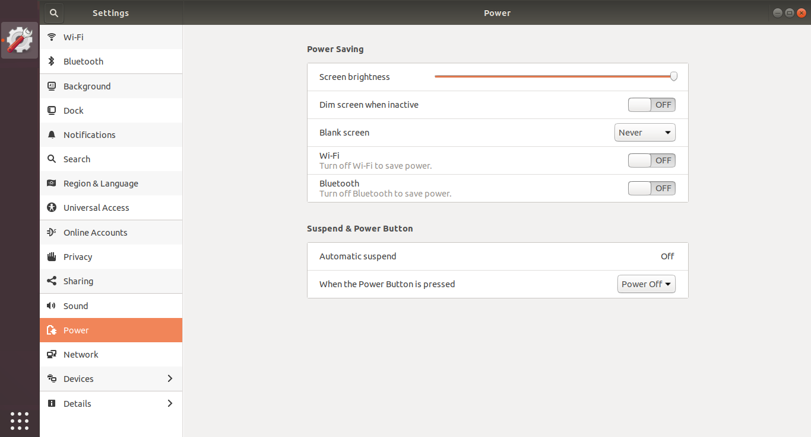

IMPORTANT NOTE #2:
In one case it was observed that the kernel for jupyter was not automatically deployed into the right location. Here is the procedure to manually complete its deployment:
- Find the sysml package that has been installed by the above installation procedure. It resides in <miniconda home>/pkgs/jupyter-sysml-kernel-<version>
- Go to the sub-directory “share/jupyter/kernels” of the above directory
- Use cp -r to copy the “sysml” sub-directory of the current directory to <miniconda home>/share/jupyter/kernels
- Go to <miniconda home>/share/jupyter/kernels/sysml and note the precise name of the .jar file in that directory. Now open the file kernel.json with an editor (e.g. gedit) and enter the full path and name of the .jar file in the third parameter line under “argv”
IMPORTANT NOTE #3:
The default URL of the database server is configured to a public database of a company called “Intercax”. If you don’t want to mess with their database, you need to reconfigure the database URL to point to your own local SysML2 API service:
- Open the kernel.json file with an editor (e.g. gedit).
It can be found in
~/miniconda3/share/jupyter/kernels/sysml
- Change “intercax.com” to “localhost”:
