Gesellschaft für Systems Engineering e.V.
Functional Architectures Working Group
SysML v2 pilot installation for FAS - HowTo

Subject: Making the OpenSource pilot implementation of SysML2 run locally, in otder to create a functional architectures plugin for SysML2

Copyright 2022 Gesellschaft für Systems Engineering e.V. (GfSE)
Licensed under the Apache License, Version 2.0 (the "License");
you may not use this file except in compliance with the License.
You may obtain a copy of the License at
http://www.apache.org/licenses/LICENSE-2.0
Unless required by applicable law or agreed to in writing, software
distributed under the License is distributed on an "AS IS" BASIS,
WITHOUT WARRANTIES OR CONDITIONS OF ANY KIND, either express or implied.
See the License for the specific language governing permissions and
limitations under the License.

Scope and Purpose
This document describes how to set up the pilot environment as shown below, for contributing to the development of the FAS plugin for SysML v2.

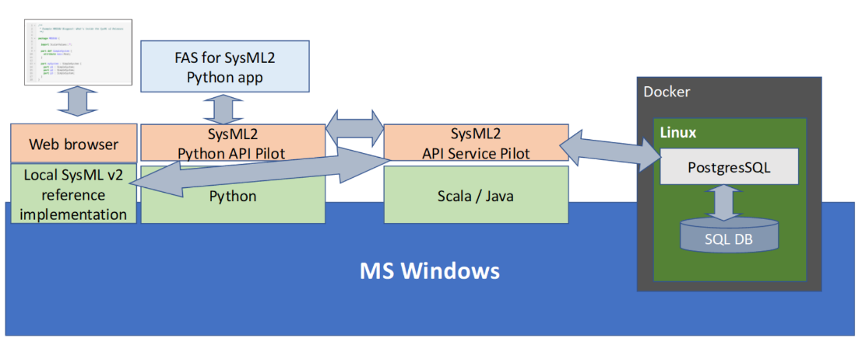
The document references manuals from the GitHub pages of the SysML v2 pilot implementation. It provides additional annotations.

Providing a local SysML2 API service

- See the following instructions for installation and startup instructions to run a PostgresSQL database in a docker container and the corresponding scala code to host the SysML2 service on top:
  - Install docker. Make sure that Microsoft’s WSL (Windows Subsystem for Linux) is installed from Microsoft store.
The processor’s virtualization must be enabled via Bios settings.
Docker desktop may need to be started via “Run as administrator”.
  - Cmd prompt may need to be started via “Run as administrator”.
  - Run the instructions from https://github.com/Systems-Modeling/SysML-v2-API-Services up to the point where the docker pull command needs to be run.
NOTE: The precise docker pull command is “docker pull postgres”

  - Go here: GitHub - Systems-Modeling/SysML-v2-API-Services: Proof-of-concept pilot implementation for the Systems Modeling API and Services.
Select “Code” -> “Download zip”:
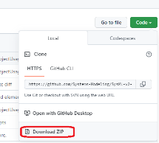

Extract the above ZIP archive and do the following in the extracted folder:
- Run sbt clean on the command prompt
- Run sbt run on the command prompt
- Go to “localhost:9000/docs/” with a web browser. This will trigger some initialization the first time. Then the REST API can be accessed.You can now make REST/HTTP requests to your local SysML v2 API and Services web application either via Swagger doc, or via any REST/HTTP client such as Postman.
- If you want to allow any client to connect to the server (not just localhost, which is the only one that can connect by default):
Find the application.conf file and add the line “play.filters.disabled+=play.filters.hosts.AllowedHostsFilter” as follows:
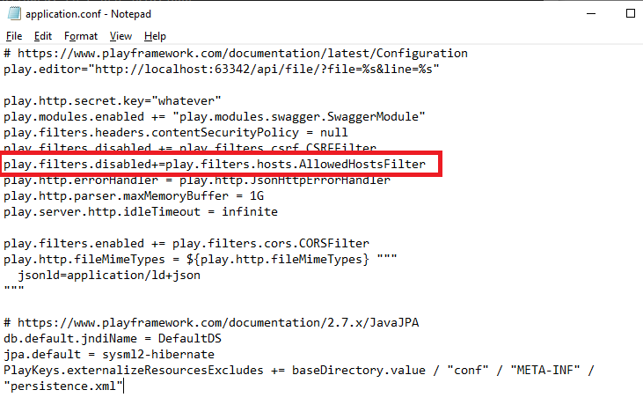

NOTE: To delete the sample docker container that was installed during the above, use “docker rm sysml2-postgres”.

Some notes on restarting the database and the service,
once they have been taken into use:

After a fresh boot, one needs to
- Start docker desktop via “run as administrator”
- Start the docker container with the PostGres SQL database
- Go to the folder with SysML2 API an call “sbt run” again
- Open “localhost:9000/docs/” once or even a second time
- Wait for the SysML2 API to re-do some database table maintenance it seems to do after each new start (TO BE DONE: Is this caused by a configuration flaw that can be avoided?):
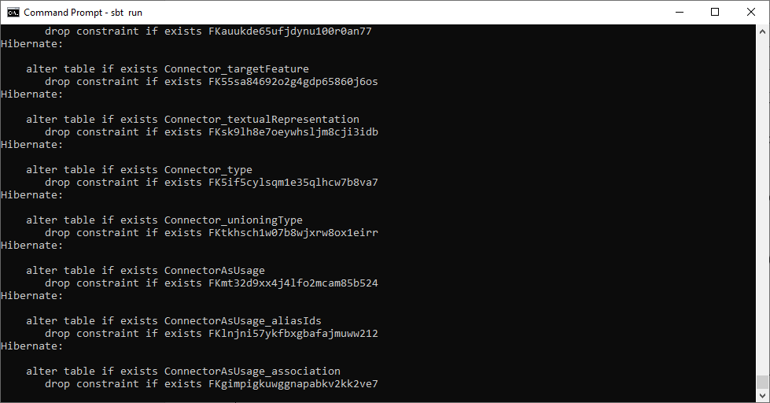
=> This may take some time, especially on a slow computer.
So plan for enough time in advance!

Testing the local SysML v2 API Pilot Service

- Once the Rest API responds to localhost:9000/docs/, use that page to create a dummy project as a new project, as follows:
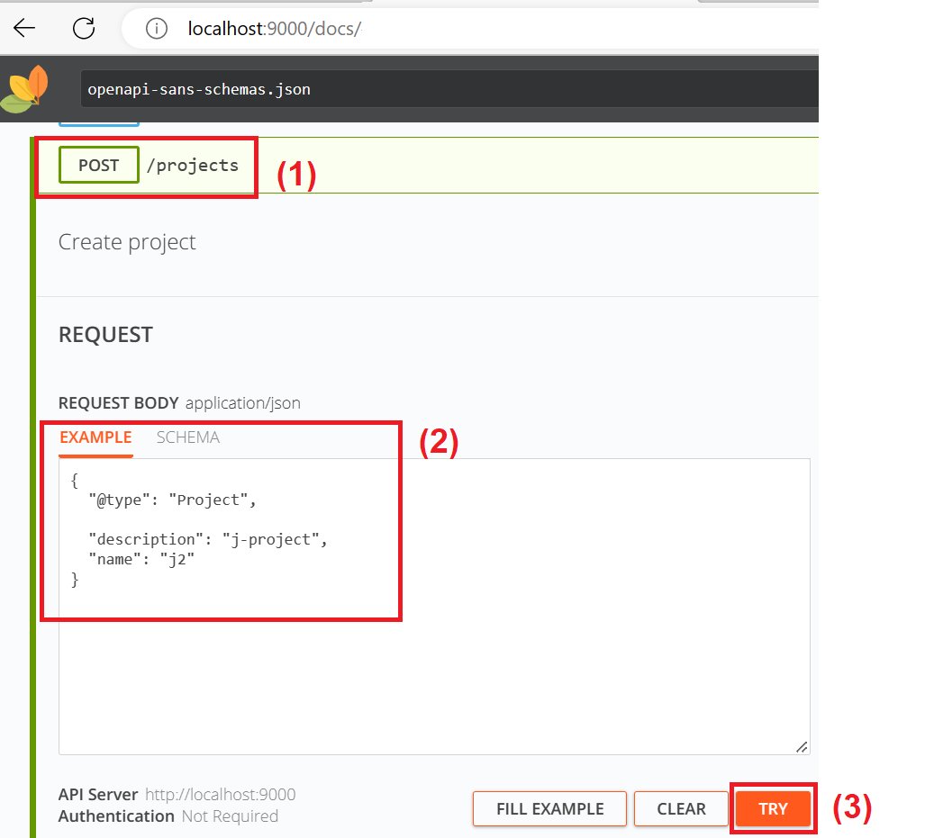

OBSERVATION: The example shown in the screenshot above is different from the default example that is shown by the API. We needed to get rid of the “id” field from the default example. It is suspected that this is the case for more of the default examples shown by the API: If you get an error message, remove the id. Then it may work.

Making the SysML2 API run in python
- Download the sysml2 api repository:
Go to the github homepage of the API (https://github.com/Systems-Modeling/SysML-v2-API-Python-Client ) and proceed according to the screenshot below.
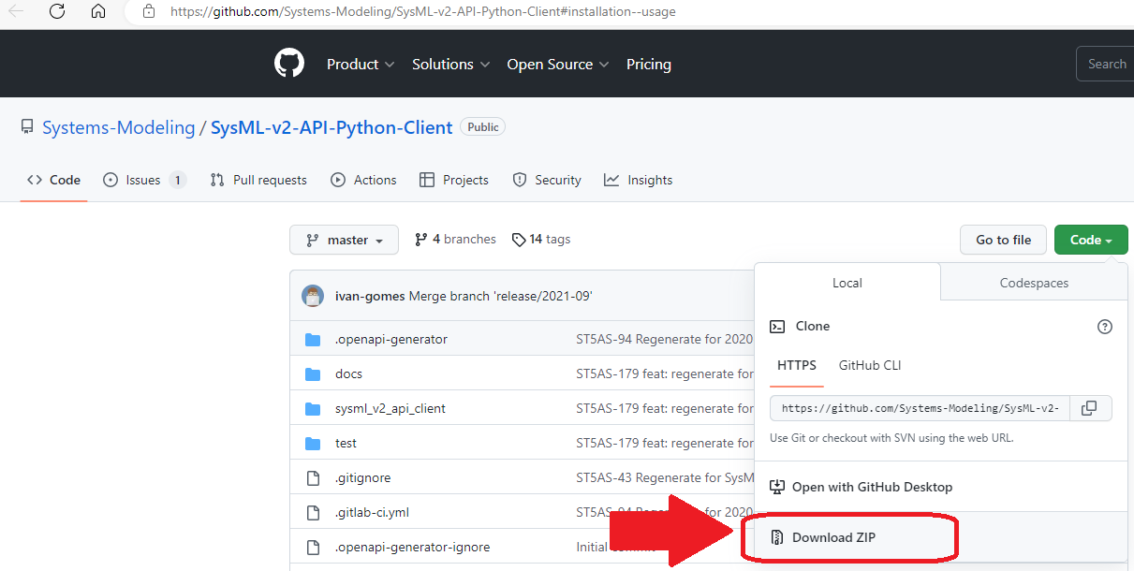
- Use pip install on the downloaded package:
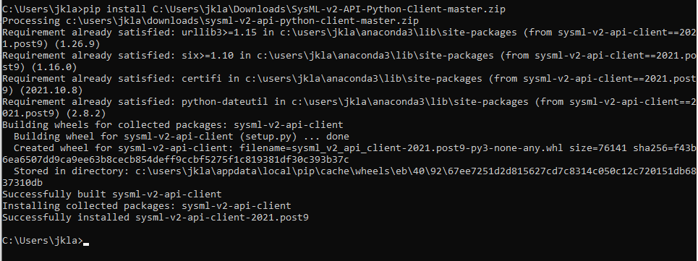

Run a sample python program to query for the created project

The following python code can be stored in a file “Test.py” and executed with the command “python Test.py”:

from __future__ import print_function
import time
import sysml_v2_api_client
from sysml_v2_api_client.rest import ApiException
from pprint import pprint
# Defining the host is optional and defaults to http://localhost
# See configuration.py for a list of all supported configuration parameters.
configuration = sysml_v2_api_client.Configuration(
host = "http://localhost:9000"
)

# Enter a context with an instance of the API client
with sysml_v2_api_client.ApiClient(configuration) as api_client:
# Create an instance of the API class
api_instance = sysml_v2_api_client.ProjectApi(api_client)

try:
# Get projects
api_response = api_instance.get_projects()
pprint(api_response)
except ApiException as e:
print("Exception when calling ProjectApi->get_projects: %s\n" % e)

Familiarize yourself with the Rest API
The following video (second part) explains the API: https://www.youtube.com/watch?v=vj5BOy5G8ho

Install the SysML v2 reference implementation
Follow these instructions: https://github.com/Systems-Modeling/SysML-v2-Release/tree/master/install/jupyter

IMPORTANT:
The default URL of the database server is configured to a public database of a company called “Intercax”. If you don’t want to mess with their database, you need to reconfigure the database URL to point to your own local SysML2 API service:
- Open the kernel.json file.
It can be found in
C:\Users\<user name>\AppData\Local\miniconda3\share\jupyter\kernels\sysml
- Change “intercax.com” to “localhost”:
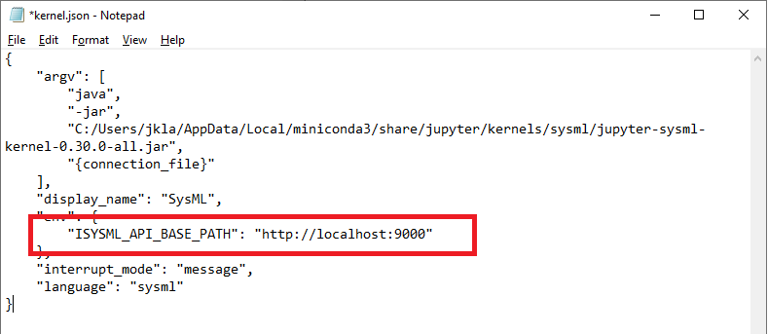

Try out the SysML v2 reference implementation

Invoke “jupyter notebook” from a “cmd” prompt. Then open an empty SysML sheet.

Paste the following into the notebook and execute it:

action def GetMoney {
out money;
}
action def MonitorPayment {
in money;
out clearance;
}
action def ProvideMusicTrack {
in clearance;
out music_track;
}
action def PlayMusicTrack {
in music_track;
out audio_signal;
}
action def ProduceSound {
in audio_signal;
}
action def OverallUseCase {
action a1:GetMoney;
action a2:MonitorPayment;
action a3:ProvideMusicTrack;
action a4:PlayMusicTrack;
action a5:ProduceSound;
flow from a1.money to a2.money;
flow from a2.clearance to a3.clearance;
flow from a3.music_track to a4.music_track;
flow from a4.audio_signal to a5.audio_signal;
}

Use “%viz OverallUseCase” to visualize.
Use “%publish OveralluseCase” to publish to the repository

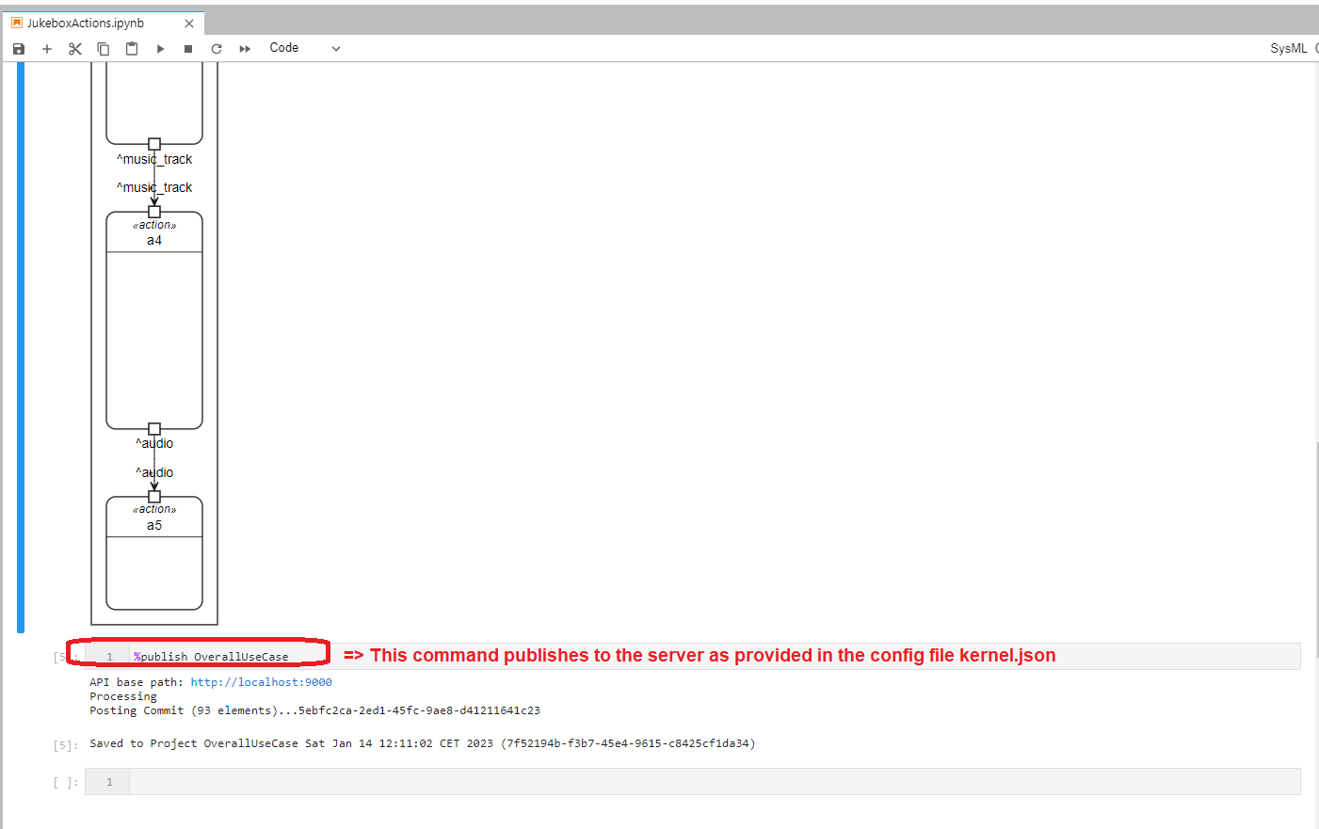

You can use the python script Test.py as shown further above, in order to verify that a project has been created on the server, during publication to the server:

