FUNCTIONAL ARCHITECTURES
Working group OF
GESELLSCHAFT FÜR
SYSTEMS ENGINEERING e.V.
How to set up a SysML v2
pilot installation
on Windows

Jesko Lamm, Axel Berres, Tim Weilkiens
fas@gfse.de

Copyright 2023 Gesellschaft für Systems Engineering e.V. (GfSE)
Licensed under the Apache License, Version 2.0 (the "License"); you may not use this file except in compliance with the License. You may obtain a copy of the License at http://www.apache.org/licenses/LICENSE-2.0
Unless required by applicable law or agreed to in writing, software distributed under the License is distributed on an "AS IS" BASIS, WITHOUT WARRANTIES OR CONDITIONS OF ANY KIND, either express or implied.
See the License for the specific language governing permissions and limitations under the License.

Table of contents
Table of Contents
Table of contents 3
Scope and Preconditions 4
Scope 4
Preconditions 4
Preparation 5
Get a postgres image 5
Start the container 5
Check with a client 6
In case the container should be deleted 6
Providing a local SysML2 API service 7
Restarting the service 7
Testing the local SysML v2 API Pilot Service 9
Run a sample python program to query for the created project 10
Familiarize yourself with the Rest API 11
Install the SysML v2 reference implementation
12
Try out the SysML v2 reference implementation 13
Appendix A - How To, Docker Installation 15
On Windows 15
Install Linux Subsystem on Windows 16
Manual Installation 16
Appendix B - Installation of SBT 18
Scoop installation 18
Install sbt with scoop 18
Windows 18
Setting up Programming Environments 19
Setting up Java 19

Scope and Preconditions

Scope
This document is provided for Windows operating systems. For Linux, a separate document is under preparation.
This HowTo wants to show how to install and use the open source pilot implementation of SysML v2 locally. This is a required step to create, test, and use a functional architecture plugin for SysML v2.
This document describes how to set up the pilot environment as shown below, to use the FAS plugin for SysML v2 or to contribute to its development.
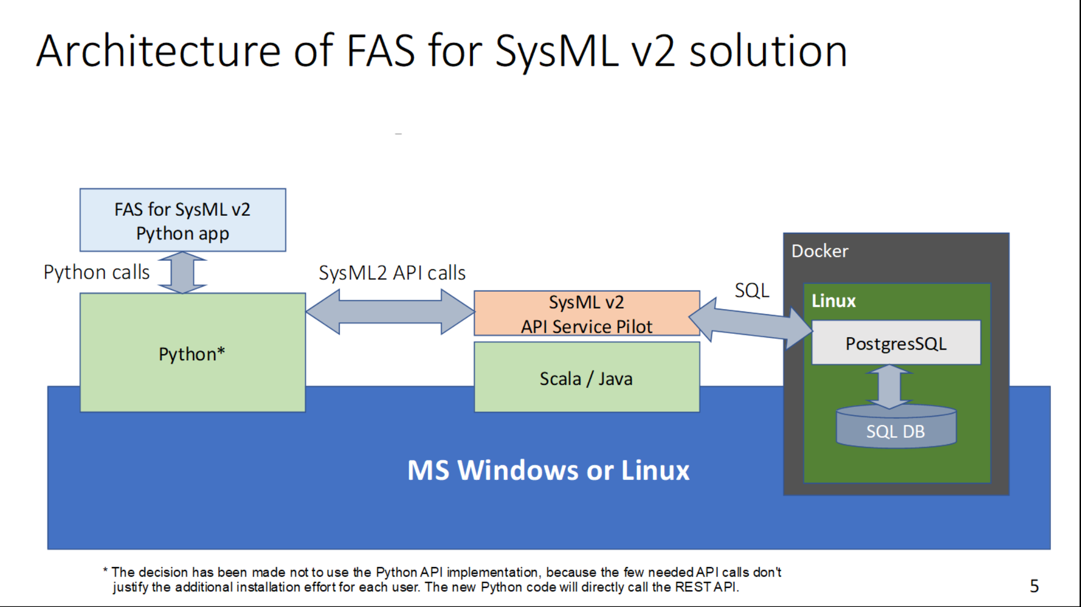
The document refers to the manuals available on the GitHub pages of the SysML v2 pilot implementation. The manuals are combined into one how to. In addition, there are notes based on the experiences we made during the use.

Preconditions
Before starting to set up the environment, some programs must be installed. Furthermore, the source code for the SysML v2 Pilot implementation is required.
The following list describes the programs that must be installed:
- Docker (https://www.docker.com/)
- Java JDK or OpenJDK 11 (https://openjdk.org/)
- Scala’s Simple Build Tool `sbt` (https://www.scala-sbt.org/index.html)

For detailed instructions we refer to the appendices.

Preparation
To provide a unique environment, docker was chosen to set up the database backend. The following instructions show the installation and startup instructions to run a PostgresSQL database in a docker container. If not done, first install docker as described in Appendix A - How To, Docker Installation. Make sure that Microsoft’s WSL (Windows Subsystem for Linux) is installed. It is available from Microsoft store.
To set up a Postgres database, the Postgres image needs to be loaded from docker hub and a database container needs to be set up.

Get a postgres image
Use the `docker pull` command to download the docker image for the latest version of PostgreSQL available on Docker Hub - https://hub.docker.com/_/postgres
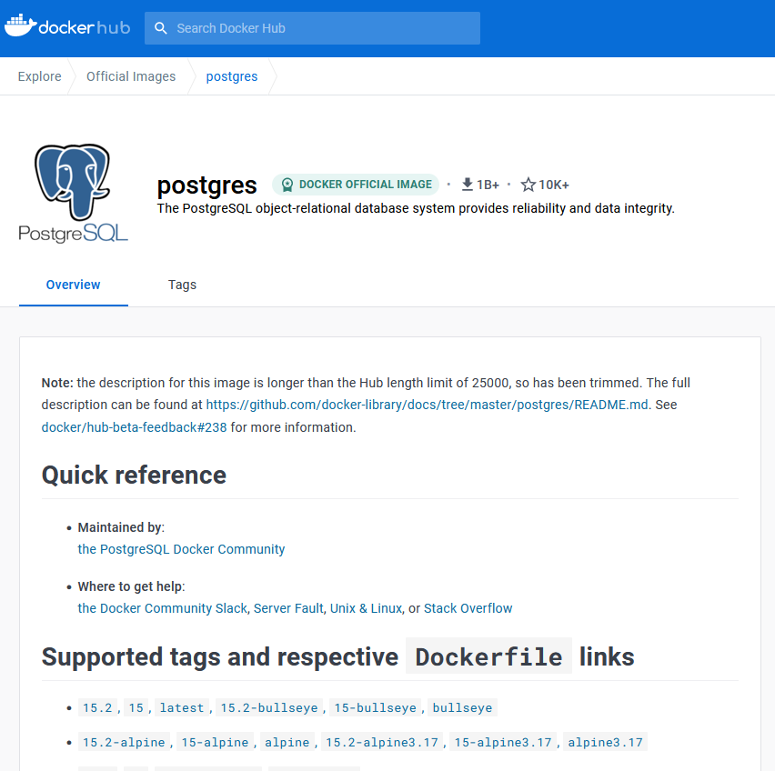

Start the container
Use the `docker run` command to start a docker container from the downloaded image, as shown below. This will initialize PostgreSQL database in a Docker container and make it available at port 5432 on your local machine.
Remark: For the assumed pilot use, don’t change the settings. The pilot test implementation relies on those. Also the password has to be exactly as shown in the screenshot above. Do not change it for use of the pilot implementation – but remember it is NOT for production use.
> docker run --name sysml2-postgres -p 5432:5432 -e POSTGRES_PASSWORD=mysecretpassword -e POSTGRES_DB=sysml2 -d postgres
1b063510047825758238a2f5afa68a92c55f0a1124471b2d1c52b5298e68da4b
The above way of starting docker will make the database lose all data when the docker container is stopped or the computer running it is rebooted. Use a local volume via dockers “-v” command line parameter to prevent that. Here would be an example:
> run --name sysml2-postgres -v "c:\Temp\DockerVolume":/var/lib/postgresql/data -p 5432:5432 -e POSTGRES_PASSWORD=mysecretpassword -e POSTGRES_DB=sysml2 -d postgres

A new container is created and started in the Docker App. In the log file you can see what was executed during the startup.
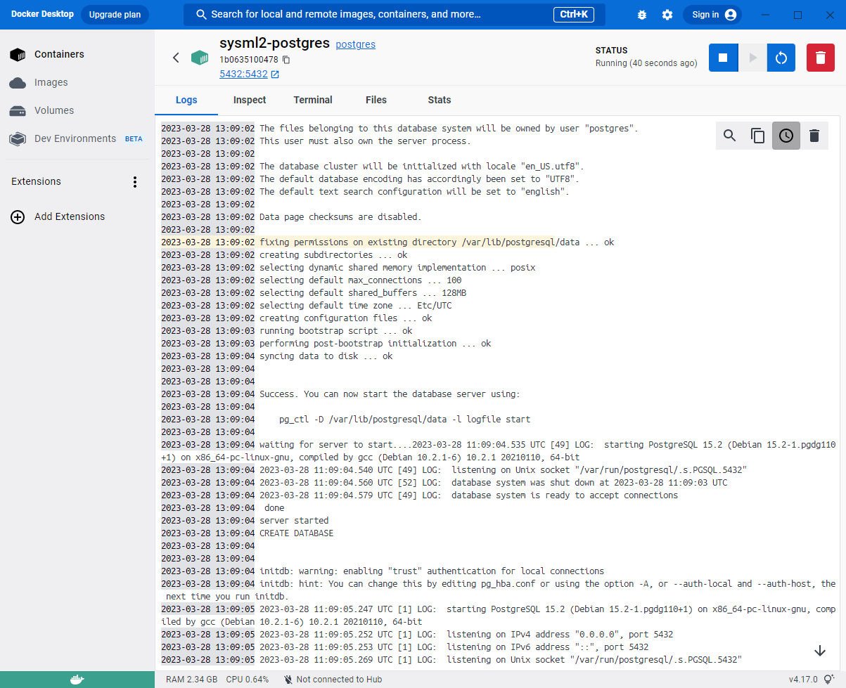

Check with a client
Once the Postgres container is running, one may consider checking the presence of the database, by connecting to it from a PostgreSQL client. Here is some information that may be useful:
- Host = localhost
- Port = 5432
- User = postgres
- Password = mysecretpassword
- Database = sysml2
- Possible clients:

Here is an example of how to open a shell inside the container and use psql to query the database:
> docker exec -i -t sysml2-postgres /bin/bash
root@fb9eaea619ab:/# psql -U postgres -d sysml2
psql (15.2 (Debian 15.2-1.pgdg110+1))
Type "help" for help.

sysml2=# \dt
List of relations
Schema | Name | Type | Owner
--------+---------------------------------------------------------+-------+----------
public | acceptactionusage | table | postgres
public | acceptactionusage_actiondefinition | table | postgres
public | acceptactionusage_aliasids | table | postgres

In case the container should be deleted
You have two options to remove the created container. First using Docker Desktop or using PowerShell. To delete the sample docker container that was installed previously, use “docker rm sysml2-postgres”.
> docker rm sysml2-postgres

Providing a local SysML2 API service
* Remeber that the database takes longer to start if it needs to load previous content.
This can lead to error messages, if starting 'sbt run' before the database is ready
If sbt is not installed, please visit the Appendix B - Installation of SBT. Clone the required resources available from https://github.com/Systems-Modeling/SysML-v2-API-Services. After cloning, follow the following steps.
Note: If you do not know how to clone from git, use the “Download” button to download a ZIP archive with latest branch content. Then extract it.
Remark: From now on each step may take some time, be patient it is a pilot implementation.
In PowerShell, switch to the local copy of the SysML v2 API Services folder. Then take the following steps:
> sbt clean

- if the clean was successful, now that project can be created
- during this step the content of the directory ~/.sbt/1.0/plugins is cleaned up

> sbt run

- now many log messages are displayed, please wait until the following line appears:
> … (Server started, use Enter to stop …

Now you can switch to the browser and call the page localhost:9000/docs/. Now you have to wait again, because `sbt` is compiling the code. For this reason, it may take a few minutes until the server responds.
Remark: The first time it takes a long time because DB structure must be created.
Done, now you have a SysML 2 service to experiment with. You can now make REST/HTTP requests to your local SysML v2 API and Services web application either via Swagger doc, or via any REST/HTTP client such as Postman.
Remark: The DB structure will be recreated on each new start of the service, because the “Hibernate” framework is by default configured to hibernate.hbm2ddl.auto=create-drop
To avoid getting your database deleted and re-initialized on each new start of the service, go to the configuration file SysML-v2-API-Services-master\conf\META-INF\persistence and find the line that sets the value of “hibernate.hbm2ddl.auto”. If you are sure you know what you are doing, you can set the value to “none” (but normally this only makes sense if you have also configured docker to keep the SQL database persistent on a local volume – see the note on adding a local docker volume in the docker-related parts of this document). Here is how the new configuration looks like:

Here would be a sample procedure for initializing a persistent database you will not lose on reboot*:
- Run the docker container with a local docker volume
- Ensure that the above configuration file defines hibernate.hbm2ddl.auto=create-drop
- start sbt-run and perform all subsequent steps until the REST API is repsonsive
- change the above configuration file so it defines hibernate.hbm2ddl.auto=none
Remark: Here is a hint for improving performance: You can redirect output to the “nul” device to avoid wasting time on the delivery of UI output (however, the disadvantage is not be able to monitor via the UI what the service is doing).
This would be the command with redirection to the “nul” device:
> sbt run > nul

Restarting the service
The following notes on restarting the database and the service, once they have been taken into use was done by our experience.
After a fresh boot, you need to
- Start docker desktop again, potentially via “run as administrator”
- Start the docker container with the PostGres SQL database
- Go to the folder with SysML2 API and call “sbt run” again
- Open “localhost:9000/docs/” once or even a second time

Wait for the SysML2 API to re-do some database table maintenance it seems to do after each new start. It is currently under investigation whether this happens by design, or due to a configuration flaw that could be addressed in this HowTo via some configuration instructions.
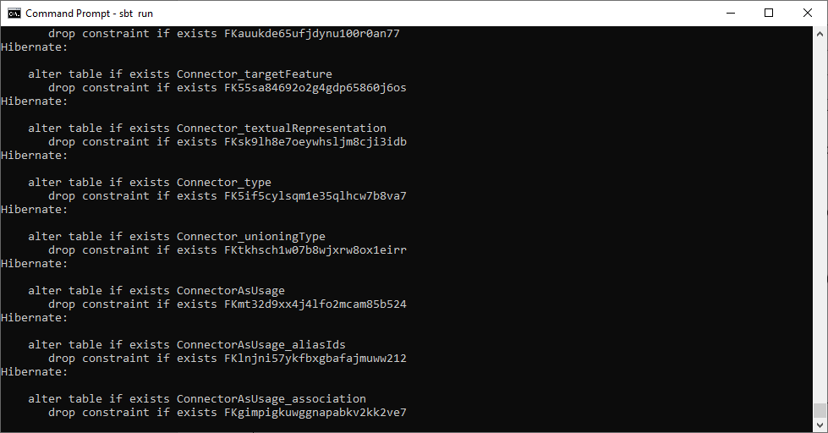
Remark: This may take some time, especially on a slow computer. So, plan for enough time in advance!

Testing the local SysML v2 API Pilot Service
Once the Rest API responds to localhost:9000/docs/, use that page to create a dummy project as a new project, as follows:
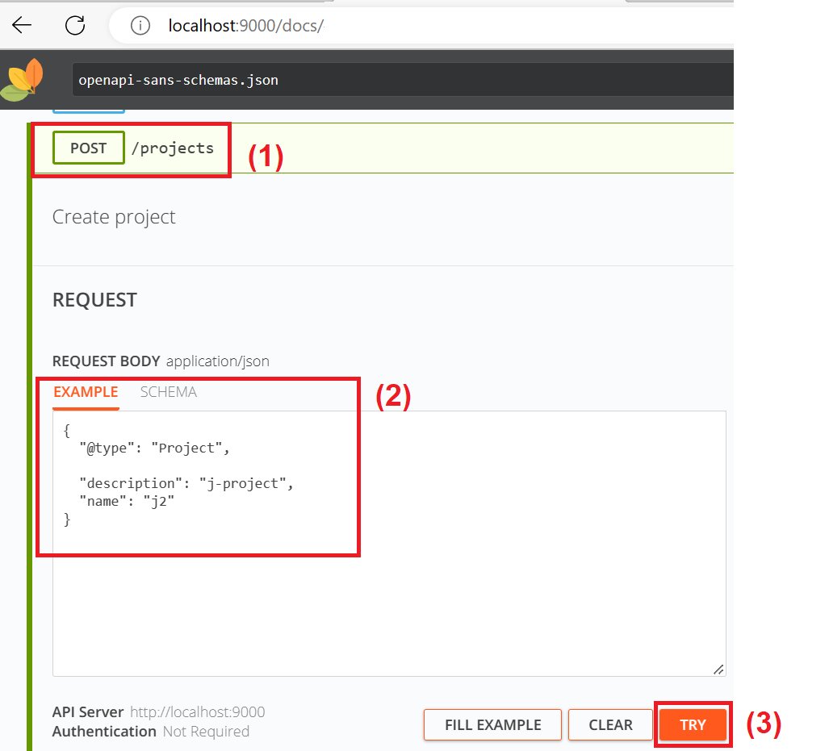

OBSERVATION: The example shown in the screenshot above is different from the default example that is shown by the API. We needed to get rid of the “id” field from the default example. It is suspected that this is the case for more of the default examples shown by the API: If you get an error message, remove the id. Then it may work.

Run a sample python program to query for the created project
The following python code can be stored in a file “Test.py” and executed with the command “python Test.py”:
import requests
hosturl = "http://localhost:9000"
bSuccess = False
try:
response = requests.get(hosturl + "/projects")
bSuccess = True
except requests.exceptions.ConnectionError:
bSuccess = False
sErrorMessage = 'Error: Could not connect to server'
print(sErrorMessage)

if bSuccess and response.status_code!=200:
bSuccess = False
sErrorMessage = 'Error during REST API call'
print(sErrorMessage)

if bSuccess:
print("Projects on server " + hosturl + ":")
data = response.json()
for response in data:
print(response.get("name") + " (" + response.get("@id") + ")" )

Familiarize yourself with the Rest API
The following video (second part) explains the API: https://www.youtube.com/watch?v=vj5BOy5G8ho
There is also the SysML v2 API cookbook, which can easily be googled.
When using “commit” commands, there are multiple possible payload formats stated in the different guides. However, only one of the stated formats has been found useful when committing multiple objects which refer to each other and hence need to keep their UUIDs when being committed to the repository. This “change”-based format should be used already for the first commit to an empty project (even thought this is strictly speaking not yet a change).
The following example shows the format that has been found to work properly.
Python example of a commit with the recommended payload format:
import requests
import json
from datetime import datetime

host = "http://localhost:9000"
timestamp = datetime.now()
project_name = f"SampleProject - {timestamp}"
project_body = {"@type":"Project","name": project_name,"description": "Sample commit"}
project_url = f"{host}/projects"
project_response = requests.post(project_url,
headers={"Content-Type": "application/json"},
data=json.dumps(project_body))
project_id = project_response.json()['@id']

commit_body = {"change": [{"payload": {"@type": "ActionDefinition",
"name": "Action1",
"elementId": "12b62464-19de-11ee-8b4e-009337bd64cd"
},
"identity":{"@id": "12b62464-19de-11ee-8b4e-009337bd64cd"}
},
{"payload": {"@type": "ActionDefinition",
"name": "Action2",
"elementId": "661a9d6b-5561-4ddb-bded-77c02d519380"
},
"identity":{"@id": "661a9d6b-5561-4ddb-bded-77c02d519380"}
},
{"payload": {"@type": "Dependency",
"client": [{"@id": "12b62464-19de-11ee-8b4e-009337bd64cd"}],
"relatedElement": [{"@id": "12b62464-19de-11ee-8b4e-009337bd64cd"},
{"@id": "661a9d6b-5561-4ddb-bded-77c02d519380"}],
"shortName": '',
"source": [{"@id": "12b62464-19de-11ee-8b4e-009337bd64cd"}],
"target": [{"@id": "661a9d6b-5561-4ddb-bded-77c02d519380"}],
"textualRepresentation": [],
"elementId": "02b62464-19de-11ee-8b4e-009337bd64cf"
},
"identity":{"@id": "02b62464-19de-11ee-8b4e-009337bd64cf"}
}

]}

commit_post_url = f"{host}/projects/{project_id}/commits"

commit_post_response = requests.post(commit_post_url,
headers={"Content-Type": "application/json"},
data=json.dumps(commit_body))

Note that the following line is important: "identity":{"@id": "02b62464-19de-11ee-8b4e-009337bd64cf"}
It ensures that the elements are committed with the stated UUID and not with a new one.

Install the SysML v2 reference implementation
Follow these instructions: https://github.com/Systems-Modeling/SysML-v2-Release/tree/master/install/jupyter
IMPORTANT:
The default URL of the database server is configured to a public database of a company called “Intercax”. If you don’t want to mess with their database, you need to reconfigure the database URL to point to your own local SysML2 API service:
- Open the kernel.json file.
It can be found in
C:\Users\<user name>\AppData\Local\miniconda3\share\jupyter\kernels\sysml
- Change “intercax.com” to “localhost”:
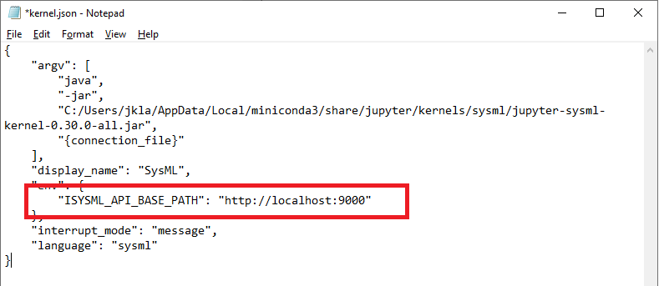

Try out the SysML v2 reference implementation
Invoke “jupyter notebook” from a “cmd” prompt. Then open an empty SysML sheet. Paste the following into the notebook and execute it:
action def GetMoney {
out money;
}
action def MonitorPayment {
in money;
out clearance;
}
action def ProvideMusicTrack {
in clearance;
out music_track;
}
action def PlayMusicTrack {
in music_track;
out audio_signal;
}
action def ProduceSound {
in audio_signal;
}
action def OverallUseCase {
action a1:GetMoney;
action a2:MonitorPayment;
action a3:ProvideMusicTrack;
action a4:PlayMusicTrack;
action a5:ProduceSound;
flow from a1.money to a2.money;
flow from a2.clearance to a3.clearance;
flow from a3.music_track to a4.music_track;
flow from a4.audio_signal to a5.audio_signal;
}

Use “%viz OverallUseCase” to visualize.
Use “%publish OveralluseCase” to publish to the repository
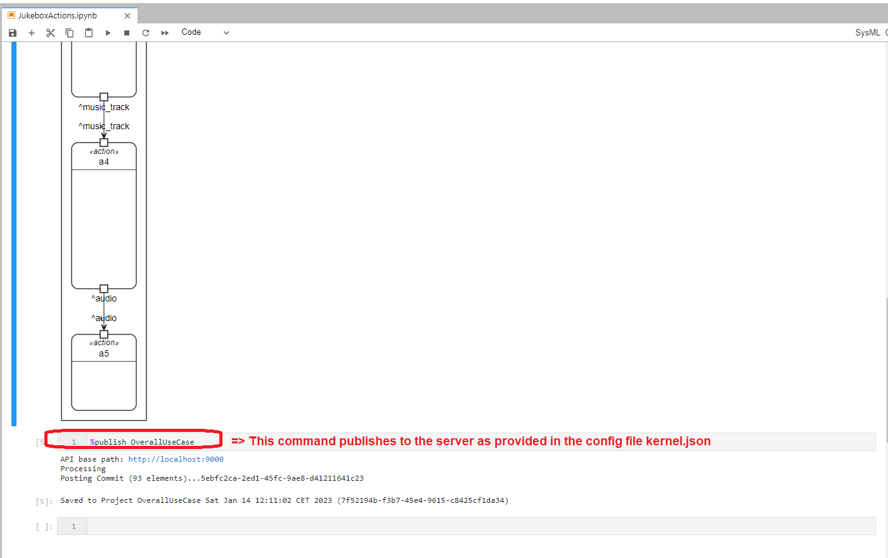
You can use the python script Test.py as shown further above, in order to verify that a project has been created on the server, during publication to the server:
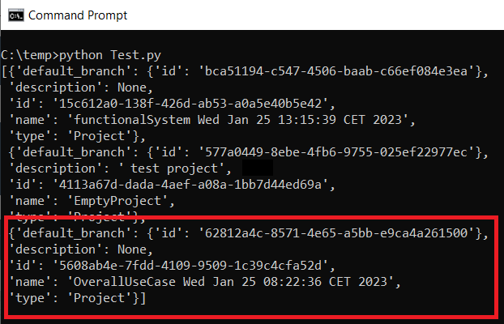

Appendix A - How To, Docker Installation
It is recommended to install and run Docker and Linux, but can also be used on Windows.
Remark: To use docker the processor’s virtualization must be enabled via Bios settings. Also, docker desktop and Cmd prompt may need to be started via “Run as administrator”.

On Windows
For installation of Docker please follow the next steps:
- Docker can be downloaded from https://docs.docker.com/get-docker/
- A detailed description of the installation is given at the (https://docs.docker.com/desktop/install/windows-install/)

The Docker installation file must be run as administrator. Now the configuration can be selected as shown below left.
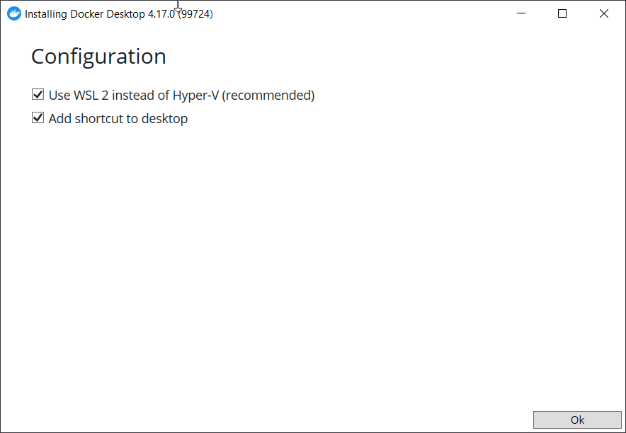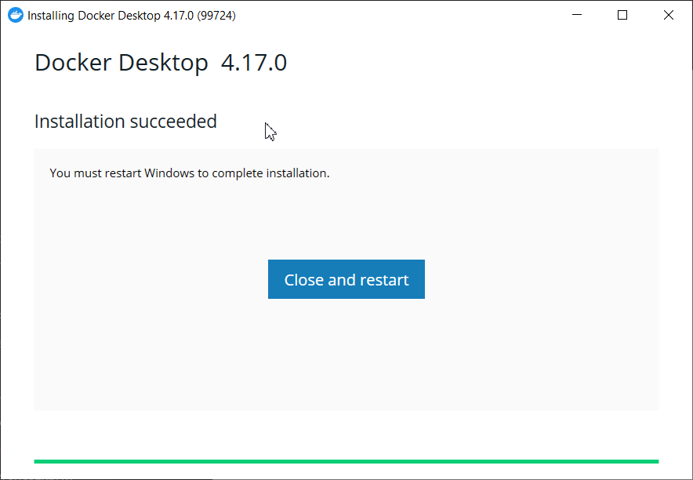
A shortcut on the desktop is not really need, so the shortcut can be omitted and Ok can be pressed immediately. If the installation was successful, a restart of the computer is required. After the reboot, the Docker Desktop can be started. Docker must be started with admin rights. After the first start, Docker asks for future usage.
Please pay attention to the license agreement given by Docker when using it.


After these have been accepted, Docker Desktop starts. To support further development, questions about the use of Docker can optionally be answered. However, this point can also be skipped.

Install Linux Subsystem on Windows
In order to start and use Docker containers correctly in Windows, a Linux extension of Windows is required. This is provided by Microsoft. If Docker starts with the following message, an update of the WSL kernel is required.
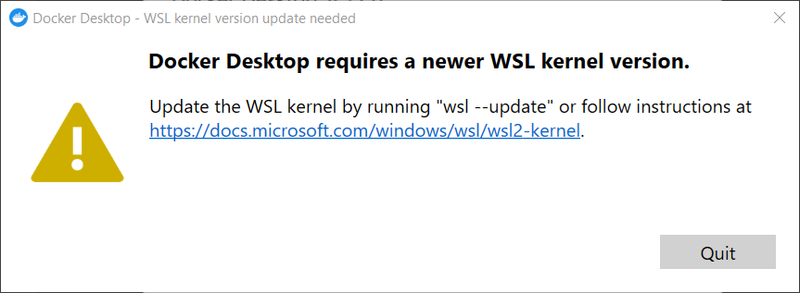
The detailed information about the installation is given in the following links. Only the necessary steps are described below.
- Installation for Windows 10, https://learn.microsoft.com/en-us/windows/wsl/install
- Manual Installation, https://learn.microsoft.com/en-us/windows/wsl/install-manual

Manual Installation
If there is no access to the Microsoft store, the installation must be performed manually. For the installation, the PowerShell must be started with administration rights.
> dism.exe /online /enable-feature /featurename:Microsoft-Windows-Subsystem-Linux /all /norestart

Tool zur Imageverwaltung für die Bereitstellung
Version: 10.0.19041.844

Abbildversion: 10.0.19044.2604

Features werden aktiviert
[==========================100.0%==========================]
Der Vorgang wurde erfolgreich beendet.
- Enable virtualization
> dism.exe /online /enable-feature /featurename:VirtualMachinePlatform /all /norestart

Tool zur Imageverwaltung für die Bereitstellung
Version: 10.0.19041.844

Abbildversion: 10.0.19044.2604

Features werden aktiviert
[==========================100.0%==========================]
Der Vorgang wurde erfolgreich beendet.
Afterwards the extension must be installed with the file wsl_update_xxx.msi. For this the installation file for the appropriate hardware must be obtained and installed. After successful installation the message appears.
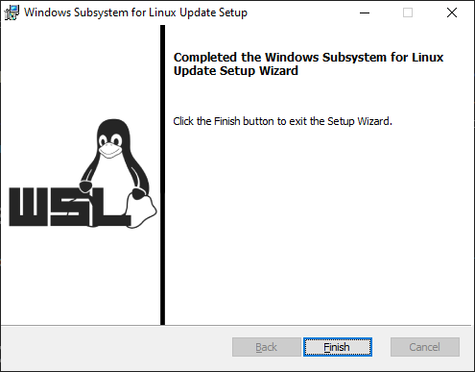
To check if the installation was successful, the command `wsl --list` can be executed. If the instances `docker-desktop-data` and `docker-desktop` are present, Docker is ready for further use.
> wsl --list
Windows-Subsystem für Linux-Distributionen:
docker-desktop-data (Standard)
docker-desktop

Appendix B - Installation of SBT
SBT can be installed by scoop or by the installation file downloaded. First, the following instructions are based on the scoop installation, then the Windows installation is shown.

Scoop installation
If not installed scoop needs to be installed (https://www.makeuseof.com/windows-install-scoop/). With all that being said, let's get to installing Scoop.
Open PowerShell. Inside PowerShell, type the code below:
PS D:\> iwr -useb get.scoop.sh | iex
iwr is short for Invoke Web Request. This command starts a session to access something on the internet. Altogether, this command line will download and install Scoop.
Press Enter. PowerShell will now install Scoop.
If you got an error regarding the execution policy after you entered the command line, enter the command below in PowerShell:
PS D:\> Set-ExecutionPolicy RemoteSigned -scope CurrentUser
This will change the execution policy to remote signed for your account and will allow you to install Scoop. Once you have scoop installed, you can run scoop help in PowerShell or Command Prompt to get a list of the scoop commands.

Install sbt with scoop
The following picture shows the sbt installation with scoop.
PS D:\> scoop install sbt
Installing 'sbt' (1.8.2) [64bit] from main bucket
sbt-1.8.2.zip (36,9 MB) [==============================================================================================] 100%
Checking hash of sbt-1.8.2.zip ... ok.
Extracting sbt-1.8.2.zip ... done.
Linking ~\scoop\apps\sbt\current => ~\scoop\apps\sbt\1.8.2
Creating shim for 'sbt'.
'sbt' (1.8.2) was installed successfully!

Windows
The installer for sbt is available from the following link https://www.scala-sbt.org/download.html.
- Download standalone Tool for windows
- Run execution file

Done. And now the check with PowerShell:
PS D:\> sbt
… sbt server started at local:sbt-server-d5f387fae786a18f2bda

Setting up Programming Environments

Setting up Java
This pilot implementation uses JDK 11 for compiling and running SysML v2 API and Services. Download and setup JDK 11 on your machine. You can use Oracle JDK 11 or OpenJDK 11.
https://jdk.java.net/archive/jdk
https://www.oracle.com/de/java/technologies/downloads/

