A lean formula for the core of the FAS method, enabling easy and simple tool support for the method

(Original German title: „Eine schlanke Formel für den Kern der FAS-Methode, zur einfachen Werkzeug-Umsetzung der Methode“)
Jesko G. Lamm, Functional Architectures Working Group of
Gesellschaft für Systems Engineering e.V. (German chapter of INCOSE)

This English summary presents the core ideas of the following German publication:
Lamm, J.G.: «Eine schlanke Formel für den Kern der FAS-Methode, zur einfachen Werkzeug-Umsetzung der Methode», in Koch, W.; Wilke, D.; Dreiseitel, S.; Kaffenberger, R. (Eds.): Tag des Systems Engineering – Paderborn 16.-18. November 2022, Gesellschaft für Systems Engineering e.V. (GfSE Verlag), Bremen, Germany, 2022, pp. 127-131
Please cite this document using the above original German
reference, and add the translation information:
“English translation by Lamm, J.G. in December 2022 and April 2023”
Copyright 2022 Gesellschaft für Systems Engineering e.V. (GfSE)
Licensed under the Apache License, Version 2.0 (the "License");
you may not use this file except in compliance with the License.
You may obtain a copy of the License at
http://www.apache.org/licenses/LICENSE-2.0
Unless required by applicable law or agreed to in writing, software
distributed under the License is distributed on an "AS IS" BASIS,
WITHOUT WARRANTIES OR CONDITIONS OF ANY KIND,
either express or implied.
See the License for the specific language governing permissions and
limitations under the License.

Introduction
The FAS Method [La+10, We+22] allows for deriving functional architectures from use cases.

Matrix-based formulation of the FAS Method
Once the system context and the use cases of a system are defined, the main steps for deriving the functional architecture according to the FAS method are: the further modeling of use cases with use case activities and object flows, the grouping of use case activities into functional groups, the creation of functional blocks as 1:1 counter-parts of the functional groups, and the establishment of flows (matter, energy, information) that can be derived from the previously created object flows [LW10, We+22].
In the following, it will be explained how a matrix representation of the FAS method maps to some of the entities of the FAS method that were mentioned above.
- Let there be M use case activities.
- Let there be N functional groups, or later: functional blocks.
This means that the use case activities can be identified with an index m ∈{1,2 … M}, and the functional groups (or later: functional blocks) can be identified with another index n ∈{1,2 … N}.
To represent object flows of all use case activities, let’s introduce an M x M matrix O, whose elements om1,m2 are from the set of possible object flows (due to practical considerations, one should use space-free strings or text-based IDs of object flows, if the target tool can carry out symbolic computations). Let the row index m1 correspond to the activity on the source side of the flow and let the column index m2 correspond to the target activity, accordingly (see example in fig. 1). Furthermore, more than one object flow in the same direction between the same activities can be represented by using the operator “+“ (scalar addition) to concatenate the object flows.
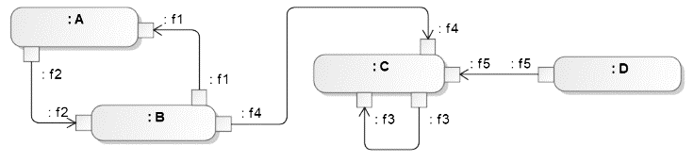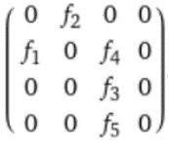
Fig. 1: Activities and object flows in traditional representaion (on the left) and in representation via the matrix O (on the right), where the activities A-D are indexed in alphabetical order
In the FAS method, the next step after the above activity modeling will be the functional grouping. Its outcome will be represented by an NxM matrix G with the elements gn,m. Here, n and m are again the indices of use case activities and functional groups, respectively.
The matrix elements are defined as follows:
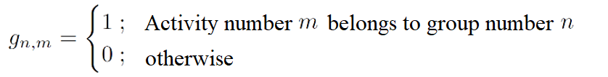
Note that the sum of each column has to be exactly 1, at least if the functional grouping is exhaustive. This is due to the fact that the FAS method requests a disjoint decomposition of use case activities via the functional grouping [La+10].
Once the functional grouping has been done, the functional architecture can be created automatically [We+22]. This is the step that will benefit from the matrix representation of the method, because the above matrix representation scheme allows for representing the functional architecture with an NxN-Matrix F, as follows:
F = GOGT (FAS method in matrix representation)
The diagonal elements of matrix F can be ignored in the context of the FAS method, because these elements represent object flows inside the functional blocks. The other matrix elements fn1,n2 describe flows of matter, information or energy in-between the functional blocks. The concrete matrix element fn1,n2 denotes the flow from the functional block number n1 to the functional block number n2.

Computation with symbolic maths
Example in GNU Octave:
pkg load symbolic; M=4;N=3; O=ones(M,M)*sym('0'); O(1,2)=sym('f2');
O(2,1)=sym('f1'); O(2,3)=sym('f4'); O(3,3)=sym('f3'); O(4,3)=sym('f5');
G=ones(N,M)*sym('0'); G(1,1)=1; G(2,2)=1; G(2,3)=1; G(3,4)=1; G*O*G'
The result of the above code line is shown in Fig. 3 .Note that the operator "+" can be used in the matrix representation to express multiple flows between the same blocks.
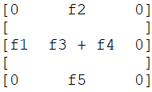
Fig. 3: GNU Octave computed this functional architecture using symbolic math.

Closing Remark
This new formulation of the FAS method can be called "FAS-as-a-formula".

Acknowledgment
Thanks to Tim Weilkiens for review / improvements / inspiration.

References
[LW10] Lamm, J.G.; Weilkiens, T.: Funktionale Architekturen in SysML. In (Maurer, M.; Schulze, S.O., eds..): Tag des Systems Engineering, München Freising, 10.-12. November 2010. Carl Hanser Verlag, München, S. 109–118.
[We+22] Weilkiens, T.; Lamm, J.G.; Roth, S.; Walker, M.: Model-Based System Architecture – Second Edition, Wiley, 2022.

