***ER model***

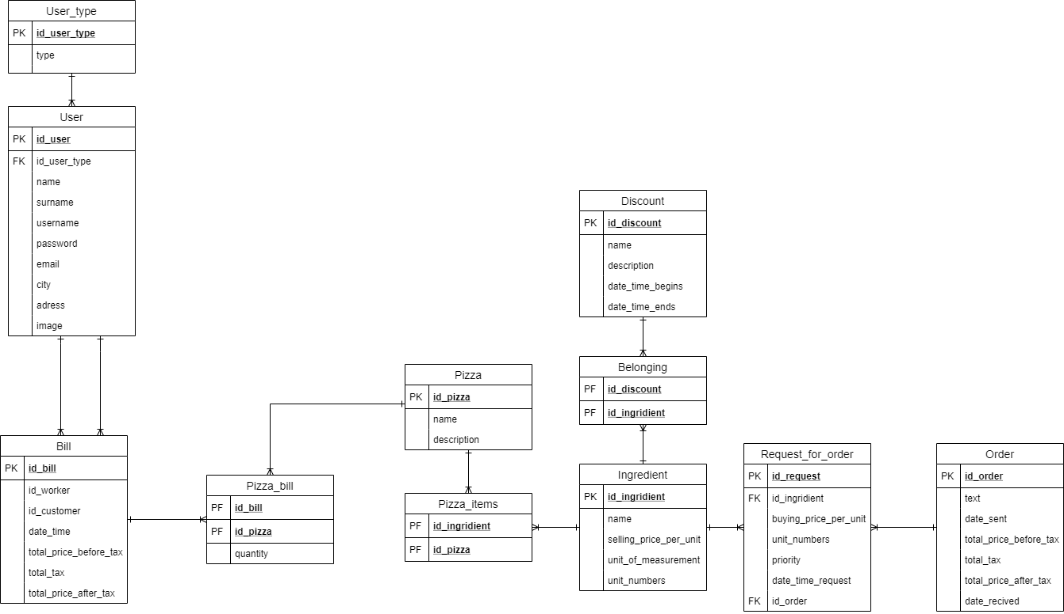

Table **User_type**:

* “***id_user_type***” → Primary key and identificator of this table. // INT AUTOINC
* “***type***” → In the first version there will be 3 user types. They are “admin”, “worker” and “customer”. This attribute will be more deeply explained in Table user. // VARCHAR(30) NOT NULL

Table **User**:

* “***id_user***” → Primary key and identificator of this table. //INT AUTOINC
* “***id_user_type***” → Foreign key that references table **UserType**, attribute “***id_user_type***”. When an user logins, the specific window will open and the user will have specific capabilities there depending on which “***id_user_type***” he has. For each “***id_user_type***” there will be an unique window. Upon registration the user will automatically get “***id_user_type***” that is connected to the “***type***” customer. There will be only 1 user which has “***type***” admin. Admin user will be able to change the “***type***” of the customer to the worker, and vice-versa (if somebody starts/stops working for him).  // INT NOT NULL
* “***name***” → The name of an user. // VARCHAR(30) NOT NULL
* “***surname***” → The surname of an user // VARCHAR(50) NOT NULL
* “***username***” → Unique attribute for each user which will let them connect to the application. // VARCHAR(25) NOT NULL UNIQUE
* “***password***” → Attribute for each user which will let them connect to the application.  // VARCHAR(25) NOT NULL
* “***email***” →  Unique attribute for each user which will let them connect to the application. They will be able to use either email or username.  // VARCHAR(25) NOT NULL UNIQUE
* “***city***” → Self explanatory attribute. Can be null, but in that case no delivery will be possible. // VARCHAR(40)
* “***address***” → Self explanatory attribute. Can be null, but in that case no delivery will be possible. If there is one it must be inserted via specific way (eg. 21200 Šimići 25) / /VARCHAR(60)
* “***image***” → An image which will represent the user. Not needed for anything //IMAGE

Table **Bill**:

* “***id_bill***” → Primary key and identificator of this table. // INT AUTOINC
* “***id_worker***” → Foreign key that references table **User**, attribute “***id_user***”. “***id_usertype***” in that table must correspond to worker type. // INT NOT NULL
* “***id_customer***” → Foreign key that references table **User**, attribute “***id_user***”. “***id_usertype***” in that table must correspond to customer type. // INT NOT NULL
* “***date_time***” → Date and time when transaction was made between customer and cashier. // DATETIME
* “***total_price_before_tax***” → Self explanatory attribute. // DECIMAL (6,2)
* “***total_tax***” → Self explanatory attribute. // DECIMAL (6,2)
* “***total_price_after_tax***” → Self explanatory attribute. // DECIMAL (6,2)

Table **Pizza_bill**:

* “***id_bill***” → Foreign key that references table **Bill**, attribute “***id_bill***” and a part of primary key (there are 2 parts and this is the 1st one). // INT
* “***id_pizza***” → Foreign key that references table **Pizza**, attribute “***id_pizza***” and a part of primary key (there are 2 parts and this is the 2nd one). // INT
* “***quantity***” → A number which represents the quantity of specific pizza that was bought. // INT NOT NULL

Table **Pizza**:

* “***id_pizza***” → Primary key and identificator of this table. // INT AUTOINC
* “***name***” → The name of the pizza. // VARCHAR(50)
* “***description***” → The description of the pizza. // TEXT

Table **Pizza_items**:

* “***id_ingredient***” → Foreign key that references table **Ingredient**, attribute “***id_ingredient***” and a part of primary key (there are 2 parts and this is the 1st one). // INT
* “***id_pizza***” → Foreign key that references table **Pizza**, attribute “***id_pizza***” and a part of primary key (there are 2 parts and this is the 2nd one). // INT

Table **Ingredient**:

* “***id_ingredient***” → Primary key and identificator of this table. // INT AUTOINC
* “***name***” → Self explanatory attribute. // VARCHAR(50) NOT NULL
* “***selling_price_per_unit***” → Selling price per unit with tax included. // DECIMAL (5,2) NOT NULL
* “***unit_of_measurement***” → Self explanatory attribute. // VARCHAR(50) NOT NULL
* “***unit_numbers***” → Available units in warehouse // INT NOT NULL

Table **Belonging**:

* “***id_discount***” → Foreign key that references table **Discount**, attribute “***id_discount***” and a part of primary key (there are 2 parts and this is the 1st one). // INT
* “***id_ingredient***” → Foreign key that references table **Ingredient**, attribute “***id_ingredient***” and a part of primary key (there are 2 parts and this is the 2nd one). // INT

Table **Discount**:

* “***id_discount***” → Primary key and identificator of this table. // INT AUTOINC
* “***name***” → Self explanatory attribute. // VARCHAR(75) NOT NULL
* “***description***” → Self explanatory attribute. // TEXT NOT NULL
* “***date_time_begins***” → Date and time when discount begins. // DATETIME NOT NULL
* “***date_time_ends***” → Date and time when discount ends. // DATETIME NOT NULL

Table **Request_for_order**:

* “***id_request***” → Primary key and identificator of this table. // INT AUTOINC
* “***id_ingredient***” → Foreign key that references table **Ingredient**, attribute “***id_ingredient***”. // INT NOT NULL
* “***buying_price_per_unit***” → Buying price per unit without tax included. // DECIMAL(5,2) NOT NULL
* “***unit_numbers***” → Requested number of ingredients. // INT NOT NULL
* “***priority***” → Priority of request. It can have values of “LOW”, “MEDIUM” and “HIGH”. // VARCHAR (10) NOT NULL
* “***date_time_request***” → Date and time when request was made. // DATETIME NOT NULL
* “***id_order***” → Foreign key that references table **Order**, attribute “***id_order***”. This attribute get filled once the order is sent. // INT

Table **Order**:

* “***id_order***” → Primary key and identificator of this table. // INT AUTOINC
* “***text***” → Text that will be sent to the person which we order form. // TEXT NOT NULL
* “***date_sent***” → Date when order was sent.  // DATE NOT NULL
* “***total_price_before_tax***” → Self explanatory attribute. // DECIMAL (8, 2)
* “***total_tax***” → Self explanatory attribute. // DECIMAL (8, 2)
* “***total_price_after_tax***” → Self explanatory attribute. // DECIMAL (8, 2)
* “***date_recived***” → Date when package was received. // DATE