DENNIS LIM WEI YAO

**PROGRAMMING INTERNSHIP**

# CONTACT

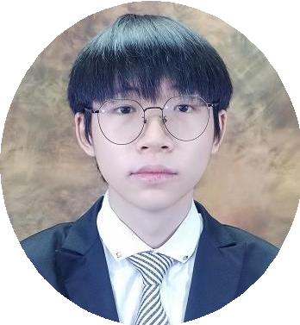

+60 1135514055

[dennis1204205@gmail.com](mailto:dennis1204205@gmail.com)

Block 1062 Tingkat 20 No 38,Taman Hijau

Paya Terubong 11060 Ayer Itam Pulau Pinang

# WEBSITE

Website: dennis.jom-jom.com Username: guest Password:1316

# LANGUAGES

English Chinese Malay

# EDUCATION

Kolej Synergy | 2023 - Present

Diploma In System Module Development

# REFERENCE

Name:Mr Ng Chuen Chuen Position:Head of IT Department Company:Kolej Synergy

Phone number: 012-4346832 [Email:c2@synergy-college.com](mailto:c2@synergy-college.com)

# PROFILE SUMMARY

I’m seeking a Programming Internship from May 2025 to June 2025, where I can apply my skills in IT Software while learning new technologies. I’m eager to grow through hands-on experience and contribute to a company’s success by tackling challenges and driving innovation.

# QUALIFICATION

* Great Learning - HTML Tutorial
* Great Learning – JavaScript Project
* Great Learning – Operators in MySQL
* Great Learning – Front End Development CSS
* Great Learning – Front End Development HTML

# SKILL

* With intermediate HTML skills to create structured web pages and manage forms, tables, and multimedia effectively.
* With intermediate CSS skills to design responsive web pages that look great on any device,and also create flexible layouts and use cohesive color schemes to enhance visual appeal.
* With intermediate PHP skills, back-end logic and database interactions are efficiently managed for secure and effective data processing.
* Build functional web apps using Laravel's routing and controllers by managing application flow and handling user requests efficiently.
* Design and query databases effectively with MySQL.
* Create basic interactivity and am advancing in JavaScript
* Skilled in systematically analyzing and resolving complex problems with efficiency and accuracy.

# WORK EXPERIENCE

Promoter | Mydin Mohamed Holdings Berhad April 2021 - July 2021

* Took high-quality group photos at events and managed the advertisement board to enhance promotional visibility.
* Coordinated event logistics and supported smooth operations, ensuring effective display of promotional content and engaging with attendees.
* Organized event logistics, including setup and tear down of materials, vendor coordination, and staff support for smooth operations.
* Reported on event feedback to improve future promotional strategies.

