**Preconditions:**

* Install the set of Android tools
* Make required environment settings (as described in presentation)
* Get ContactManager.apk and place it somewhere in file system of your PC

**Tasks:**

1. Connect physical Android device to PC via USB and make sure it listed by ADB. **Make screenshot of CLI console with ADB output.**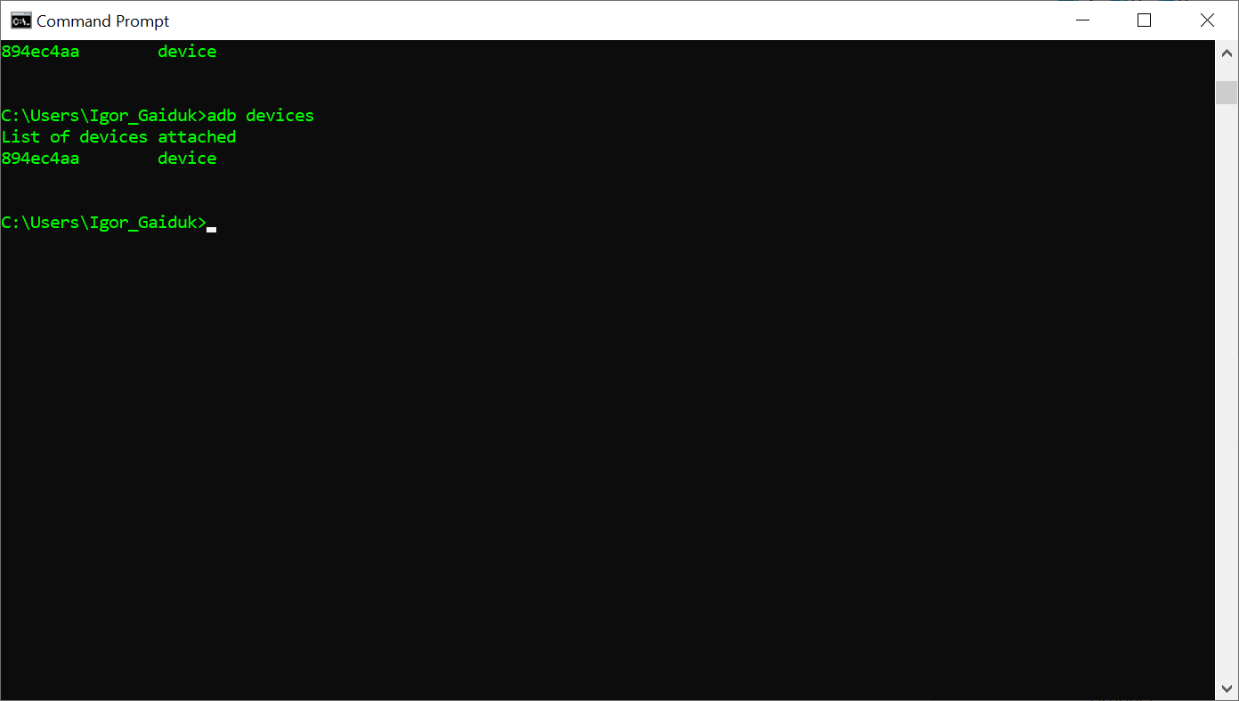
2. Install ContactManager to physical Android device using ADB. **Make screenshot of CLI console with ADB output.** Make sure you can launch and use it.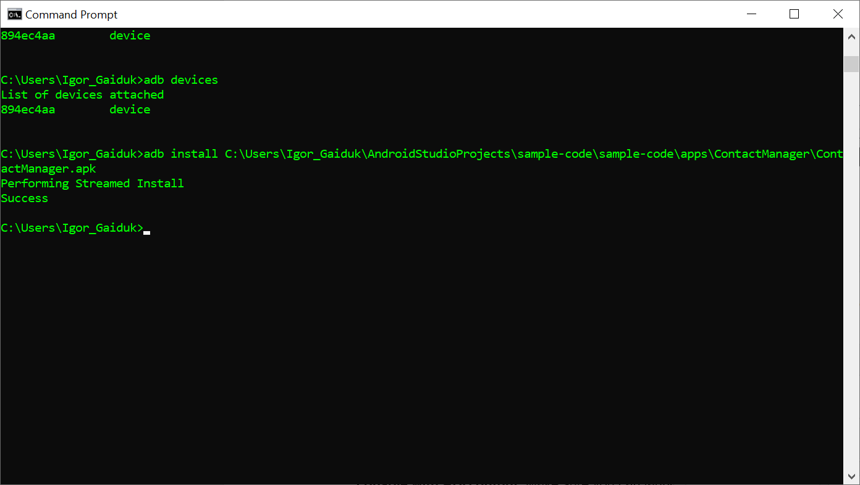
3. Create or select some AVD (use AVD Manager). Make sure that AVD and physical device are in AVD list both. **Make screenshot of CLI console with ADB output and AVD appearance.**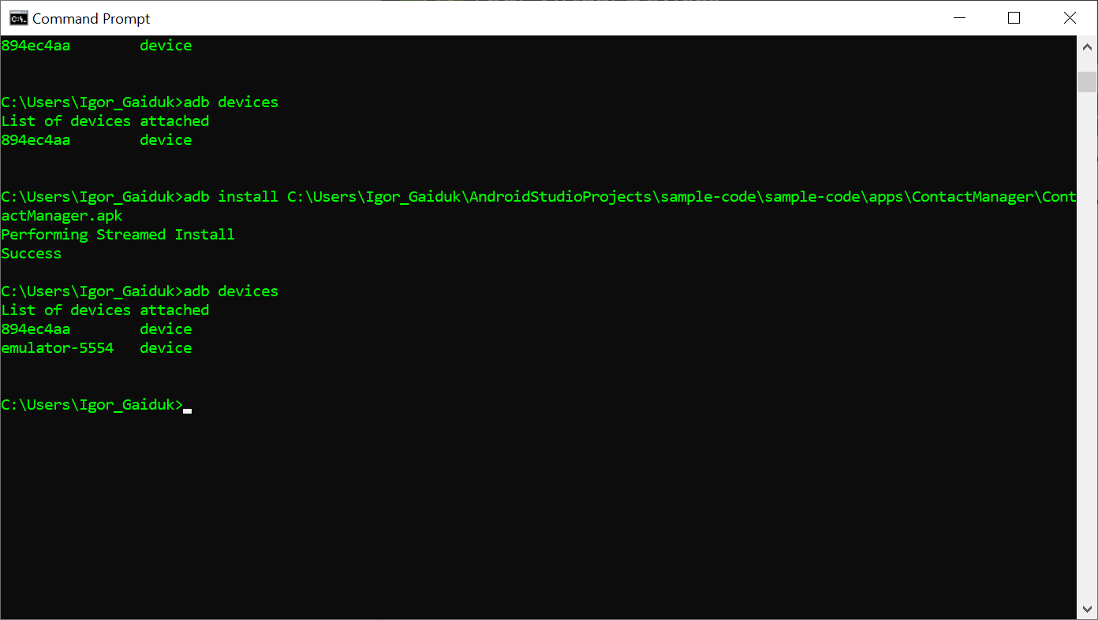
4. Learn from ADB documentation (use appropriate link in presentation or just google it) how to refer to certain device via ADB
5. Install ContactManager to AVD. **Make screenshot of CLI console with ADB output.** Make sure you can launch and use it.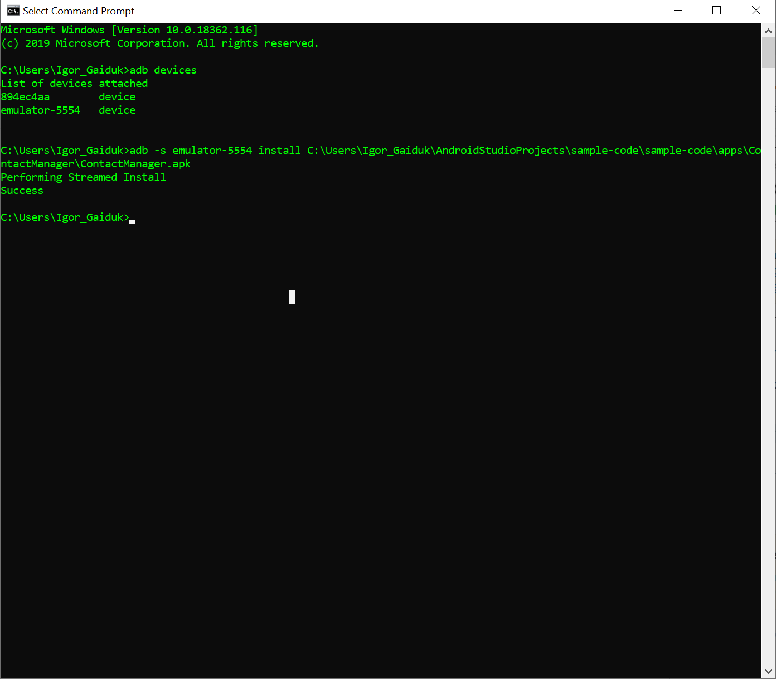
6. Uninstall ContactManager from physical device via ADB. **Make screenshot of CLI console with ADB output** 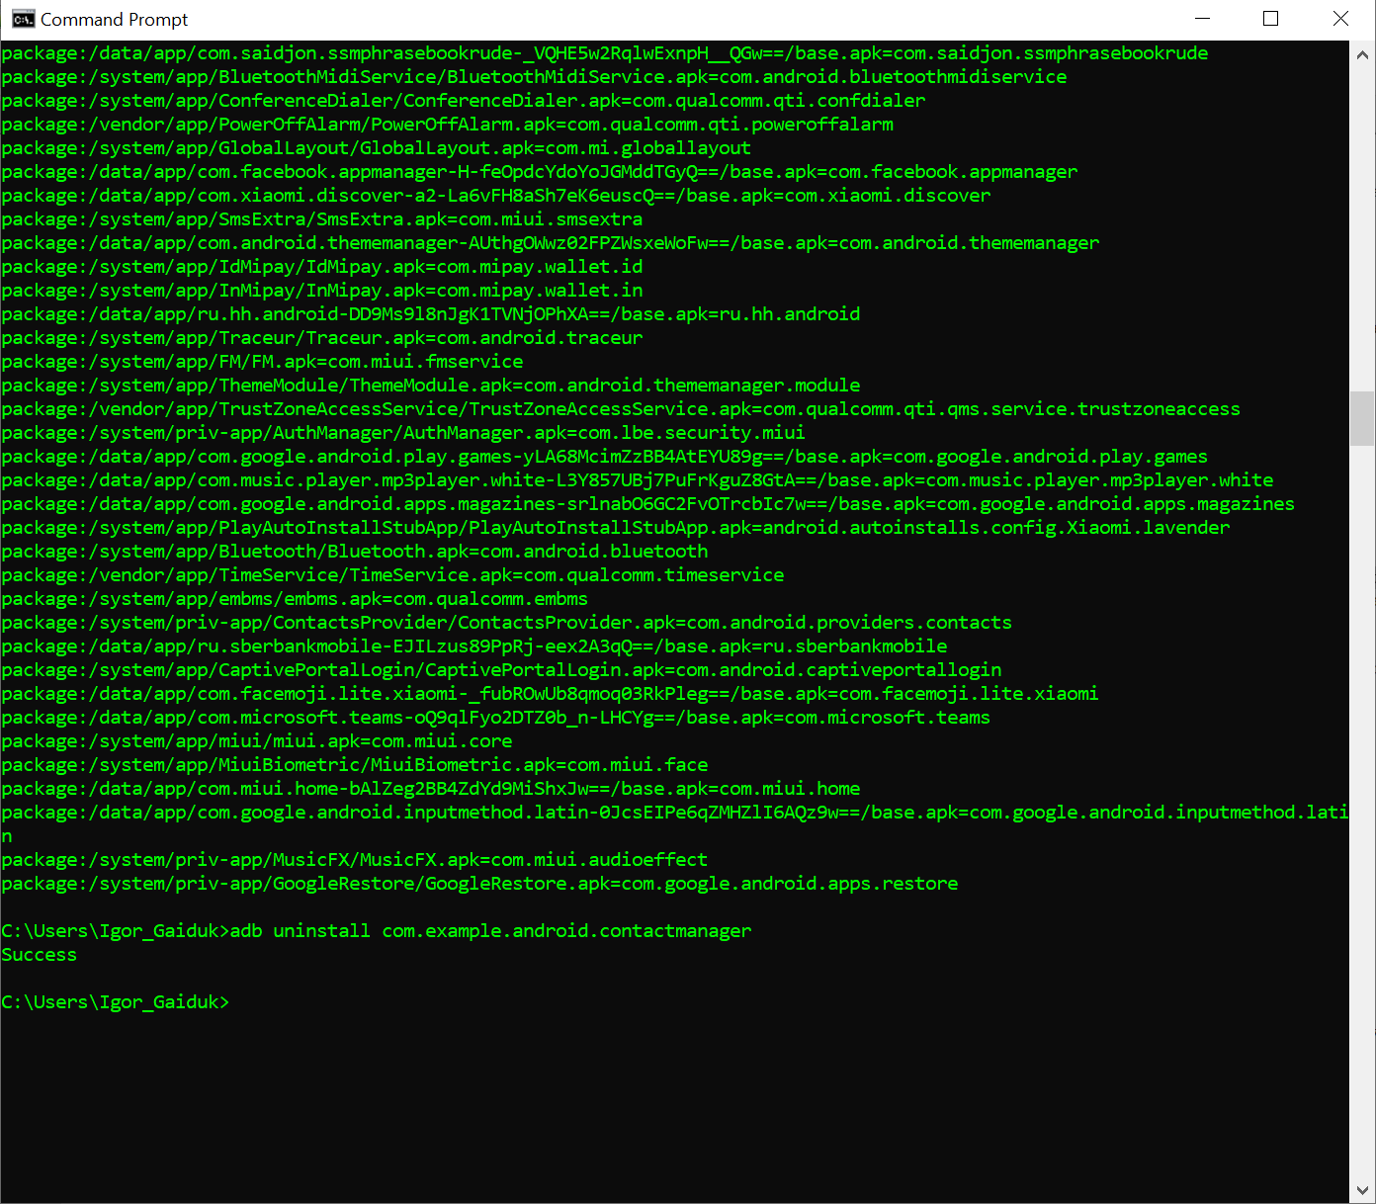
7. Put any text file to physical device and AVD via ADB. **Make screenshot of CLI console with ADB output**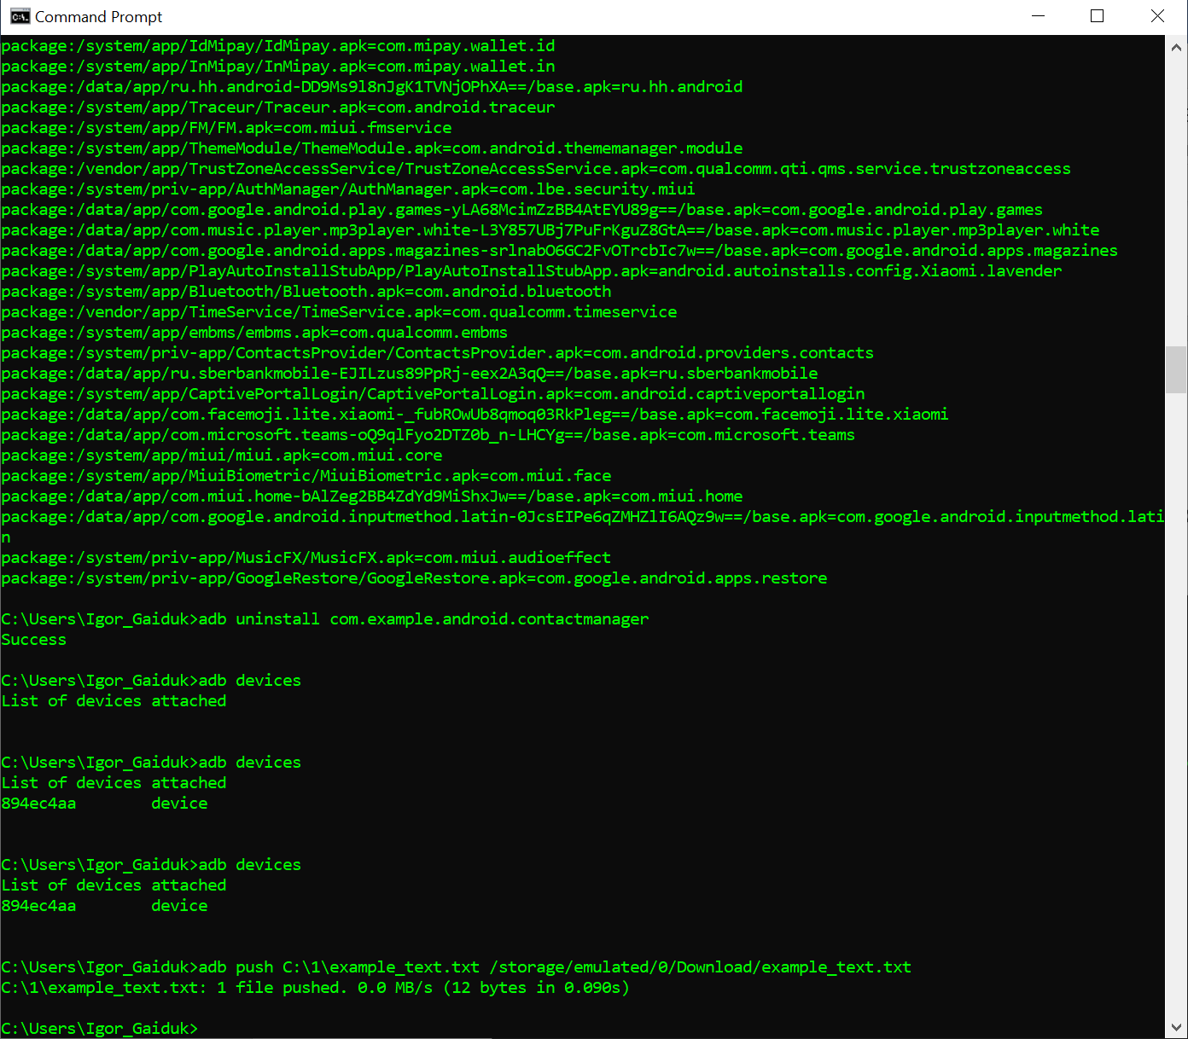
8. Find this file out via WIndows File Explorer on physical device (Android dev. should be connected as external USB drive). Make sure that this is exactly the same file you have put in the previous step
9. Remove file from both devices (study ADB docs). **Make screenshot of CLI console with ADB output.**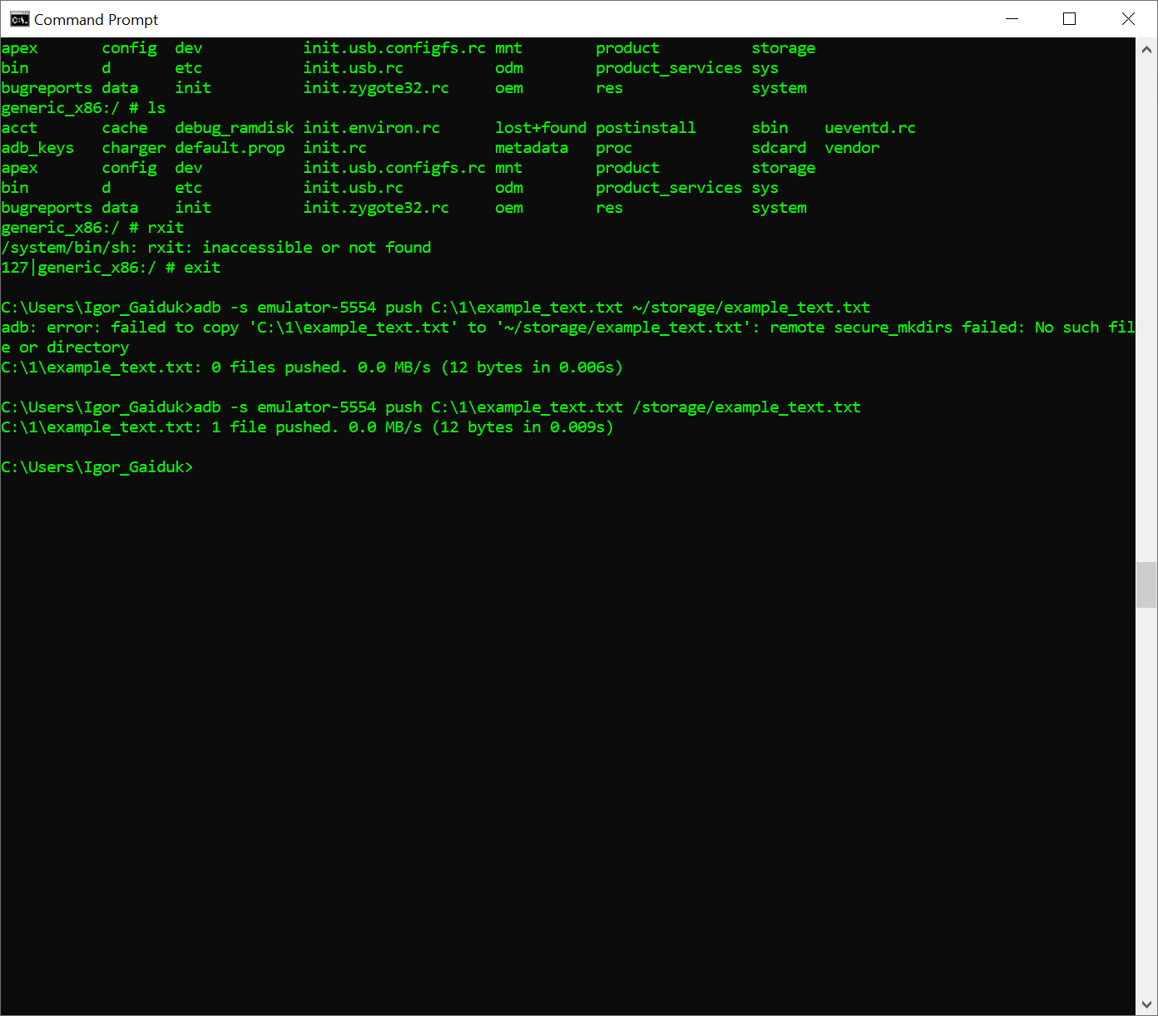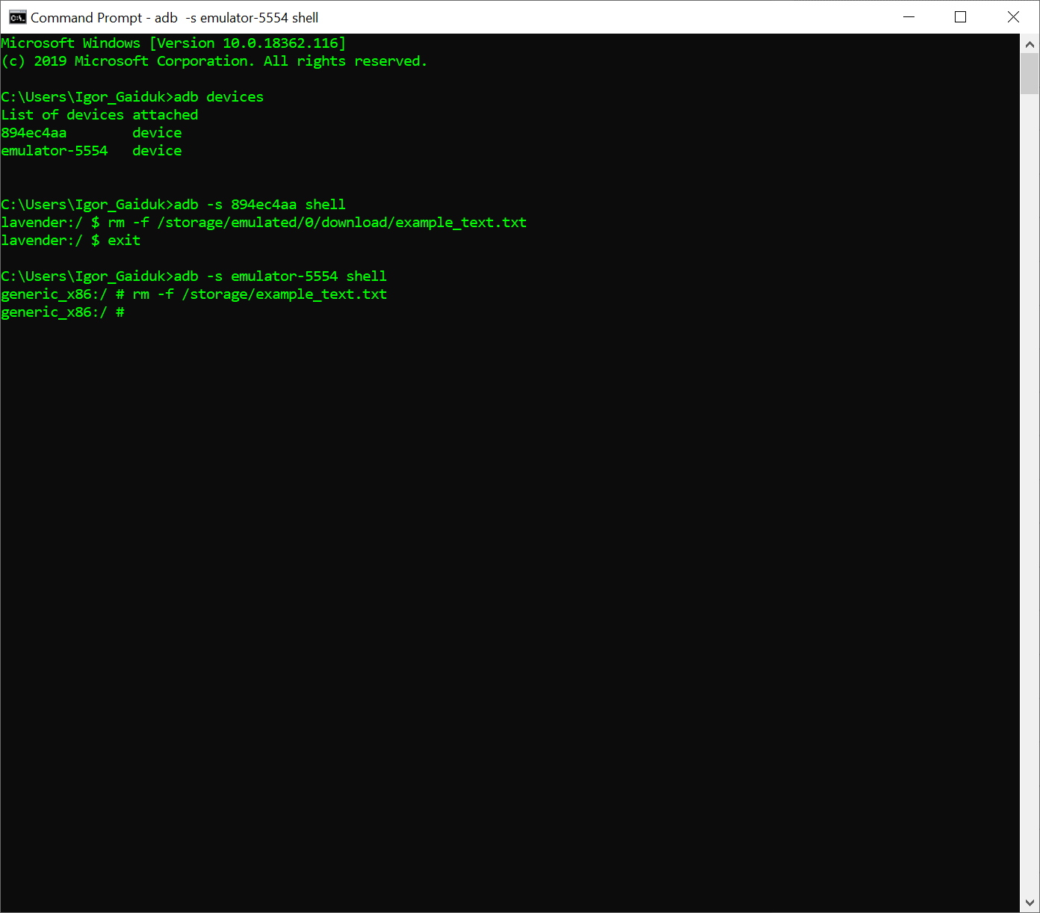

**Reporting homework exercise:**

* Create Word document and insert appropriate screenshot for the each list item of tasks, that requires it, numbered exactly as this list item
* Name Word doc with First- and Surname and “mobile_ex1” string in Camel style
* Send this document to trainer via skype