A MINI PROJECT REPORT ON
CAMPUSOS: SMART CAMPUS MANAGEMENT PLATFORM
DEPARTMENT OF INFORMATION TECHNOLOGY
SUBMITTED BY
Gaurav Jadhav | Atharva Desai | Aditya Patil
Varad Rajboinwad | Tushar Deshpande | Chaitali Shahapurkar
Tanishka Patil | Srushti Mane | Sarvesh Khaladkar
Shravani Khandzode | Omkar Shinde | Gayatri Muttepawar

Under the Guidance of
Prof. Nishanthi Naidu
&
EDI Coordinator
Ms. P. R. Balage
DEPARTMENT OF INFORMATION TECHNOLOGY
MARATHWADA MITRA MANDAL'S COLLEGE OF
ENGINEERING KARVENAGAR, PUNE – 411052
SAVITRIBAI PHULE PUNE UNIVERSITY
2026–27 SEM-I

PROJECT SCOPE
Project: CampusOS: Smart Campus Management Platform (Team A6), a web platform for Marathwada Mitra Mandal's College of Engineering (MMCOE), Pune, that takes a campus event from the venue request to the final report: a club requests a venue, faculty approve or reject it, the event is published, students reserve a seat, reminders go out, and every decision is kept in an audit trail.

Key Objectives
- Replace the paper venue-request form with an online request that a faculty coordinator approves or rejects, with a recorded reason for every rejection.
- Guarantee that two approved bookings can never overlap for the same venue and time, even when requests arrive at the same instant.
- Give students one place to discover events, reserve a seat within the venue capacity, and receive reminders 48 hours and 2 hours before an event.
- Keep an append-only audit trail of approvals, rejections, sign-ins and role changes, and export venue, club and attendance reports as PDF and CSV.
- Apply the fundamentals of the second-year IT courses (DSA, OOP, DBMS, OS, CN, Web Technology) inside real features of the system.

Scope
In scope: venue directory (building → floor → venue), booking requests with clash and buffer checking, a multi-tier approval workflow, club and team management, event publishing, seat reservation with eligibility checks and an optional waitlist, category-based recommendations, in-app and e-mail notifications, role-specific dashboards, audit logging, and report export. The system is used by five roles: Student, Club Member, Club Head, Department Event Coordinator and Principal/HOD (Super Admin).
Out of scope: online payment or ticketing, external calendar integration, live streaming, chat and social features, biometric or RFID attendance, native mobile apps, integration with the college ERP or LMS, AI-based recommendations, and public hosting (the system runs locally and in continuous integration; it is not deployed).

CERTIFICATE

This is to certify that the project report entitled “CAMPUSOS: SMART CAMPUS MANAGEMENT PLATFORM” submitted by Gaurav Jadhav, Atharva Desai, Aditya Patil, Varad Rajboinwad, Tushar Deshpande, Chaitali Shahapurkar, Tanishka Patil, Srushti Mane, Sarvesh Khaladkar, Shravani Khandzode, Omkar Shinde, Gayatri Muttepawar under the guidance of Prof. Nishanthi Naidu & EDI Coordinator Ms. P. R. Balage, Department of Information Technology, Marathwada Mitra Mandal’s College of Engineering, is a bona fide record of the academic project work carried out during the academic year 2026–2027.

………………………………
Project Guide
Prof. Nishanthi Naidu

………………………………  Head, Department of IT | Dr. Sachin Sakhare  Principal  MMCOE, Karvenagar, Pune

Place: Pune
Date: ______________________

ACKNOWLEDGEMENT
We express our sincere gratitude to our project guide, Prof. Nishanthi Naidu, and EDI Coordinator Ms. P. R. Balage, for their guidance, encouragement and support throughout the development and documentation of the CampusOS project.
We are thankful to the Department of Information Technology and Marathwada Mitra Mandal’s College of Engineering for providing the academic environment and the opportunity to apply concepts from our foundational subjects to a practical campus-management problem faced by our own clubs, students and faculty.
We also acknowledge the textbooks, official documentation and research papers that supported our understanding of data structures and algorithms, object-oriented programming, database management systems, operating systems, computer networks and web technology.
Finally, we thank the club heads, students and faculty members whose day-to-day experience of venue requests and event notices shaped the requirements of this project, and everyone who directly or indirectly contributed to its development.

Gaurav Jadhav | Atharva Desai | Aditya Patil
Varad Rajboinwad | Tushar Deshpande | Chaitali Shahapurkar
Tanishka Patil | Srushti Mane | Sarvesh Khaladkar
Shravani Khandzode | Omkar Shinde | Gayatri Muttepawar
CONTENTS
PROJECT SCOPE
CERTIFICATE
ACKNOWLEDGEMENT
LIST OF FIGURES
LIST OF TABLES
LIST OF ABBREVIATIONS
Chapter 1 INTRODUCTION
1.1 Introduction to CampusOS
1.2 Aim
1.3 Motivation
1.4 Key Objectives
Chapter 2 LITERATURE SURVEY
2.1 Literature Survey
2.2 Gap Analysis
2.3 Problem Statement
Chapter 3 PROJECT REQUIREMENT SPECIFICATIONS
3.1 Introduction and Project Scope
3.2 Functional Requirements
3.3 External Interface Requirements
3.4 System Requirements
3.5 System Implementation Plan
Chapter 4 SYSTEM IMPLEMENTATION
4.1 Proposed System Architecture
4.2 Algorithm
4.3 Methodologies
Chapter 5 COURSEWISE WORKING MODULES
5.1 Data Structures and Algorithms (B25IT301)
5.2 Object Oriented Programming (B25IT302)
5.3 Database Management Systems (B25IT401)
5.4 Operating Systems (B25IT402)
5.5 Computer Network (B25IT403)
5.6 Web Technology and Website Development (B25IT404, B25IT405)
5.7 Design Thinking for UX and Software Engineering
Chapter 6 TESTING
6.1 Test Plan
6.2 Test Cases
6.3 Test Results
Chapter 7 OTHER SPECIFICATION
7.1 Advantages
7.2 Limitations
7.3 Applications
Chapter 8 IMPLEMENTATION AND RESULT
8.1 Methodology
8.2 Results
Chapter 9 PROJECT PLAN
Chapter 10 CONCLUSION AND FUTURE WORK
10.1 Conclusion
10.2 Future Work
BIBLIOGRAPHY
REFERENCES

LIST OF FIGURES
Figure | Title
Figure 4.1 | System architecture of CampusOS
Figure 4.2 | Use case diagram
Figure 4.3 | Core entity–relationship diagram
Figure 8.1 | Sign-in page
Figure 8.2 | Student dashboard
Figure 8.3 | Event discovery feed with search and filters
Figure 8.4 | Event whose seats are fully booked
Figure 8.5 | Venue directory organised floor by floor
Figure 8.6 | Booking wizard with live clash checking
Figure 8.7 | Approval inbox showing two competing requests for one slot
Figure 8.8 | After approval: the competing request is rejected automatically
Figure 8.9 | Approved and rejected requests, with the rejection reason
Figure 8.10 | Append-only audit trail of decisions
Figure 8.11 | Venue utilisation report with PDF/CSV export
Figure 8.12 | Verification e-mail with one-time code

LIST OF TABLES
Table | Title
Table 2.1 | Summary of literature survey
Table 2.2 | Gap analysis: existing systems versus CampusOS
Table 3.1 | Users of the system and their responsibilities
Table 3.2 | Functional requirements and implementation status
Table 3.3 | Hardware requirements
Table 3.4 | Software requirements
Table 3.5 | Phase-wise implementation plan
Table 5.1 | Course-to-module mapping
Table 5.2 | Data structures used in CampusOS
Table 6.1 | Levels of testing
Table 6.2 | Representative test cases
Table 6.3 | Automated test results
Table 6.4 | Code coverage
Table 6.5 | Response-time probe (500 requests per endpoint, 100 in flight)
Table 9.1 | Week-wise project plan
Table 9.2 | Work division by area

LIST OF ABBREVIATIONS
Abbreviation | Meaning
API | Application Programming Interface
BFS | Breadth-First Search
CI | Continuous Integration
CORS | Cross-Origin Resource Sharing
CSV | Comma-Separated Values
DBMS | Database Management System
DSA | Data Structures and Algorithms
ER | Entity–Relationship
FCFS | First Come, First Served
FR | Functional Requirement
HOD | Head of Department
HTTP(S) | HyperText Transfer Protocol (Secure)
JSON / JSONB | JavaScript Object Notation / binary JSON column type
JWT | JSON Web Token
LRU | Least Recently Used
MSW | Mock Service Worker
OOP | Object Oriented Programming
OS | Operating System
OTP | One-Time Password (code)
PBL | Project Based Learning
RBAC | Role-Based Access Control
REST | Representational State Transfer
RSVP | Seat reservation for an event (from “Répondez s’il vous plaît”)
SJF | Shortest Job First
SMTP | Simple Mail Transfer Protocol
SPA | Single-Page Application
SQL | Structured Query Language
SRS | Software Requirements Specification
3NF | Third Normal Form
UI / UX | User Interface / User Experience

Chapter 1
INTRODUCTION

1.1 Introduction to CampusOS
Every week at MMCOE, clubs organise workshops, competitions, guest lectures and cultural programmes, and each one needs a venue: a seminar hall, a laboratory, a classroom or an auditorium. Today a club head requests a venue by contacting the Department Event Coordinator over a paper form, e-mail, phone or a WhatsApp message. The coordinator checks availability in a register or spreadsheet, approves the request manually, and the event is then announced on notice boards and chat groups. Students register through Google Forms, and reports are compiled by hand.
Because these channels are not connected, the same room can be promised to two clubs for the same time, approvals take days, students miss notices that are scattered across groups, and there is no single record of who approved or rejected what. The problem grows during college festivals, when many events are planned at once.
CampusOS is a centralised web platform that replaces this process with one transactional workflow:
Club requests venue → Faculty approves → Event is published → Students reserve seats → Reminders go out → Reports and audit trail
The system is built with a React single-page application, a Node.js/Express REST API, and a PostgreSQL database. Its most important rules — no overlapping approved bookings, no seats sold beyond capacity, no editing of the audit log — are enforced inside the database itself with row-level locks, an exclusion constraint and triggers, so they hold even if application code has a bug.

1.2 Aim
To design and implement a secure, role-based web platform for MMCOE that automates venue booking, event approval, event publishing, student seat reservation, notifications and administrative reporting, and that guarantees conflict-free scheduling under simultaneous requests — while visibly applying the fundamentals of the second-year Information Technology curriculum.

1.3 Motivation
- A real problem on our own campus. The double-booked hall and the missed workshop notice are experiences every team member has had; the users, roles and workflow come from how MMCOE clubs and departments actually work.
- A correctness problem, not only a form. Two clubs approved for the same room at the same instant is a classic concurrency problem. Solving it properly required transactions, locking and constraints from DBMS and OS rather than a simple availability check.
- The curriculum names it. The Website Development and Hosting course lists, as a project-based-learning topic, an end-to-end event management system with registrations, attendance, notifications and analytics — exactly the system described in our SRS.
- Transparency and accountability. An immutable audit trail and exportable reports give faculty and the principal visibility that paper registers cannot.

1.4 Key Objectives
- To reduce venue booking conflicts with an automated scheduling engine that detects overlapping requests and enforces a configurable setup/teardown buffer (15 minutes by default).
- To guarantee zero double bookings under concurrent load using pessimistic row-level locking (SELECT … FOR UPDATE) backed by a database exclusion constraint.
- To provide a multi-tier approval workflow (approve, reject with mandatory reason, request modification) in which approving one request automatically rejects competing requests for the same slot.
- To provide a centralised event discovery feed with search, filters, seat reservation within capacity, eligibility checks, seat recovery on cancellation and category-based recommendations.
- To notify users automatically on publication and status changes, and with reminders 48 hours and 2 hours before each event.
- To secure the platform with JWT authentication, bcrypt password hashing, rate limiting and Role-Based Access Control (RBAC) across five roles.
- To provide role-specific dashboards, an append-only audit trail and PDF/CSV analytics exports.

Chapter 2
LITERATURE SURVEY

2.1 Literature Survey
The survey covers two groups of work: published campus event and venue-booking systems, which show what similar projects deliver and where they stop; and the foundational work on access control, concurrency control, deadlocks, web architecture and authentication on which CampusOS’s design decisions rest. Table 2.1 summarises the survey.
Table 2.1: Summary of literature survey
Sr. | Title / Authors | Published in | Approach / key idea | Limitation or relevance to CampusOS
1 | Smart College Event Management System Using MERN Stack | IJRASET, Vol. 11, Issue III, Mar. 2023 | MERN web application in which administrators create, edit and remove college events; emphasis on data management and report generation. | Covers event listing and reports but not venue booking, clash prevention or an approval chain.
2 | Event Horizon: Shaping Campus Culture Through Advanced Event Management | IJRASET (research paper) | Club managers check venue availability and book venues; registration, calendar view and QR check-in; events appear on the calendar after admin approval. | Closest to CampusOS. Availability is checked in the application; behaviour under simultaneous requests is not a stated design goal.
3 | College Event Management System | IJERT, Vol. 15, Issue 06 | Platform that automates organisation, scheduling and participation in college events, including venue selection, invitations and catering coordination. | Broad in features; does not model departmental roles or a multi-tier approval workflow.
4 | Online College Event-Hall Booking Reservation System | IEEE conference publication (IEEE Xplore doc. 10040388) | Online reservation of college event halls managed through an administrator account. | Single administrator approval; no student seat reservation, reminders or audit trail.
5 | Web-Sched: A Collaborative Scheduling System (Ateneo de Naga University) | Academic paper | Represents 162 weekly time slots in binary form to detect room, schedule and teacher conflicts, and notifies requesters when a clash occurs. | Designed for class timetables with fixed slots; CampusOS needs arbitrary start/end times plus a buffer.
6 | R. S. Sandhu, E. J. Coyne, H. L. Feinstein, C. E. Youman, “Role-Based Access Control Models” | IEEE Computer, 29(2), 1996 | Defines the RBAC96 family: users are assigned roles, roles carry permissions, and roles can form hierarchies. | Basis for CampusOS’s five-role hierarchy (Student → Club Member → Club Head; Faculty → Coordinator / Super Admin).
7 | P. A. Bernstein, V. Hadzilacos, N. Goodman, Concurrency Control and Recovery in Database Systems | Addison-Wesley, 1987 | Lock-based concurrency control and serialisability of transactions. | Basis for approving bookings and reserving seats inside transactions with row-level locks.
8 | E. G. Coffman, M. J. Elphick, A. Shoshani, “System Deadlocks” | ACM Computing Surveys, 3(2), 1971 | Four necessary conditions for deadlock; prevention by breaking one of them. | A real deadlock in CampusOS was removed by imposing one global lock order (breaking circular wait).
9 | R. T. Fielding, Architectural Styles and the Design of Network-based Software Architectures | Ph.D. dissertation, UC Irvine, 2000 | Defines REST: stateless client–server interaction over uniform resource interfaces. | The CampusOS API is a stateless REST API over HTTP with JSON.
10 | M. Jones, J. Bradley, N. Sakimura, “JSON Web Token (JWT)” | IETF RFC 7519, 2015 | Compact, signed tokens carrying claims between parties. | Short-lived access JWTs with rotating httpOnly refresh cookies.
11 | N. Provos, D. Mazières, “A Future-Adaptable Password Scheme” | USENIX Annual Technical Conference, 1999 | bcrypt: a deliberately slow, salted, tunable password hash. | All passwords are stored as bcrypt hashes.

2.2 Gap Analysis
Comparing the surveyed systems with the needs identified at MMCOE gives the gaps listed in Table 2.2. The common pattern is that existing college systems treat booking as a form plus an availability lookup; none of the surveyed papers states how the system behaves when two approvals for the same slot arrive at the same moment, and few model the departmental approval chain or keep an immutable record of decisions.
Table 2.2: Gap analysis: existing systems versus CampusOS
Aspect | Existing systems / manual process | CampusOS
Venue clash prevention | Availability checked by a person or by a read query; a race between two approvals is not addressed | Row lock on the venue + overlap query with a 15-minute buffer; a PostgreSQL exclusion constraint as a second, independent check
Approval workflow | Single administrator or informal messages | Approve / reject with mandatory reason / request changes; college-level events routed to the Principal; competing requests auto-rejected
Seat reservation | Google Forms with no capacity link | Seats reserved inside a locked transaction; capacity trigger; waitlist and seat recovery
Notifications | Notice boards and chat groups | In-app and e-mail notifications; automatic reminders 48 h and 2 h before the event
Access control | Shared accounts or none | JWT + RBAC across five roles; department-scoped permissions
Accountability | Paper registers | Append-only audit trail enforced by a database trigger
Reporting | Manual spreadsheets | Venue utilisation, club activity and attendance reports exported as PDF/CSV
Evidence of correctness | Rarely reported | 1,278 automated tests including concurrency races

2.3 Problem Statement
At MMCOE, venue booking, event announcements, student registration and administrative record-keeping are handled through disconnected manual channels — paper forms, phone calls, chat groups, Google Forms and spreadsheets. As a result, the same venue can be booked by two clubs for the same time, approvals are slow and unrecorded, students miss events, and faculty have no reliable view of venue utilisation, club activity or attendance.
The problem is to build a centralised, role-based web platform that lets clubs request venues and faculty approve them online, guarantees that no two approved bookings overlap even under simultaneous requests, lets students discover events and reserve seats within capacity, notifies them automatically, and keeps an immutable, reportable record of every administrative decision.

Chapter 3
PROJECT REQUIREMENT SPECIFICATIONS

3.1 Introduction and Project Scope
The requirements below are taken from the team’s Software Requirements Specification (SRS), written following the structure of IEEE Std 830-1998. The SRS defines 21 numbered functional requirements (FR1–FR21) grouped into five modules, together with non-functional requirements for performance, security, reliability, usability and maintainability.
Table 3.1: Users of the system and their responsibilities
Role | Responsibilities
Principal & HOD (Super Admin) | Manage the whole platform, college-level clubs and coordinators; view all reports and the audit trail; final sign-off on college-level events
Department Event Coordinator (Faculty) | Review venue requests for the department; approve, reject with reason or request changes; book directly for official events; manage department venues and clubs; view department reports
Club Head | Create events, request venues (building → floor → venue, date and time), manage the club team, publish approved events, mark attendance, read feedback
Club Member | Assist the club head with assigned events
Student / Participant | Browse, search and filter events; reserve or cancel a seat; receive notifications and recommendations; leave feedback

The five modules of the system are: (1) Authentication & RBAC, (2) Campus Resources & Scheduling Engine, (3) Student Services & Seat RSVP Engine, (4) Notification Engine, and (5) Admin Governance, Audit Trail & Analytics.

3.2 Functional Requirements
Table 3.2: Functional requirements and implementation status
ID | Requirement | Status
FR1 | User registration with institutional e-mail and verification by one-time code (OTP) | Done for college users; outside-college sign-up is future scope
FR2 | Login authentication and signed JWT issuance | Done
FR3 | RBAC across five hierarchical roles | Done
FR4 | Secure session management with token expiry and rotating refresh tokens | Done
FR5 | User profile management | Done
FR6 | Venue directory and search by building, floor, capacity, type and equipment | Done
FR7 | Interactive time-slot picker / availability calendar | Done
FR8 | Interval overlap detection: (Start_new < End_existing + Buffer) ∧ (End_new + Buffer > Start_existing) | Done
FR9 | Configurable setup/teardown buffer between bookings (default 15 min) | Done
FR10 | Pessimistic concurrency locking (SELECT … FOR UPDATE) for zero duplicate bookings | Done
FR11 | Club management and organising-team membership | Done
FR12 | Multi-tier approval routing and slot lifecycle (Pending → Booked; competing requests auto-rejected; college-level events to Principal; direct faculty booking) | Done
FR13 | Approval inbox with approve / reject (mandatory reason) / request modification | Done
FR14 | Event discovery feed with search and filters | Done
FR15 | Seat reservation (RSVP) within capacity with eligibility verification | Done
FR16 | Participant back-out with atomic seat recovery (and optional waitlist promotion) | Done
FR17 | Category-based event recommendations from registration history | Done
FR18 | Role-specific dashboards | Done
FR19 | Notifications on publish/status change; reminders 2 days and 2 hours before | Done
FR20 | Immutable audit logging of logins, role changes and decisions | Done
FR21 | Analytics and export of venue utilisation, club activity and attendance (PDF, CSV) | Done

3.3 External Interface Requirements

3.3.1 User Interfaces
- A responsive single-page web application with a role-specific dashboard after sign-in, consistent navigation, toasts for feedback, empty states and accessible form controls (labels, roles, skip link, reduced-motion support).
- A venue screen organised floor by floor (one department per floor of the academic building), a booking wizard with live clash checking and suggested free times, an approval inbox, an events feed with filters, and report screens with export buttons.
- A separate public information page built with hand-written HTML/CSS, Bootstrap and jQuery.

3.3.2 Hardware Interfaces
CampusOS is a software-only system. It needs no special hardware; users access it through a standard desktop or laptop browser, and the server runs on a standard machine.

3.3.3 Software Interfaces
- PostgreSQL 16 accessed through the node-postgres (pg) driver with parameterised SQL.
- SMTP mail server (optional) through Nodemailer for verification codes, decisions and reminders; when SMTP is not configured, mails are written to the server log.
- pdfkit for PDF report generation.

3.3.4 Communication Interfaces
- HTTP/HTTPS between browser and API, carrying JSON request and response bodies, with correct status codes (200, 201, 401, 403, 404, 409, 422, 429).
- JWT access token in the Authorization header; refresh token in an httpOnly cookie.
- CORS restricted to an explicit list of allowed origins; rate limiting per client address.

3.4 System Requirements
Table 3.3: Hardware requirements
Component | Development machine | Server (deployment)
Processor | Intel Core i5 (10th gen) / AMD Ryzen 5 or equivalent | Quad-core processor
Memory | 8 GB RAM (16 GB recommended) | 8 GB RAM or higher
Storage | 256 GB SSD (512 GB recommended) | 100 GB
Network | Stable internet connection | Broadband connection

Table 3.4: Software requirements
Layer | Technology
Operating system | Windows 10/11, Ubuntu 22.04 or later, macOS
Frontend | React 19, React Router 7, Vite, Tailwind CSS, lucide-react icons
Backend | Node.js 20+ (developed on v24), Express 5
Database | PostgreSQL 16
Security | jsonwebtoken, bcrypt, helmet, cors, express-rate-limit, express-validator
Other libraries | nodemailer (e-mail), pdfkit (PDF export), pino (logging), compression, cookie-parser
Testing | Jest + supertest (backend), Vitest + React Testing Library + MSW (frontend)
Tools | Visual Studio Code, Git and GitHub (monorepo), GitHub Actions CI, Postman, pgAdmin
Browsers | Google Chrome (recommended), Microsoft Edge, Mozilla Firefox, Safari

3.5 System Implementation Plan
The system was built in phases, each delivered as a vertical slice in the order database → API → API testing (Postman and automated tests) → user interface. A frontend screen was never built against mock data before its API existed. Later phases added the course-wise applications of the syllabus.
Table 3.5: Phase-wise implementation plan
Phase | Content | Requirements
0 — Foundation | Schema corrections, seed data, Express skeleton, automated test harness | —
1 — Auth & RBAC | Registration with e-mail OTP, JWT + rotating refresh tokens, password reset, lockout, five-role hierarchy | FR1–FR5
2 — Venues & scheduling | Venue directory, availability calendar, booking wizard, overlap + buffer detection, row-level locking | FR6–FR10
3 — Approvals & clubs | Approve / reject / request changes, auto-reject of competitors, clubs and teams, notification bell | FR11–FR13
4 — Events & RSVP | Discovery feed, publishing, seat reservation, eligibility, seat recovery, recommendations | FR14–FR17
5 — Notifications | Background reminder worker (48 h / 2 h), idempotent dispatch | FR19
6 — Governance | Role dashboards, audit trail, analytics reports, PDF/CSV export, attendance marking | FR18, FR20, FR21
A–H — Syllabus alignment | Deadlock and race fixes; DBMS (views, cursor, function, JSONB); OOP class hierarchies; hand-written data structures; OS models; web page with Bootstrap/jQuery; test report and ethics notes | Course mapping

Chapter 4
SYSTEM IMPLEMENTATION

4.1 Proposed System Architecture
CampusOS follows a layered client–server architecture (Figure 4.1). The client layer is the React web app used by all five roles, plus a static public page. The API layer is a Node.js/Express server: every request passes the same pipeline — request id, security headers (helmet), CORS check, rate limit, JWT verification, role check and input validation — before it reaches a service. The application layer contains the service modules (auth, users, venues, bookings, clubs, events, notifications/reminders, reports/audit) and a domain layer of plain classes and data structures. The data layer is PostgreSQL, which holds 24 tables in third normal form and enforces the critical rules itself. An in-process background worker sends reminders and closes finished events; an SMTP server is used optionally for e-mail.
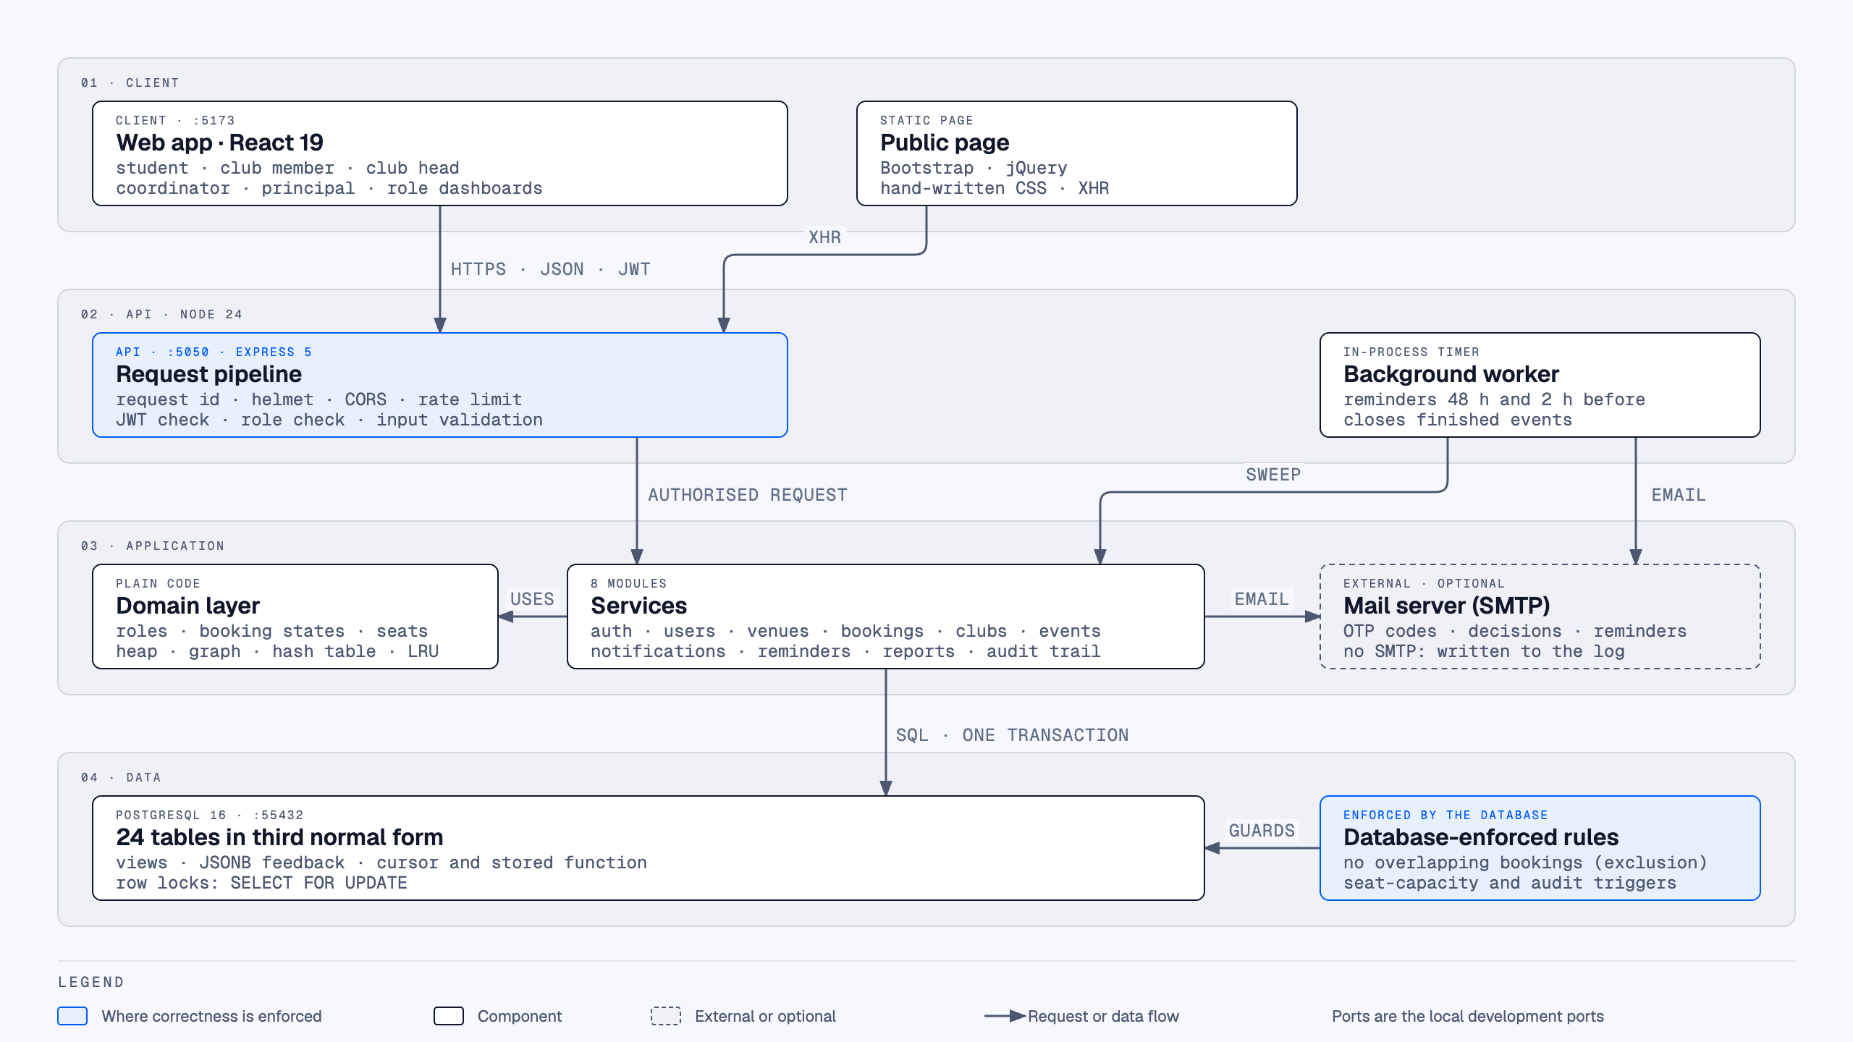
Figure 4.1: System architecture of CampusOS
Figure 4.2 shows the use cases of each actor. The roles form two inheritance chains: Student → Club Member → Club Head, and Faculty → Department Coordinator / Principal (Super Admin). A timer actor drives reminders.
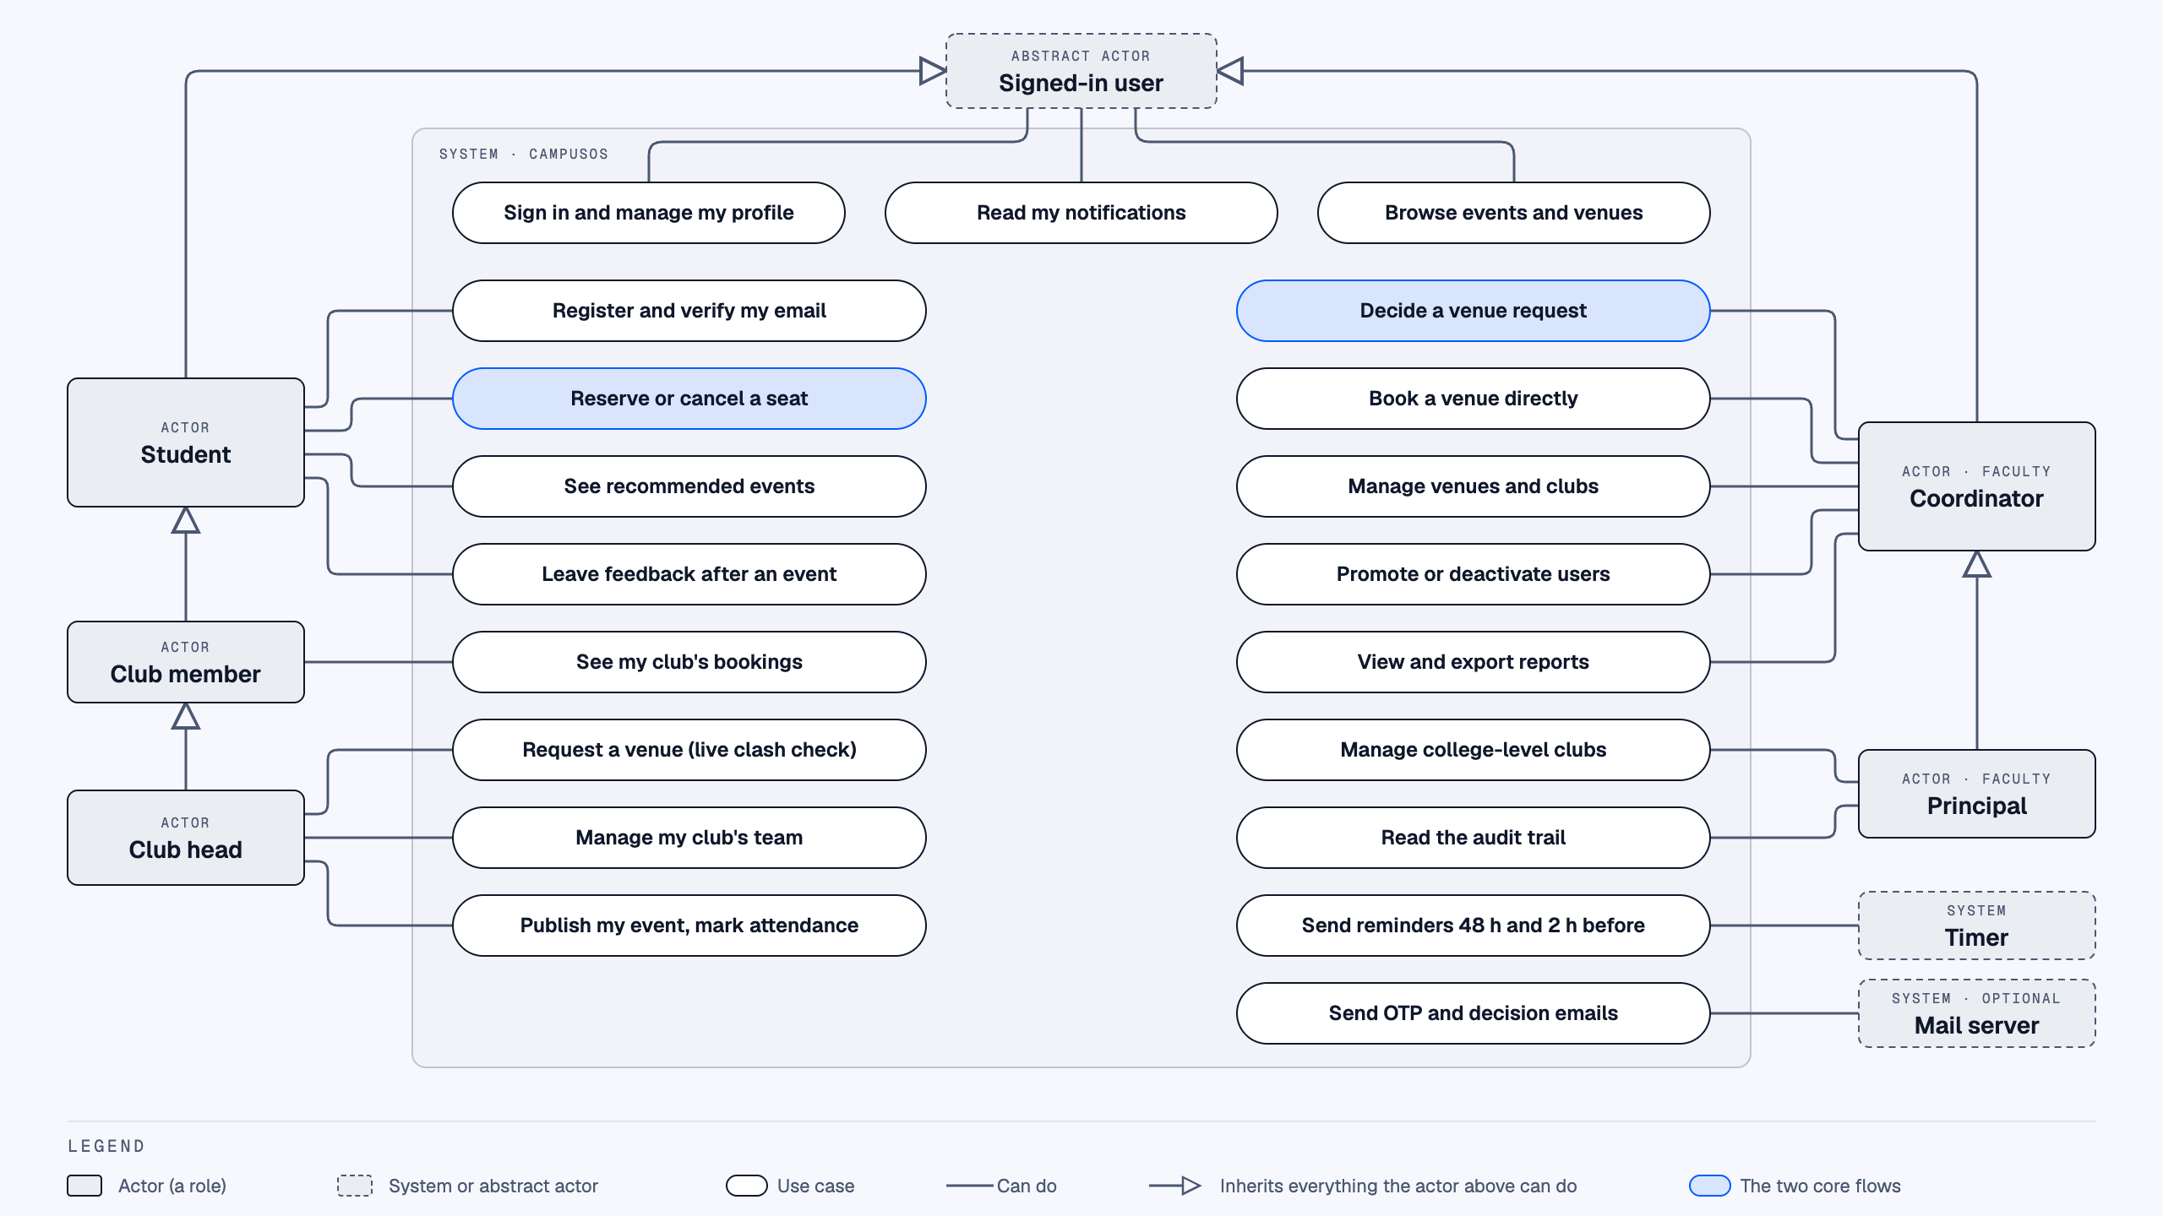
Figure 4.2: Use case diagram
Figure 4.3 shows the core of the database. A venue hosts many bookings; an event needs a booking; students hold seats through event registrations. The exclusion constraint on bookings and the capacity trigger on registrations are the two database-level guards.
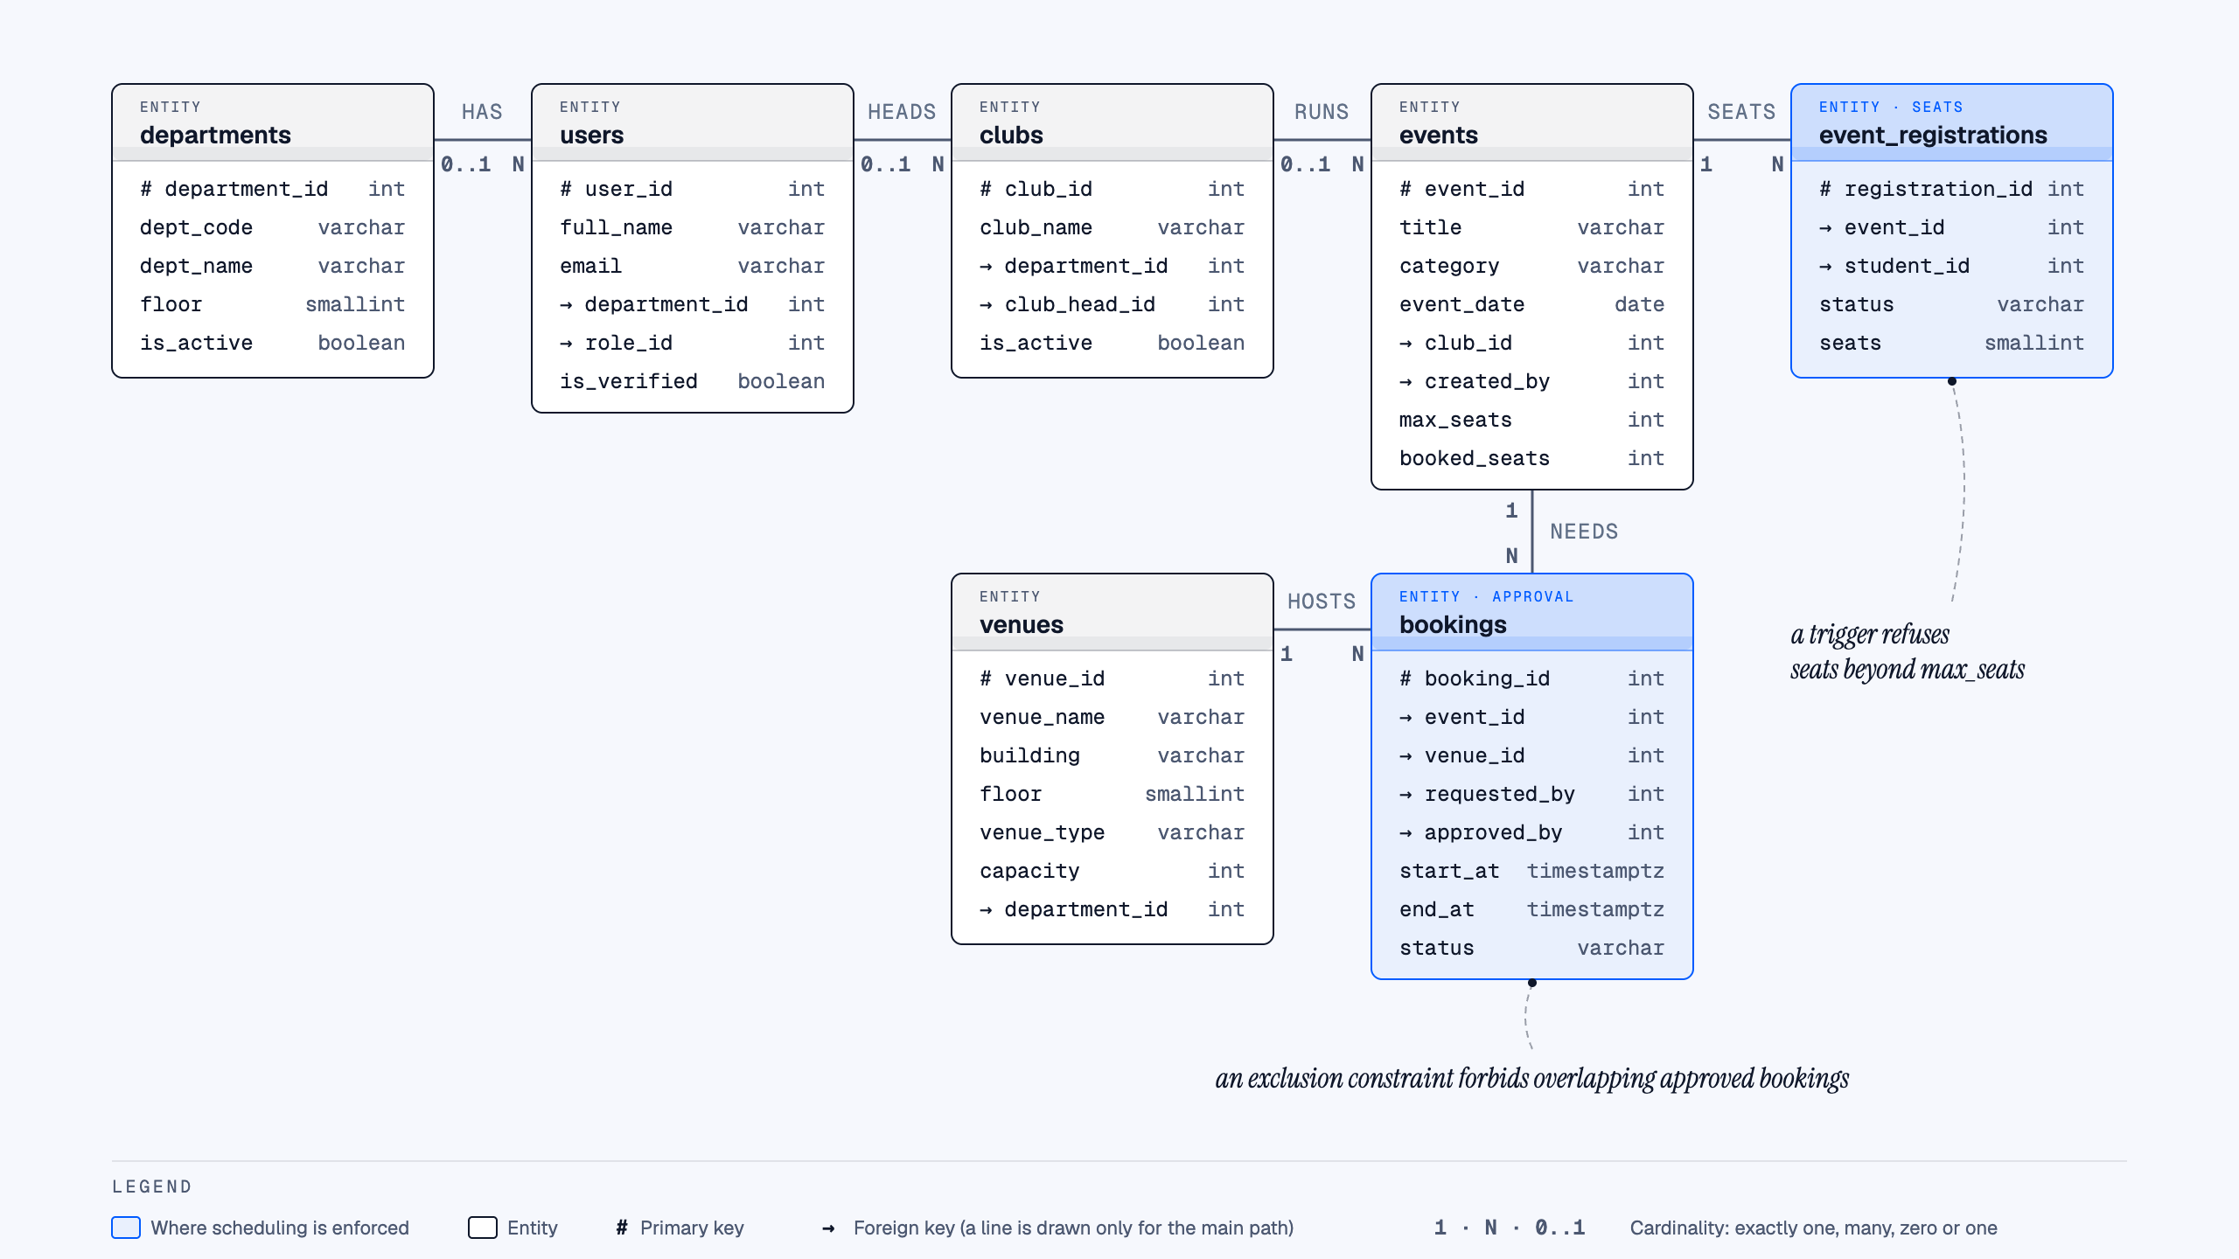
Figure 4.3: Core entity–relationship diagram

4.2 Algorithm

4.2.1 Interval Overlap Detection with Buffer (FR8, FR9)
Two bookings for the same venue conflict when their time windows, widened by the buffer B, intersect:
conflict = (Start_new < End_existing + B) AND (End_new + B > Start_existing)
- Input: venue id, requested start and end time; read buffer B (minutes) from settings.
- Reject if end ≤ start or the window is in the past.
- Query APPROVED bookings of the same venue whose window satisfies the conflict condition.
- If any row is returned, report the clash and suggest the nearest free windows; otherwise accept the request as PENDING.
- Free-window suggestion: merge-sort the day’s busy bookings, binary-search the first booking that can reach a candidate window, and select the four windows nearest the requested time with a min-heap.

4.2.2 Booking Approval with Pessimistic Locking (FR10, FR12)
- BEGIN transaction.
- SELECT the venue row … FOR UPDATE — concurrent approvals for that venue now wait in turn.
- Load the booking; its state machine allows approve() only from PENDING.
- Re-check overlap against APPROVED bookings with buffer B. If a clash exists, ROLLBACK and return 409 Conflict.
- Mark the booking APPROVED, record approved_by, write an audit-log row.
- Mark every other PENDING booking that overlaps the window as REJECTED with an automatic reason, and notify their requesters.
- COMMIT. The exclusion constraint on (venue, time range) for APPROVED rows rejects any overlap that could bypass this code.

4.2.3 Seat Reservation and Seat Recovery (FR15, FR16)
- BEGIN; SELECT the event row FOR UPDATE.
- Check eligibility (event published and upcoming, department / year rules, not already registered); one seat per student.
- If booked_seats < max_seats: insert the registration and increment booked_seats (the counting semaphore’s P operation). Otherwise refuse, or add to the waitlist if enabled.
- COMMIT. A trigger independently refuses any registration beyond max_seats.
- On cancellation: decrement booked_seats (V operation), then promote waiting students in order using a circular queue, re-queuing any entry that does not yet fit.

4.2.4 Category-Based Recommendation Scoring (FR17)
For each upcoming event the student is eligible for, a score is computed from the student’s registration history: +3 per earlier registration in the same category (counting at most 3), +4 if the event is from a club the student attended before, and +2 if it is hosted by the student’s own department. Each recommendation carries a human-readable reason. The top 20 of up to 100 scored events are selected with a binary min-heap in O(n + k log n) time, ties broken by the soonest date. No machine-learning model is used.

4.2.5 Nearest Free Venue (Dijkstra)
Campus buildings are nodes of a weighted undirected graph (adjacency list, built from the campus_paths table). Dijkstra’s algorithm with a min-heap, O((V + E) log V), ranks free venues by walking distance from the user’s location and returns the route. The seeded distances are illustrative placeholders, not measurements.

4.3 Methodologies
- Incremental, phase-wise development. Each phase was a vertical slice (database → API → tests → UI) that ended with all tests passing in continuous integration before the next began.
- Database-first correctness. Rules that must never break are encoded as constraints and triggers in PostgreSQL in addition to the application code, giving two independent layers of protection.
- Test-driven verification. Unit, integration (against a real PostgreSQL database), concurrency, schema and UI flow tests; CI coverage gates that only ratchet upward.
- Version control and documentation discipline. One GitHub monorepo, a branching and commit convention, pull-request templates, and a dated change log (UPDATES.md) recording each change with its reasoning.
- Course-wise application. Data structures, OOP hierarchies and OS concepts were introduced only where they do real work in a feature, and every claim is mapped to code in the syllabus-mapping document.

Chapter 5
COURSEWISE WORKING MODULES
This chapter shows where each second-year IT course is applied in a working module of CampusOS. Only what is implemented is listed; topics that have no natural use in the project are stated as such rather than forced. Table 5.1 gives the overview.
Table 5.1: Course-to-module mapping
Course | Concepts applied | Module(s)
B25IT301 Data Structures & Algorithms | Circular queue, merge sort, binary search, binary min-heap, n-ary tree with traversals, graph with BFS/Dijkstra, hash table with chaining | Waitlist, slot suggestions, recommendations, venue hierarchy, nearest venue, caches
B25IT302 Object Oriented Programming | Classes, encapsulation (#private), inheritance, runtime polymorphism, abstract classes, exception hierarchy, file I/O | RBAC, booking state machine, reports, error handling
B25IT401 Database Management Systems | 3NF schema, keys, constraints, views, triggers, stored function, cursor, transactions, row locking, JSONB | Whole data layer; bookings; RSVP; audit; reports; feedback
B25IT402 Operating Systems | Critical section, mutual exclusion, counting semaphore, deadlock prevention, FCFS/SJF/priority scheduling, LRU replacement | Approvals, seat reservation, approval inbox, lookup cache
B25IT403 Computer Network | Client–server model, HTTP methods and status codes, ports, cookies, CORS | API and web app
B25IT404 / B25IT405 Web Technology & Website Development | Semantic HTML, CSS, JavaScript, fetch/XHR, JSON, REST, React, Bootstrap, jQuery, form validation | Web app and public page
B25IT303 Design Thinking for UX | Role-based dashboards, accessible components, consistent navigation | Web app

5.1 Data Structures and Algorithms (B25IT301)
Seven structures were hand-written in backend/src/lib/ds/, each with its complexity documented and its own tests, and each doing a job in a real feature:
Table 5.2: Data structures used in CampusOS
Structure / algorithm | Complexity | Where it is used
Circular queue (fixed array) | O(1) enqueue/dequeue | Waitlist seat promotion after a cancellation (FR16)
Merge sort + binary search | O(n log n), O(log n) | Free-slot suggestion; recommendation ranking
Binary min-heap | O(log n) push/pop | Top-K selection of recommendations and nearest free times; Dijkstra
n-ary tree (pre-, post-, level-order) | O(n) | Campus → building → floor → venue hierarchy; post-order venue counts
Weighted graph, BFS, Dijkstra | O((V+E) log V) | Nearest free venue with walking route
Hash table (chaining, FNV-1a, resize at 0.75) | O(1) average | Registration-history tallies; index of the LRU cache

Correctness is checked against independent references, e.g. Dijkstra is compared with Floyd–Warshall on 200 random graphs, and merge sort with the built-in sort on 500 random arrays.

5.2 Object Oriented Programming (B25IT302)
- Inheritance and runtime polymorphism (RBAC): User → Student → ClubMember → ClubHead (multilevel) and User → Faculty (abstract) → DeptCoordinator / SuperAdmin (hierarchical). Policy questions such as canManageClub() and canViewUser() are methods overridden per class, replacing chains of if-role checks.
- Encapsulation (Booking state machine): a Booking keeps its status in a #private field; only approve(), reject(), requestChanges(), resubmit() and cancel() can change it, and illegal transitions throw.
- Abstract classes: Report is abstract and its build() method acts as a pure virtual function, overridden by four report classes; ReportResult.saveTo() writes CSV/JSON/PDF files (file I/O).
- User-defined exceptions: ApiError with eight subclasses (e.g. ConflictError → SlotUnavailableError) thrown throughout and translated to HTTP status codes; process-level handlers catch unexpected exceptions.

5.3 Database Management Systems (B25IT401)
- Design: 24 tables in third normal form with 38 foreign keys, 41 check constraints and composite primary keys on junction tables; ER diagram in Figure 4.3.
- Integrity in the database: an EXCLUDE constraint forbids overlapping APPROVED bookings for one venue; a trigger refuses seats beyond capacity; a trigger makes the audit log append-only.
- Transactions and concurrency: approvals and RSVPs run in transactions with SELECT … FOR UPDATE; the reminder worker claims rows with FOR UPDATE SKIP LOCKED so two workers never send the same reminder.
- SQL features: four reporting views written with JOIN, GROUP BY and HAVING; a PL/pgSQL stored function and trigger pair; a cursor-driven function; UNION, NOT IN and a self-join in real endpoints.
- Semi-structured data: event feedback stored in a JSONB column (used in place of a separate NoSQL database).

5.4 Operating Systems (B25IT402)
- Critical section and mutual exclusion: the venue row lock makes the approve-and-auto-reject sequence a critical section.
- Counting semaphore: an event’s free seats are modelled by SeatSemaphore — reserve is P (wait), cancel is V (signal).
- Deadlock prevention: two functions locked the clubs and users tables in opposite orders; this was found, documented as a case study, and fixed by imposing one global lock order (removing circular wait).
- CPU scheduling policies: the faculty approval inbox can be ordered by FCFS, SJF or priority, and computes average waiting time for each.
- Page replacement: an LRU cache with explicit invalidation for settings and venue lookups.
- Shell scripts for database reset, backup and test runs.

5.5 Computer Network (B25IT403)
The system is an application-layer client–server design: the browser (development port 5173) talks to the API (port 5050) over HTTP using GET/POST/PATCH/DELETE with meaningful status codes, and the API talks to PostgreSQL over TCP. Refresh tokens travel in httpOnly cookies, CORS allows only listed origins, and rate limiting protects sign-in. Lower-layer topics (data link, IP routing, wireless) are not applicable to a web application.

5.6 Web Technology and Website Development (B25IT404, B25IT405)
The main web app is a React single-page application using fetch and JSON against a REST API, with client- and server-side validation. A separate public information page (/about) is written in semantic HTML with hand-written CSS, Bootstrap and jQuery, and calls the API health endpoint with XMLHttpRequest. The project corresponds directly to the course’s PBL topic of an end-to-end event management system with registrations, attendance, notifications and analytics. Hosting and DNS are not covered because the project is not deployed.

5.7 Design Thinking for UX and Software Engineering
Each role sees a dashboard tailored to its tasks; components are accessible (labels, roles, skip link, reduced-motion support) and the colour palette was checked for contrast. Engineering practice includes the SRS with numbered requirements, UML/ER diagrams, a commit convention, continuous integration on every push, and a dated change log.

Chapter 6
TESTING

6.1 Test Plan
The test target is the whole system: the Express API, the React web app and the PostgreSQL schema. Tests run automatically in GitHub Actions on every push, and a pull request below the coverage gate fails. Table 6.1 lists the levels of testing.
Table 6.1: Levels of testing
Level | What it checks | Tool | Database
Unit | One function or class: policies, validators, data structures, OS models | Jest, Vitest | None
Integration | A real HTTP request through routes, middleware, services and SQL | Jest + supertest | Real PostgreSQL 16
Concurrency | Many simultaneous requests against one row, to prove locking | Jest + supertest | Real PostgreSQL 16
Schema | Constraints and triggers reject bad data even when the API is bypassed | Jest | Real PostgreSQL 16
Component / flow | Screens rendered and driven as a user would | Vitest + Testing Library + MSW | None (network mocked)
Equivalence | New algorithm vs. a reference on thousands of random inputs | Jest | None

Test environment: Apple M4 laptop, 16 GB RAM, macOS; Node.js v24; PostgreSQL 16; the test database is rebuilt from schema.sql and seed.sql before each run. CI runs on Ubuntu.

6.2 Test Cases
Table 6.2: Representative test cases
ID | Test case | Input / action | Expected result | Result
TC01 | Register with non-college e-mail | Sign-up with an address outside the allowed domain | Rejected with a validation error | Pass
TC02 | Verify account by OTP | Correct code within its validity period | Account verified; sign-in allowed | Pass
TC03 | Repeated wrong passwords | Several failed sign-ins on one account | Account temporarily locked | Pass
TC04 | Reused refresh token | Old refresh token sent after rotation | Session revoked; 401 | Pass
TC05 | Unauthorised role | Student calls the approval endpoint | 403 Forbidden | Pass
TC06 | Overlapping booking | Request a venue for a time overlapping an approved booking | Refused as a clash, with suggested free times | Pass
TC07 | Buffer violation | Request starting 5 min after an approved booking ends (buffer 15 min) | Refused as a clash | Pass
TC08 | Simultaneous approvals | 20 competing requests for one slot approved at the same instant | Exactly 1 approved, 19 refused | Pass
TC09 | Auto-reject of competitors | Approve one of two pending requests for a slot | The other becomes REJECTED with a reason | Pass
TC10 | Reject without reason | Reject a request with an empty reason | Validation error | Pass
TC11 | Last-seat race | 20 students reserve the last seat at once | Exactly 1 succeeds; seats never exceed capacity | Pass
TC12 | Seat recovery | A registered student cancels | Seat count decremented; waitlisted student promoted (if enabled) | Pass
TC13 | Double publish | 20 simultaneous publishes of one event | Exactly 1 succeeds; one broadcast | Pass
TC14 | Deadlock regression | 15 addMember + 15 changeRole calls on the same club and users | No deadlock; all complete | Pass
TC15 | Reminder idempotency | Run the reminder sweep twice in the same window | Each user gets one reminder, not two | Pass
TC16 | Audit immutability | UPDATE or DELETE an audit row directly in SQL | Rejected by the trigger | Pass
TC17 | Database overlap guard | Insert an overlapping APPROVED booking directly in SQL | Rejected by the exclusion constraint | Pass
TC18 | Report export | Export venue utilisation as CSV and PDF | Files generated with correct figures | Pass

6.3 Test Results
The figures below are from the full test run of 20 September 2026 on the environment described in Section 6.1.
Table 6.3: Automated test results
Suite | Test files | Tests | Passed | Failed | Skipped
Backend (Jest) | 59 | 1030 | 1030 | 0 | 0
Frontend (Vitest) | 15 | 248 | 248 | 0 | 0
Total | 74 | 1278 | 1278 | 0 | 0

Table 6.4: Code coverage
 | Statements | Branches | Functions | Lines
Backend (measured) | 98.71% | 91.03% | 99.47% | 99.44%
Backend (CI gate) | 97% | 89% | 97% | 98%
Frontend (measured) | 94.17% | 88.54% | 91.41% | 95.81%
Frontend (CI gate) | 90% | 84% | 85% | 92%

Table 6.5: Response-time probe (500 requests per endpoint, 100 in flight)
Endpoint | p50 (ms) | p95 (ms) | Max (ms) | Failed
GET /api/health | 9.3 | 20.5 | 26.1 | 0
GET /api/venues | 32.2 | 39.7 | 44.6 | 0
GET /api/events | 71.0 | 76.8 | 81.0 | 0
GET /api/dashboard | 23.4 | 26.0 | 27.8 | 0
GET /api/reports/venue-utilisation | 34.0 | 37.4 | 40.5 | 0

All responses are far inside the SRS target of 3 seconds. This probe ran on one laptop against a small seeded database, so it is not a load test: the SRS target of 500 simultaneous users has not been verified. Two real defects were found by testing and fixed with regression tests — a deadlock between two club-membership functions, and a duplicate broadcast when an event was published twice at once.

Chapter 7
OTHER SPECIFICATION

7.1 Advantages
- Zero double bookings: enforced by row locking in the application and by an exclusion constraint in the database, and proved by a 20-way concurrent test.
- Faster, recorded approvals: one-click approve / reject / request-changes, with competing requests resolved automatically and every decision in the audit trail.
- One place for students to discover events, reserve a seat, receive reminders and leave feedback.
- Accountability through an append-only audit log of sign-ins, role changes and decisions.
- Ready-made reports on venue utilisation, club activity and attendance, exportable as PDF and CSV.
- Secure by design: bcrypt hashes, short-lived JWTs with rotating refresh tokens, RBAC, rate limiting and input validation on every endpoint.
- Zero licence cost: built entirely on open-source software.
- Maintainable: modular layers, 1,278 automated tests and CI on every change.

7.2 Limitations
- Not deployed; it runs locally and in CI. Hosting, a domain and HTTPS are not set up.
- Sign-up for students from other colleges (part of FR1) is not built yet.
- Not load-tested at the SRS target of 500 concurrent users; the global rate limit (300 requests per 15 minutes per address) could be shared by many users behind one college network address.
- Classrooms are approved like other venues; the system does not see the teaching timetable.
- Some venue capacities, equipment lists and campus walking distances are placeholders, not verified data.
- Not tested on real mobile devices or in all four target browsers; no formal accessibility audit or usability study.
- No data-retention policy yet: expired codes, tokens and old notifications are not purged.

7.3 Applications
- Venue and event management for engineering colleges and universities with multiple departments and student clubs.
- Booking of shared resources such as seminar halls, laboratories, auditoriums and sports facilities in any institution.
- Registration and seat management for workshops, guest lectures, technical fests and cultural festivals.
- Departmental reporting for accreditation and annual reports (club activity, venue utilisation, attendance).
- Booking of meeting rooms and training halls in offices, with the same approval and audit workflow.

Chapter 8
IMPLEMENTATION AND RESULT

8.1 Methodology
The implementation follows the end-to-end workflow of the system. Each step below corresponds to a screen of the web application and to the API and database logic described in Chapter 4.
- Sign up and sign in. A student signs up with a college e-mail, verifies it with a one-time code, and signs in. The API issues a short-lived access token and a refresh cookie, and the dashboard for the user’s role opens.
- Request a venue. A club head chooses building → floor → venue, a date and a time. The booking wizard checks for clashes live, applies the 15-minute buffer and suggests the nearest free times.
- Decide. The department coordinator sees competing requests in the approval inbox. Approving one locks the venue row, approves it, and rejects the competitors with a reason, all in one transaction.
- Publish and register. The club head publishes the approved event; students find it in the feed and reserve a seat. When seats run out the event shows as fully booked.
- Remind and report. The worker sends reminders 48 h and 2 h before the event. Coordinators and the principal view the audit trail and export reports.

8.2 Results
The screenshots below are taken from the running application with the seeded MMCOE data (six departments, one per floor of the academic building, and the clubs listed on the college website).
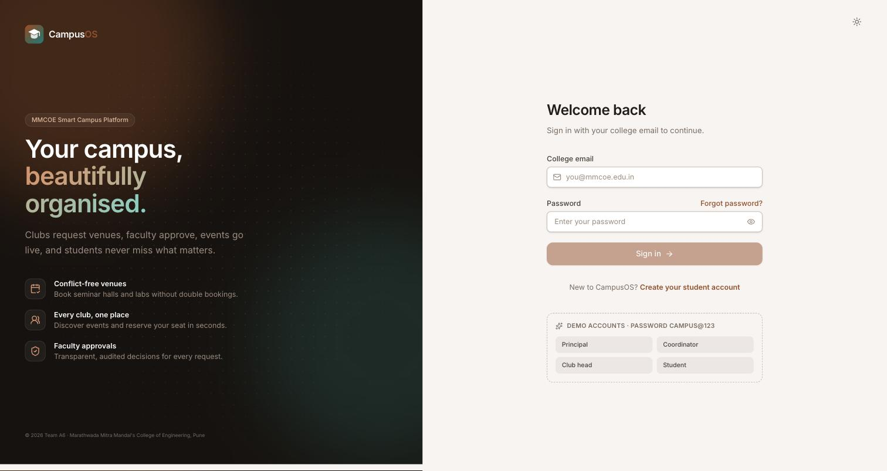
Figure 8.1: Sign-in page
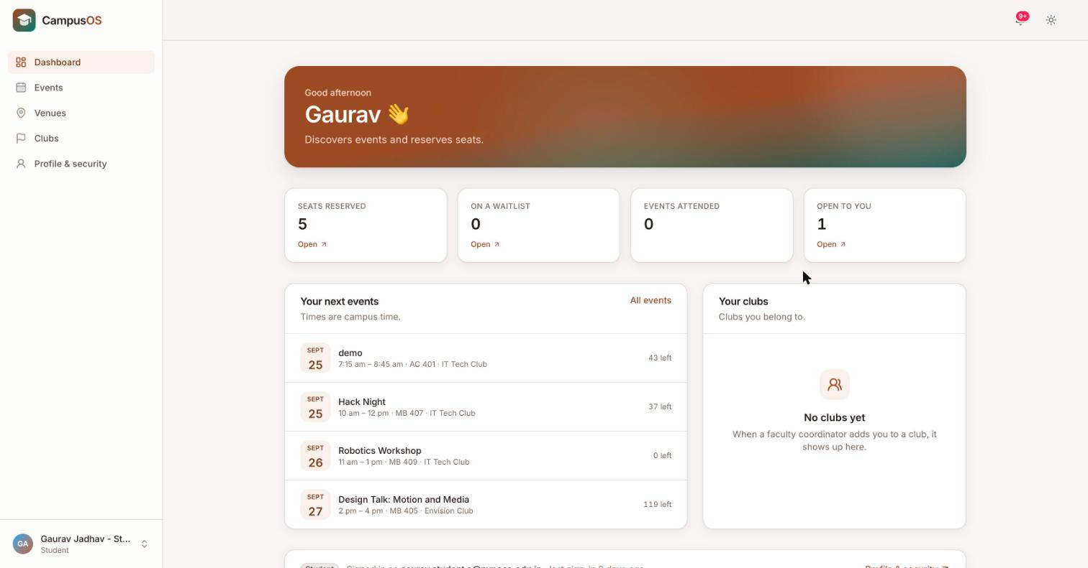
Figure 8.2: Student dashboard
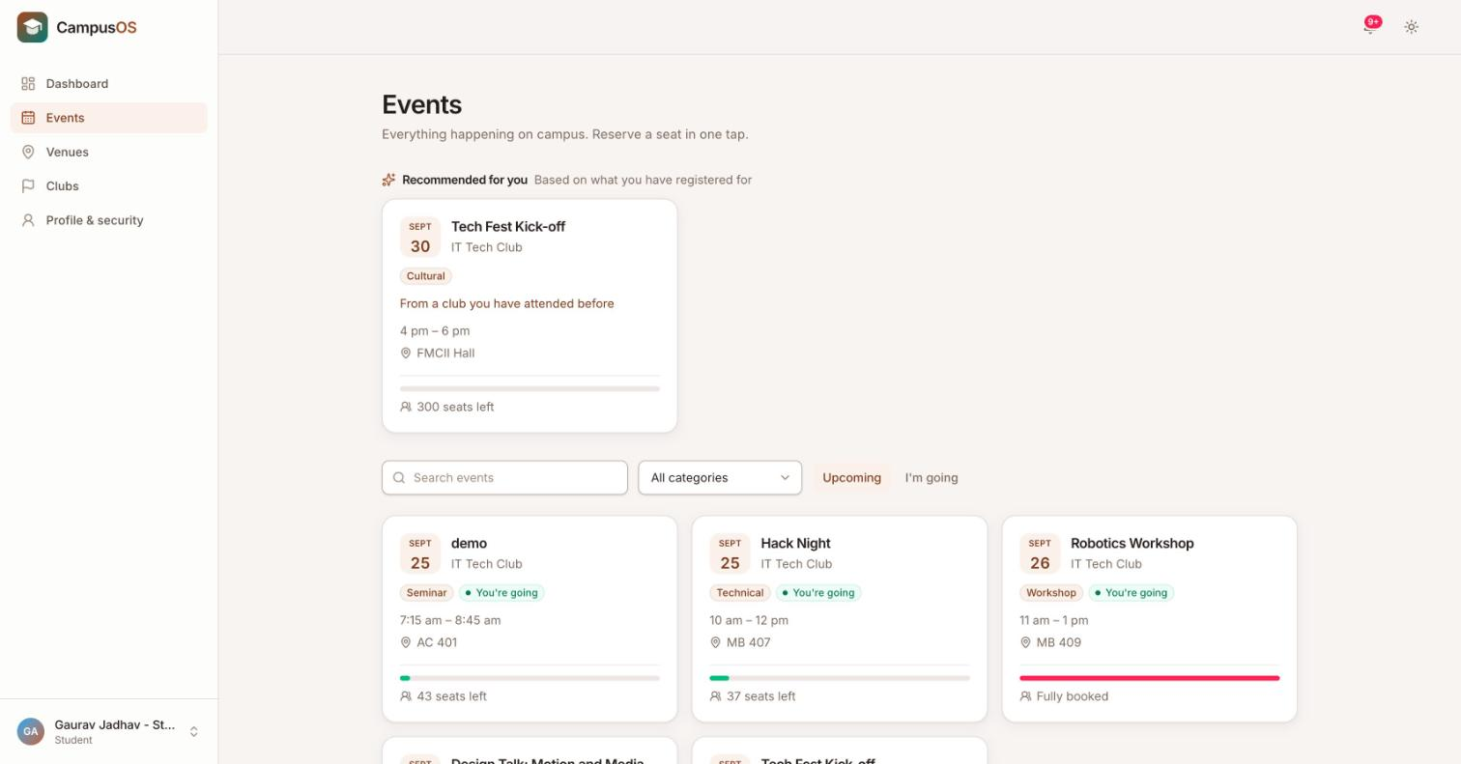
Figure 8.3: Event discovery feed with search and filters
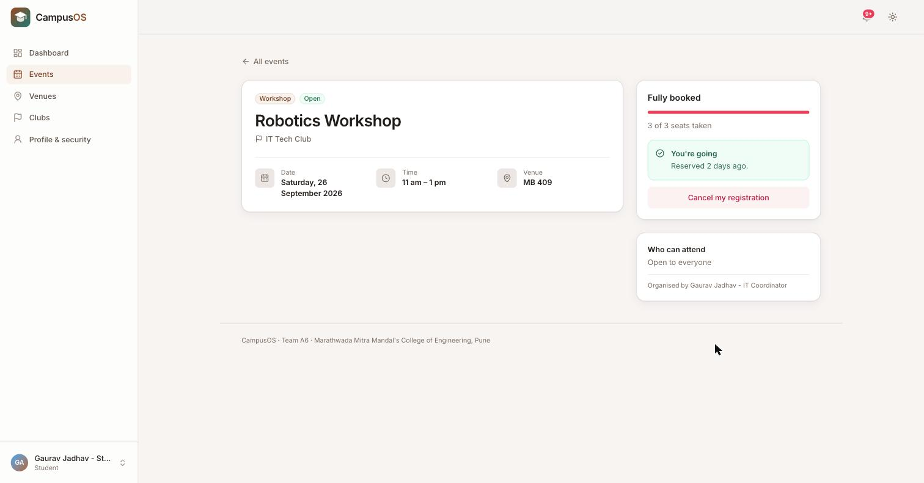
Figure 8.4: Event whose seats are fully booked
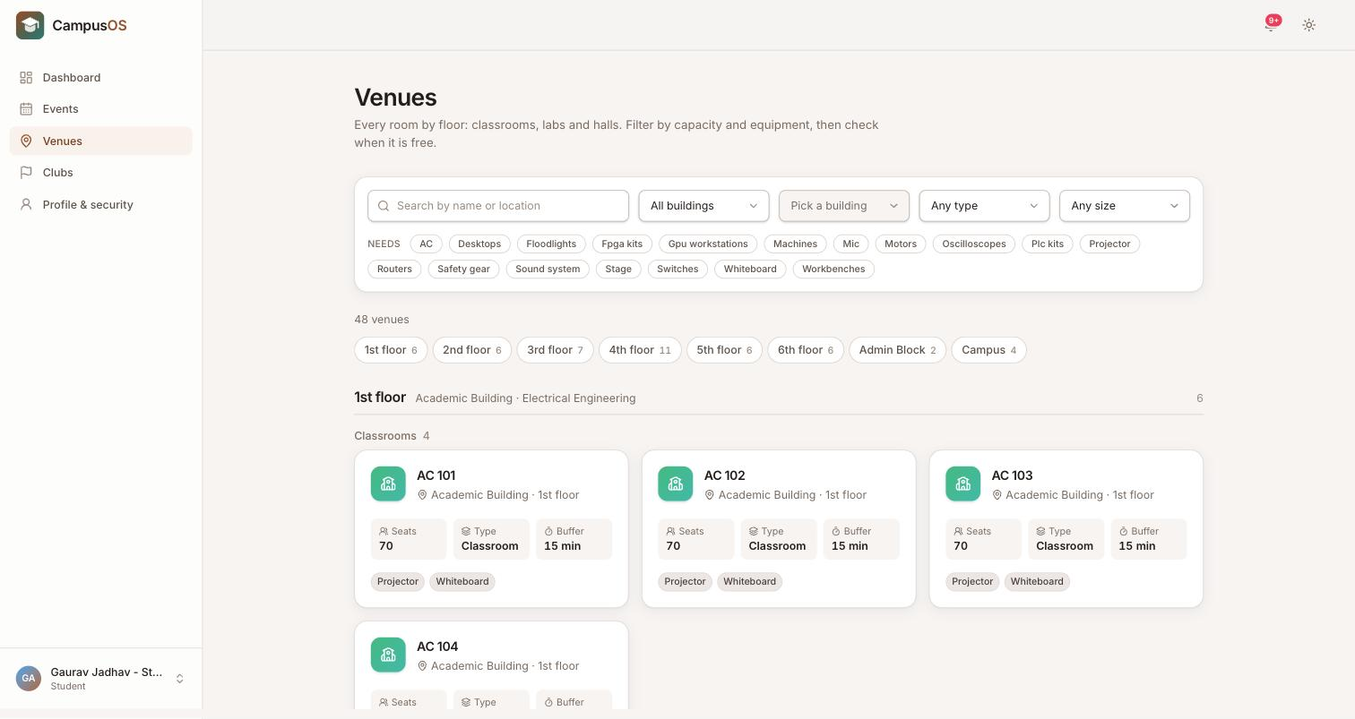
Figure 8.5: Venue directory organised floor by floor
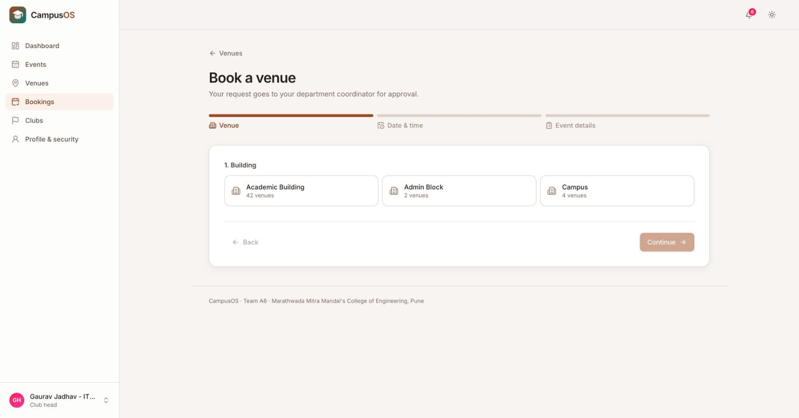
Figure 8.6: Booking wizard with live clash checking
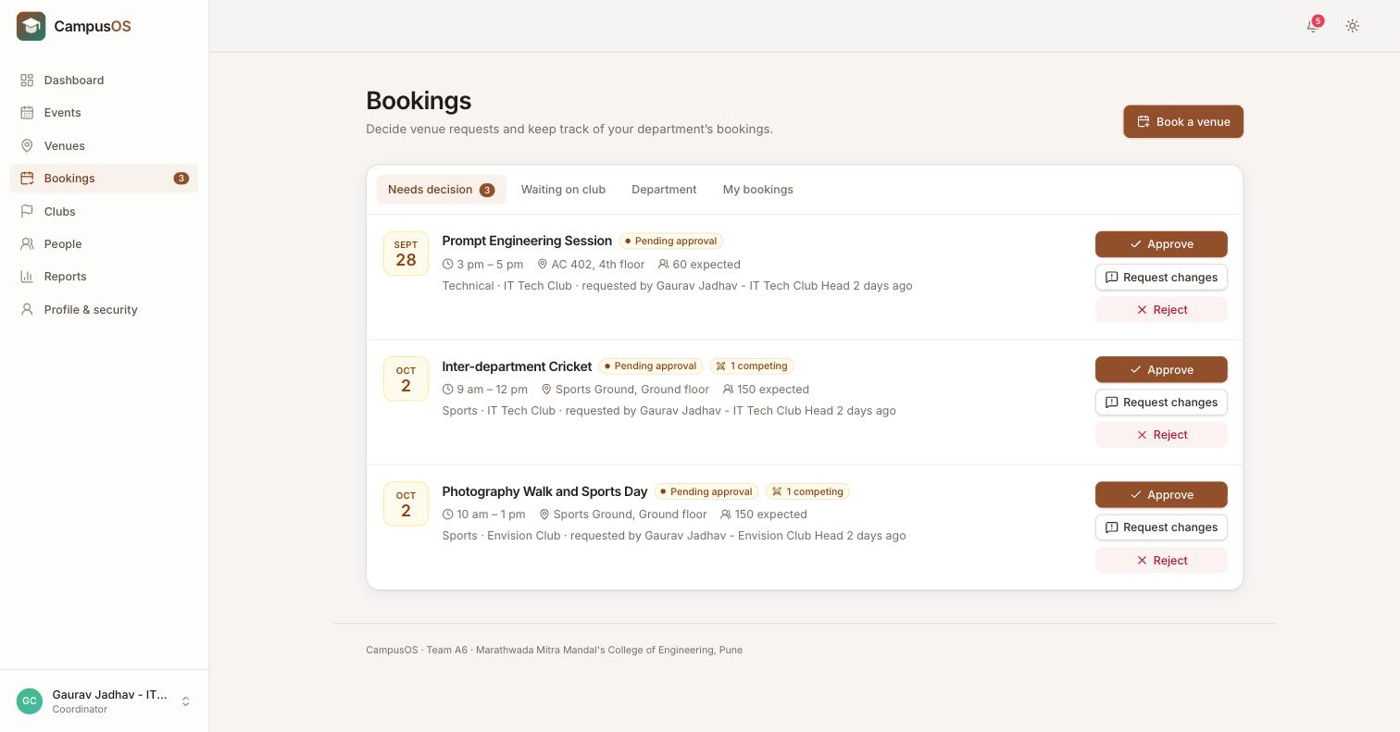
Figure 8.7: Approval inbox showing two competing requests for one slot
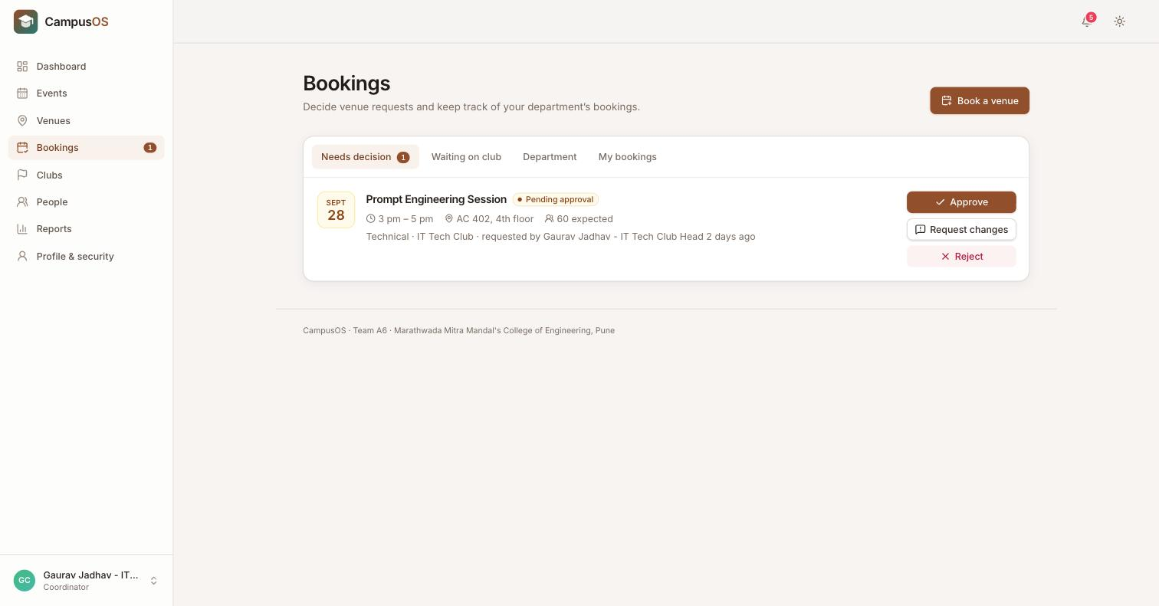
Figure 8.8: After approval: the competing request is rejected automatically
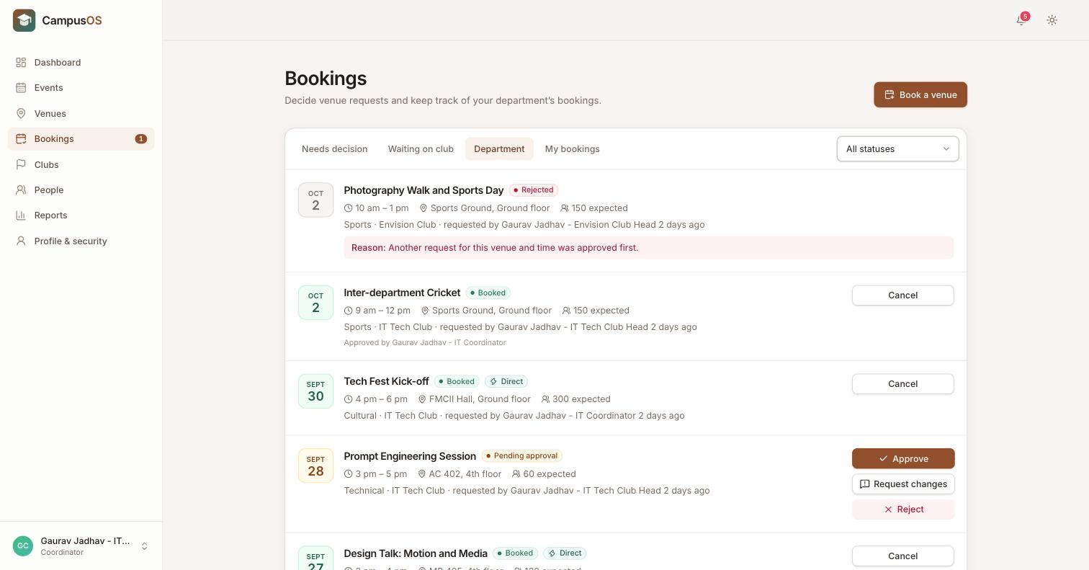
Figure 8.9: Approved and rejected requests, with the rejection reason
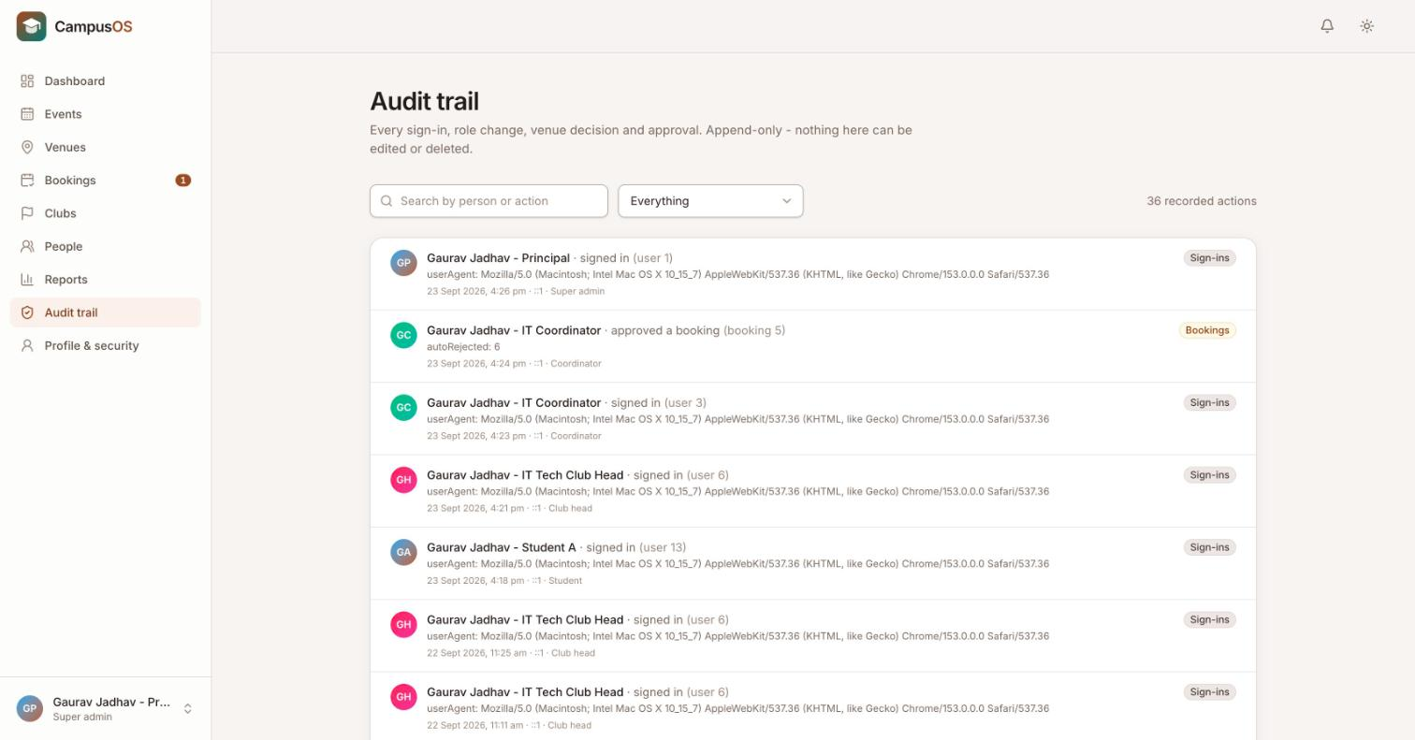
Figure 8.10: Append-only audit trail of decisions
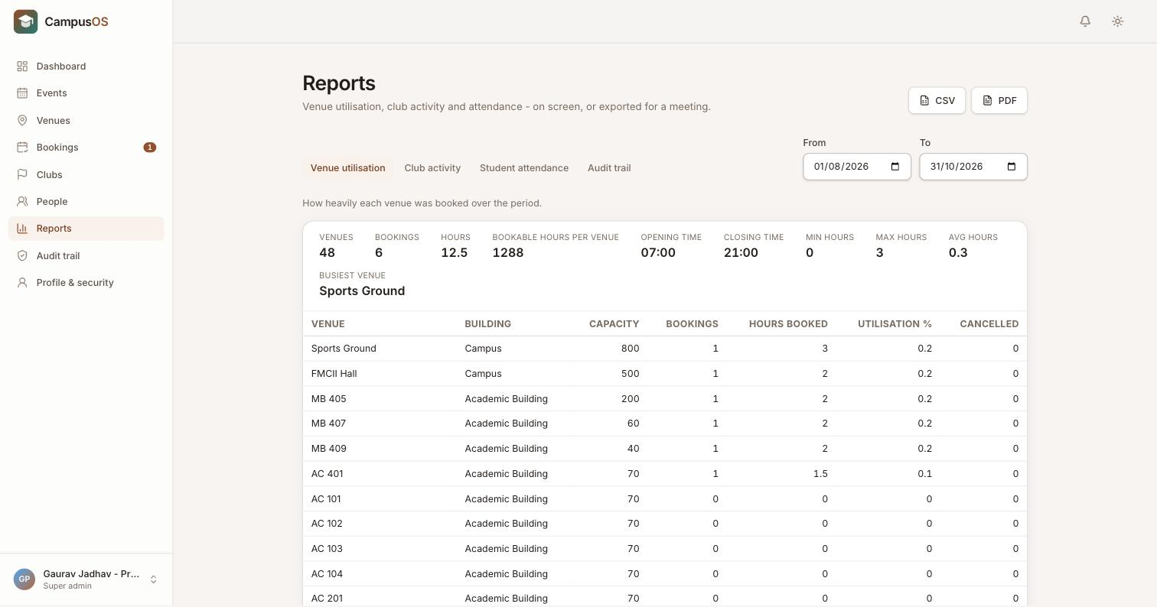
Figure 8.11: Venue utilisation report with PDF/CSV export
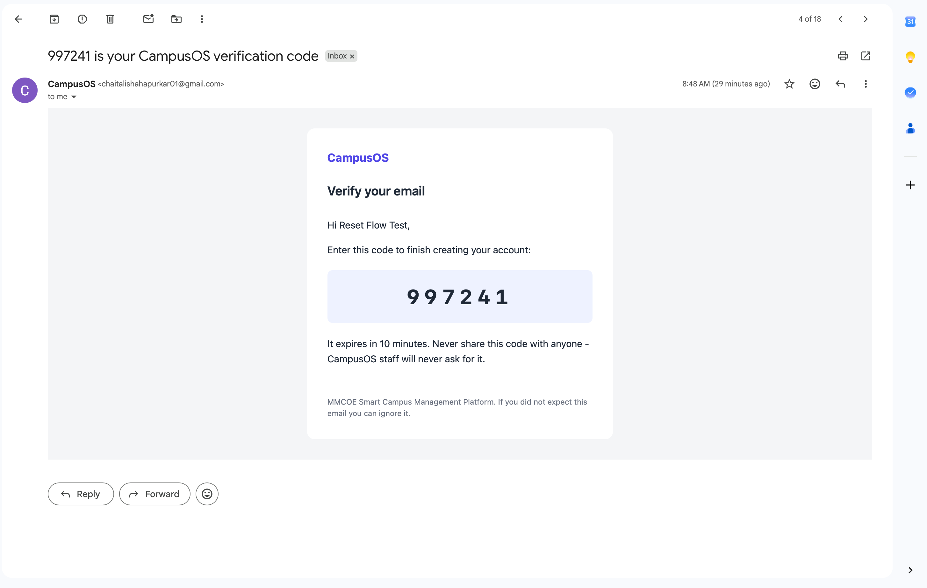
Figure 8.12: Verification e-mail with one-time code
Summary of results: 20 of the 21 functional requirements are fully implemented and FR1 is implemented for college users; 1,278 automated tests pass with 98.7% backend and 94.2% frontend statement coverage; the four concurrency races (simultaneous approvals, last seat, double publish, lock order) each end with exactly the correct outcome; and measured response times are well under the 3-second target on the test machine.

Chapter 9
PROJECT PLAN
The project ran across the first semester of 2026–27. Table 9.1 gives the week-wise plan as it was carried out; dates are taken from the repository commit history and the weekly reports.
Table 9.1: Week-wise project plan
Week | Dates (2026) | Activity | Outcome
0 | 30 Jul | Problem identification, team formation, repository created | Week 0 report; repository initialised
1 | 31 Jul – 6 Aug | Requirement gathering, SRS, workflow and architecture overview | SRS (FR1–FR21); workflow diagrams; Week 1 report
2 | 7 – 14 Aug | Monorepo scaffolding (backend, frontend, db, docs), contribution structure | Project skeleton and documentation hub
3 | 15 – 21 Aug | Database design | First PostgreSQL schema (18 tables); ER diagram
4 | 22 – 28 Aug | Review of SRS and schema (no code commits) | Corrections identified
5 | 29 Aug – 5 Sep | Initial frontend pages and database routes | First screens
6 | 6 – 12 Sep | Phase 0: foundation | Schema fixes, seed data, Express skeleton, test harness
7 | 13 – 17 Sep | Phases 1–6: full implementation | All 21 FRs implemented; CI green
8 | 18 – 21 Sep | Phases A–H: syllabus alignment, defect fixes, test report | DSA, OOP, DBMS, OS, web additions; deadlock fixed; 1,278 tests
9 | 22 – 24 Sep | Review 2 presentation | Demonstration and feedback
10–12 | 25 Sep – 13 Oct | Documentation, demo video, diagrams, screenshots, publication draft | Final documentation set
13 | Late Oct | Project report | This report

Table 9.2: Work division by area
Area | Members
Full stack: database, backend, frontend, testing, CI, documentation | Gaurav Jadhav
Backend | Srushti Mane, Sarvesh Khaladkar
Database | Chaitali Shahapurkar, Tushar Deshpande, Tanishka Patil
Frontend | Atharva Desai, Gayatri Muttepawar, Shravani Khandzode
Team leaders | Gaurav Jadhav, Sarvesh Khaladkar, Tushar Deshpande

Risk management: concurrency correctness was identified early as the highest technical risk and was addressed with locking, database constraints and dedicated race tests; schedule risk was managed by building in independent vertical slices so that phases could be split among sub-teams.

Chapter 10
CONCLUSION AND FUTURE WORK

10.1 Conclusion
CampusOS replaces MMCOE’s manual, scattered process for venue booking and event management with a single role-based web platform. Clubs request venues online, faculty decide with one click and a recorded reason, students discover events, reserve seats and receive reminders, and administrators have dashboards, an immutable audit trail and exportable reports.
The central technical result is that double bookings and overbooking are prevented not by a check that can race, but by transactions with row-level locks backed by an exclusion constraint and triggers in PostgreSQL — and this is demonstrated by automated tests in which twenty simultaneous requests always produce exactly one winner. The project also shows the second-year IT curriculum at work in a real system: data structures in scheduling and recommendations, OOP class hierarchies in access control and the booking state machine, normalisation, views, triggers and transactions in the database, semaphores, deadlock prevention and scheduling policies from operating systems, and HTTP, REST and web technologies in the client–server design. All 21 functional requirements are implemented (FR1 for college users), backed by 1,278 passing automated tests.

10.2 Future Work
- External participants: sign-up for students from other colleges using e-mail and a one-time code, controlled by a per-event “open to other colleges” switch.
- Classroom approval chain: a classroom-specific chain (club head → faculty coordinator → institute timetable coordinator → department timetable coordinator) so that event bookings never clash with the teaching timetable.
- Deployment and load testing: host the system with HTTPS and verify the 500-concurrent-user target.
- QR-code check-in at the venue for live attendance.
- Mobile application with push notifications.
- Data retention and privacy: consent notice, data export and erasure, and purging of expired records.

BIBLIOGRAPHY
- A. Silberschatz, H. F. Korth, S. Sudarshan, Database System Concepts, 7th ed., McGraw-Hill, 2019.
- A. Silberschatz, P. B. Galvin, G. Gagne, Operating System Concepts, 10th ed., Wiley, 2018.
- T. H. Cormen, C. E. Leiserson, R. L. Rivest, C. Stein, Introduction to Algorithms, 3rd ed., MIT Press, 2009.
- E. Balagurusamy, Object Oriented Programming with C++, McGraw-Hill Education.
- A. S. Tanenbaum, D. J. Wetherall, Computer Networks, 5th ed., Pearson, 2011.
- PostgreSQL Global Development Group, PostgreSQL 16 Documentation — Explicit Locking, Constraints, Triggers. https://www.postgresql.org/docs/16/
- Node.js Documentation. https://nodejs.org/docs/
- Express Documentation. https://expressjs.com/
- React Documentation. https://react.dev/
- Vite Documentation. https://vitejs.dev/
- Jest Documentation, https://jestjs.io/ ; Vitest Documentation, https://vitest.dev/
- OWASP Foundation, Authentication and Password Storage Cheat Sheets. https://cheatsheetseries.owasp.org/

REFERENCES
- “Smart College Event Management System Using MERN Stack,” International Journal for Research in Applied Science and Engineering Technology (IJRASET), vol. 11, no. III, Mar. 2023.
- “Event Horizon: Shaping Campus Culture Through Advanced Event Management,” International Journal for Research in Applied Science and Engineering Technology (IJRASET). https://www.ijraset.com/research-paper/event-horizon-shaping-campus-culture-through-advanced-event-management
- “College Event Management System,” International Journal of Engineering Research & Technology (IJERT), vol. 15, no. 06 (IJERTV15IS060107). https://www.ijert.org/college-event-management-system-ijertv15is060107
- “Online College Event-Hall Booking Reservation System,” IEEE conference publication, IEEE Xplore document 10040388. https://ieeexplore.ieee.org/document/10040388
- “Web-Sched: A Collaborative Scheduling System,” Ateneo de Naga University. https://www.academia.edu/36299821/Web_Sched_A_Collaborative_Scheduling_System
- R. S. Sandhu, E. J. Coyne, H. L. Feinstein, C. E. Youman, “Role-Based Access Control Models,” IEEE Computer, vol. 29, no. 2, pp. 38–47, 1996.
- P. A. Bernstein, V. Hadzilacos, N. Goodman, Concurrency Control and Recovery in Database Systems, Addison-Wesley, 1987.
- E. G. Coffman, M. J. Elphick, A. Shoshani, “System Deadlocks,” ACM Computing Surveys, vol. 3, no. 2, pp. 67–78, 1971.
- R. T. Fielding, “Architectural Styles and the Design of Network-based Software Architectures,” Ph.D. dissertation, University of California, Irvine, 2000.
- M. Jones, J. Bradley, N. Sakimura, “JSON Web Token (JWT),” IETF RFC 7519, May 2015.
- N. Provos, D. Mazières, “A Future-Adaptable Password Scheme,” in Proc. USENIX Annual Technical Conference, 1999.
- IEEE Recommended Practice for Software Requirements Specifications, IEEE Std 830-1998.

