CUSTOMER SEGMENTATION AND CLUSTERING

Wireframe Document

# Home Page

* Logo & Title – Displays the application logo at the top, followed by the title "Customer Segmentation and Clustering" to indicate the purpose of the tool.
* File Upload Section – Users can select and upload a CSV file, which is displayed in a preview box to ensure correct selection.
* Predict Button – A clearly visible "Predict" button allows users to start the analysis after file validation.
* User-Friendly Design – The page features a visually appealing background, smooth animations, and a structured layout for a seamless experience.
* Guided Workflow – The interface ensures an easy-to-follow process, leading users from file upload to predictive modeling efficiently.

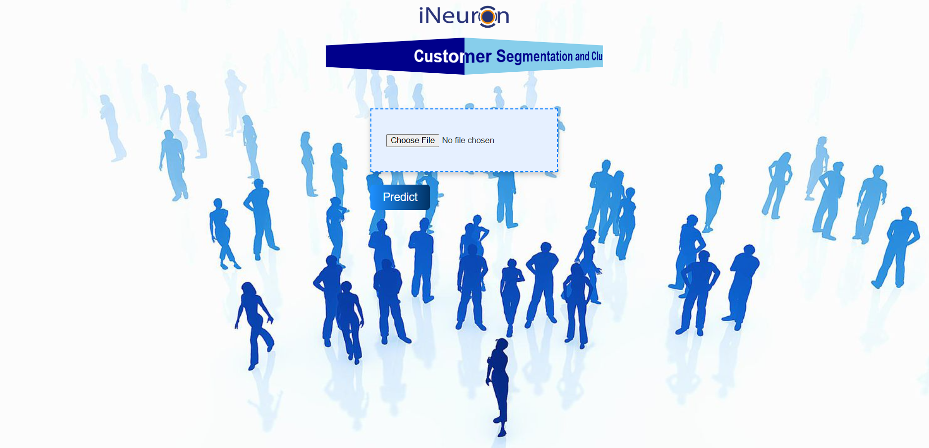

# Graphs

**Elbow Plot**

* Used to determine the **optimal number of clusters** for K-Means.
* Plots the **number of clusters (K) vs. inertia (within-cluster sum of squares)**.
* The point where the **inertia curve bends ("elbow point")** is the optimal number of clusters.

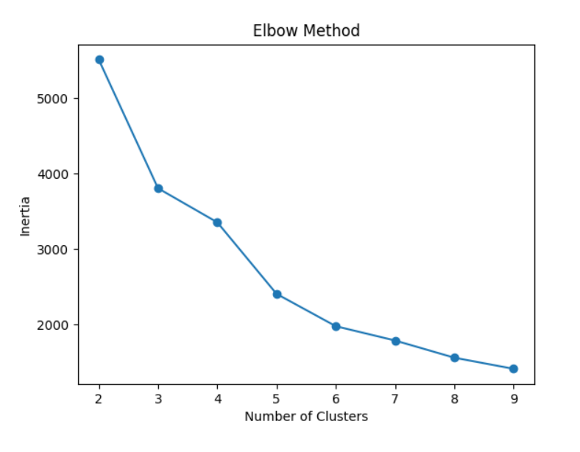

**Silhouette Score Plot**

* Measures **how well-separated** the clusters are.
* Plots the **Silhouette Score for different K values** (higher score means better clustering).
* Helps in validating the **quality of clusters** chosen by the Elbow Method.

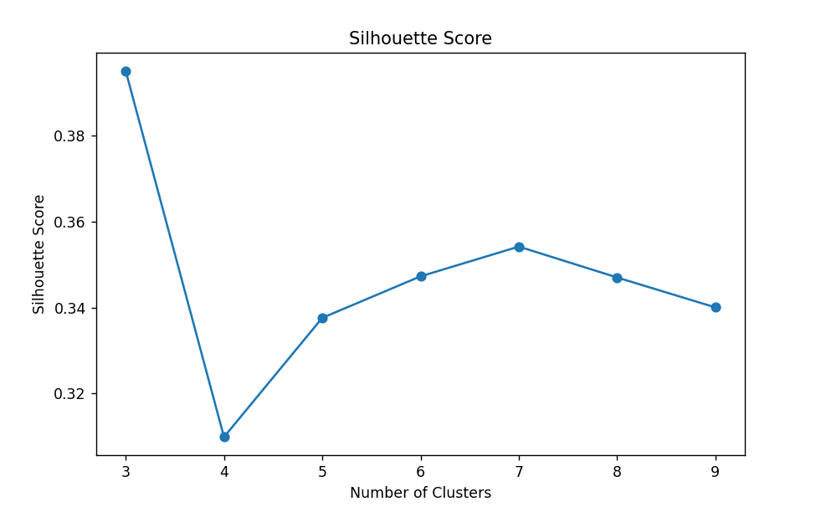

**2D Scatter Plot (MonetaryValue vs. Frequency)**

* Displays clusters using **two key customer behavior features: Monetary Value (spending) and Frequency (purchase count)**.
* Each cluster is **color-coded** to differentiate customer segments.
* Helps in understanding how customers group based on their spending and engagement.

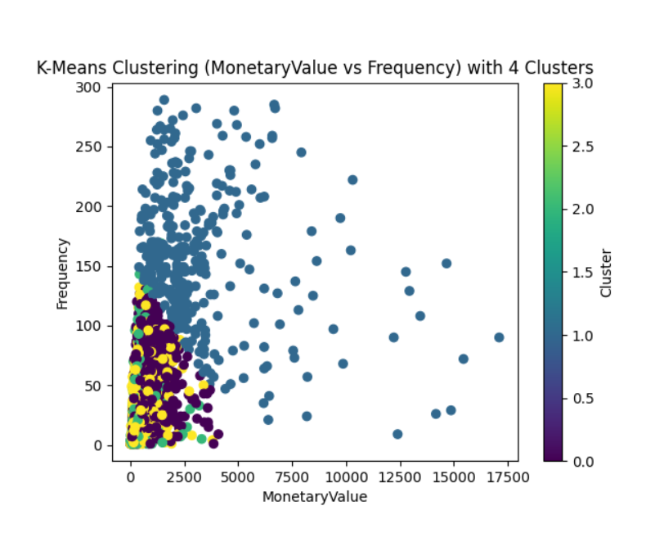

**3D Scatter Plot (MonetaryValue vs. Frequency vs. Recency)**

* Adds an extra dimension (Recency – time since last purchase).
* Visualizes clusters in a **more detailed space**, showing how spending, frequency, and recency interact.
* Enables a better **segmentation analysis** for customer behavior.

