For all SQL query questions, take screenshots of your results and save your queries in a .sql file.

Check the assignment folder for the two database files.

### Part 1: Basic queries with SELECT

1. Using the order_details table, find the revenue (price * quantity) earned on each order.

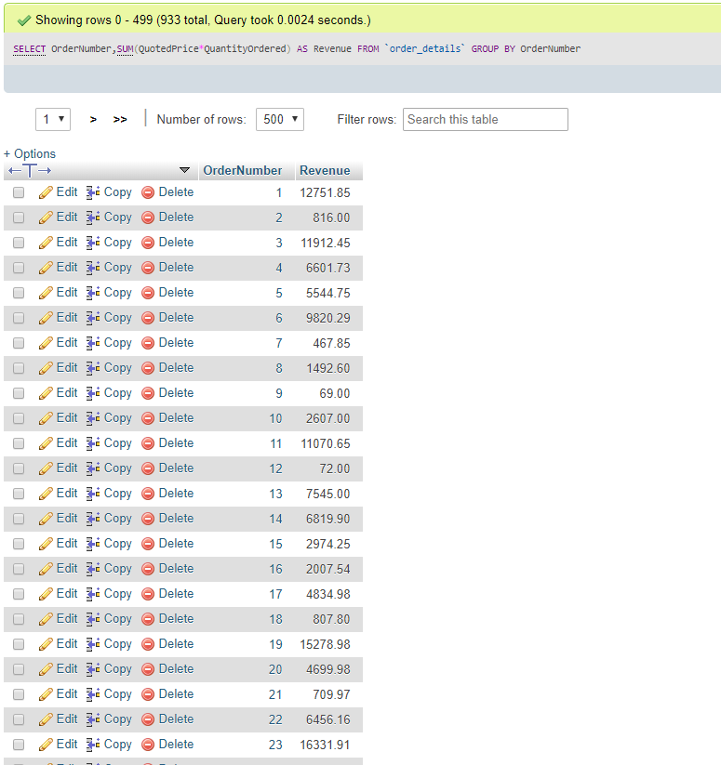

1. Using the employees table, find the age of each employee in years and order from youngest to oldest. NOTE: You do not have to account for leap years.

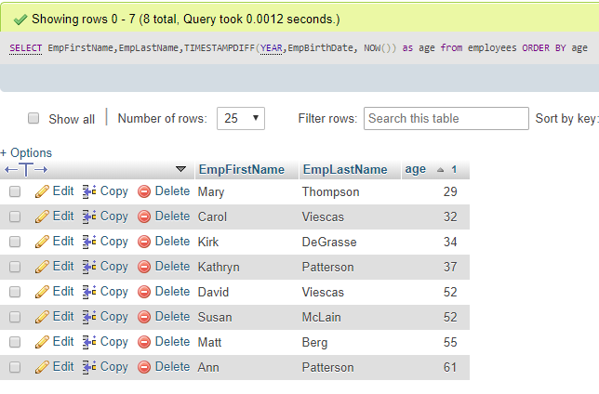

### Part 2: Conditional queries

1. Using the employees table, find all employees with a first name that contains an 'r' and a last name that does not contain a 'q'.

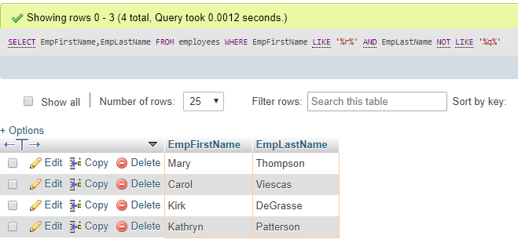

### Part 3: Database Design

1. Explain what is wrong with the following table and how you would fix it. **5 marks**

|  |  |  |  |  |
| --- | --- | --- | --- | --- |
| CompanyName | Address | Email | Products | Phone |
| Telle. Co | 12 Dirk St | Rep@telle.com | Computer, Phone, Power cables | 519-555-4410 |
| Barba. Co | 133 Shep St | Rep@barb.com | Hair care, Shampoo, Dye, Combs | NULL |

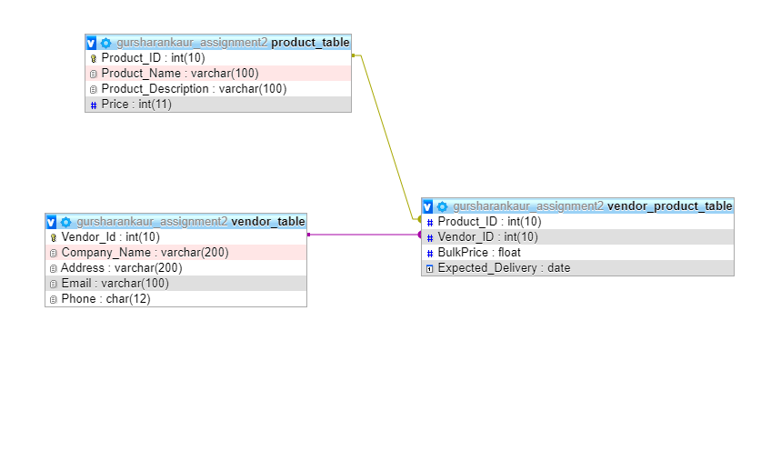

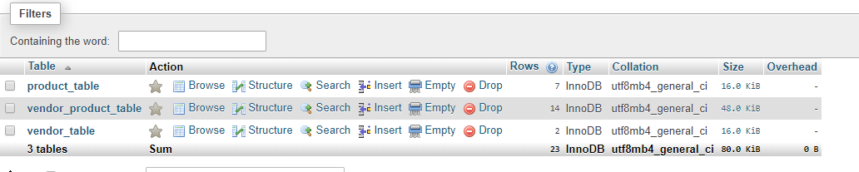

### Part 4: Joins

1. Find the first name and phone number of all customers who have ever ordered a helmet. **HINT**: Use the keyword **DISTINCT.**

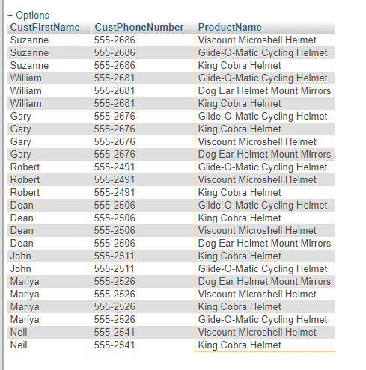

1. Display the first name of all customers who have the same first name as an employee

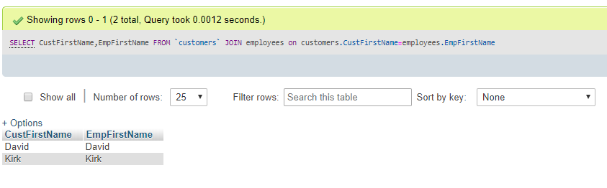

### Part 5: Aggregate Functions

1. Find the combined total value (QuantityOrdered*QuotedPrice*2) of all orders made by customers from the state of 'OR'

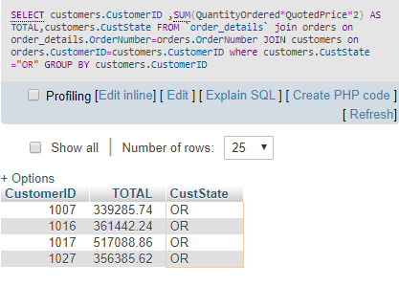

***Git Hub link***

<https://github.com/Ggursharnkaur2669/gursharankaurAssignmnet2>