Lab2 (redhat2) :
Name : ghada emad bhoul OS

1. Create a script named backup.sh in /usr/local/bin and Set the SUID bit so that the script runs with the permissions of the file owner (root).
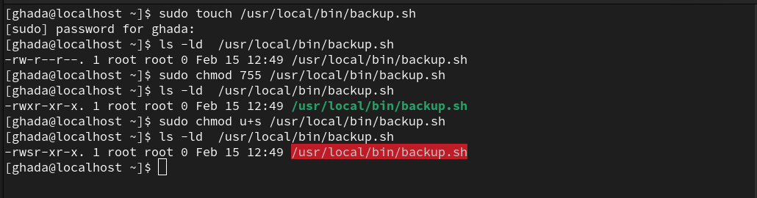
---------------------------------------------------------------------------------------
2. Create a directory named shared_team in /home and Set the SGID bit so that any files created in this directory inherit the group ownership of the directory.
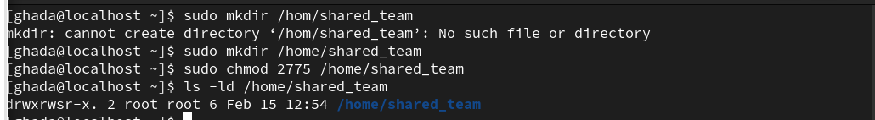
---------------------------------------------------------------------------------------
3. Set the sticky bit on the shared_team directory so that users can only delete their own files.
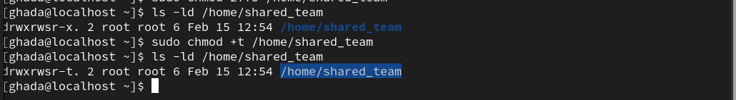
---------------------------------------------------------------------------------------
4.Create a shared directory named shared where:
add read and write permissions for a group named developers using ACL .
All new files and subdirectories inherit the group developers permissions(use the setgid permession).
Only the owner of a file can delete it (use the sticky bit).
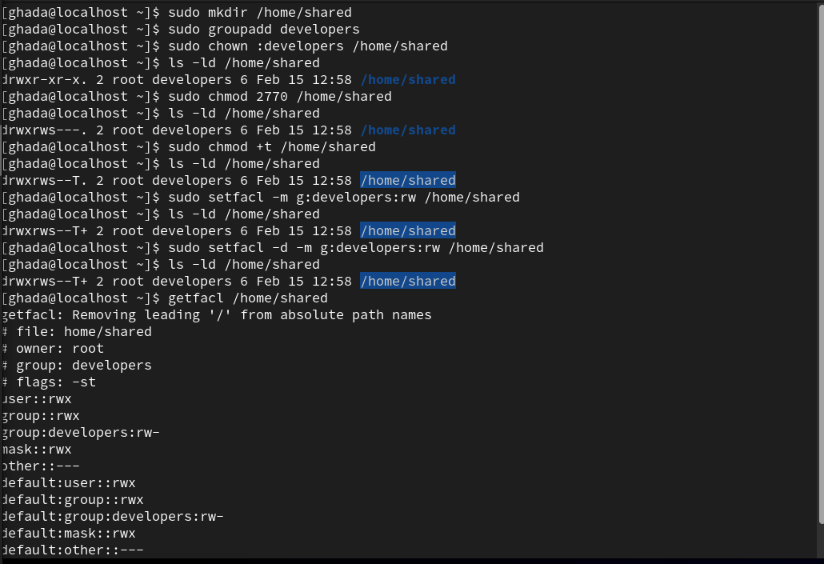
---------------------------------------------------------------------------------------
5.What is the difference between traditional Linux permissions and ACLs?

Traditional Linux permissions (rwx) only allow setting permissions for owner, group, and others.
ACLs (Access Control Lists) allow more granular control, letting you assign permissions to specific users or groups.
---------------------------------------------------------------------------------------
6.Create a directory named lab_acls and navigate into it:
---------------------------------------------------------------------------------------
7.Create a file named testfile.txt:
---------------------------------------------------------------------------------------
8.Create two users (alice and bob) and a group (developers):
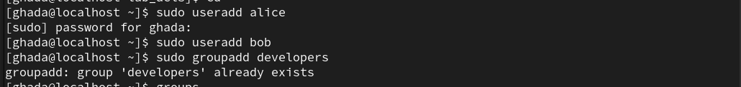
---------------------------------------------------------------------------------------
9.Add alice and bob to the developers group:
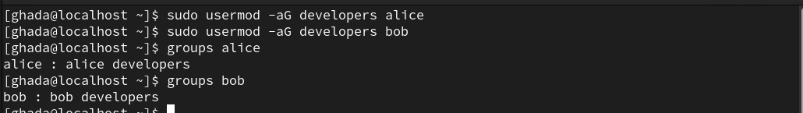
---------------------------------------------------------------------------------------
10.View and List the ACL of a file named testfile.txt.
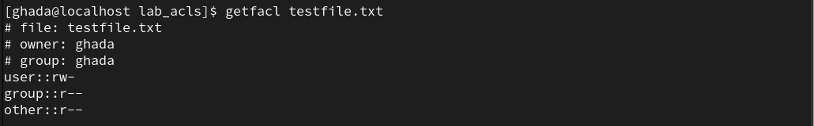
---------------------------------------------------------------------------------------
11.read and write permissions for a user named alice to the file testfile.txt and Verify the changes.

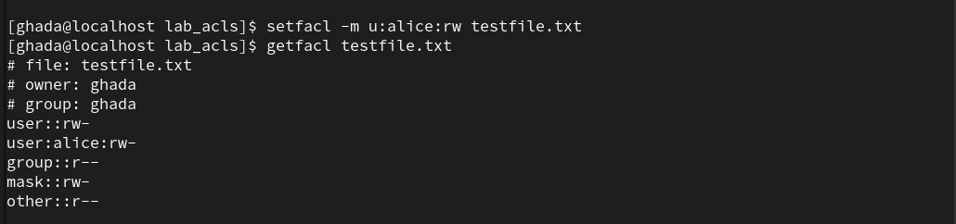
---------------------------------------------------------------------------------------
12.Add execute permission for a group named developers to the file testfile.txt and Verify the changes.
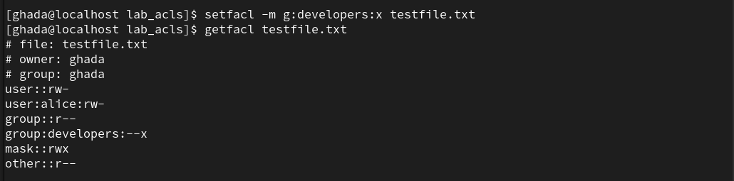
---------------------------------------------------------------------------------------
13.Remove the ACL entry for the user alice from the file testfile.txt and Verify the changes.
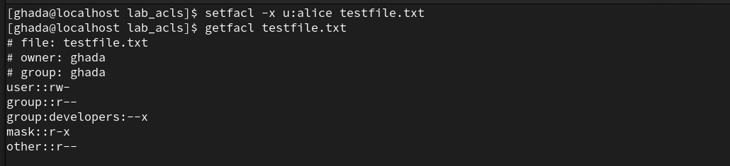
---------------------------------------------------------------------------------------
14.Set read and execute permissions for bob on all files and subdirectories inside lab_acls.

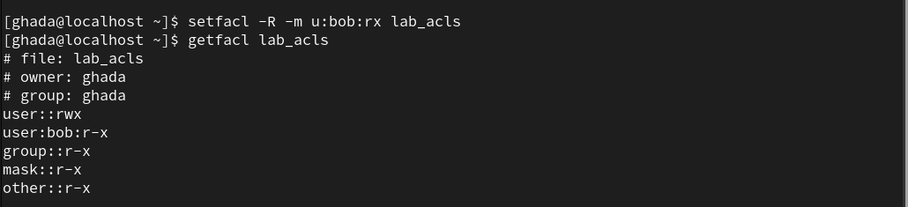
---------------------------------------------------------------------------------------
15.How does the mask affect the effective permissions of named users and groups?
The mask determines the maximum permissions allowed for users and groups in ACL.
If a named user/group has rwx but the mask is r--, the effective permission will be r--.

---------------------------------------------------------------------------------------
16.Set the mask for the file testfile.txt to r-- and observe how it affects the effective permissions of named users and groups.

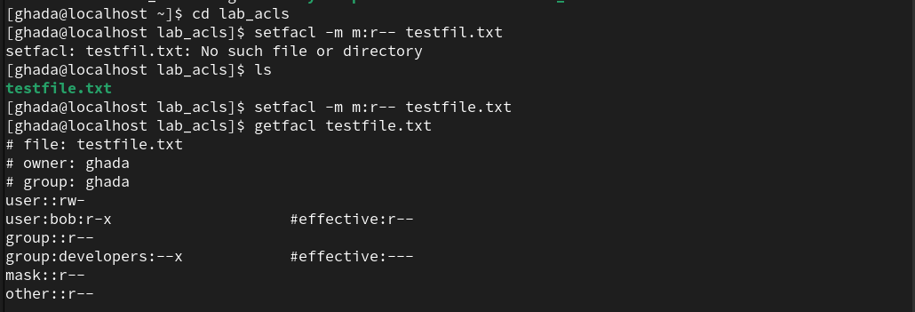
---------------------------------------------------------------------------------------
17.Add read and write permissions for two users, alice and bob, to the file testfile.txt in a single command.
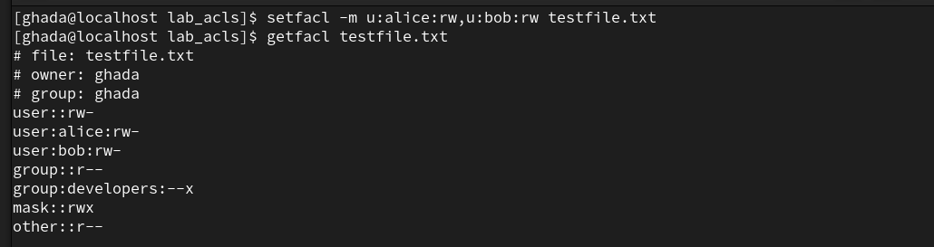
---------------------------------------------------------------------------------------
18.Backup the ACLs of the directory mydir to a file named mydir_acls.txt.
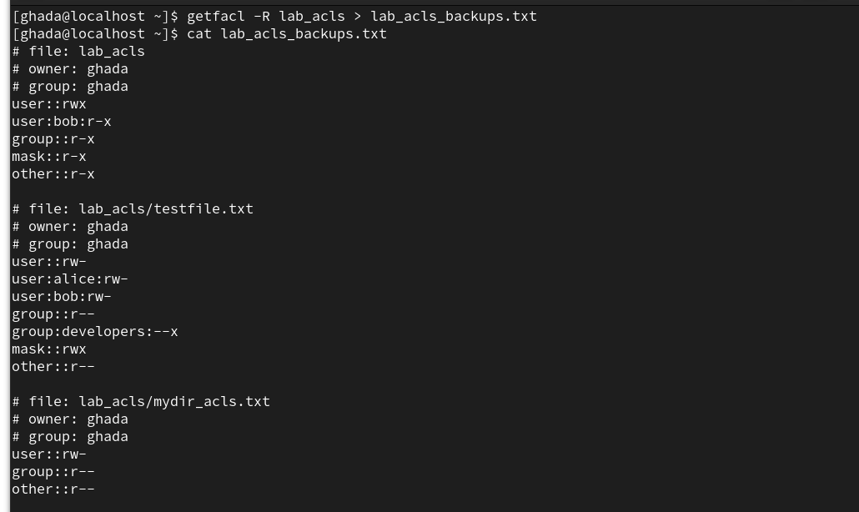
---------------------------------------------------------------------------------------
19.Check the Current SELinux Mode.
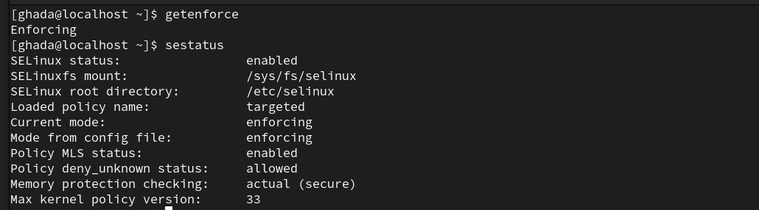
---------------------------------------------------------------------------------------
20.Change SELinux mode temporarily.
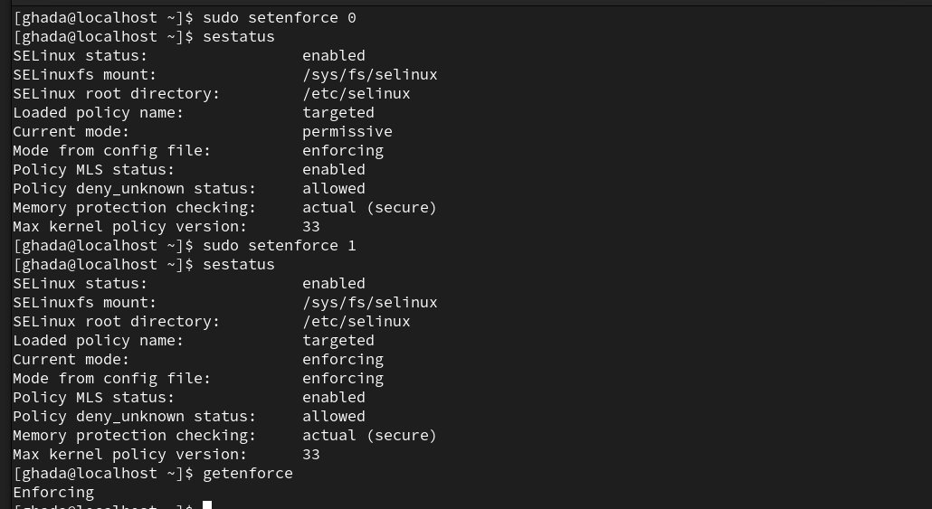
---------------------------------------------------------------------------------------
21.Change SELinux Mode Permanently.
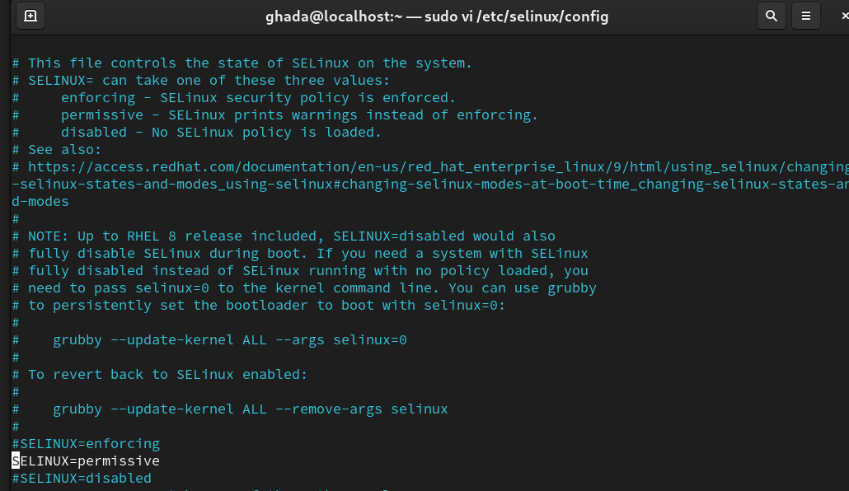
Enforcing → fully enabled
permissive → warnings only, no enforcement
disabled → turns Selinux off ( and require reboot).
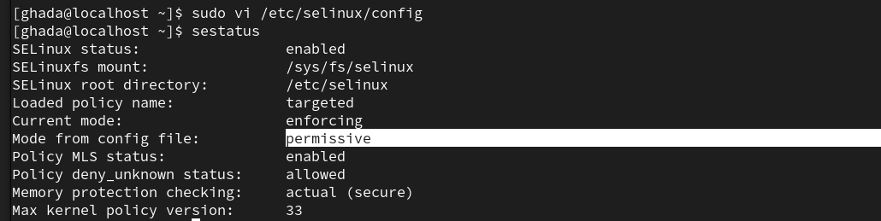
---------------------------------------------------------------------------------------
22.what different between cp , mv ,cp -a (ContextSwitching).
Cp : copies files but doesn’t preserve selinux context and new file gets the default context of the destination
mv : moves files without changing selinux context. Keeps the orignial selinux context
cp -a : copies files and preserves selinux context , maintains the original selinux labels.
------------------------------------------------------------------------------
23.Run Apache web Server on /websites [must SELinuxMode=Enforcing]
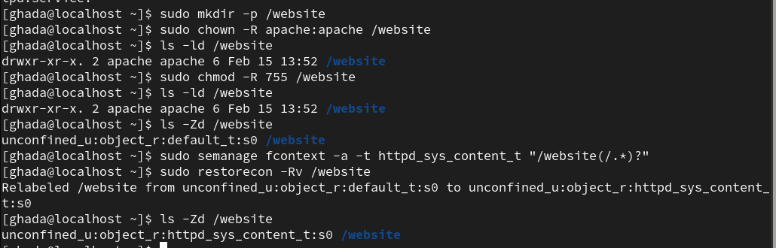

allow apache to accesss directories
configure apache to use /website directory
in /etc/httpd/conf/httpd.conf

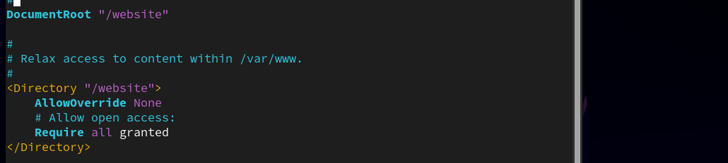
Restart Apache and Verify

