Apache lap1
Team Member :
1. Ghada Emad Bhloul
2. Esraa Tarek Mohammed Foda
3. Fatma Ali Abdel Fatah Mansour
4. Aml Mohsen Mohamed elzaatary
5. Nada Mohammed Ehab

1. already install apache

2. Create two simple html pages named “page1.html, page2.html” then use the
suitable directive to automatically redirect from localhost/page1.html to
localhost/page2.html.

At the end of apache.config file

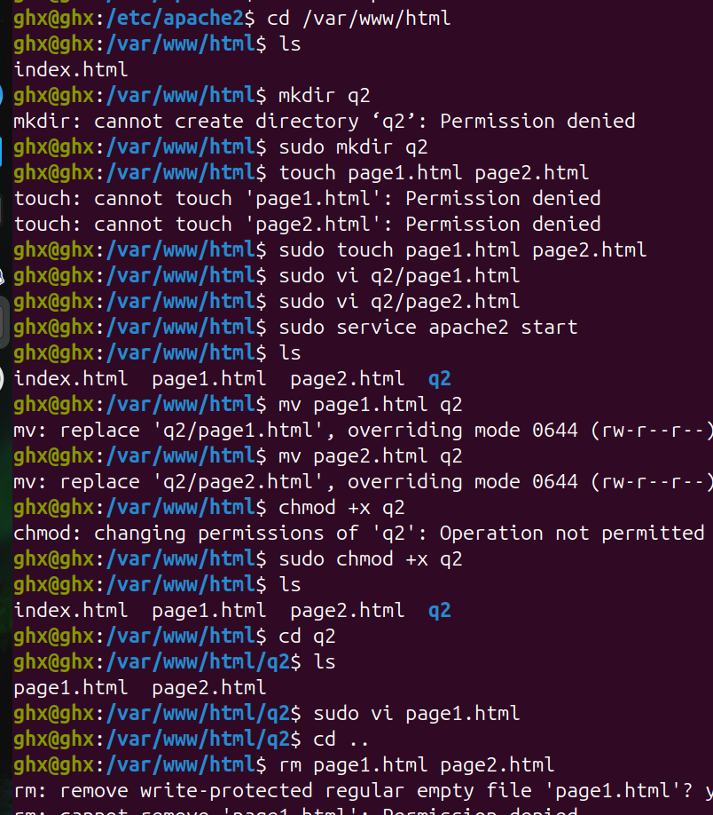
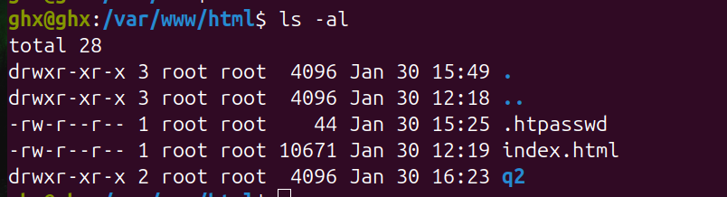

3. Ask for user name and password when accessing a directory


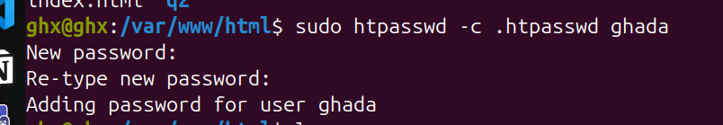

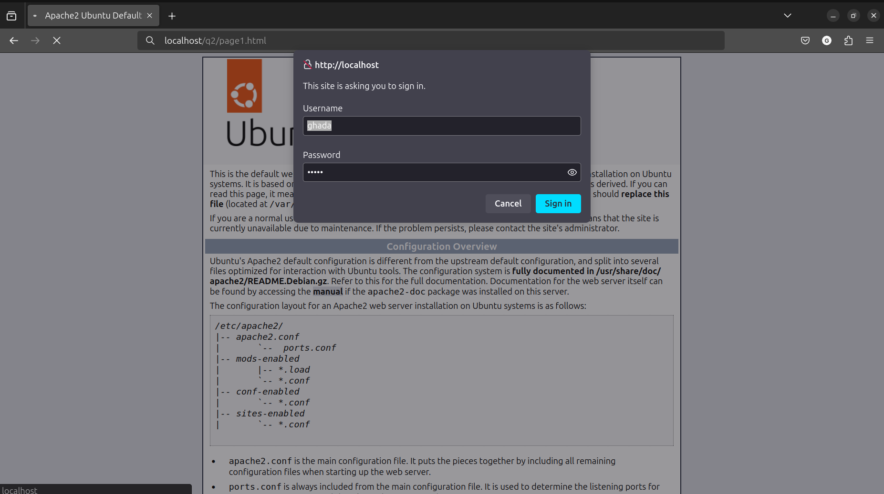

4. Apply authentication before downloading PDF files.

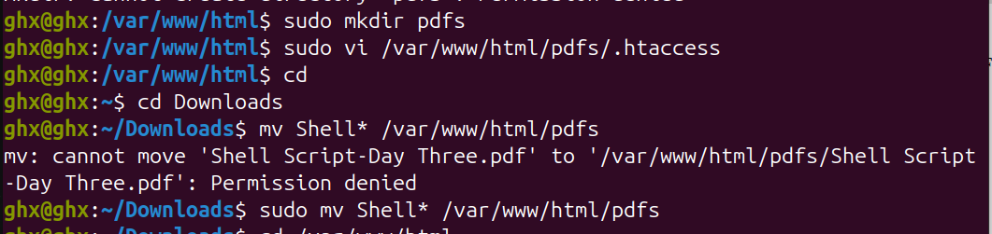
In apache.config file


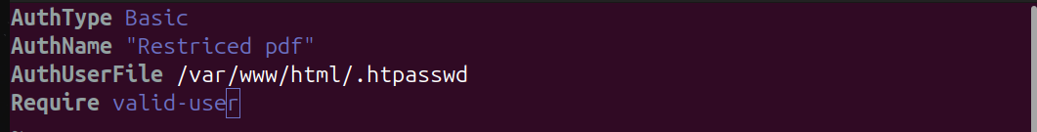
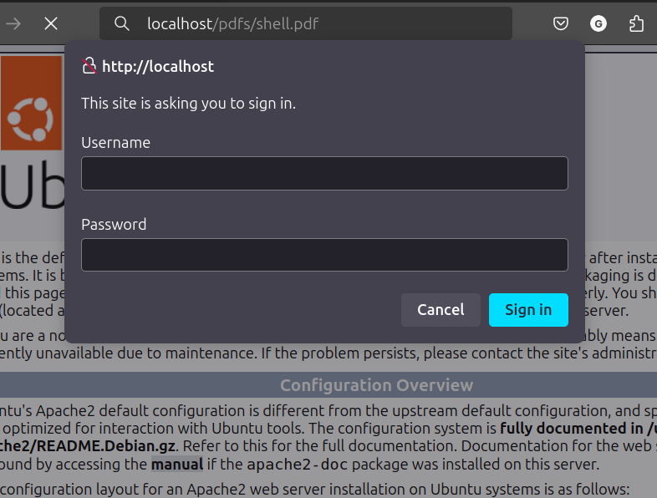

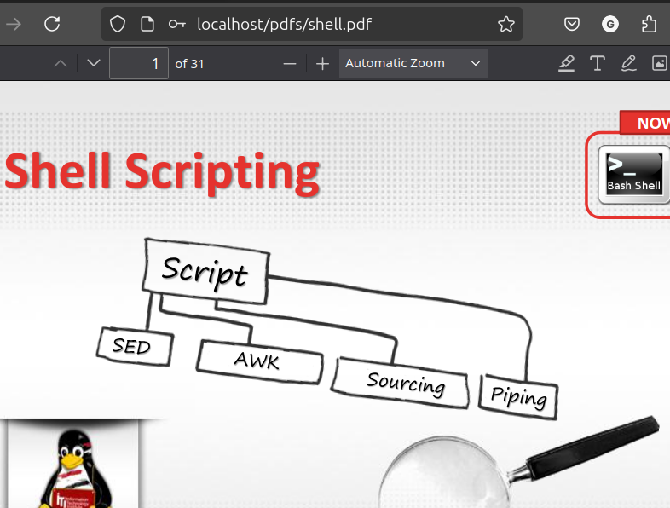

5. Create a directory then allow access to one of your classmates only.

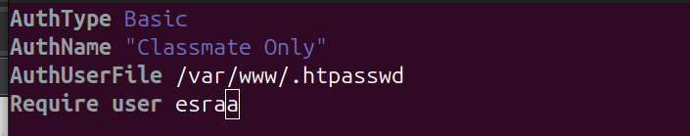

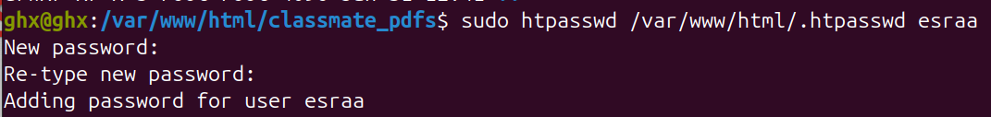
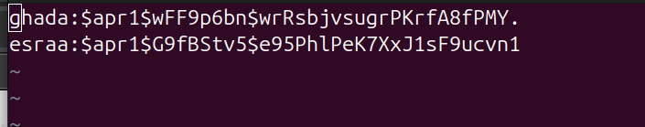


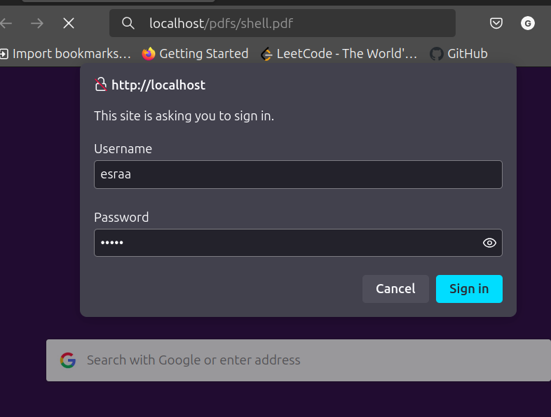

6. Disable listing the directory content (hint use indexs)

