Lap3

1. Insert new student and his score in exam in different subjects as transaction

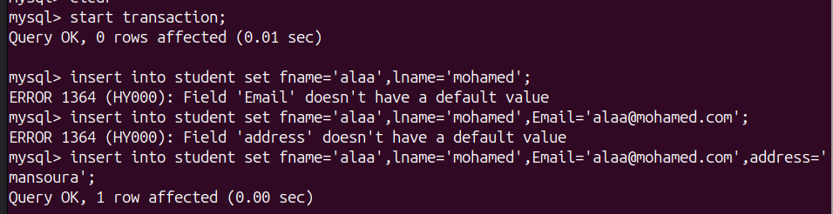
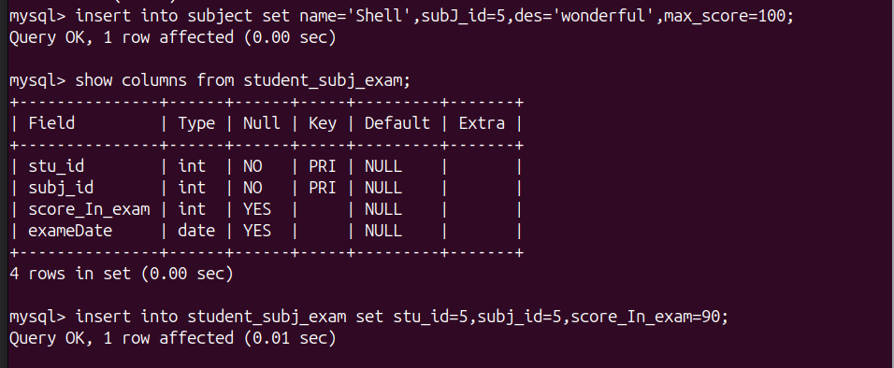
2. Display the date of exam as the following: day 'month name' year.
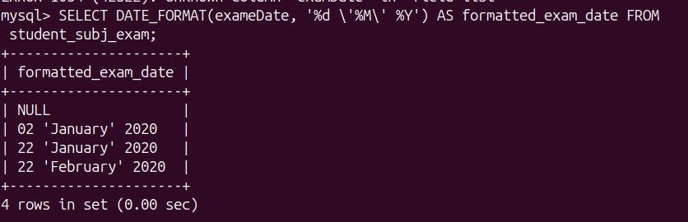
3. Display name and age of each students
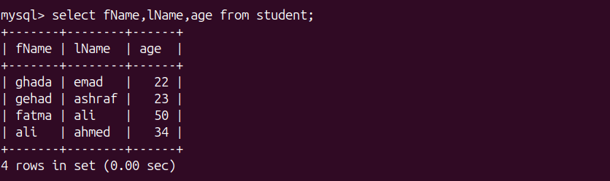
4. Display the name of students with their Rounded score in each Exam
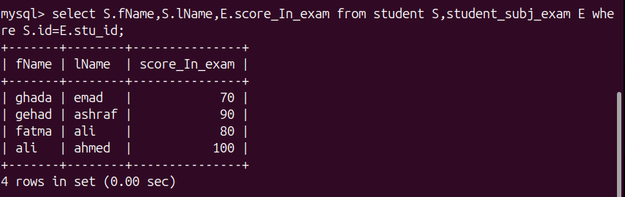

5. Display the name of students with the year of Birthdate
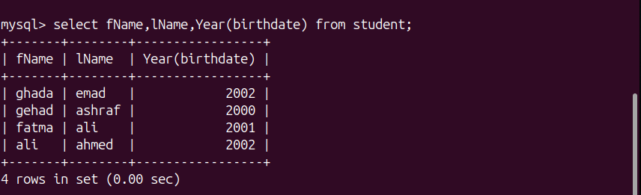
6. Add new exam result, in date column use NOW
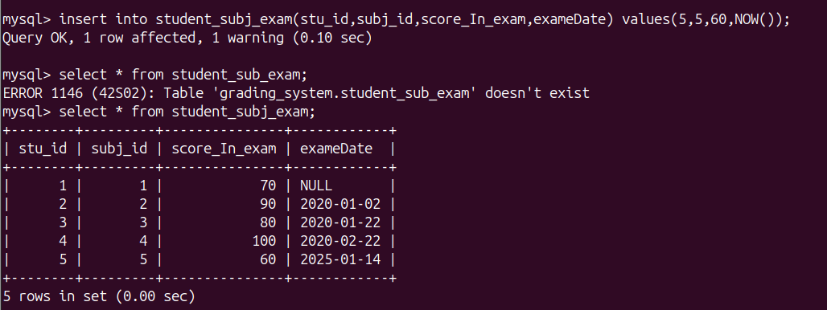
7. Create Hello world function which take username and return welcome
message to user using his name
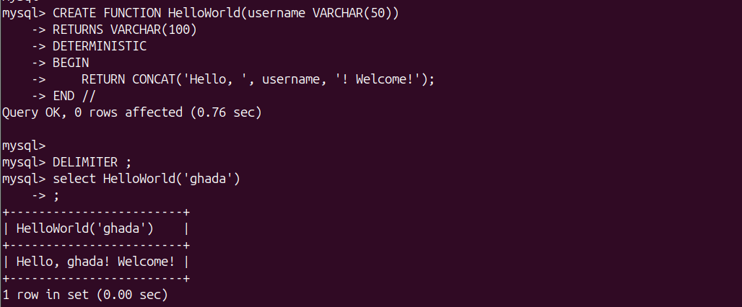
8. Create multiply function which take two number and return the multiply of
them
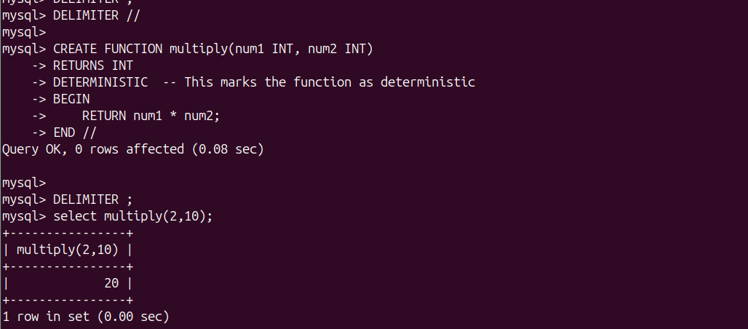
9. Create function which takes student id and Exam id and return score the
student in Exam.
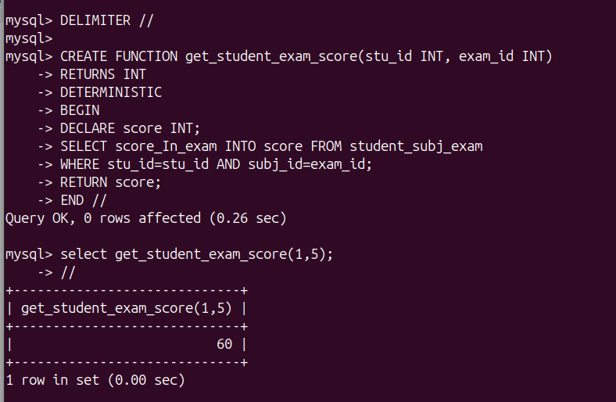

10. Create function which takes Exam id and return the number of students
who failed in a Exam (Score less than 50).
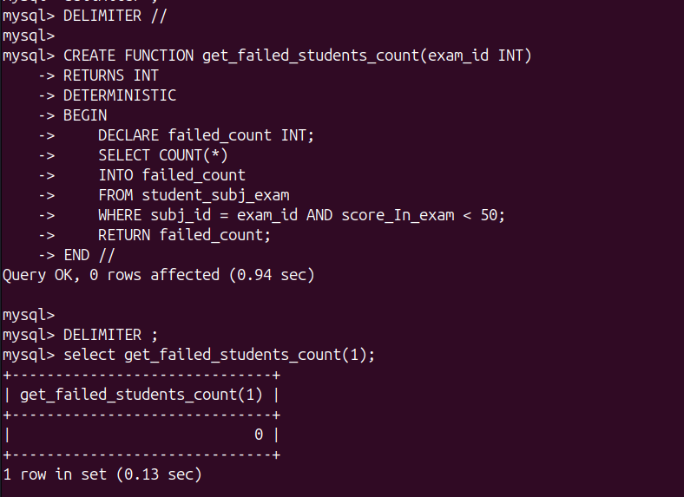
11. Create function which take subject name and return the average of max
grades for subject
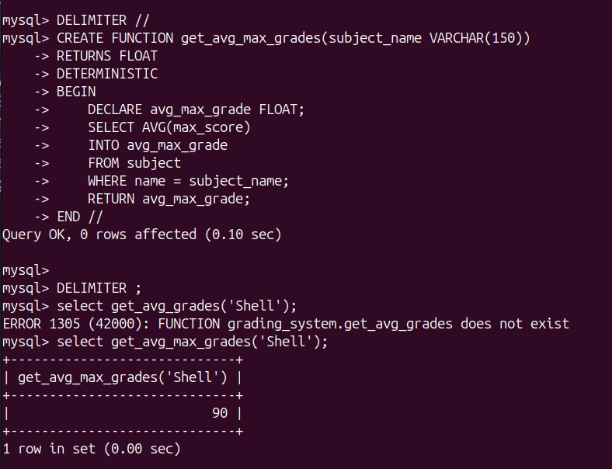
12. Create Table called Deleted_Students which will hold the deleted students
info(same columns as in student tables)
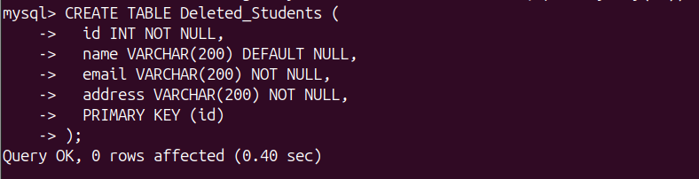
13. Create trigger to save the deleted student from Student table to
Deleted_Students.
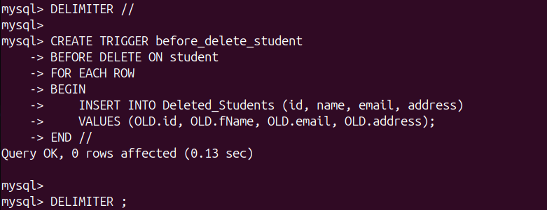
14. Create trigger to save the newly added students to Student table to
Backup_Students.
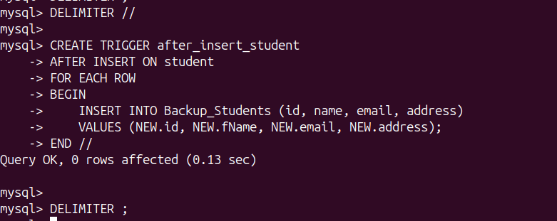
15. (Bouns) Create trigger to keep track the changes of contact info table
(add/update rows); it will logs the time of action and description of
action to another table.
16. Dump your database (Grading Database) into SQL file.
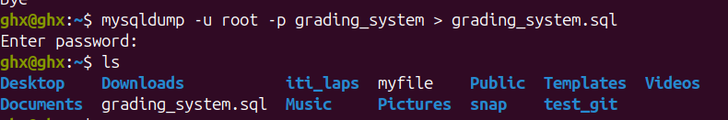
17. Dump Students table into file.
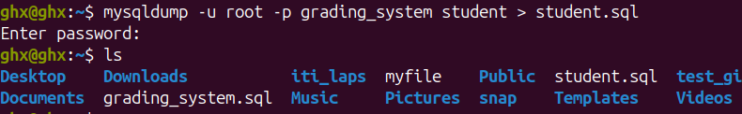
18. Import SQL file into your backup database (Grading_Backup Database)
