The University of Jordan/Aqaba Branch
Faculty of Information Technology and Systems
Department of Business Information Technology



PLACE YOUR PROJECT TITLE HERE (5 to 10 words)

by
First Author
Second Author

Supervised by
Dr. Nazeeh Ghatasheh

Submitted to the
Department of Business Information Technology
Faculty of Information Technology and Systems
The University of Jordan – Aqaba Branch

in Partial Fulfillment of
the Requirements for the Degree of
Bachelor of Science

January 2014 - Aqaba - Jordan

The undersigned hereby certify that they have read and recommend to the Faculty of Information Technology and Systems for acceptance a documentation

PLACE YOUR PROJECT TITLE HERE

Submitted to the
Department of Business Information Technology
Faculty of Information Technology and Systems
The University of Jordan – Aqaba Branch

in Partial Fulfillment of
the Requirements for the Degree of
Bachelor of Science
by
First Author and Second Author

Examining Committee
___________________________ __________________ ________
Supervisor Signature Date
___________________________ __________________ ________
Member Signature Date
___________________________ __________________ ________
Chairman Signature Date
Abstract
(In English) The abstract is a concise and accurate summary of the project work. It states the problem, the methods of investigation, and the general conclusions, and should not contain tables, graphs or illustrations. It must not exceed 150 words, and should contain relevant keywords that will make your work more likely to be found in an electronic search. Do not put a separate list of keywords. There must be a single abstract for the entire thesis. (you need to write one in English and one in Arabic, BOTH)
Keywords: This is an example, of how it might appear in your document; a maximum of 6 words, or phrases; separated by semi-colons; sentence-cased; no period after
الخلاصة
(In Arabic) تتضمن موجزاً وافياً للنقاط الرئيسية التي تناولها التقرير، تعطي قارئ التقرير توضيحاً كافياً لفكرة المسألة العلمية للمشروع. تلخص النتائج الأساسية والإستنتاجات المستقاة عند تنفيذ المشروع. لا يتعدى طولها 150 كلمة. تكتب عادةً بعد الانتهاء من كتابة جميع فصول التقرير تماماً، ( وكقاعدة عامة فإنها تمثل تجميعاً لمجموعة جمل قصيرة تؤخذ من كافة أجزاء التقرير)

كلمات رئيسية: ستة كلمات رئيسية بحد أقصى تساعد للوصول إلى العمل عبر محركات البحث أو أنظمة الأرشفة؛ بينها فواصل منقوطة

Dedication

This work is lovingly dedicated to our respective parents who have been our constant source of inspiration. They have given us the drive and discipline to tackle any task with enthusiasm and determination. Without their love and support this project would not have been made possible.

Authors

Table of Contents
Abstract II
Dedication III
Table of Contents IV
List of Figures VII
List of Tables VIII
List of Symbols IX
List of Abbreviations X
Acknowledgments XI
Chapter I. Introduction 1
1.1. Overview 2
1.1.1. General things 2
1.1.2. Some facts 2
1.1.3. Related History 2
1.1.4. Technologies that might be useful or related 2
1.2. Related Study 2
1.3. Existing System 2
1.3.1. Existing system description 2
1.3.2. Issues or Problems in the existing system 3
1.4. Purpose of this Project 3
1.5. Scope of this Project 3
1.6. Motivations and Importance of this Project 3
1.7. Purpose of this Document 4
1.8. Overview of this Document 4
Chapter II. Methodologies 5
2.1. SDLC Phases 5
2.1.1. Phase I 5
2.1.2. Phase II 5
2.1.3. …. 5
2.1.4. ….. 5
2.2. Development Environment and Requirements 5
2.3. Project Management 6
2.3.1. Schedule (GANTT Chart) 6
2.3.2. Cost Estimation 6
2.3.3. Benefit Estimation 6
2.3.4. Cost vs Benefit Analysis 6
Chapter III. Data and System Analysis 8
3.1. Overview…. 8
3.2. Interviews and Data Gathering Summary 8
3.2.1. Primary data analysis 8
3.2.2. Secondary data analysis 8
3.3. Use Case Diagram 9
3.4. Current Logical Data Flow Diagram 10
3.5. Requirements Analysis 10
3.5.1. User functional requirements 10
3.5.2. User non functional requirements 10
3.5.3. System functional requirements 10
3.5.4. System non functional requirements 10
3.5.5. HCI requirements 10
3.5.6. Usability requirements 11
3.5.7. Portability requirements 11
3.5.8. Hardware requirement 11
3.5.9. Software Requirements 11
3.6. Our Proposed System 11
3.7. Alternative Solutions 12
Chapter IV. Design of the Proposed System 13
4.1. System Flow 13
4.2. Data Flow Diagrams 13
4.2.1. Processes Decomposition 14
4.2.2. Logical DFD of the Proposed System 14
4.2.3. Physical DFD of the Proposed System 14
4.3. Entity Relationship Diagram 15
4.4. Database Schema 16
4.5. Class Diagram 17
4.6. Sequence Diagram 18
4.7. System Modules Architecture 18
4.8. System Main Algorithms 18
4.9. Input Design 19
4.10. Output Design 19
Chapter V. Implementation and Validation 20
5.1. Section A 20
5.2. Section B 20
5.3. Section C 20
Chapter VI. Results and Discussions 21
Chapter VII. Conclusion and Recommendation for Future Work 22
7.1. Attainment of Objectives 22
7.2. Limitations of the Work 22
7.3. Possible Application of the Work 23
7.4. Possible Future Work 23
Bibliography 24
Appendices 31
Appendix A 31
Appendix B 32
Appendix C 32
Users Manual 34
Installation Guide 34

List of Figures
This is the List of Figures. This must be included if you have any figures in your document. If you do not have any figures, you should delete this page.

Figures must be numbered consecutively. They can be numbered with the chapter number or with no reference to the chapter number. You must use the same numbering system for tables, figures, illustrations, etc. Avoid mixing numbering systems.

Your figure captions should either be consistently in sentence case (i.e., only the first letter of the caption and any proper nouns are capitalized) or consistently in title case (i.e., most words in the caption are capitalized, with the general exception of prepositions, conjunctions and articles).

List of Tables

List of Symbols
If you are using specialized symbols in your thesis, list them here. Lists of symbols, lists of abbreviations, glossaries, etc., may go in any order you wish, so long as they appear after the Lists of Tables and/or Figures and before the Acknowledgements. If you do not have any specialized symbols in your document and do not need a list of them, you should delete this page.

List of Abbreviations
If you are using specialized symbols in your thesis, list them here. Lists of symbols, lists of abbreviations, glossaries, etc., may go in any order you wish, so long as they appear after the Lists of Tables and/or Figures and before the Acknowledgements. If you do not have any specialized symbols in your document and do not need a list of them, you should delete this page.

Acknowledgments
The following are usually mentioned in the Acknowledgements:
• Supervisor and committee
• Grant support
• Helpful fellow students, lab mates, etc.
• Family support
Acknowledgements may extend for more than one page, but should be no longer than two pages.

Example:
I offer my enduring gratitude to the faculty, staff and my fellow students at University of Jordan, who have inspired me to continue my work in this field. I owe particular thanks to Dr. XYZ, whose penetrating questions taught me to question more deeply.

I thank Dr. RZY for enlarging my vision of science and providing coherent answers to my endless questions.

Special thanks are owed to my parents, whose have supported me throughout my years of education, both morally and financially.

I would like to thank my committee members who were more than generous with their expertise and precious time. A special thanks to Dr. ABCD, my committee chairman for his countless hours of reflecting, reading, encouraging, and most of all patience throughout the entire process. Thank you Dr. GDY, Dr. LXY, and Dr. YYYY for agreeing to serve on my committee. I would like to acknowledge and thank my faculty for allowing me to conduct my project work and providing any assistance requested. Special thanks goes to the members of staff development and human resources department for their continued support. Finally I would like to thank the beginning instructors, teaching assistants, laboratories supervisors and administrators in our faculty that assisted us with this project. Their excitement and willingness to provide feedback made the completion of this research an enjoyable experience.

- Introduction
The introduction must outline the theme, hypotheses and/or goals of the project and provide sufficient information to enable a non-specialist researcher to understand these. It must contain the elements listed below.
- A thorough review of relevant literature
- A clear statement of the research question – the hypotheses and/or goals of the research
In this chapter start from general ideas towards specific ones, having a smooth transition
In the document have
- A coherent structure that flows logically and smoothly from chapter to chapter
- A brief synopsis at the beginning of each research chapter
- A description of methods used, in sufficient detail to enable a reader to understand how the data were gathered and to apply similar methods in another study
- A complete account of the research presented in a systematic manner typical of the field of study
New chapters must begin on a new page.
Headings and subheadings must never appear at the bottom of the page without at least one, preferably two lines of text underneath. Instead, move the heading to the next page, even if it means leaving a larger lower margin on the preceding page.

  - Overview
Start talking about the field of project, facts, technologies. History, etc
    - General things

    - Some facts

    - Related History

    - Technologies that might be useful or related

  - Related Study
Talk about someone else doing something similar to your work or directly related

  - Existing System
Describe the currently used systems, local cases, etc

    - Existing system description

    - Issues or Problems in the existing system
Try to show the GAPs or missing things that could be improved in the current systems, local systems, etc

  - Purpose of this Project
State the issues you want to tackle from those previously mentioned

  - Scope of this Project
Show the boundaries of what the work you are doing here, for example show the group of users taking into consideration, the specific departments or facilities, specific culture, specific running environment, online or offline system, education level, skill level, etc
This area specifies the focus of your project, to tell the reader of what is included and what is not studied or performed.

  - Motivations and Importance of this Project
Why you are doing this work, why it is important, how it might help, what is the expected benefit, etc

  - Purpose of this Document
Why you are writing this document? What will be the benefit from this DOCUMENT

  - Overview of this Document
For each chapter write a brief summary that will show what the reader will find in it. For example Chapter I talks about the history of the work, and what are the issues generally found, etc. Chapter II states the facts found by analysis and interviews, the design of the systems currently used, etc

- Methodologies
SDLC steps and output from each phase, what are the scientific rules or basics you rely on to obtain the result, or show if you used Agile or object orientation methodologies…

  - SDLC Phases
    - Phase I

    - Phase II

    - ….

    - …..

  - Development Environment and Requirements
Here you show the tools you used to develop your proposed system, tools for information gathering and analysis, design tools, CASE tools used, programming languages, skills needed to develop the proposed solution, etc
For example, Eclipse IDE, MS Visual Studio 200X, Note Pad, Power Designer… and for each specify the purpose of it and how it is used in the development phases.

  - Project Management
Here you need to talk about organizing your time, resources, dates. Meetings, interview dates, how much the development of your system will cost in terms of tangible and intangible costs (development time, money. Implementation cost, developers or programmers time or cost, or any cost from the first time you start the project until you deliver the final working programs or documentation needed, employees satisfaction, di). Also show the benefit of the system in terms of cost saving over the current system, time saving, employee reduction, resources reduction, or any tangible or intangible benefit
    - Schedule (GANTT Chart)

    - Cost Estimation

    - Benefit Estimation

    - Cost vs Benefit Analysis

- Data and System Analysis
  - Overview….
Start writing about the main things you started analyzing, where did you go and how did you get information…
Then in the section below write about the data gathering, try to summarize the data collected about the specific problem you are trying to solve. For example you might talk summarize what you found on the organization you are conducting this study over, or form used by the employees or customers, interviews conducted, surveys and questionnaires, observations. So here will be the important ideas that describes well the organization you are studying, in order to have a good idea about how the work is actually done, or find any special considerations that should be taken into account while developing your project or final output.

  - Interviews and Data Gathering Summary

    - Primary data analysis
Interviews, surveys, and questionnaires data gathering summary

    - Secondary data analysis
Data collected from organization website, internal forms, communication letters or formal emails, informal emails, etc

  - Use Case Diagram
Depict the activities you found during the analysis phase, you may draw one level or many levels of the use cases.

  - Current Logical Data Flow Diagram
Depict at least the logical context level DFD of the current system or work.

  - Requirements Analysis
Here you will show all the requirements of your system
    - User functional requirements
System users, customers, managers, etc

    - User non functional requirements

    - System functional requirements

    - HCI requirements
If any
    - Usability requirements
If any
    - Portability requirements
If any
    - Hardware requirement
Hardware needed to run the software

    - Software Requirements
Software needed to run the software

  - Our Proposed System
Describe the system you are proposing to be designed and implemented. For example you may say here a web based application to handle the business process, having three tier architecture, etc
You may also put a figure that represents the configuration and what is found on each component of the .
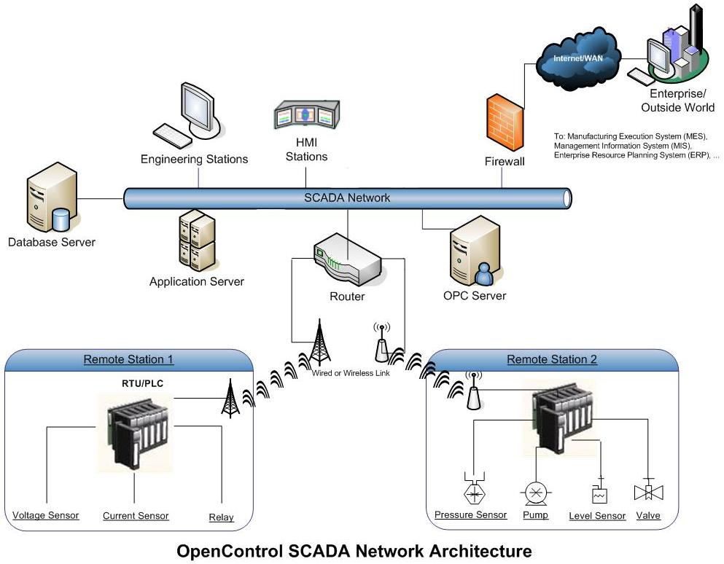

  - Alternative Solutions
Here list some of other solution to the main problem you are working on, for example a possible solution could be the use of mobile based application to handle the customers’ requests, or a desktop application etc…
(here you are suggesting other solution, its optional to analyze them briefly or compare them in order to have a backup plan in case your proposed solution might not be used, also it is a good place to state your ideas for similar systems that others can study or implement)

- Design of the Proposed System
Start from general design to a detailed design of your proposed system, include everything needed to explain how actually your proposed system is functioning to satisfy the previously stated requirements.
  - System Flow
Flowchart representing the whole program decision structure
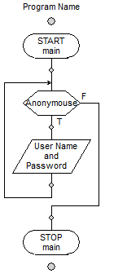

  - Data Flow Diagrams
Depict the Logical AND\OR Physical DFDs of your proposed system, start by Context Level DFD, then Diagram 0, and expand as much as you see it is needed to understand it. (if your current DFD is not different than the one built during the analysis section , then here you can expand it showing the different levels with more details)

    - Processes Decomposition

    - Logical DFD of the Proposed System

    - Physical DFD of the Proposed System

  - Entity Relationship Diagram

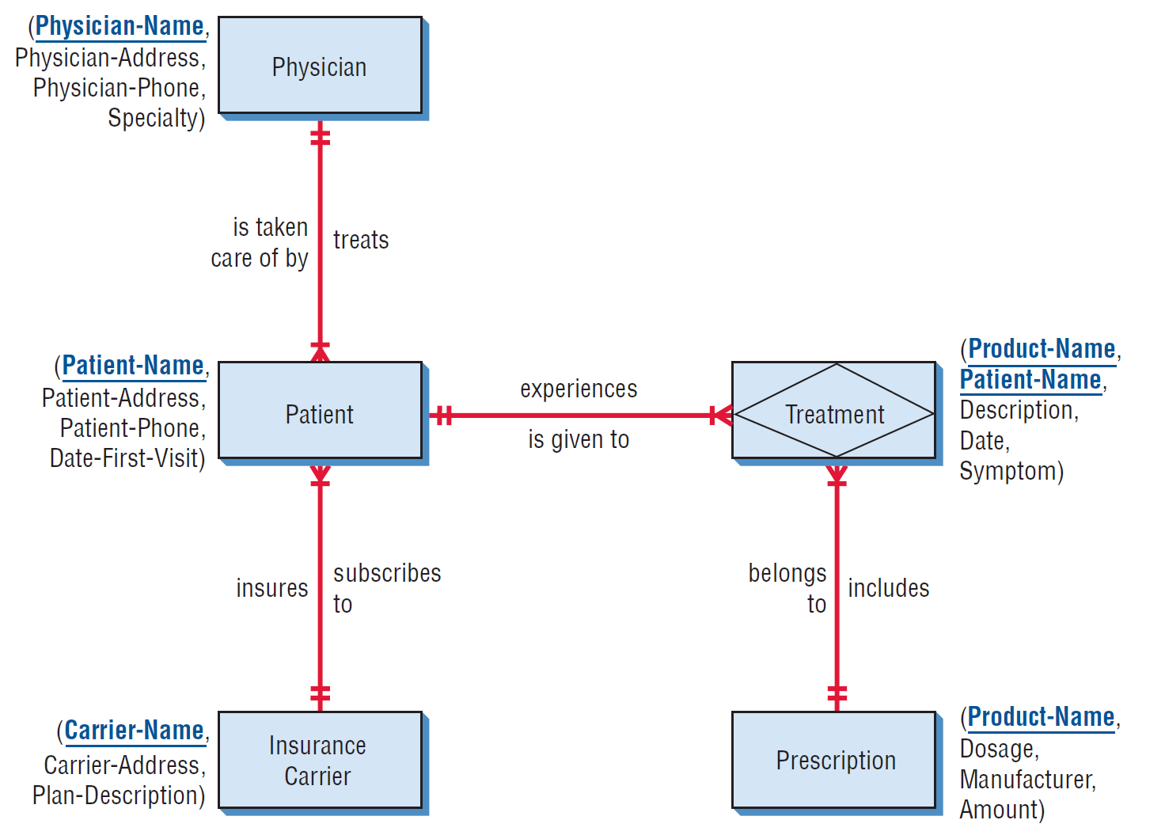

  - Database Schema

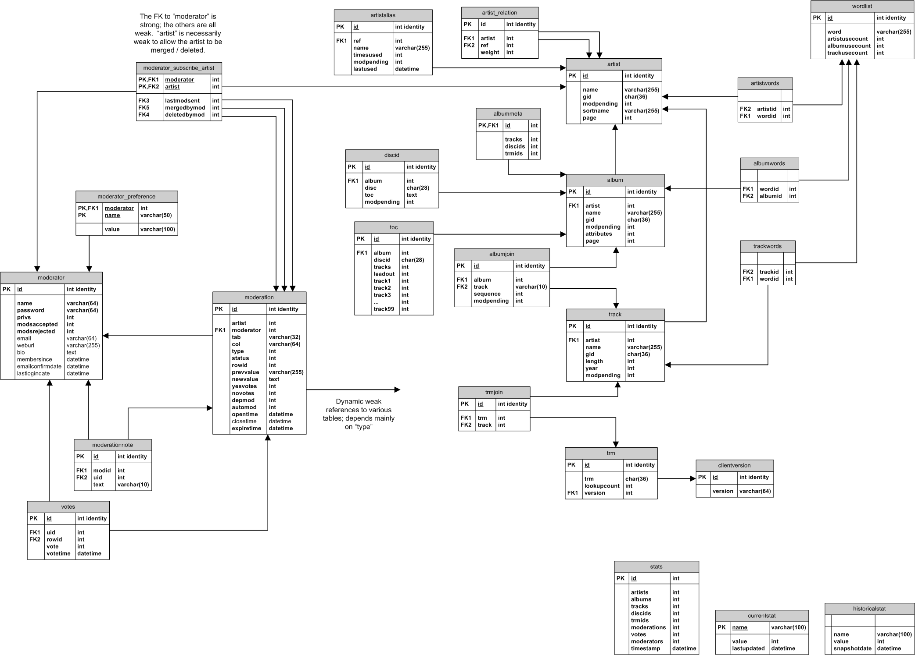

  - Class Diagram

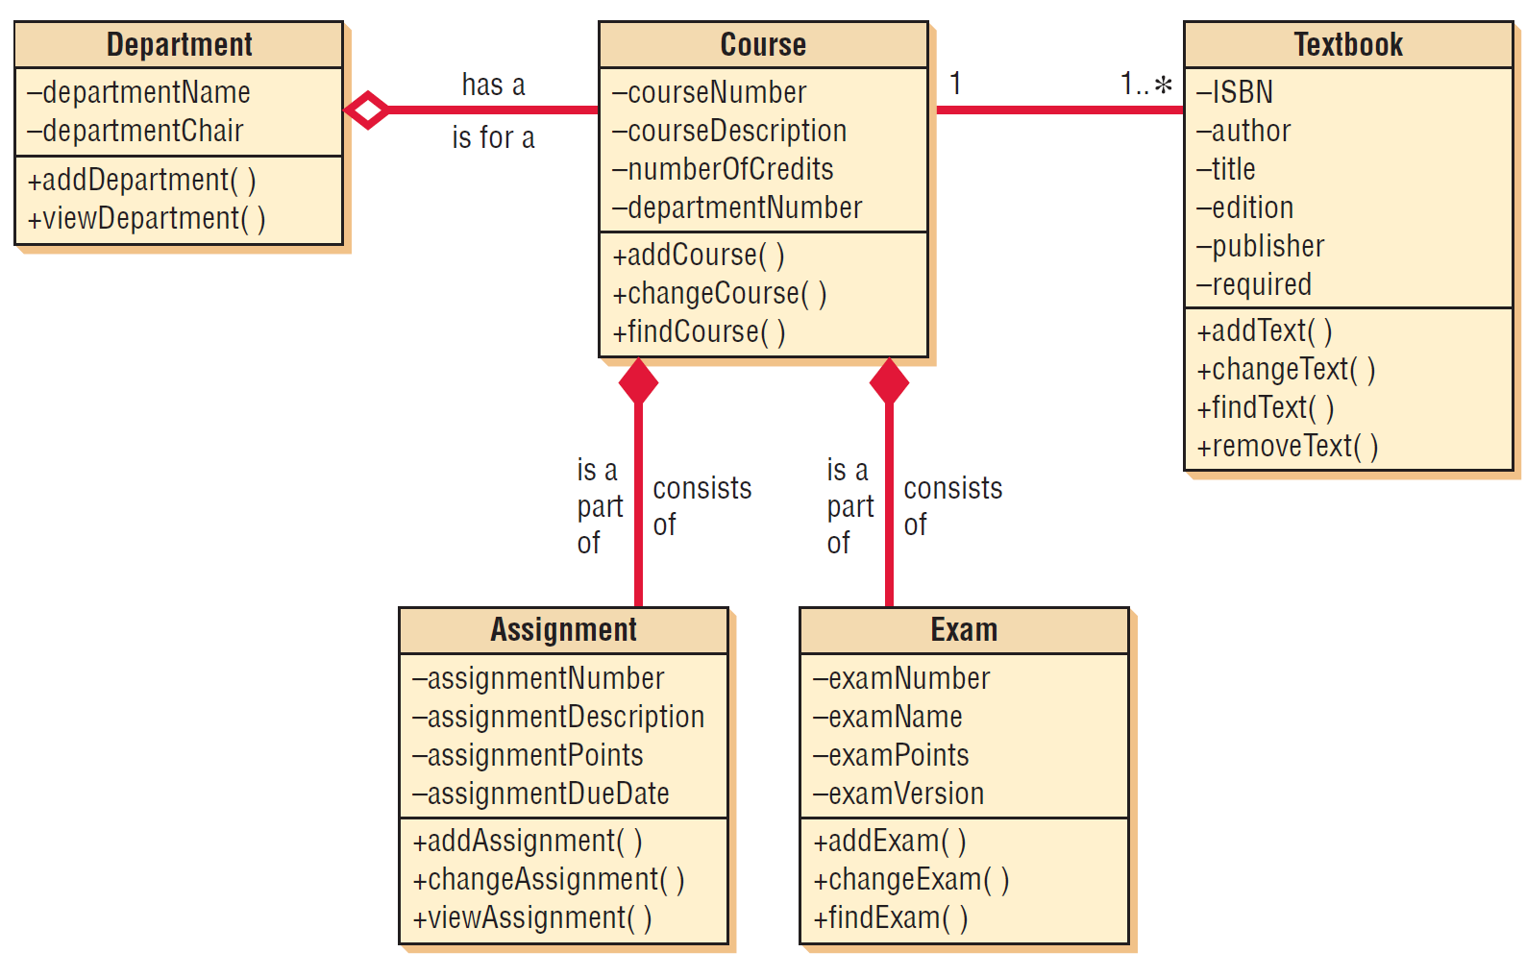

  - Sequence Diagram

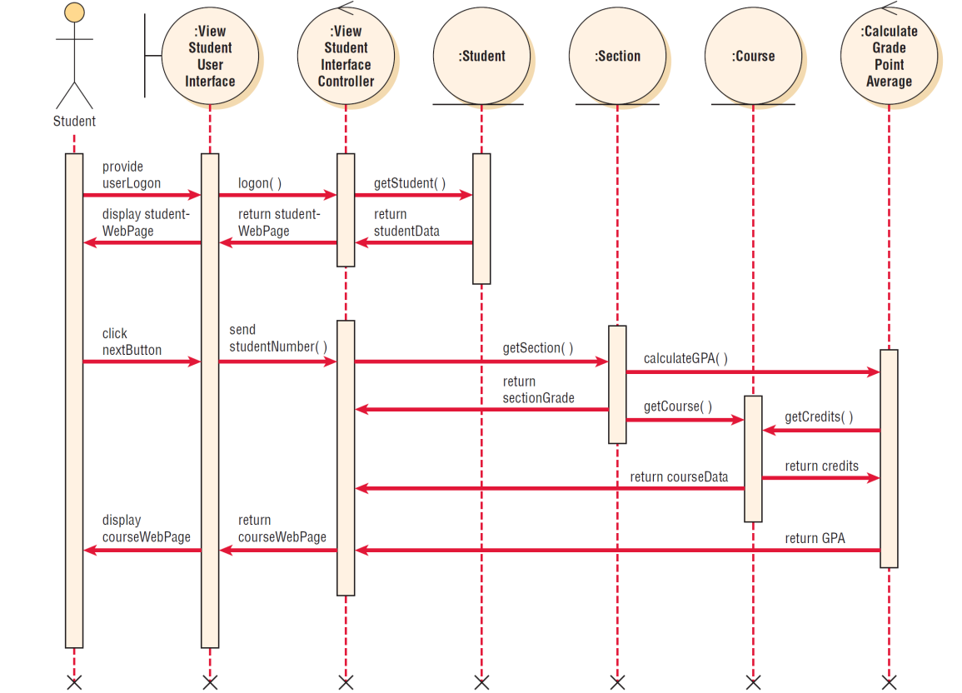

  - System Modules Architecture
Description of the main system components, modules, and what does each module do.

  - System Main Algorithms
The pseudocode of the main system module
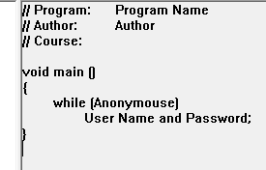

  - Input Design
Input methods, screens, etc

  - Output Design
Output methods, screens, reports, etc

- Implementation and Validation
Here show the actual program main screens, and actual program operations, inputs\outputs examples. Also prove that the system is valid by showing how it handles errors, wrong data entry, violations etc,
database snapshots of the actual schema, relations and tables and sample data, also illustrate what changes happen to the database when some actions are performed (sample transactions)
  - Section A

  - Section B

  - Section C

- Results and Discussions
This chapter could be integrated with the implementation chapter or written alone, as you see suitable for your project. Here you need to discuss the result of your work. For example you may describe how fast some operations are performed with the new system, or compare the performance of the new system with the old methods or systems used. Another example might be comparing the performance of your system with other systems that exist, as those mentioned in the related work. As much as you can try to prove that your implemented system is performing well or better than others…
Also if something goes wrong in the implementation and doesn’t perform as expected could be stated here.
If you faced any difficulties while programming some features, or some special cases that performed out of ordinary.

- Conclusion and Recommendation for Future Work

demonstrate mastery of the field of study
The section includes the following:
- Overall analysis and integration of the research and conclusions of the work in light of current research or work in the field
- Conclusions regarding goals or hypotheses of the thesis that were presented in the Introduction, and the overall significance and contribution of the thesis research
- Comments on strengths and limitations of the thesis research
- Discussion of any potential applications of the research findings
- An analysis of possible future research directions in the field drawing on the work of the work
  - Attainment of Objectives
To which level your implemented system or approach of solving the main problem is satisfying the requirements.
  - Limitations of the Work
What was limiting you from implementing some features, completing some tasks, etc. for example time, skills, official procedures, formal decisions or approvals, …
  - Possible Application of the Work
Who might use your application, who might follow your proposed approaches, etc
  - Possible Future Work
What you or others might do or add in the future to your work to make it better.

Bibliography
(References and Recourses used)
Bibliography: Resources and References used, that are cited or not
You need to follow a specific referencing style format, suggested is the IEEE Citation Style (http://www.ijssst.info/info/IEEE-Citation-StyleGuide.pdf).

IEEE Citation Style Guide
Any citation style is set up to give the reader immediate information about sources cited in the text. In IEEE citations, the references should be numbered and appear in the order they appear in the text. When referring to a reference in the text of the document, put the number of the reference in square brackets. Eg: [1]
The IEEE citation style has 3 main features:
• The author name is first name (or initial) and last. This differs from MLA style where
author’s last name is first.
• The title of an article (or chapter, conference paper, patent etc.) is in quotation marks.
• The title of the journal or book is in italics.
These conventions allow the reader to distinguish between types of reference at a glance.
The correct placement of periods, commas and colons and of date and page numbers
depends on the type of reference cited. Check the examples below. Follow the details exactly. Eg.: put periods after author and book title, cite page numbers as pp., abbreviate all months to the first three letters (eg. Jun.)
Check the distinctions between print and electronic sources (especially for journals) carefully.

Print References
Book
Author(s). Book title. Location: Publishing company, year, pp.
Example:
W.K. Chen. Linear Networks and Systems. Belmont, CA: Wadsworth, 1993, pp. 123-35.
Book Chapters
Author(s). “Chapter title” in Book title, edition, volume. Editors name, Ed. Publishing location: Publishing company, year, pp.
Example:
J.E. Bourne. “Synthetic structure of industrial plastics,” in Plastics, 2nd ed., vol. 3. J. Peters, Ed. New York: McGraw-Hill, 1964, pp.15-67.
Article in a Journal
Author(s). “Article title”. Journal title, vol., pp, date.
Example:
G. Pevere. “Infrared Nation.” The International Journal of Infrared Design, vol. 33, pp. 56-99, Jan. 1979.
Articles from Conference Proceedings (published)
Author(s). “Article title.” Conference proceedings, year, pp.
Example:
D.B. Payne and H.G. Gunhold. “Digital sundials and broadband technology,” in Proc. IOOC-ECOC, 1986, pp. 557-998.

Papers Presented at Conferences (unpublished)
Author(s). “Paper’s title,” Conference name, Location, year.
Example:
B. Brandli and M. Dick. “Engineering names and concepts,” presented at the 2nd Int. Conf. Engineering Education, Frankfurt, Germany, 1999. Standards/Patents
Author(s)/Inventor(s). “Name/Title.” Country where patent is registered. Patent number, date.
Example:
E.E. Rebecca. “Alternating current fed power supply.” U.S. Patent 7 897 777, Nov. 3, 1987.

Electronic References
Books
Author. (year, Month day). Book title. (edition). [Type of medium]. Vol. (issue). Available: site/path/file [date accessed].
Example:
S. Calmer. (1999, June 1). Engineering and Art. (2nd edition). [On-line]. 27(3). Available: www.enggart.com/examples/students.html [May 21, 2003].
Journal
Author. (year, month). “Article title.” Journal title. [Type of medium]. Vol. (issue), pages. Available: site/path/file [date accessed].
Example:
A. Paul. (1987, Oct.). “Electrical properties of flying machines.” Flying Machines. [Online]. 38(1), pp. 778-998. Available: www.flyingmachjourn/properties/fly.edu [Dec. 1, 2003].
World Wide Web
Author(s)*. “Title.” Internet: complete URL, date updated* [date accessed].
M. Duncan. “Engineering Concepts on Ice. Internet: www.iceengg.edu/staff.html, Oct. 25, 2000 [Nov. 29, 2003].

Odd Sources
Newspaper
Author(s)*. “Article title.” Newspaper (month, year), section, pages.
Examples:
B. Bart. “Going Faster.” Globe and Mail (Oct. 14, 2002), sec. A p.1. “Telehealth in Alberta.” Toronto Star (Nov. 12, 2003), sec. G pp. 1-3.

Dissertations and Theses
Author. “Title.” Degree level, school, location, year.
Example:
S. Mack. “Desperate Optimism.” M.A. thesis, University of Calgary, Canada, 2000.
Lecture
Lecturer(s). Occasion, Topic: “Lecture title.” Location, date.
Example:
S. Maw. Engg 251. Class Lecture, Topic: “Speed skating.” ICT 224, Faculty of Engineering, University of Calgary, Calgary, Alberta, Oct. 31, 2003.
E-mail
Author. Subject line of posting. Personal E-mail (date).
Example:
J. Aston. “RE: new location, okay?” Personal e-mail (Jul. 3, 2003).
Internet - Newsgroup
Author or Topic*, “Title,” Complete network address, date when it was updated [date accessed].
Example:
G.G. Gavin. “Climbing and limb torsion #3387,” USENET: sci.climb.torsion, Apr. 19, 2000 [Oct. 4, 2002]. * if you can’t find this information, exclude it.
Exact page number References
To refer readers to specific page numbers in a text, use the number of the reference followed by a colon (:) and the page numbers.
Example:
Johnson suggests that citing will lead to a decrease in being cited for plagiarism [1:28-29].
The [1] refers to the numbered reference
And the 28-29 refers to the pages being cited.

Appendices

All appendices must be presented together after the concluding chapter. Page numbering for appendices continues on from the body of the thesis, in sequence.
Appendices must be limited to supporting material genuinely subsidiary to the main argument of the project. Appendices must only include material that is referred to in the Body of the work.
The following are appropriate for inclusion in the appendices:
- Additional details of methodology and/or data
- Diagrams of specialized equipment developed
Copies of questionnaires or surveys used in the research. Please ensure that personal information (e.g., names or contact information of subjects and/or researchers) is removed and/or blacked out from your questionnaire/survey copies.

Appendix A

Vision ... Bus.Req... Arch... Infr...
Components, and EA
Quality:
Data Gathering
porters vale chain
TAM
Security Policy
Verification phase
The maintenance and review phase

Appendix B

Appendix C

Users Manual
Step by step show how the user can use your system.

Installation Guide
Step by step show what is needed to install and run your system, skills needed to operate, etc

