Abstract

As many other models, ResNet, SSD mobilenet and EffecientDet are models to use in object detection. The accuracy of the model indicates how good the model will be in the deployment, In this report I will compare between ResNet and SSD mobile net to choose the better accuracy for deployment.

Introduction

Residual Network or (ResNet) is a famous deep learning model that was introduced to solve the problem of the vanishing gradient that accompanied the introduction of layers in complex models. This model works on enhancing the efficiency of the model by dropping some links between the neurons and hence decreasing the vanishing gradient. Further more SSD mobile net is a single shot multi-box detection model which is based on mobilenet backbone in its pipeline.

Methods

To Run Each model I did the following steps:
- I edited the Notebook to get the new pretrained model reference and clone it from the chosen model’s path.
- I downloaded the pipeline configuration of the new model to replace the current file with it.
- I customised the pipeline file to edit the no of classes to be the desired output which is 3. Also, I altered the model type from classification to detection to be able to get the bounding boxes location. Furthermore, I edit all the path to the customized path of the inputs and tf files. Moreover, I edit the no of patches to be 8 to avoid errors.
- I downloaded the logs and viewed the results using tensorboard.

Results
In the following Table (1.1), you will find the result of training both SSD Mobilenet v2 FPN-lite and Resnet 50 v1 FPN model.

Table 1: evaluation results
Detection Box evaluation @ step 2000 | Model2 (mobile-net) | Model3 (ResNet)
Precision MAP | 0.1022 | 0.07008
Precision MAP(Large) | 0.4784 | 0.3176
Precision MAP(medium) | 0.3582 | 0.2208
Precision MAP(small) | 0.04045 | 0.0226
Precision MAP(@.5IOU) | 0.2249 | 0.1402
Precision MAP(@.75IOU) | 0.08515 | 0.06855
Recall AR@1 | 0.025 | 0.01744
Recall AR@10 | 0.107 | 0.07548
Recall AR@100 | 0.1587 | 0.1241
Recall AR@100(Large) | 0.5059 | 0.3397
Recall AR@100 (medium) | 0.4532 | 0.3757
Recall AR@100(small) | 0.09985 | 0.06862
Loss/classification_loss | 0.3948 | 0.3648
Loss/localization_loss | 0.4162 | 0.4781
Loss/regularization_loss | 0.1486 | 0.3141
Loss/total_loss | 0.9596 | 1.157

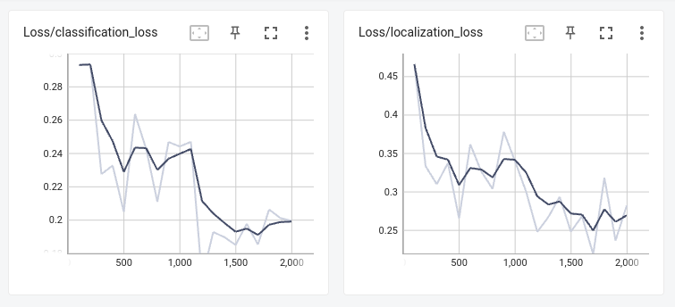Figure 1: SSD mobilenet classification and localization loss

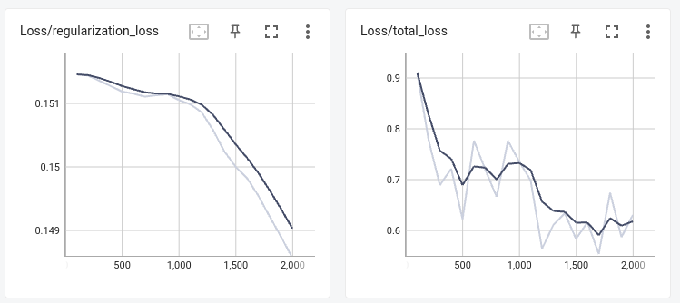Figure 2: SSD mobilenet regularization and total loss

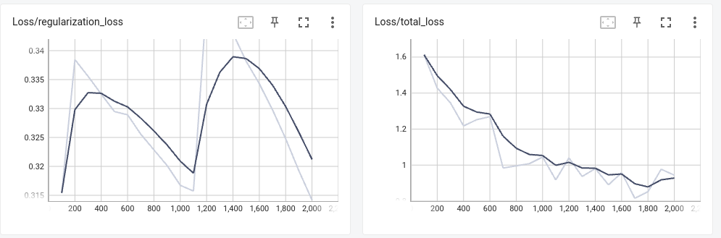Figure 3: Resnet mobilenet regularization and total loss
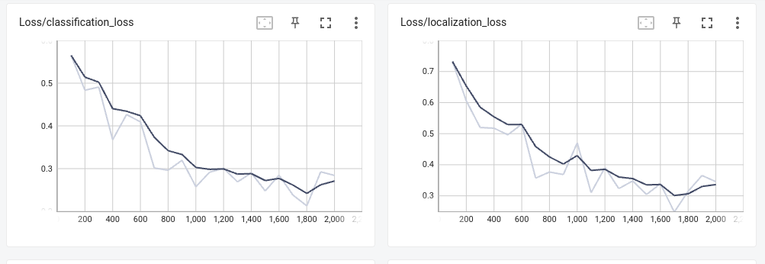Figure 4: ResNet classification and localization loss

Discussion

Despite the fact that ResNet took more than double the training time. the results shows that both the precision and the recall of the mobilenet are better at the evaluation point than the ResNet model. It also shows a smaller overall losses in the ssd mobilenet compared with the resnet.

We can notice here that the training loss in higher that the evaluation loss in both models. This behaviour is expected because the model might over fit the sample due to the the diversity of the dataset or the sample sizes. This also appears in the loss graph in the training where the loss settles and starts to increase by time due to the over fitting so the training must stop.

In order to have a better model effeciency we should increase the diversity of the training dataset. This can be presented in data augmention like flipping , altering , or changing the data samples in the future to have better results.

Conclusion
In conclusion both models shows better precision and recall in the training than the evaluation. Also the SSD mobilnet shows better metrics than the Resnet. Hence it is better to implement using the SSD Mobilenet model.

Refrences

ResNet: The basics and 3 resnet extensions (2023) Datagen. Available at: https://datagen.tech/guides/computer-vision/resnet/ (Accessed: April 23, 2023).
Cochard, D. (2021) MobilenetSSD : A machine learning model for fast object detection, Medium. axinc-ai. Available at: https://medium.com/axinc-ai/mobilenetssd-a-machine-learning-model-for-fast-object-detection-37352ce6da7d (Accessed: April 29, 2023).

