Introduction and Questions Answer
In PID Control, each value represents the factor that compensates the error in order to decrease it and optimize the function. The P represents the proportional which represents the presents. The I represents integration which represents the past. The D is the derivative which represents the future. Each error we get to decide how much of these factor is more important and hence influence the error so we make tuning for the parameters to optimize it.
Each of these factor affect different perspective, for example A higher proportional gain leads to a stronger response to delta error and a faster approach to the set point, but can also lead to overshooting and instability. On the other hand the I removes the steady state error but it may lead to oscillations. The d however, reduces overshoots and oscillations and faster change in response of error but might amplify the noise.
In order to improve the PID controller I might calculate the system as a mathematical model to accurately calculate the tuned PID variables in both throttle and steering to have the best function without overshooting or undershooting.
In order to run the project you should build the project using make then open Carla simulator then run the .sh file.

A Design of where the PID Can be automatically tuned can have two approaches. The first one is by iterating each of the factors ( steering (P,I,D) , throttle(P,I,D) , and time update ) until the optimum results are optained. This approach can give great results but is time and cost consuming. Another approach may be by analizing the curve and iterating those parameters in a scope of these results. Eg. if the steady state error is great and the oscillations are terrible the model may alter the values of the I in order to compensate such a behaviour. This approach will be harder to implement but will be very time efficient to use it. A better approach is to train an AI Model with the PID controller data to have predictions in a more intellegent way.

Model based vs PID
 | PID | Model Based
Tuning | The PID is less accurate to tune in comparision. | The Model based is more precize to tune the controller becaused it is based on mathematical model.
designing | The PID design is it easier to do. | The model based design is complex to do because its is more complicated to get the accurate mathematical model of every thing in a huge system like a car
Change | The pid is more likely to adapt to changes. | The model base design will fail if sudden change is added to the system.
automation | Easy to be automated | Harder to be automated

Visualizations and results:
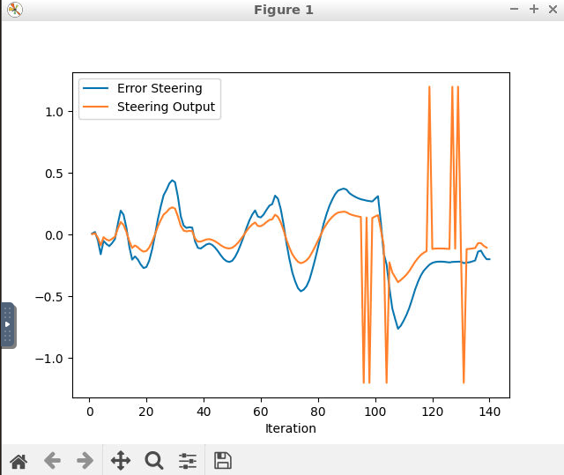

There results shows the change of the error with no of iterations and the output of the steering. The results shows the rise of the steering graph with the rise of the of the error which indicates how the error is the motive to turn on the steering of the car. The graph shows oscillations in the error which indicates some overshooting that should be managed in further records. Also It shows pulses that is tuned by the output. The error is always trying to converge to zero which is a good indication that the car PID aims toward minimizing the error.

Discussion

In these results we can see that the error is small compared to output value. All the error are less than 0.1. Also the throttle vary from zero to positive while the error is direction oriented to it vary from negative to positive. While the car managed to pass the goal successfully, the output has some oscillation that should be optimized in further notice.

