COMPONENTS

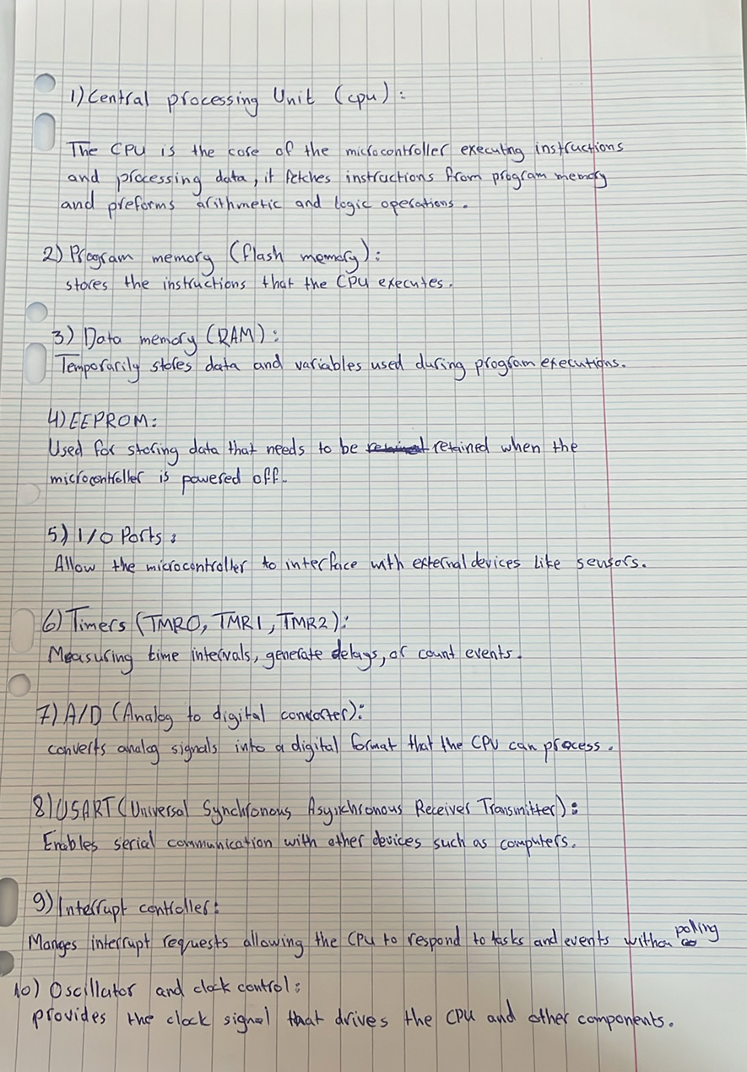

INTERRUPTIONS

The PIC16F877 microcontroller has several interrupt sources:

1. External Interrupts

-INT (External Interrupt): Triggered by a signal change on the RB0/INT pin (rising or falling edge).

-Port Change Interrupt: Triggered by any change in the input pins of PORTB (RB4–RB7).

2. Timer Interrupts

-Timer0 Overflow Interrupt: Triggered when Timer0 overflows.

-Timer1 Overflow Interrupt: Triggered when Timer1 overflows.

-Timer2 Match Interrupt: Triggered when Timer2 matches the value set in its PR2 (Period Register).

3. Peripheral Interrupts

-ADC (Analog-to-Digital Converter) Interrupt: Triggered when an ADC conversion is complete.

-USART (Universal Synchronous Asynchronous Receiver Transmitter) Interrupts:

Receive Interrupt: Triggered when data is received via USART.

Transmit Interrupt: Triggered when the transmit register is empty.

-SSP (Synchronous Serial Port) Interrupts:

SPI/I²C Interrupt: Triggered by SPI or I²C communication events.

-CCP (Capture/Compare/PWM) Interrupts:

CCP1 Interrupt: Triggered by events on the CCP1 module.

CCP2 Interrupt: Triggered by events on the CCP2 module.

-Parallel Slave Port (PSP) Interrupt: Triggered when there’s an input/output operation on PORTD when the microcontroller is configured in parallel slave mode.

