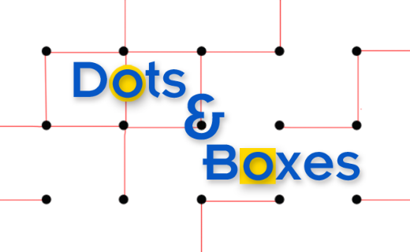

CPCS331 – Artificial Intelligence – Spring2020 -Project I

[ Using Alpha Beta, Minimax and MCTS algorithms]

|  |  |  |
| --- | --- | --- |
| Student Name | Student Number | Section |
| Elham Imdad | 1779096 | AA |
| Ghadeer Qalas | 1778773 |
| Lena abdulmanan | 1705454 |

## Part 1

## 1. Minimax and alpha-beta pruning technique to solve “Dots and Boxes” puzzle

## 1.1 Introduction

The problem that we’re trying to solve is Dots and Boxes problem. Dots and Boxes is a combinatorial game popular among children and adults around the world. In a game of Dots and Boxes, the players draw a rectangular grid of dots and take turns drawing lines between pairs of horizontally or vertically adjacent dots, forming boxes. A game’s size is defined in terms of the number of boxes. The player who draws the fourth line of a box captures the box. When this happens, the player gains a point and then must draw another line. At the end of the game, the player with the most points wins. If both players captured the same amount of boxes, the match is considered as a tie.

## 1.2 Problem formulation as a search problem

## Initial state:

The game starts with an empty 3x3 dots matrix or it can be at any size. (note that any matrix larger than 6x6 is not solvable by the computer.)

Example of the initial state of 3x3 matrix:

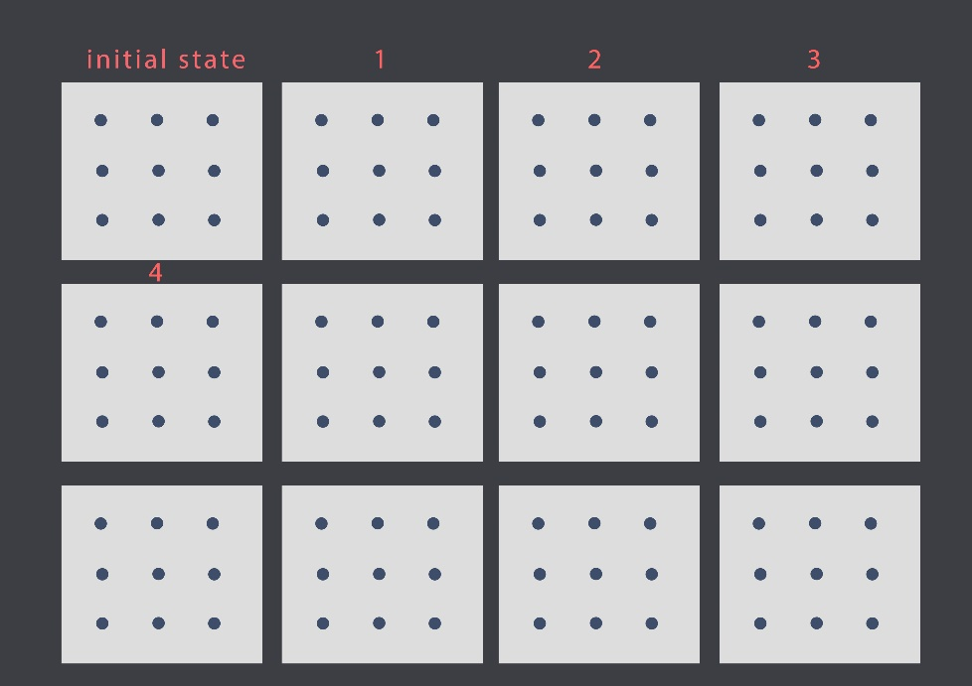

## Actions:

Connecting adjacent dots either vertically or horizontally in the grid to form edges.

Example:



## Transition model:

Connect the edges to form boxes.

Example:

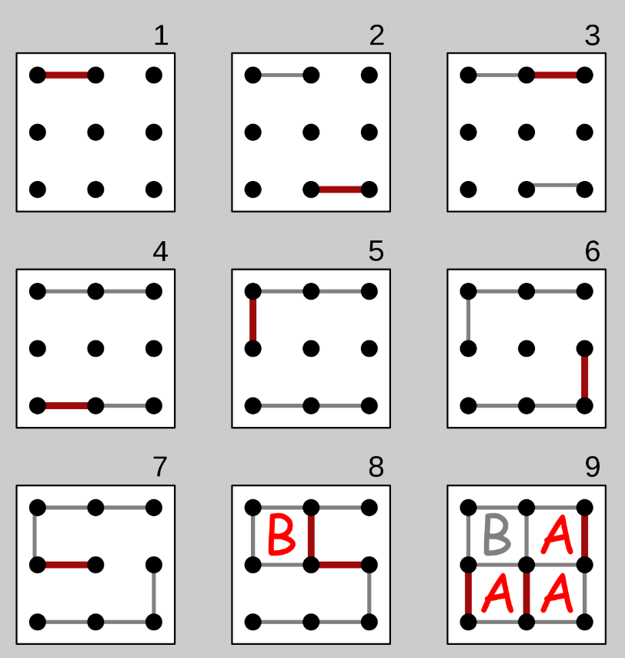

## Goal test:

We reach the goal state if all boxes are formed in the grid. The winner is the one who created more boxes, and if the number of boxes is equal then it is a tie.



Goal state

A game of 3 x 3 grid whereas the blue player is the winner.

## Path cost function:

Path function is not applicable.

## 1.3 Technical discussion

The AI Techniques for solving " Dots and Boxes" Problem used in this report are minimax algorithm, and Alpha beta pruning algorithm:

**MiniMax technique:**

MiniMax algorithm is the most common artificial intelligence algorithm for a computer to participate in two-player combinatorial games. It works by looking ahead from the current game configuration a certain number of moves to see all the possible states the game could reach, building a game tree that is complete to a certain depth. Each state of the game will contain a score, given by an evaluation function. In Dots and Boxes game, this evaluation assigns a good score to a move that will give points to the player. On the other hand, it will give a bad score to a move which allows the opponent to ﬁnish the square in the future. We`re going to implement this method using java.

The Mininmax pseudocode in our problem:

**function** minimax(board, depth, player)

**If** board.depth >= depth or children.isEmpty() **then**

**return** the heuristic value of board

**If** player = "MAX" **then**

value = -∞

**for each** child of board **do**

minMaxVal = minimax(child, depth-1, "MIN")

**If** minMaxVal > value **then**

value = minMaxVal

**return** value;

**else if** player = "MIN" **then**

value = ∞

**for each** child of board **do**

minMaxVal = minimax(child, depth-1, "MAX")

**If** minMaxVal < value **then**

value = minMaxVal

**return** value;

The minimax function returns a heuristic value for leaf nodes (children is empty and nodes at the maximum search depth). Minimax treats the two players (the max player and the min player) separately in its code. If the player is max, then it recursively calls minimax and changing the player to min, decrements depth and returns the maximum value. If the player is min, then it recursively calls minimax and changing the player to max, decrements depth and returns the minimum value.

**Alpha-beta pruning technique:**

we are going to solve the problem of dots and boxes by using, Alpha beta Pruning algorithm which is an improvement of minimax algorithm, it allows us to take the possible correct values of max and min without having to look at each node in the tree by *pruning* nodes that are not going to affect the final decision. Here is how we are going to implement the algorithm in solving dots and boxes; as in minimax algorithm we have *min* that try to get the lowest possible score and *max* that tries to get the highest possible score, in addition we have ***alpha*** *which is the best choice for max at the current state* and ***beta*** *which is best choice for min at the current state*. alpha initially equals to (-∞) and beta initially equals to (+∞), the values of alpha and beta are past to children and updated at their levels. prune if alpha >= beta. in the code we are going to choose the initial value for alpha as (-1000), and beta as (+1000). The possible moves are going to be represented as a tree that is searched by the algorithm (depth first search) to find the optimal path for max to win, also prune the nodes that are not needed.

**General algorithm for Alpha beta Pruning**

Function alphaBetaPruning(state) returns an action

v 🡨 max-value(state, -∞, +∞)

Return the action in action(state) with value v

Function max-value(state,alpha,beta) returns a utility value

If terminal-test(state) then return utility(state)

v 🡨 -∞

For each a in action(state) do

v 🡨 max(v, min-value,result(s,a), alpha, beta)

If v >= beta then return v

Alpha 🡨 max(alpha, v)

return v

Function min-value(state,alpha,beta) returns a utility value

If terminal-test(state) then return utility(state)

v 🡨 +∞

For each a in action(state) do

v 🡨 min(v, max-value,result(s,a), alpha, beta)

If v <= alpha then return v

beta 🡨 min(beta, v)

return v

## 1.4 Discussion of results

## 1.5 Results

**Minimax results:**

**Alpha beta pruning results:**

!! Welcome to the game of Dots and Boxes !!

Be prepared to be crushed by the power of Artificial Intelligence ... !!

Kidding! You totally can beat it!

Press 1 to start the game or press 2 to escape from the inevitable doom!!

1

Please enter the number of rows for the board:

2

Please enter the number of columns for the board:

2

Please enter the number of plies used by the AI:

5

0 1 2 3 4

__________________

0| * * *

1| 8 5

2| * * *

3| 1 9

4| * * *

_________________________

Please enter the 'X' coordinate of your choice (an integer such as 4): 4

Please enter the 'Y' coordinate of your choice (an integer such as 4): 4

Current Score =====>> Your Score - AI Score = 0

0 1 2 3 4

__________________

0| * * *

1| 8 5

2| * * *

3| 1 9

4| * * |

_________________________

AI selected the following coordinates to play:

( 1 , 0 )

Current Score =====>> Your Score - AI Score = 0

0 1 2 3 4

__________________

0| * - * *

1| 8 5

2| * * *

3| 1 9

4| * * |

_________________________

Please enter the 'X' coordinate of your choice (an integer such as 4): 2

Please enter the 'Y' coordinate of your choice (an integer such as 4): 0

Current Score =====>> Your Score - AI Score = 0

0 1 2 3 4

__________________

0| * - | *

1| 8 5

2| * * *

3| 1 9

4| * * |

_________________________

AI selected the following coordinates to play:

( 3 , 0 )

Current Score =====>> Your Score - AI Score = 0

0 1 2 3 4

__________________

0| * - | - *

1| 8 5

2| * * *

3| 1 9

4| * * |

_________________________

Please enter the 'X' coordinate of your choice (an integer such as 4): 0

Please enter the 'Y' coordinate of your choice (an integer such as 4): 0

Current Score =====>> Your Score - AI Score = 0

0 1 2 3 4

__________________

0| | - | - *

1| 8 5

2| * * *

3| 1 9

4| * * |

_________________________

AI selected the following coordinates to play:

( 0 , 1 )

Current Score =====>> Your Score - AI Score = 0

0 1 2 3 4

__________________

0| | - | - *

1| | 8 5

2| * * *

3| 1 9

4| * * |

_________________________

Please enter the 'X' coordinate of your choice (an integer such as 4): 4

Please enter the 'Y' coordinate of your choice (an integer such as 4): 0

Current Score =====>> Your Score - AI Score = 0

0 1 2 3 4

__________________

0| | - | - |

1| | 8 5

2| * * *

3| 1 9

4| * * |

_________________________

AI selected the following coordinates to play:

( 4 , 1 )

Current Score =====>> Your Score - AI Score = 0

0 1 2 3 4

__________________

0| | - | - |

1| | 8 5 |

2| * * *

3| 1 9

4| * * |

_________________________

Please enter the 'X' coordinate of your choice (an integer such as 4): 2

Please enter the 'Y' coordinate of your choice (an integer such as 4): 2

Current Score =====>> Your Score - AI Score = 0

0 1 2 3 4

__________________

0| | - | - |

1| | 8 5 |

2| * | *

3| 1 9

4| * * |

_________________________

AI selected the following coordinates to play:

( 3 , 2 )

Current Score =====>> Your Score - AI Score = 0

0 1 2 3 4

__________________

0| | - | - |

1| | 8 5 |

2| * | - *

3| 1 9

4| * * |

_________________________

Please enter the 'X' coordinate of your choice (an integer such as 4): 0

Please enter the 'Y' coordinate of your choice (an integer such as 4): 2

Current Score =====>> Your Score - AI Score = 0

0 1 2 3 4

__________________

0| | - | - |

1| | 8 5 |

2| | | - *

3| 1 9

4| * * |

_________________________

AI selected the following coordinates to play:

( 2 , 3 )

Current Score =====>> Your Score - AI Score = 0

0 1 2 3 4

__________________

0| | - | - |

1| | 8 5 |

2| | | - *

3| 1 | 9

4| * * |

_________________________

Please enter the 'X' coordinate of your choice (an integer such as 4): 0

Please enter the 'Y' coordinate of your choice (an integer such as 4): 4

Current Score =====>> Your Score - AI Score = 0

0 1 2 3 4

__________________

0| | - | - |

1| | 8 5 |

2| | | - *

3| 1 | 9

4| | * |

_________________________

AI selected the following coordinates to play:

( 2 , 1 )

Current Score =====>> Your Score - AI Score = -5

0 1 2 3 4

__________________

0| | - | - |

1| | 8 | 5 |

2| | | - *

3| 1 | 9

4| | * |

_________________________

Please enter the 'X' coordinate of your choice (an integer such as 4): 4

Please enter the 'Y' coordinate of your choice (an integer such as 4): 2

Current Score =====>> Your Score - AI Score = -5

0 1 2 3 4

__________________

0| | - | - |

1| | 8 | 5 |

2| | | - |

3| 1 | 9

4| | * |

_________________________

AI selected the following coordinates to play:

( 1 , 2 )

Current Score =====>> Your Score - AI Score = -13

0 1 2 3 4

__________________

0| | - | - |

1| | 8 | 5 |

2| | - | - |

3| 1 | 9

4| | * |

_________________________

Please enter the 'X' coordinate of your choice (an integer such as 4): 0

Please enter the 'Y' coordinate of your choice (an integer such as 4): 3

Current Score =====>> Your Score - AI Score = -13

0 1 2 3 4

__________________

0| | - | - |

1| | 8 | 5 |

2| | - | - |

3| | 1 | 9

4| | * |

_________________________

AI selected the following coordinates to play:

( 4 , 3 )

Current Score =====>> Your Score - AI Score = -13

0 1 2 3 4

__________________

0| | - | - |

1| | 8 | 5 |

2| | - | - |

3| | 1 | 9 |

4| | * |

_________________________

Please enter the 'X' coordinate of your choice (an integer such as 4): 1

Please enter the 'Y' coordinate of your choice (an integer such as 4): 4

Current Score =====>> Your Score - AI Score = -12

0 1 2 3 4

__________________

0| | - | - |

1| | 8 | 5 |

2| | - | - |

3| | 1 | 9 |

4| | - * |

_________________________

AI selected the following coordinates to play:

( 3 , 4 )

Current Score =====>> Your Score - AI Score = -21

0 1 2 3 4

__________________

0| | - | - |

1| | 8 | 5 |

2| | - | - |

3| | 1 | 9 |

4| | - * - |

_________________________

Stop this Madness!!!

!!! Inevitable Doom!!! You were crushed by the AI!!

Process finished with exit code 0

(an integer such as 4): 0

Current Score =====>> Your Score - AI Score = 0

0 1 2 3 4

__________________

0| * - | *

1| 8 5

2| * * *

3| 1 9

4| * * |

_________________________

AI selected the following coordinates to play:

( 3 , 0 )

Current Score =====>> Your Score - AI Score = 0

0 1 2 3 4

__________________

0| * - | - *

1| 8 5

2| * * *

3| 1 9

4| * * |

_________________________

Please enter the 'X' coordinate of your choice (an integer such as 4): 0

Please enter the 'Y' coordinate of your choice (an integer such as 4): 0

Current Score =====>> Your Score - AI Score = 0

0 1 2 3 4

__________________

0| | - | - *

1| 8 5

2| * * *

3| 1 9

4| * * |

_________________________

AI selected the following coordinates to play:

( 0 , 1 )

Current Score =====>> Your Score - AI Score = 0

0 1 2 3 4

__________________

0| | - | - *

1| | 8 5

2| * * *

3| 1 9

4| * * |

_________________________

Please enter the 'X' coordinate of your choice (an integer such as 4): 4

Please enter the 'Y' coordinate of your choice (an integer such as 4): 0

Current Score =====>> Your Score - AI Score = 0

0 1 2 3 4

__________________

0| | - | - |

1| | 8 5

2| * * *

3| 1 9

4| * * |

_________________________

AI selected the following coordinates to play:

( 4 , 1 )

Current Score =====>> Your Score - AI Score = 0

0 1 2 3 4

__________________

0| | - | - |

1| | 8 5 |

2| * * *

3| 1 9

4| * * |

_________________________

Please enter the 'X' coordinate of your choice (an integer such as 4): 2

Please enter the 'Y' coordinate of your choice (an integer such as 4): 2

Current Score =====>> Your Score - AI Score = 0

0 1 2 3 4

__________________

0| | - | - |

1| | 8 5 |

2| * | *

3| 1 9

4| * * |

_________________________

AI selected the following coordinates to play:

( 3 , 2 )

Current Score =====>> Your Score - AI Score = 0

0 1 2 3 4

__________________

0| | - | - |

1| | 8 5 |

2| * | - *

3| 1 9

4| * * |

_________________________

Please enter the 'X' coordinate of your choice (an integer such as 4): 0

Please enter the 'Y' coordinate of your choice (an integer such as 4): 2

Current Score =====>> Your Score - AI Score = 0

0 1 2 3 4

__________________

0| | - | - |

1| | 8 5 |

2| | | - *

3| 1 9

4| * * |

_________________________

AI selected the following coordinates to play:

( 2 , 3 )

Current Score =====>> Your Score - AI Score = 0

0 1 2 3 4

__________________

0| | - | - |

1| | 8 5 |

2| | | - *

3| 1 | 9

4| * * |

_________________________

Please enter the 'X' coordinate of your choice (an integer such as 4): 0

Please enter the 'Y' coordinate of your choice (an integer such as 4): 4

Current Score =====>> Your Score - AI Score = 0

0 1 2 3 4

__________________

0| | - | - |

1| | 8 5 |

2| | | - *

3| 1 | 9

4| | * |

_________________________

AI selected the following coordinates to play:

( 2 , 1 )

Current Score =====>> Your Score - AI Score = -5

0 1 2 3 4

__________________

0| | - | - |

1| | 8 | 5 |

2| | | - *

3| 1 | 9

4| | * |

_________________________

Please enter the 'X' coordinate of your choice (an integer such as 4): 4

Please enter the 'Y' coordinate of your choice (an integer such as 4): 2

Current Score =====>> Your Score - AI Score = -5

0 1 2 3 4

__________________

0| | - | - |

1| | 8 | 5 |

2| | | - |

3| 1 | 9

4| | * |

_________________________

AI selected the following coordinates to play:

( 1 , 2 )

Current Score =====>> Your Score - AI Score = -13

0 1 2 3 4

__________________

0| | - | - |

1| | 8 | 5 |

2| | - | - |

3| 1 | 9

4| | * |

_________________________

Please enter the 'X' coordinate of your choice (an integer such as 4): 0

Please enter the 'Y' coordinate of your choice (an integer such as 4): 3

Current Score =====>> Your Score - AI Score = -13

0 1 2 3 4

__________________

0| | - | - |

1| | 8 | 5 |

2| | - | - |

3| | 1 | 9

4| | * |

_________________________

AI selected the following coordinates to play:

( 4 , 3 )

Current Score =====>> Your Score - AI Score = -13

0 1 2 3 4

__________________

0| | - | - |

1| | 8 | 5 |

2| | - | - |

3| | 1 | 9 |

4| | * |

_________________________

Please enter the 'X' coordinate of your choice (an integer such as 4): 1

Please enter the 'Y' coordinate of your choice (an integer such as 4): 4

Current Score =====>> Your Score - AI Score = -12

0 1 2 3 4

__________________

0| | - | - |

1| | 8 | 5 |

2| | - | - |

3| | 1 | 9 |

4| | - * |

_________________________

AI selected the following coordinates to play:

( 3 , 4 )

Current Score =====>> Your Score - AI Score = -21

0 1 2 3 4

__________________

0| | - | - |

1| | 8 | 5 |

2| | - | - |

3| | 1 | 9 |

4| | - * - |

_________________________

Stop this Madness!!!

!!! Inevitable Doom!!! You were crushed by the AI!!

Process finished with exit code 0

0 1 2 3 4

__________________

0| | - | - |

1| | 8 5 |

2| | | - *

3| 1 9

4| * * |

_________________________

AI selected the following coordinates to play:

( 2 , 3 )

Current Score =====>> Your Score - AI Score = 0

0 1 2 3 4

__________________

0| | - | - |

1| | 8 5 |

2| | | - *

3| 1 | 9

4| * * |

_________________________

Please enter the 'X' coordinate of your choice (an integer such as 4): 0

Please enter the 'Y' coordinate of your choice (an integer such as 4): 4

Current Score =====>> Your Score - AI Score = 0

0 1 2 3 4

__________________

0| | - | - |

1| | 8 5 |

2| | | - *

3| 1 | 9

4| | * |

_________________________

AI selected the following coordinates to play:

( 2 , 1 )

Current Score =====>> Your Score - AI Score = -5

0 1 2 3 4

__________________

0| | - | - |

1| | 8 | 5 |

2| | | - *

3| 1 | 9

4| | * |

_________________________

Please enter the 'X' coordinate of your choice (an integer such as 4): 4

Please enter the 'Y' coordinate of your choice (an integer such as 4): 2

Current Score =====>> Your Score - AI Score = -5

0 1 2 3 4

__________________

0| | - | - |

1| | 8 | 5 |

2| | | - |

3| 1 | 9

4| | * |

_________________________

AI selected the following coordinates to play:

( 1 , 2 )

Current Score =====>> Your Score - AI Score = -13

0 1 2 3 4

__________________

0| | - | - |

1| | 8 | 5 |

2| | - | - |

3| 1 | 9

4| | * |

_________________________

Please enter the 'X' coordinate of your choice (an integer such as 4): 0

Please enter the 'Y' coordinate of your choice (an integer such as 4): 3

Current Score =====>> Your Score - AI Score = -13

0 1 2 3 4

__________________

0| | - | - |

1| | 8 | 5 |

2| | - | - |

3| | 1 | 9

4| | * |

_________________________

AI selected the following coordinates to play:

( 4 , 3 )

Current Score =====>> Your Score - AI Score = -13

0 1 2 3 4

__________________

0| | - | - |

1| | 8 | 5 |

2| | - | - |

3| | 1 | 9 |

4| | * |

_________________________

Please enter the 'X' coordinate of your choice (an integer such as 4): 1

Please enter the 'Y' coordinate of your choice (an integer such as 4): 4

Current Score =====>> Your Score - AI Score = -12

0 1 2 3 4

__________________

0| | - | - |

1| | 8 | 5 |

2| | - | - |

3| | 1 | 9 |

4| | - * |

_________________________

AI selected the following coordinates to play:

( 3 , 4 )

Current Score =====>> Your Score - AI Score = -21

0 1 2 3 4

__________________

0| | - | - |

1| | 8 | 5 |

2| | - | - |

3| | 1 | 9 |

4| | - * - |

_________________________

Stop this Madness!!!

!!! Inevitable Doom!!! You were crushed by the AI!!

Process finished with exit code 0

0 1 2 3 4

__________________

0| | - | - |

1| | 8 5

2| * * *

3| 1 9

4| * * |

_________________________

AI selected the following coordinates to play:

( 4 , 1 )

Current Score =====>> Your Score - AI Score = 0

0 1 2 3 4

__________________

0| | - | - |

1| | 8 5 |

2| * * *

3| 1 9

4| * * |

_________________________

Please enter the 'X' coordinate of your choice (an integer such as 4): 2

Please enter the 'Y' coordinate of your choice (an integer such as 4): 2

Current Score =====>> Your Score - AI Score = 0

0 1 2 3 4

__________________

0| | - | - |

1| | 8 5 |

2| * | *

3| 1 9

4| * * |

_________________________

AI selected the following coordinates to play:

( 3 , 2 )

Current Score =====>> Your Score - AI Score = 0

0 1 2 3 4

__________________

0| | - | - |

1| | 8 5 |

2| * | - *

3| 1 9

4| * * |

_________________________

Please enter the 'X' coordinate of your choice (an integer such as 4): 0

Please enter the 'Y' coordinate of your choice (an integer such as 4): 2

Current Score =====>> Your Score - AI Score = 0

0 1 2 3 4

__________________

0| | - | - |

1| | 8 5 |

2| | | - *

3| 1 9

4| * * |

_________________________

AI selected the following coordinates to play:

( 2 , 3 )

Current Score =====>> Your Score - AI Score = 0

0 1 2 3 4

__________________

0| | - | - |

1| | 8 5 |

2| | | - *

3| 1 | 9

4| * * |

_________________________

Please enter the 'X' coordinate of your choice (an integer such as 4): 0

Please enter the 'Y' coordinate of your choice (an integer such as 4): 4

Current Score =====>> Your Score - AI Score = 0

0 1 2 3 4

__________________

0| | - | - |

1| | 8 5 |

2| | | - *

3| 1 | 9

4| | * |

_________________________

AI selected the following coordinates to play:

( 2 , 1 )

Current Score =====>> Your Score - AI Score = -5

0 1 2 3 4

__________________

0| | - | - |

1| | 8 | 5 |

2| | | - *

3| 1 | 9

4| | * |

_________________________

Please enter the 'X' coordinate of your choice (an integer such as 4): 4

Please enter the 'Y' coordinate of your choice (an integer such as 4): 2

Current Score =====>> Your Score - AI Score = -5

0 1 2 3 4

__________________

0| | - | - |

1| | 8 | 5 |

2| | | - |

3| 1 | 9

4| | * |

_________________________

AI selected the following coordinates to play:

( 1 , 2 )

Current Score =====>> Your Score - AI Score = -13

0 1 2 3 4

__________________

0| | - | - |

1| | 8 | 5 |

2| | - | - |

3| 1 | 9

4| | * |

_________________________

Please enter the 'X' coordinate of your choice (an integer such as 4): 0

Please enter the 'Y' coordinate of your choice (an integer such as 4): 3

Current Score =====>> Your Score - AI Score = -13

0 1 2 3 4

__________________

0| | - | - |

1| | 8 | 5 |

2| | - | - |

3| | 1 | 9

4| | * |

_________________________

AI selected the following coordinates to play:

( 4 , 3 )

Current Score =====>> Your Score - AI Score = -13

0 1 2 3 4

__________________

0| | - | - |

1| | 8 | 5 |

2| | - | - |

3| | 1 | 9 |

4| | * |

_________________________

Please enter the 'X' coordinate of your choice (an integer such as 4): 1

Please enter the 'Y' coordinate of your choice (an integer such as 4): 4

Current Score =====>> Your Score - AI Score = -12

0 1 2 3 4

__________________

0| | - | - |

1| | 8 | 5 |

2| | - | - |

3| | 1 | 9 |

4| | - * |

_________________________

AI selected the following coordinates to play:

( 3 , 4 )

Current Score =====>> Your Score - AI Score = -21

0 1 2 3 4

__________________

0| | - | - |

1| | 8 | 5 |

2| | - | - |

3| | 1 | 9 |

4| | - * - |

_________________________

Stop this Madness!!!

!!! Inevitable Doom!!! You were crushed by the AI!!

Process finished with exit code 0

0 1 2 3 4

__________________

0| | - | - |

1| | 8 | 5 |

2| | | - |

3| 1 | 9

4| | * |

_________________________

AI selected the following coordinates to play:

( 1 , 2 )

Current Score =====>> Your Score - AI Score = -13

0 1 2 3 4

__________________

0| | - | - |

1| | 8 | 5 |

2| | - | - |

3| 1 | 9

4| | * |

_________________________

Please enter the 'X' coordinate of your choice (an integer such as 4): 0

Please enter the 'Y' coordinate of your choice (an integer such as 4): 3

Current Score =====>> Your Score - AI Score = -13

0 1 2 3 4

__________________

0| | - | - |

1| | 8 | 5 |

2| | - | - |

3| | 1 | 9

4| | * |

_________________________

AI selected the following coordinates to play:

( 4 , 3 )

Current Score =====>> Your Score - AI Score = -13

0 1 2 3 4

__________________

0| | - | - |

1| | 8 | 5 |

2| | - | - |

3| | 1 | 9 |

4| | * |

_________________________

Please enter the 'X' coordinate of your choice (an integer such as 4): 1

Please enter the 'Y' coordinate of your choice (an integer such as 4): 4

Current Score =====>> Your Score - AI Score = -12

0 1 2 3 4

__________________

0| | - | - |

1| | 8 | 5 |

2| | - | - |

3| | 1 | 9 |

4| | - * |

_________________________

AI selected the following coordinates to play:

( 3 , 4 )

Current Score =====>> Your Score - AI Score = -21

0 1 2 3 4

__________________

0| | - | - |

1| | 8 | 5 |

2| | - | - |

3| | 1 | 9 |

4| | - * - |

_________________________

Stop this Madness!!!

!!! Inevitable Doom!!! You were crushed by the AI!!

Process finished with exit code 0

0 1 2 3 4

__________________

0| | - | - |

1| | 8 | 5 |

2| | - | - |

3| | 1 | 9 |

4| | - * |

_________________________

AI selected the following coordinates to play:

( 3 , 4 )

Current Score =====>> Your Score - AI Score = -21

0 1 2 3 4

__________________

0| | - | - |

1| | 8 | 5 |

2| | - | - |

3| | 1 | 9 |

4| | - * - |

_________________________

Stop this Madness!!!

!!! Inevitable Doom!!! You were crushed by the AI!!

Process finished with exit code 0

# Part 2

# 2. Monte Carlo Tree Search technique to solve “Dots and Boxes” puzzle

## 2.1 MCTS Algorithm explanation.

A tree structure is a hierarchy of linked nodes where each node represents a particular state. The structure has nodes, these nodes have none, one or more child nodes. There is a particular way for a solution, The exits path from the "root" node (initial state) to a "goal" node (desired state). Tree search algorithms attempt to find a solution by traversing the tree structure, it's starting at the root node and thoughtfully expanding the child nodes in a specific way.

Monte Carlo algorithm is a tree search algorithm that starts from any state and tries to improve it by producing its successors and choose the one that is more optimal than the current node and the other successors. It becomes useful as it continues to evaluate other alternatives periodically during the learning phase by executing them, instead of the current perceived optimal strategy. The process of Monte Carlo Tree Search can be broken down into four distinct steps, viz., selection, expansion, simulation, and backpropagation. Figure (1) shows each of these steps below:

2.2 Example

We will apply the MCTS algorithm for Dots and boxes problem. The dots and boxes game is the problem of starts each player takes turns adding a single vertical or horizontal line between two enjoined adjacent dots. When a player completes the fourth side of a 1×1 box earns one point and takes another turn. The game ends when no more lines can be placed.

In our example, we will play between two humans or between human and computer.

2.2.1 Color of players:

Player #1: holder blue color.

Player #1: holder red color.



2.2.2 Board of game:

The real board representation:

The board size is 5X5. On the start of a Dot and Boxes, the blue side is always the first player. The UI will count points and time automatically.

* New Game button to start a new game with the computer.
* To stop the game, hit the Stop Game button on the left side.
* If you want to play with other players, you can Un-lead Engine, start a new game without game engine loaded.

2.2.3 MCTS Algorithm

Here where using MCTS algorithm to implements the game, first of all create root and the children of nodes. Choosing the successor depends on its heuristic function. It must be better than the current state and other successors.

The heuristic function is computed by the total number of boxes and lines. This piece of code calculates the heuristic function:

After that judge between two players depends on heuristic function:

2.2.4 Final output:

## 2.3 Hill-climbing Algorithm Evaluation

Thursday

|  |  |
| --- | --- |
|  | MCTS performance |
| Completeness | No, it might fail when it gets stuck on local maxima. That is, all successors of the current state are worse than it. |
| Optimality | No, but it finds the local optimal solution (a solution which all its successors have higher cost than it, but it costs more than the optimal solution). |
| Time complexity | $$O(∞)$$ |
| Space complexity | $$O(b) where b is a constant$$ |