

King Abdulaziz University

Faculty of Computing and Information Technology

Department of Computer Science

CPCS-324, Second semester 2020

[Mid Term Project]

CPCS324 – Algorithm and data structure – Spring2020 – Group Project I

09/04/2020

|  |  |
| --- | --- |
| Student Name | Student Number |
| Arwa Alahamdi | 1606184 |
| Elham Saleem | 1779096 |
| Reem khalil | 1505841 |
| Ghadeer Qalas | 1778773 |

1. Introduction

In this project, we applied the different concepts of the data structure on different algorithms. The project divides into three milestones, each milestone we learned a new concept of data structure, where we got a great experience. The experience that we can summarize is how we can apply what we learned in the project with full of learning and exploring. In milestone one, we applied encapsulation concept on two methods: .makeAdjMatrix and .addEdge. In milestone two, we implemented Prim’s algorithm, where compares between cites by edges in the prim method. In milestone three, here we learned a new way to implement two algorithms Prim and Dijkstra by using the Priority Queue class.

1. Milestone One:

We can say: we faced challenges in this milestone in applied encapsulation concept that we learned it, and how to do it in the project in a different way, not difficulties to solve it. In this part, the main challenge we faced is how to apply the encapsulation concept and work well with other functions in the project.

* A screenshot of a cell phone

  Description automatically generated.addEdge function:

Figure 1: add edge function with encapsulation.

* .makeAdjMatrix function:

Figure 2: make adjacency matrix function with encapsulation.

* The output of Milestone one:

Figure 3: The output of milestone 1.

1. Milestone Two:

The main challenge we faced is how to apply Prim’s algorithm and measure the minimum spanning-tree between cites. In this part, we learned a new way of how to use paper and pencil before applying the algorithm. It was a great experience when we think like real computer science students by analyzing algorithms before coding.

* 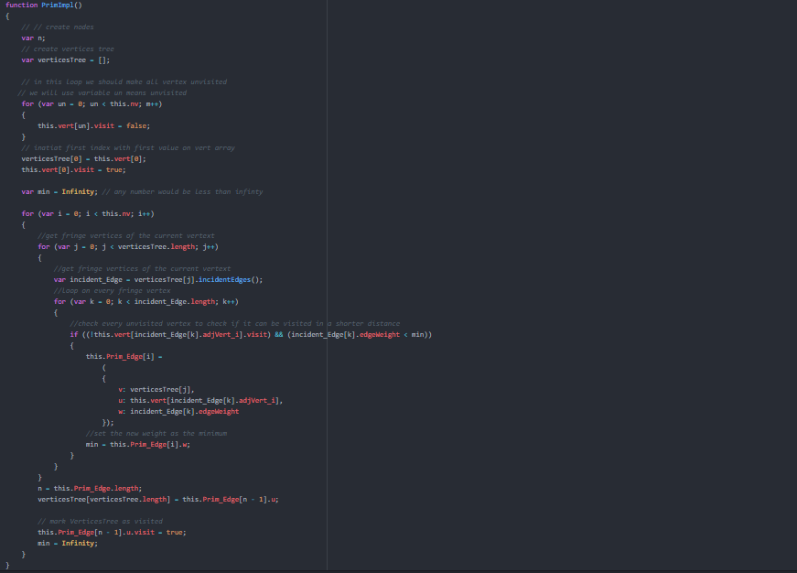Prim’s algorithm
* Figure 4: Prim’s algorithm.
* The output of milestone two

Figure 5: Output milestone 2.

1. Milestone Three:

The main challenge we faced in this part is how each member of us work and integrate the work with other members in the group. It was absolutely a great way to learn how to work with a group in a coding project. Each member of us got some challenges in her task where member 4 that challenge faced is how to apply a suitable class in the priority queue and do the function of implementation in the main class. Member 2&3: how to apply Dijkstra’s algorithm and Prim’s algorithm and integrate with the priority queue. Member 1: how to apply API docs with all algorithms.

* Priority Queue

Figure 6: Priority Queue Class.

* Prim’s algorithm

Figure 7: Prim’s algorithm using PQ.

* Dijkstra’s algorithm

Figure 8: Dijkstra’s algorithm using PQ.

* The output of milestone 3

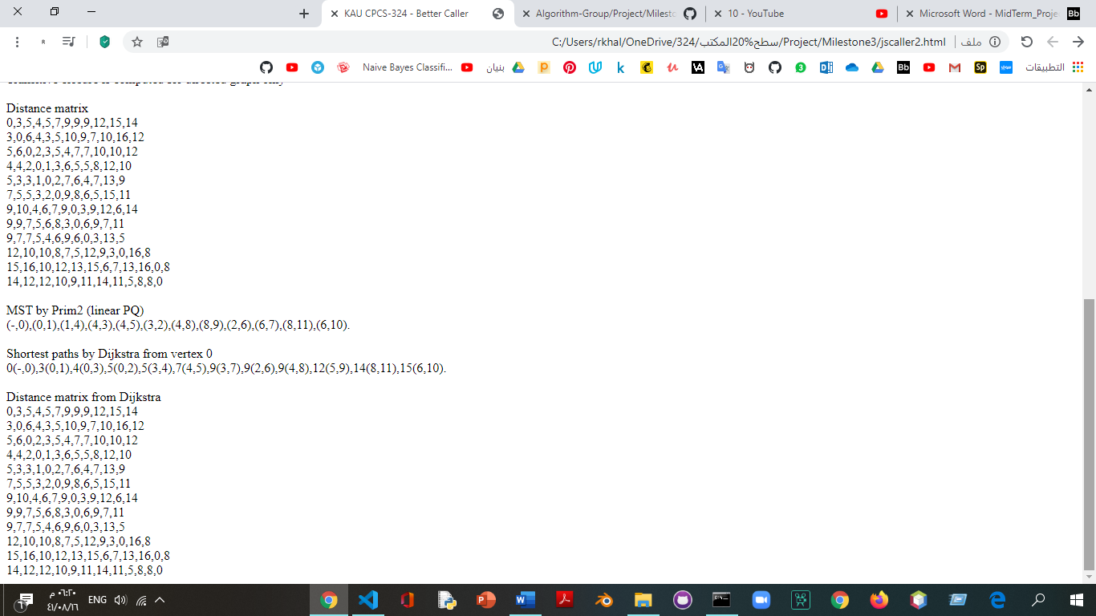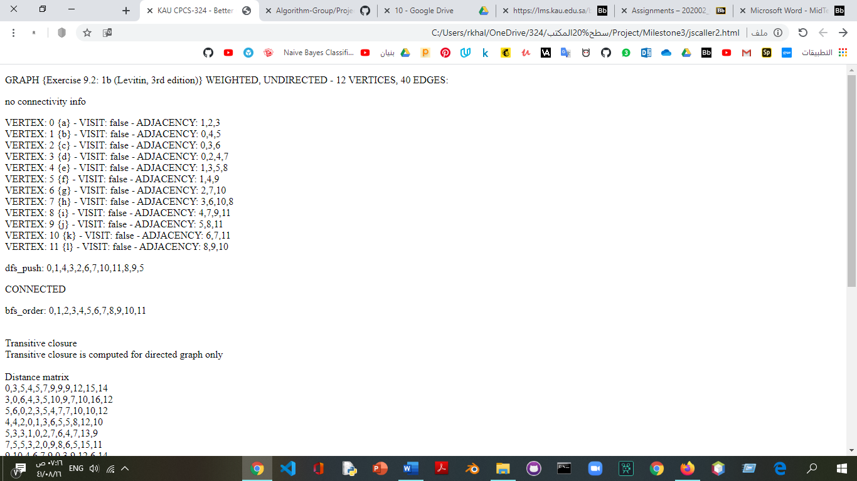

Figure 9: The output of milestone 3

1. Conclusion

In this project, we got a great experience and learned a lot of things like teamwork, using Git and GitHub with the team. Moreover, we applied to the data structure concept and algorithms. In this experience, we got a new concept of problems in the programming world and how we can convert it to challenges to solving.