In this article, we will learn to create HTTPS self-signed certificate and create a Node.js application using HTTPS Server.  
  
**STEP 1 - Download openssl for Windows**  
  
Download your compactible Openssl setup from *https://slproweb.com/products/Win32OpenSSL.html*

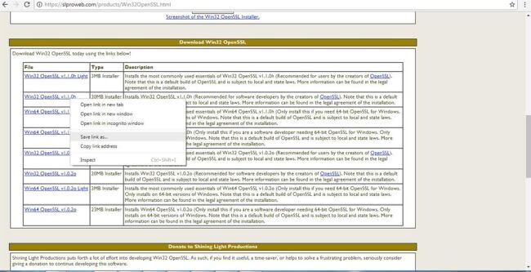

Double click the OpenSSL file using default settings to complete the installation.

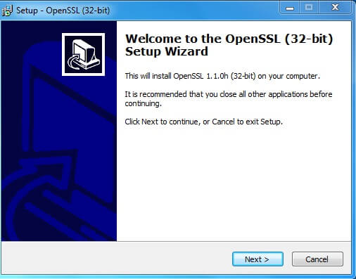

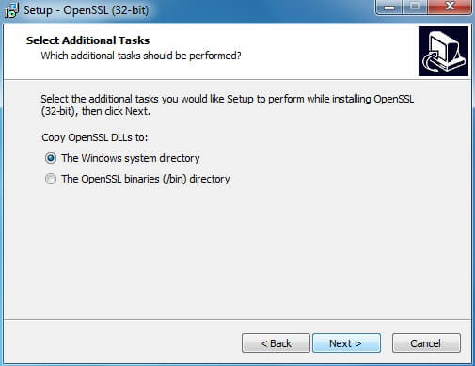

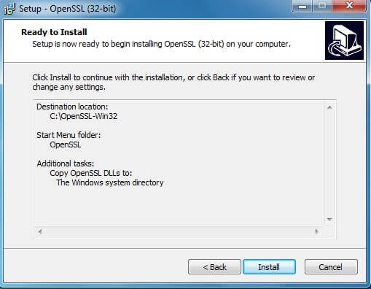

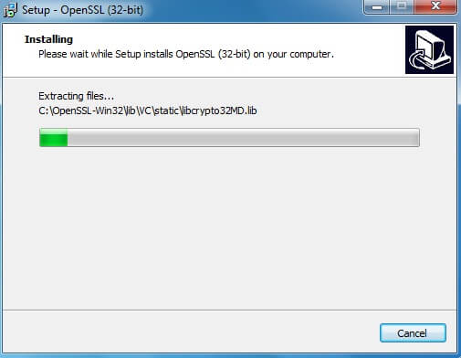

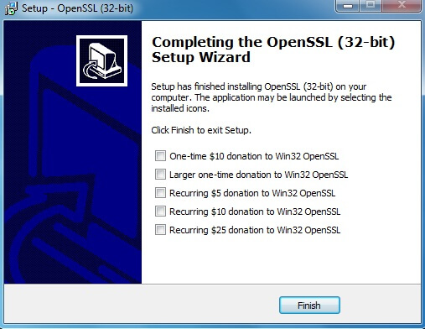

**STEP 2 - Set up OpenSSL for usage**In Windows, click Start > Run   
  
In the Open box, type CMD and click OK

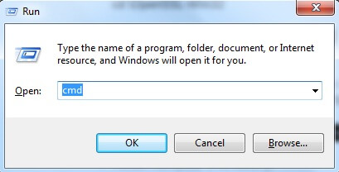

A command prompt window appears,  
  
Type the following command at the prompt and press Enter:  
  
*cd \OpenSSL-Win32*

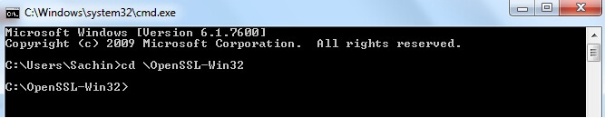

The line changes to C:\OpenSSL-Win32  
  
Type the following command at the prompt and press Enter,  
 *set OPENSSL_CONF=c:\OpenSSL-Win32\bin\openssl.cfg*

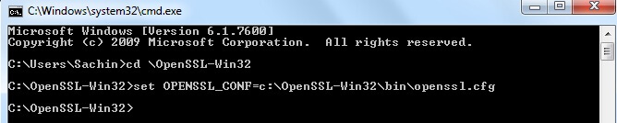  
Restart computer (mandatory)

**STEP 3 - Generate a Certificate Signing Request (CSR) using OpenSSL on Windows**

1. In Windows, click Start > Run
2. In the Open box, type CMD and click OK



A command prompt window appears.  
  
Type the following command at the prompt and press Enter:  
  
*cd \:OpenSSL-Win32\bin*  
  
The line changes to C:\OpenSSL-Win32\bin  
  
Type the following command at the prompt and press Enter:  
  
*openssl req -newkey rsa:2048 -new -nodes -keyout key.pem -out csr.pem*  
  
Then Type the following command at the prompt and press Enter:  
  
*openssl x509 -req -days 365 -in csr.pem -signkey key.pem -out server.crt*

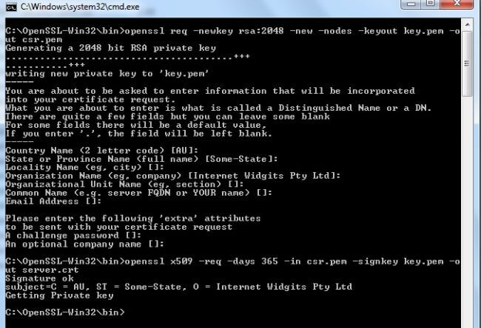

Which will create the following files in bin directory

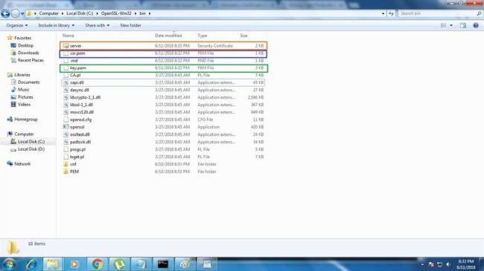

**STEP 5 - Code**  
File Name: MainApp.js

1. varhttp = require('http');
2. varexpress = require('express');
3. varapp = express();
4. consthttpsPort = 1234;
5. varhttps = require('https');
6. varfs = require('fs');
7. varoptions = {
8. key: fs.readFileSync('./key.pem', 'utf8'),
9. cert: fs.readFileSync('./server.crt', 'utf8')
10. };
11. //console.log("KEY: ", options.key)
12. //console.log("CERT: ", options.cert)
13. varsecureServer = https.createServer(options, app).listen(httpsPort, () => {
14. console.log(">> CentraliZr listening at port " + httpsPort);
15. });
16. app.get('/sach', **function**(req, res) {
17. res.sendFile(__dirname + '/public/index.htm');
18. });

**File Name - index.htm**

1. <html>
3. <head>
4. <title>My First HTTPS Secure Page</title>
5. </head>
7. <body> Welcome to NodeJs Tutorials.... By Sachin Ghadi. </body>
9. </html>

Copy your csr.pem,key.pem,server.cert from C:\OpenSSL-Win32\bin to your applications root directory.

Create new folder in your directory and rename it as public and copy index.htm into it. The Folder Sturcture will look like this,

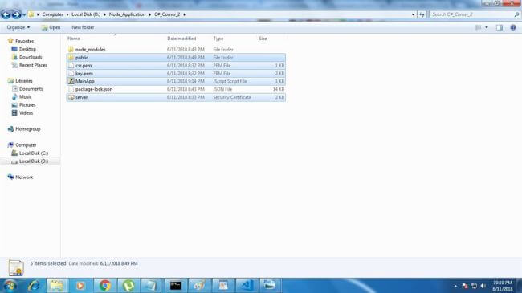

**STEP 6 - Code Execution**Install required packages like --> npm install express

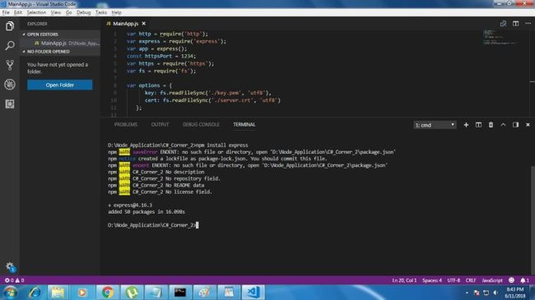

Execute code using the following command,  
  
-->node MainApp.js 

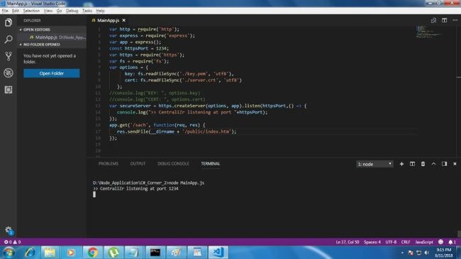

Our application is now runing on 1234 port using localhost.  
  
Now, open the latest browser (I am using Chrome) and enter the following URL.  
  
*https://localhost:1234*

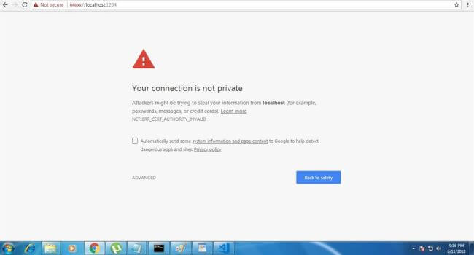

Click on ADVANCED,

Now Click on Proceed to localhost(unsafe).

Success!  
  
One more step to go, geeks...  
  
Append/search in your URL. Now, your URL will be *https://localhost:1234/sach*

Node.js

We have done it ... enjoy!  
  
If you have any doubts regarding the same, just mention it in the comments